Venue: OLD HOUGH FISHERY: PROSPECT, LUCKY DIP, UPPER BENBO

Date: 18.10.20

Before I go into the match report for the final match of 2020 I would like to offer the clubs sincerest condolences to the family of Michael Crowther. We learned that Mike had passed after being in hospital for the last couple of weeks and the news is deeply saddening to us all as the club has lost a true gentleman.

Mike joined the club in 2016 to join his dad John who has been a member for some time and since this day Mike has been a pleasure to be around and have as a member of South Manchester AC. Never moaning, never complaining…. just loved his fishing. I think when you strip it all back, take away the leagues, competitions etc. we’re all the same, we all just enjoy being out on the bank in the fresh air having the crack with the lads and it really brings it home how lucky we are to be able to do so.

I’ve personally got many fond memories of Mike and all of them make me smile. Like the time at lindholme he launched a huge method feeder packed with groundbait down the margin between us and it scared the living daylights out of me! Whilst writing this I have been speaking to Phil Zahra who told me about a day at Manor Farm when it was a boiling hot day and after a night on the beers Mike was camped under his brolly on boundary pool keeping cool, Phil saw Mike hook into a decent fish and half hour later Phil looked over to see Mike still playing the same fish! Phil gave him some banter asking why he was messing about with it….. It turned out to be the biggest fish of the week when Mike finally netted it! I think everyone in the club will have several fond memories from fishing and having a few beers with Mike and I can safely say he’ll be held in our hearts for a very long time.

In 2017 Mike and Carl had a great run in the pair’s competition getting to the semi-final stage only narrowly missing out on a final place. In 2019 Mike put in his best performance ever to earn his place on the SMAC hall of fame page with 105lb 12oz from Old Hough, Upper Benbo which got him second in the match, and in 2020 Mike would have been made up to come 3rd in the teams of 4 competition with Dave, Tommy and Alan. A huge shame we won’t be able to present Mike with this award I’m sure you’ll agree.

Mike’s family will be in our collective thoughts and prayers, in particular; his dad John, Frank, Ian and Dave who we all know very well. The next few weeks will be tough but we are all here for you, if you need anything at all just ask.

Top guy, true gentleman, good friend. Rest in peace Michael Crowther.
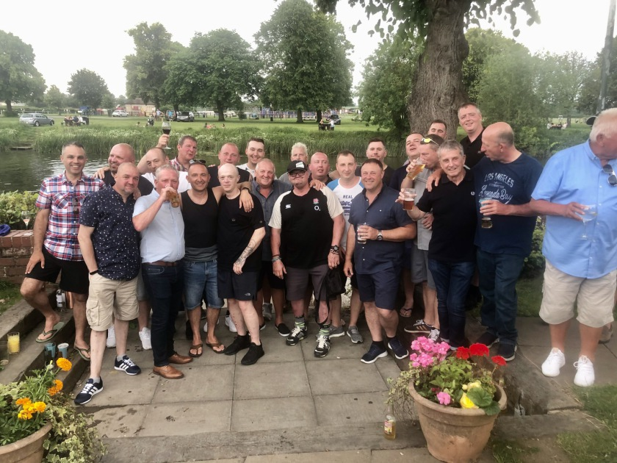

On to the final match report of 2020 and it was a tough day at the hough with not many decent weights to report on. Ian and Dave fought a brother’s battle on upper benbo for bragging rights as going in to this match they were level on points. It was a close match and the Coleman brothers finished first and second overall. Ian with 65lb and Dave with 55lb so Ian ended up 1 point clear of last year’s runner up Dave. Much to everyone’s disappointment as we all like Dave. Ian, not so much hahaha. Third place in the match went to Alan hesling with 50lb off lucky dip, Alan forgot to go in the pools for the first time this year which means he missed out on being able to retire with his winnings!

We’ve got a new club champion!!! Andy ‘the Meerkat’ Sonley. He’s had a brilliant year with a huge average points per match at 5.75 only dropping 2 points across the 9 matches we fished, he’s weighed in a total of 846lb which is an average of 105lb per match which is pretty epic. Andy had a cracking weekend on Benny’s lake at Lindholme resulting in him weighing in a colossal 279lb which is the new SMAC match record. I think you’ll all agree he’s a sound guy and a top angler. Andy does things a little differently to most and is the ‘master mugger’ earning him the Meerkat title, he’s not just got this in his armoury though and has proved that over the last couple of matches when the temperatures have dropped and he’s had to adjust his tactics to suit. A well-deserved title win, well done Andy!

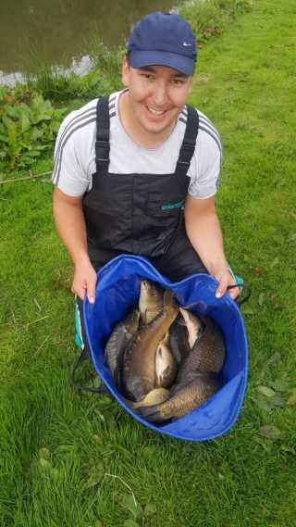

The teams of 4 competition has come to an end with Ian Coleman, Andy Sonley, Phil Topham and Gary Marsland topping the table with a combined 131 points so a massive well done to them. Second place went to Steve Barlow, Steve Thomason, Gavin Dodd and Andy Webb with 128 points and third place went to Dave Coleman, Tommy Edwards, Alan Hesling and Mike Crowther with 122 points – without Mikes input these guy’s would’ve finished 6th! Well done to everyone who’s won something in this league. I’ll sort the payouts out over the next week or so as it looks like a presentation night might not be able to happen.

Steve Tomo topped the over 55’s and Tier 2 league after having a brilliant season which saw him reach the final of the Garbolino club angler final. Well done Steve a great year for you.

That’s me done now until next year, thanks to everyone for sticking with us whilst we’ve had to do things a bit differently, hopefully you’ve all had an enjoyable season, I particularly enjoyed the festival we ran which I thought was a great success. I’m looking forward to getting back to normal next year so I don’t get any more grief for drawing bad pegs haha. Take care and hope you enjoy the winter league which Paul Pannett is running this year.

All the Best

Pete.
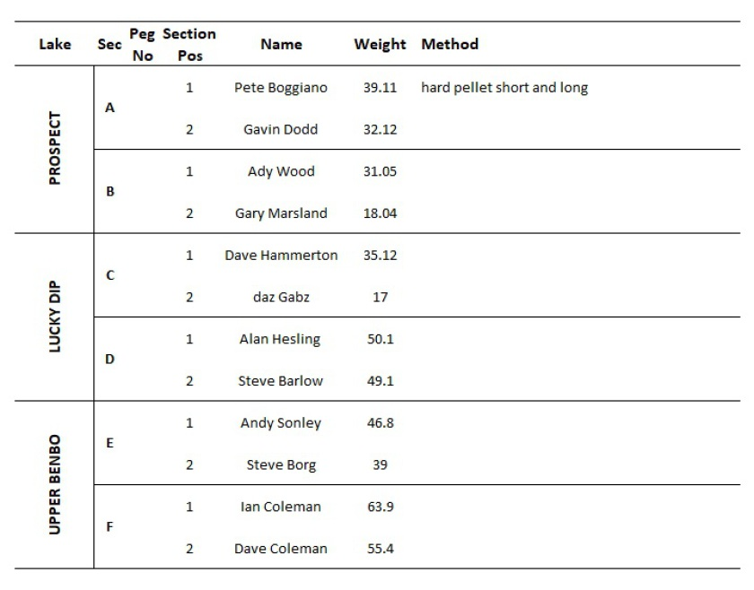

Venue: PARTRIDGE LAKES MARSH, SPEY & COVEY 5
Date: 04.10.20

The penultimate match of the shortened 2020 season took us to Partridge lakes in Warrington. The pair’s final was fished between Andy Sonley/Mick Abdy and Adrian Wood/Ste Tomo. It looked like a reasonably fair draw and it turned out to be the closest pairs final ever with only 1lb 2oz separating the teams at the weigh in! a massive well done to both pairings for making it to the final and congratulations to Andy and Mick for winning the competition, a great team effort in the end, nice work guys!

Pete Boggiano won the overall match with 82lb from peg 130 on covey 5, second place went to Steve Tomo with 65lb from peg 126 and Andy Sonley pulled a great performance out of the bag with 60lb from unfancied peg 9 on Marsh, well done guys.

This section win from Andy pretty much secures the title, he’s 2 points clear with a huge weight advantage…. Barring a massive slip up at Old Hough Andy should be on for his first league title, let’s see if anyone can step up to rumble him!

The teams of 4 competition is hotting up for the last match with any one of the top 5 teams in with a chance of framing, it’s all about who turns up! Good luck to all the teams in the last match J

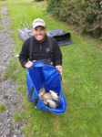
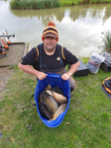
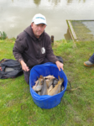
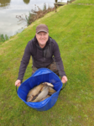
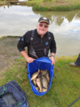
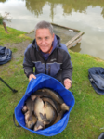
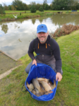
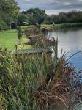
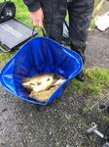

Venue: LINDHOLME LAKES STRIP AND LAURELS
Date: 20.09.20

Expectations are always high when we make the journey to Lindholme Lakes as the matches there are usually epic, unfortunately this wasn’t the case as the whole venue fished really tough and only 1 or 2 decent weights were recorded across the 2 lakes we fished.

The match was won by Andy Sonley with 109lb from peg 39 on laurels, this puts Andy 1 point clear at the top of the league for the first time since he joined us a couple of years ago, I reckon he’s got the bottle to win the league with just 2 matches remaining he’ll be tough to catch, especially with an overall weight of 740lb, 400lb clear of second place!!! Well done Andy.

Second in the match was Adrian Wood with 79lb from peg 22 Laurels and 3rd was Ian Coleman with 59lb from peg 14 laurels. Well done guys.

The pair’s league has now ended resulting in a final of Andy Sonley & Mick Abdy vs Adrian Wood & Steve Thomason. This is a one off final match to be competed at the next match all anglers are available. Good luck to the finalists and well done for making it to the final.

There is £400 in the pot which has been made available from the funds saved from missed matches earlier in the year and the split will be 1st = £120 each / 2nd = £80 each so a decent prize fund!

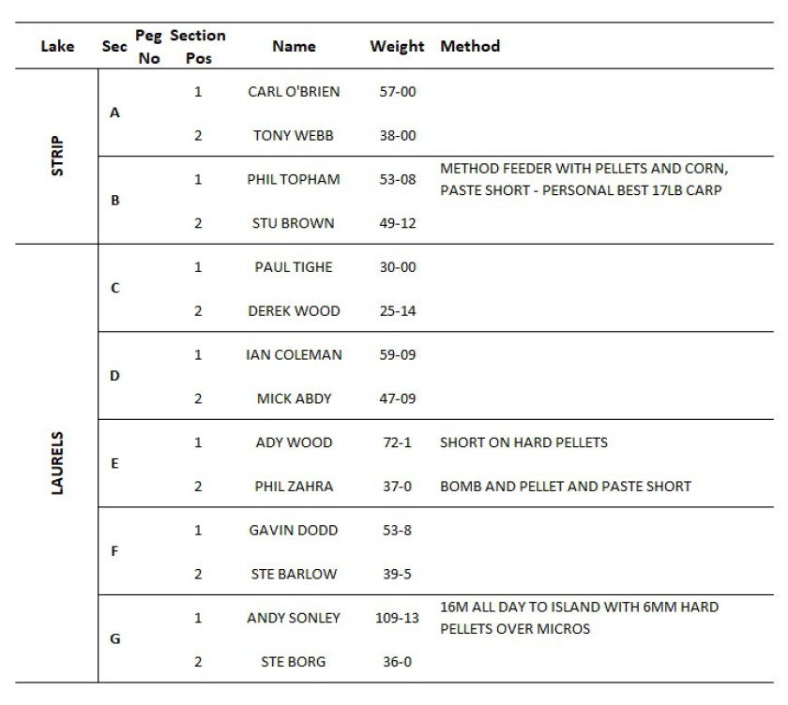
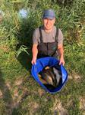
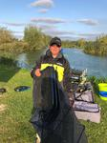
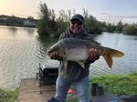
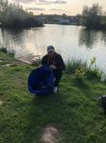
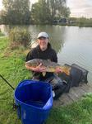
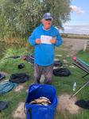

Venue: CUNNERIES S CANAL AND HAWK
Date: 06.09.20

Our one and only trip to the cunneries this year leads us into the final quarter of a shortened season and for the first time since the first match we have a new league leader with Andy Sonley taking the top spot as we close in on the last 3 matches. He’s level on points with Pete Boggiano and Steve Tomo but ahead on weight….. Has he got the bottle to win the league?

The pairs is also very tight with the top 3 all very close and in contention for the top 2 places to take them to the final. Interestingly the top 2 teams in the pair’s league have better weights from the guys in tier 2 than their supposedly superior counterparts from tier 1! Interesting!

The match was basically decided by the wind on S Canal with all 4 car park pegs picking up section wins….. Not taking anything away from the guys on these pegs but Stevie wonder could draw that end and still come away with 6 points and £30, that is of course if he went in the pools LOL! Phil Zarha won the match from peg 15 S Canal, his first match win since 2017! Well done Phil. Second went to the meerkat Andy Sonley from Hawk peg 19 and third in the match went to Diane on peg 36 S canal. Well done guys and girls xxxx love you xxxx Tomo xxx

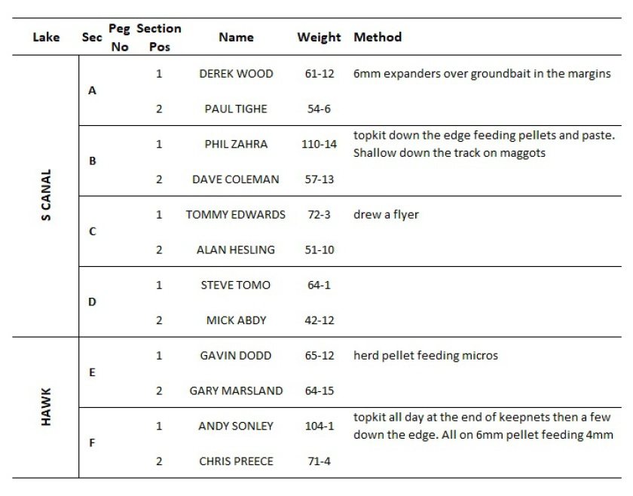
Venue: HERONBROOK BRIDGE AND MATCH LAKE
Date: 23.08.20

Our last trip to Heronbrook for the 2020 season and it fished nowhere near as good as it can unfortunately and it was a real struggle for most!

I’ve now included dropped points and weights in all league tables as we’re over halfway through the revised season, it’s looking really close at the top of the individual league with current champ Pete Boggiano on 23 points just one point ahead of 5 anglers in joint second place all on 22 points. The other leagues are all shaping up nicely for close finishes with only 2 matches left to get in the finals of the pairs it could all change over the next month!

Well done to Steve Tomo for the overall match win from peg 17 Match Lake with the only ton plus weight of the day 124lb, nice work mate! Chris Preece picked up second place with 86lb from peg 4 match lake and Ian Clarkson gets in the top 3 from Bridge peg 24. Well done guys!

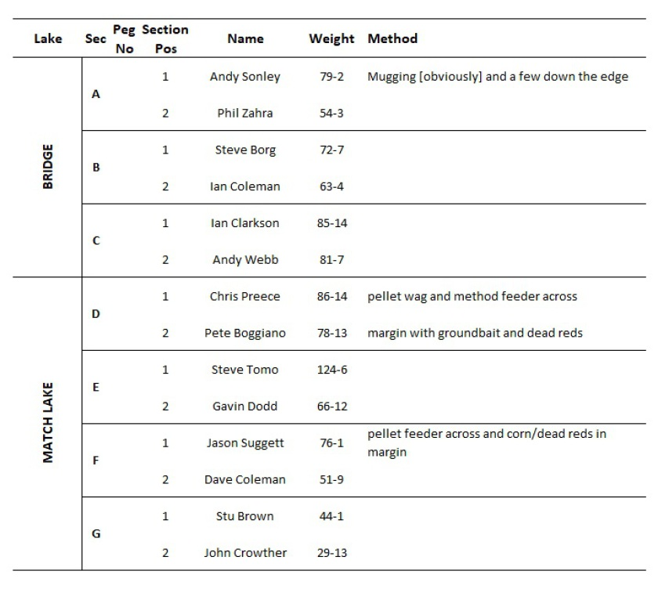
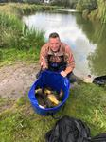
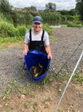
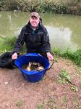
Venue: BLAKE HALL: HALL AND BLAKE POOLS

Date: 09.08.20

A brand new venue in the shape of Blake Hall Fisheries hosted the 4th match of the season with 34 anglers spread evenly across the 2 lakes of Hall and Blake. Hopes were high for some big lumps as the lakes are apparently stocked with some massive carp. Unfortunately they just weren’t in a feeding mood which resulted in some difficult fishing for most.

Daz Gabz won the match from peg 13 Blake, his second match win on the bounce and is properly on form with an average match weight of 132lb across the 3 matches he’s fished so far! Epic performance Daz, well done mate. Second overall went to Steve Tomo from peg 1 Hall pool with 75lb closely followed by Andy ‘the meerkat’ Sonley with 74lb from peg 5 Hall pool.

A difficult match but at least the weather was nice and the banter was decent.

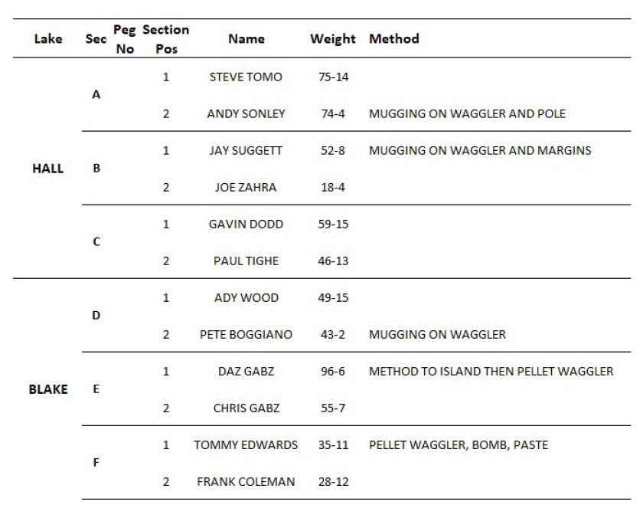
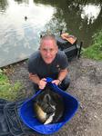
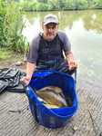
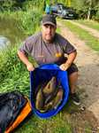
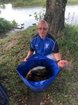
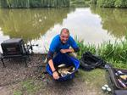
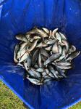
Venue: HERONBROOK – ISLAND, MATCH POOL AND MATCH LAKE

Date: 27.07.20

After securing an extra lake we were well spaced across the above 3 lakes, only having to put 1 section on the new bit of match lake which nobody fancied and rightly so as it was a bit of a grind in this section.

Daz Gabz is on fire in 2020 and picked up the overall win from peg 6 on Match Lake with an impressive 145lb. Second place went to Ste Hammerton from peg 3 on Island with 103lb and Ste Tomo picked up 3rd place from peg 5 Match Lake with 102lb.

There were some monster carp caught with lots of doubles. Mike Crowther got his new personal best with an 18lb 10oz mirror carp being beat by Geds 20lb monster mirror which is the current biggest fish of the season! Nice work guys!

Nobody went swimming.

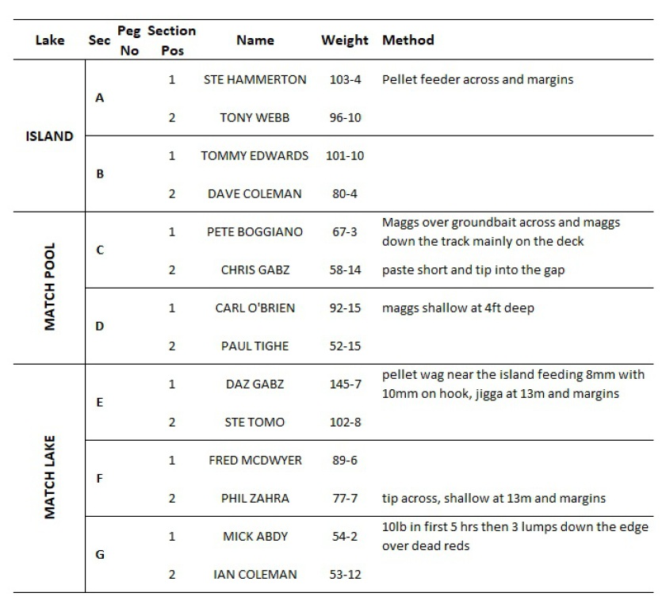
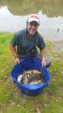
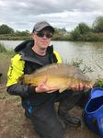
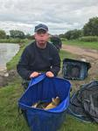
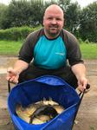
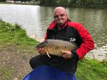
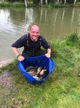
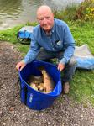
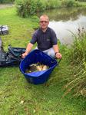
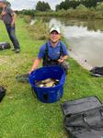
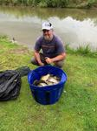
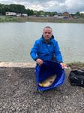
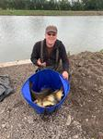
Venue: LINDHOLME LAKES – BENNY’S AND STRIP

Date: 12.07.20

What a couple of weeks fishing we’ve had! After the annual fishing holiday was unfortunately cancelled we managed to quickly arrange the first SMAC festival at Heronbrook over 3 days. The event was seeded to give everyone a chance at picking up the top prize and this worked really well. Massive congratulations to Daz Gabz on winning the competition and well done to everyone else who framed. There was a massive 8331lb of fish caught over the 3 days with 39 ton plus weights and 3 double tons, epic!! Safe to say this won’t be the last time we run this festival.

Just when we though it couldn’t get much better we’ve spent an awesome 2 days at Lindholme. A 14 man knock up was held on the Saturday on Benny’s which threw up some cracking weights. Andy Sonley won this with a massive 285lb and there were 3 more double ton up weights and 7 ton plus weights! A total close to 2200lb of fish caught between just 14 anglers!

We were then split across Benny’s and Strip pond for the 2nd SMAC match of 2020. Benny’s was obviously the fancied draw but strip has been known to throw up a few good weights in the past. On the day Benny’s massively outperformed strip as expected and the weights were just unbelievable….. 7 double tons were recorded along with 16 ton plus weights making it the best SMAC match of all time. The previous was Heronbrook in 2018 where the average weight was 110lb per angler and a total of 3539lb was recorded. This match smashed it with 4822lb at an average of 126lb per angler! Epic is an understatement.

There were countless personal best math weights recorded; too many to mention! So well done to everyone who got their PB match weight. Andy Sonley won the match again with a huge 279lb which is now the new SMAC match record taking the crown from Paul Tighe. Well done Andy, a cracking couple of days fishing mate. Second place overall went to new member Chris Preece with 262lb and third place went to Pete Boggiano with 247lb. Well done to all the framers and section winners.

I’ve included the final table below from the heronbrook festival along with the results from Saturday’s knock up and the pictures from Sunday’s match.

Thanks to everyone who was involved in setting up the festival and organising the night away at Lindholme….. 2 events that are sure to continue!
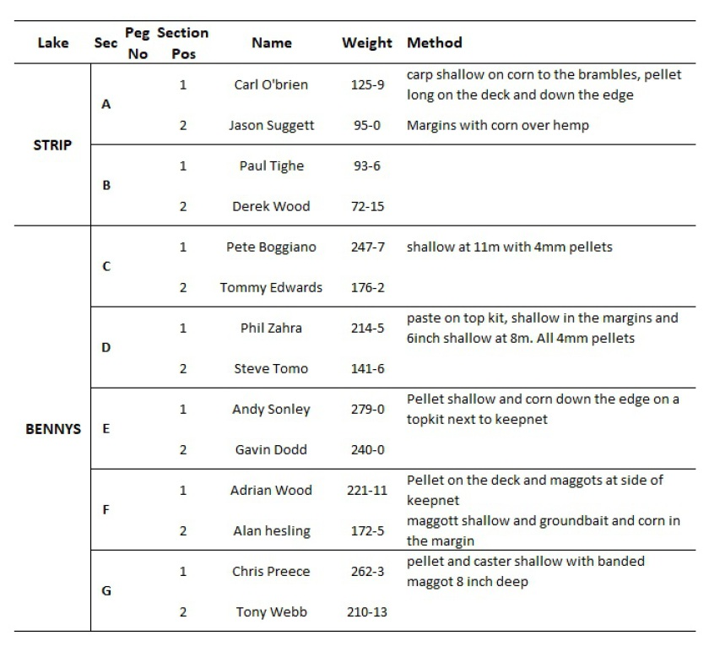
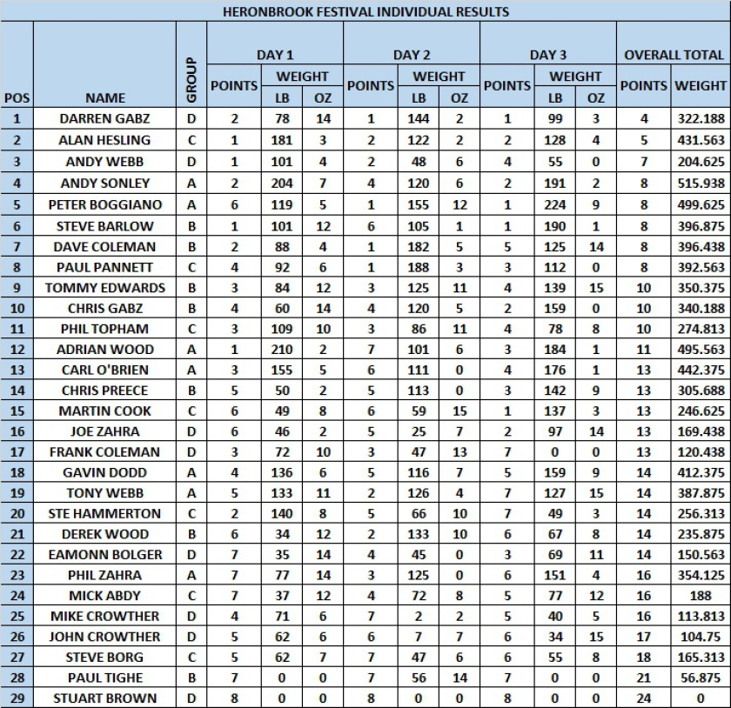

Saturday 11.07.12 Knock up results

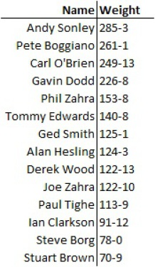
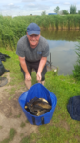
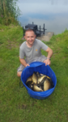
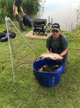
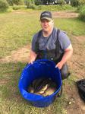
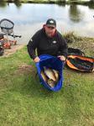
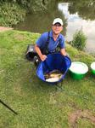
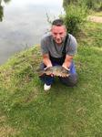

Venue: HERONBROOK FISHERIES – MEADOW AND BRIDGE

Date: 15.06.20

Almost 8 months have passed by since the end of the 2019 season and it was great to get back on the bank with 38 turning out for the 1st [what should’ve been the 6th] SMAC 2020 match. A reduced 9 match season means it’s more of a sprint to the line this year and with only 1 dropper the pressure is on!

A warm, muggy day greeted us at the fantastic heronbrook fisheries, expectations were mixed due to the fact the lakes were hammered in the previous week with a festival being on for the 3 days before but overcast conditions led a few to believe it would fish well. The cloud cover unfortunately disappeared after a short period of time which made the fishing really difficult for some. A few good weights still came out but not to the usual heronbrook standard we’ve become used too!

Well done to Paul Pannett on the overall match win, a good solid performance from peg 34 on meadow to put 120lb on the scales and Ady Wood from the next peg picking up second overall with 111lb. Pete Boggiano wasn’t too far behind with 109lb from Peg 1 – the top 3 all coming off Meadow.

Below are the framers and details along with some pics from the match. God knows what’s happened to everyone’s head on the bridge pictures!
