MATCH 15: OLD HOUGH, PROSPECT, LUCKY, GOOSE AND BOULDERS
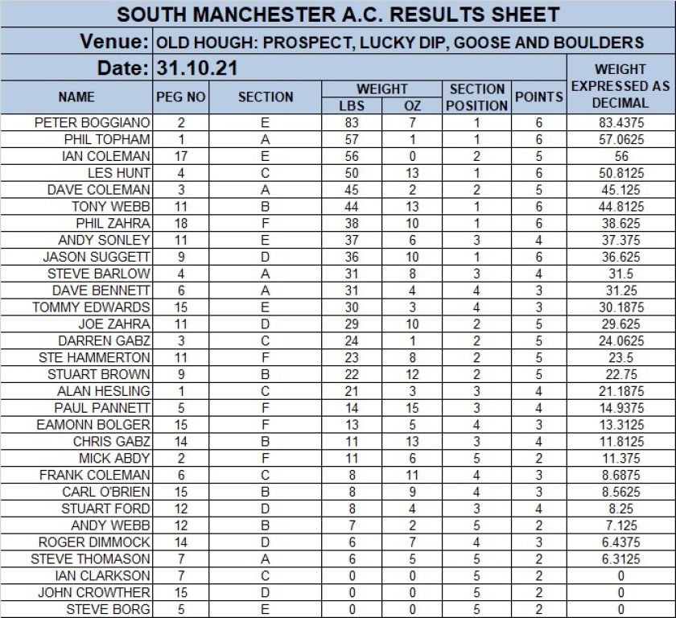

MATCH 14: PARTRIDGE LAKES - COVEY 6, SPEY AND MARSH
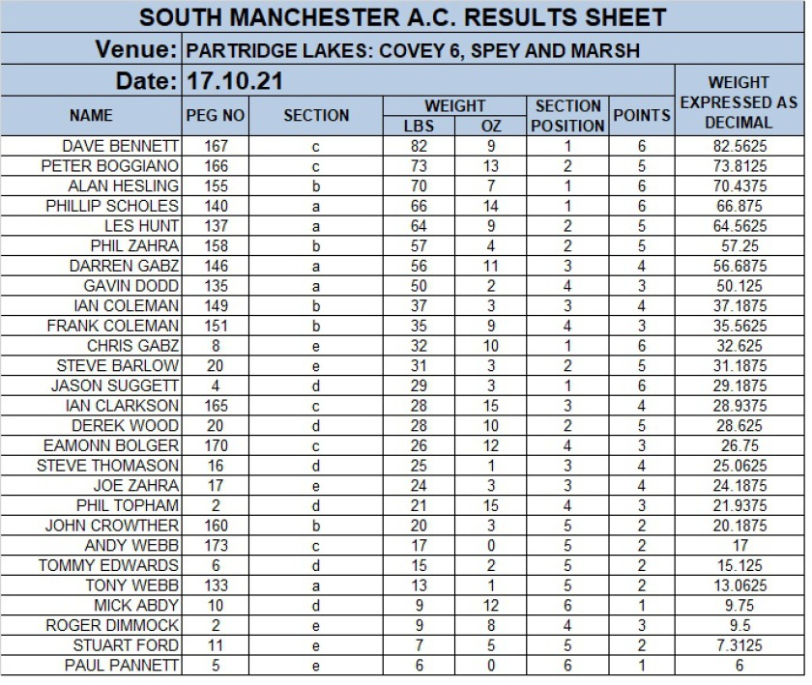

MATCH 13: CUDMORE - SUEZ, MOORS AND PANAMA
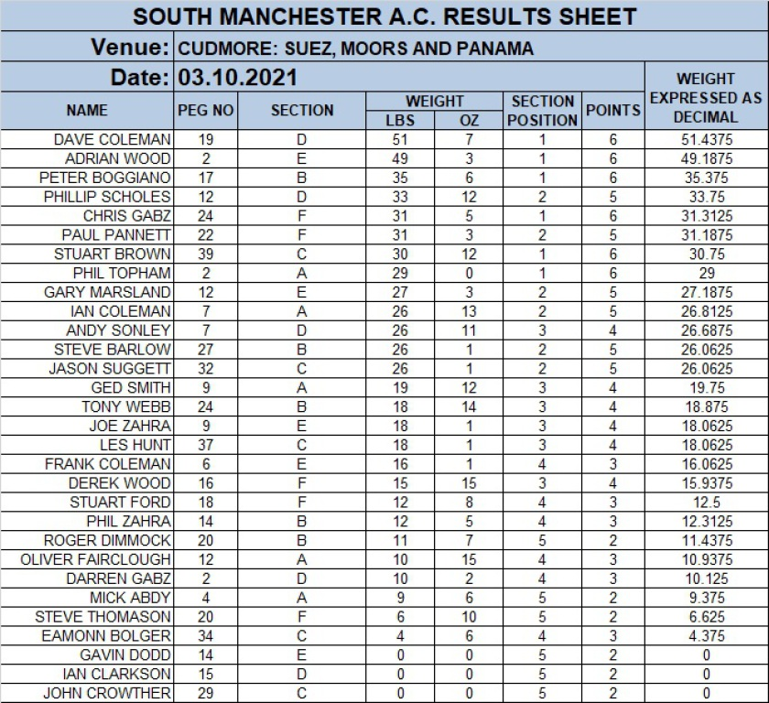

MATCH 12: HERONBROOK - CANAL, MEADOW AND ISLAND
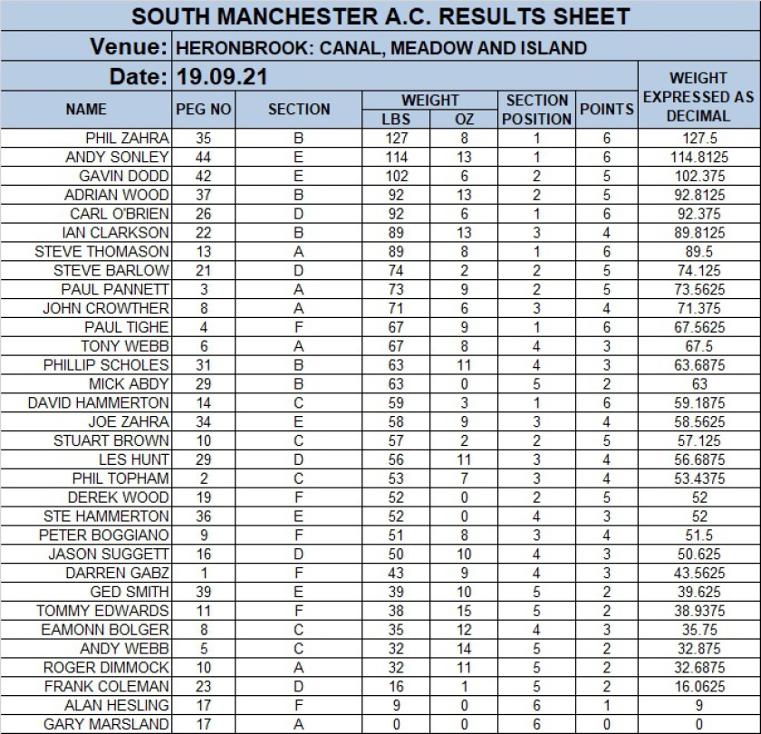

MATCH 11: HAMPTON SPRINGS: MEADOW, ALICE SPRINGS & POPLARS

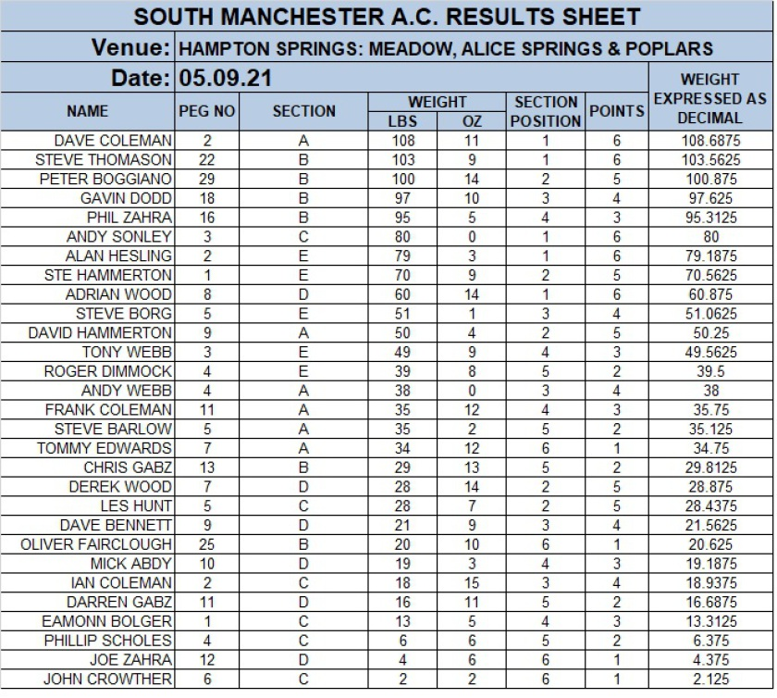

MATCH 10: CUNNERIES: S CANAL, HAWK AND OLD CANAL

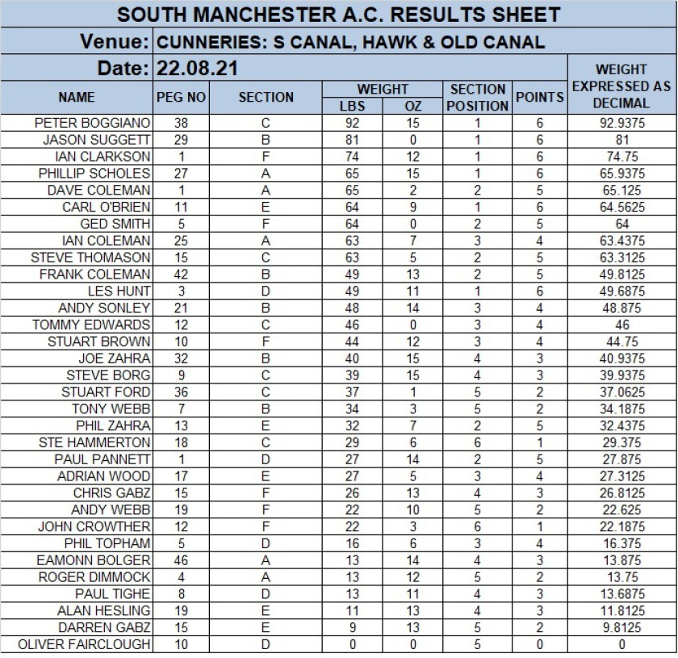

MATCH 9: HERONBROOK: MATCH LAKE, ISLAND AND MATCH POOL

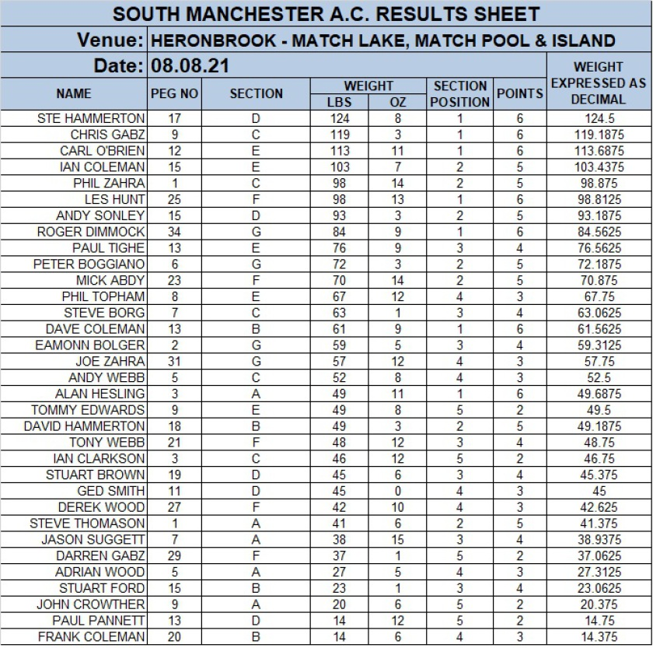

MATCH 8: LINDHOLME: BENNY'S

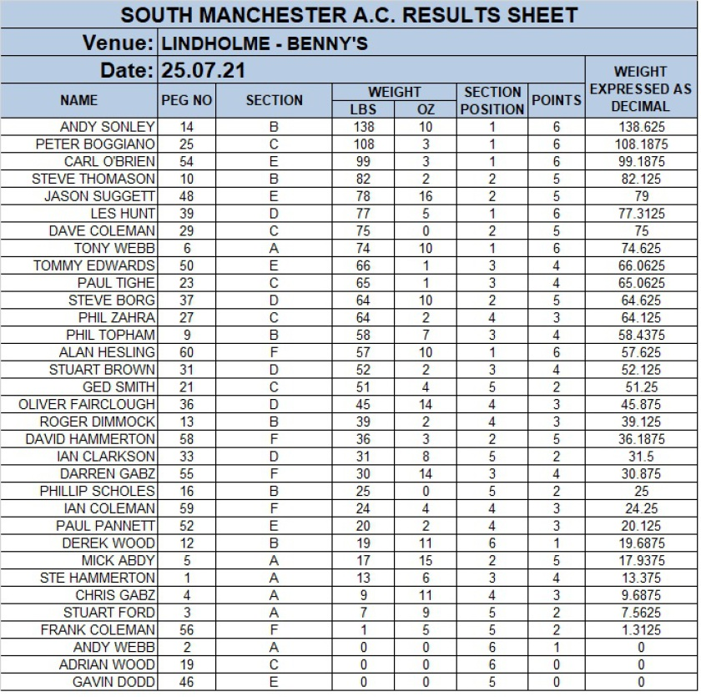

MATCH 7: CUDMORE: SUEZ, MOORS AND PANAMA

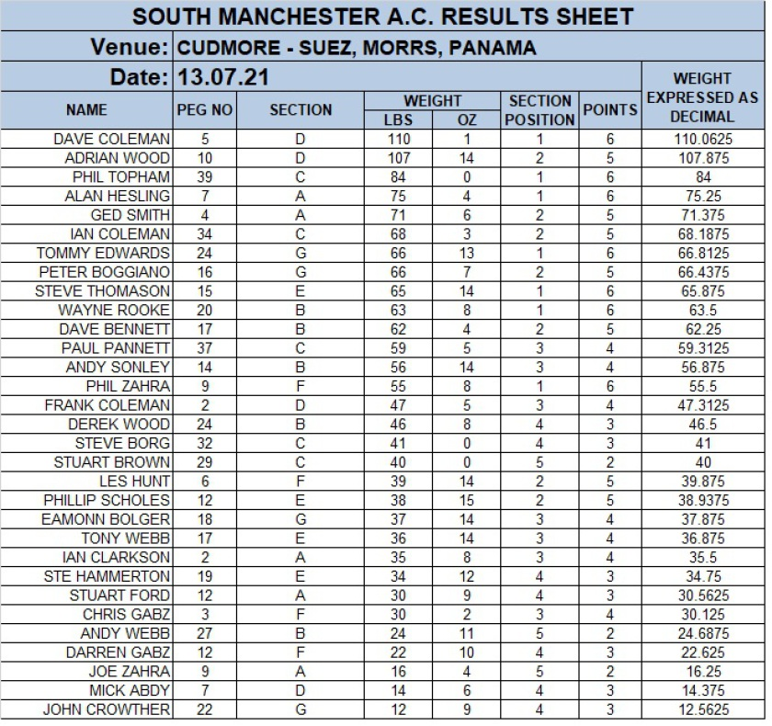

MATCH 6: HERONBROOK: MEADOW AND CANAL

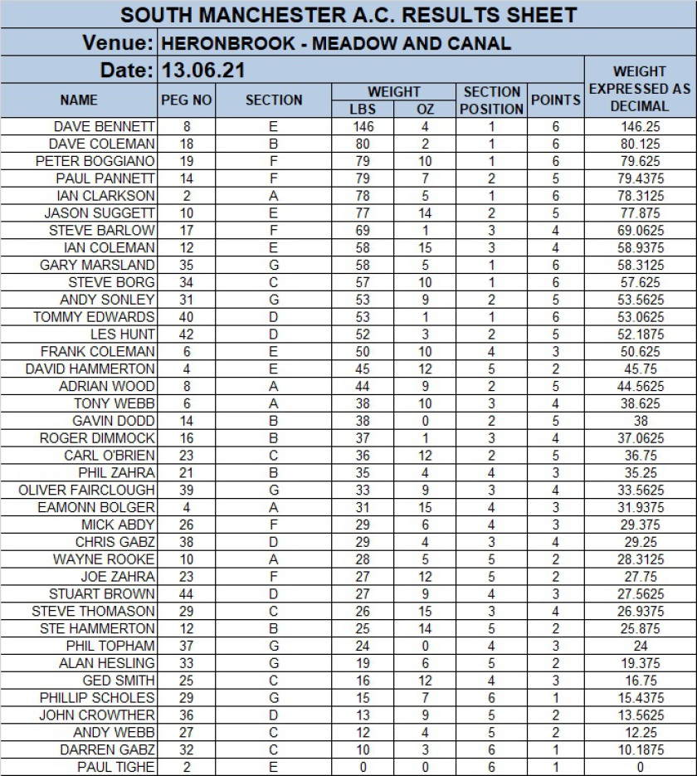

MATCH 5: CUNNERIES: OLD CANAL, S CANAL AND KESTREL

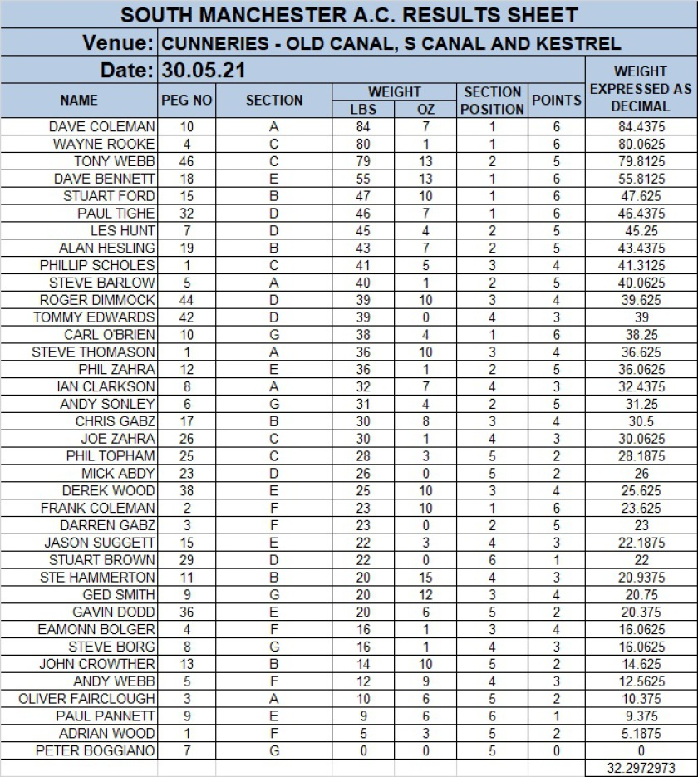

MATCH 4: LINDHOLME LAKES - BONSAI

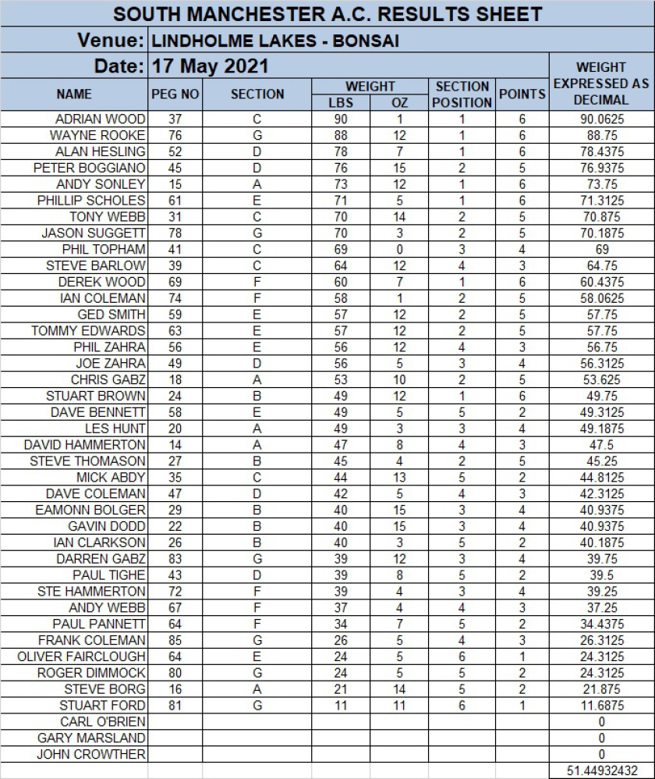

MATCH 3: HERONBROOK: MATCH LAKE, MATCH POOL, ISLAND

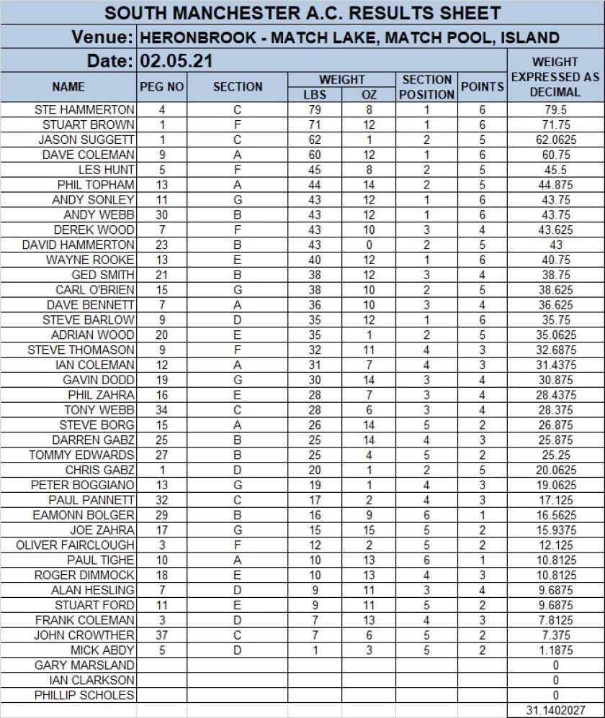

MATCH 2 : OLD HOUGH: UPPER, LOWER AND BIG MAX

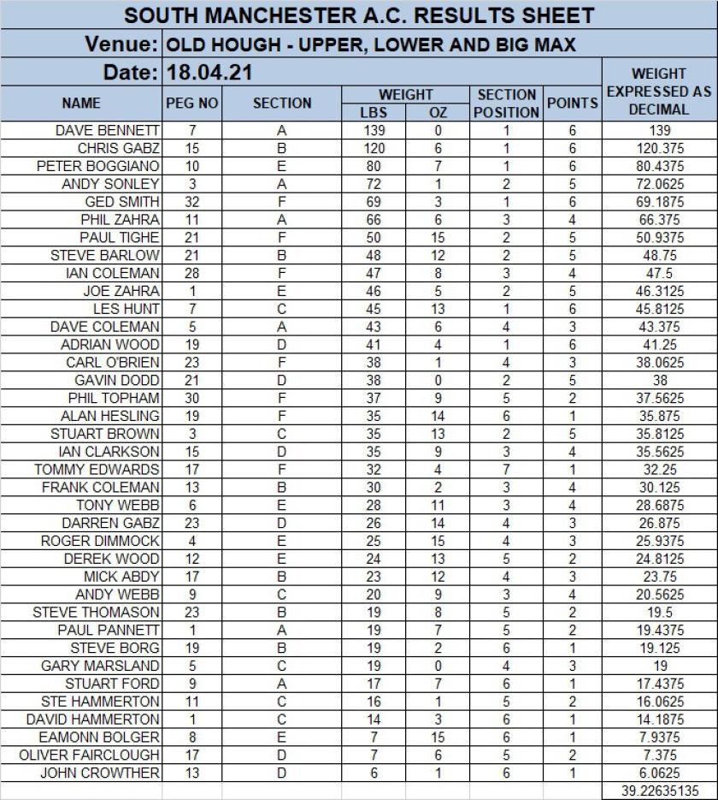

MATCH 1 : ASTON PARK SPLIT AND LILLY

