2022 MATCH REPORTS

MATCH 15 - OLD HOUGH: UPPER BENBO, LOWER BENBO AND BIG MAX
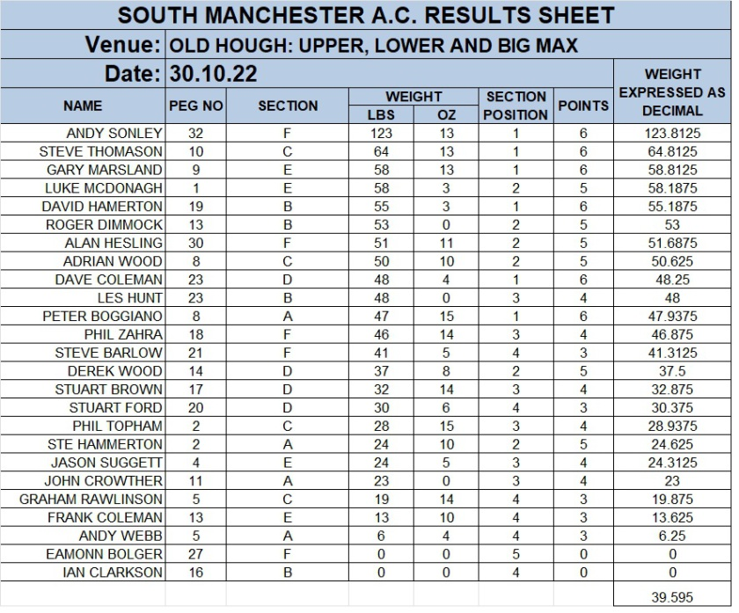

MATCH 14 - CUNNERIES: S CANAL, OLD CANAL AND HAWK
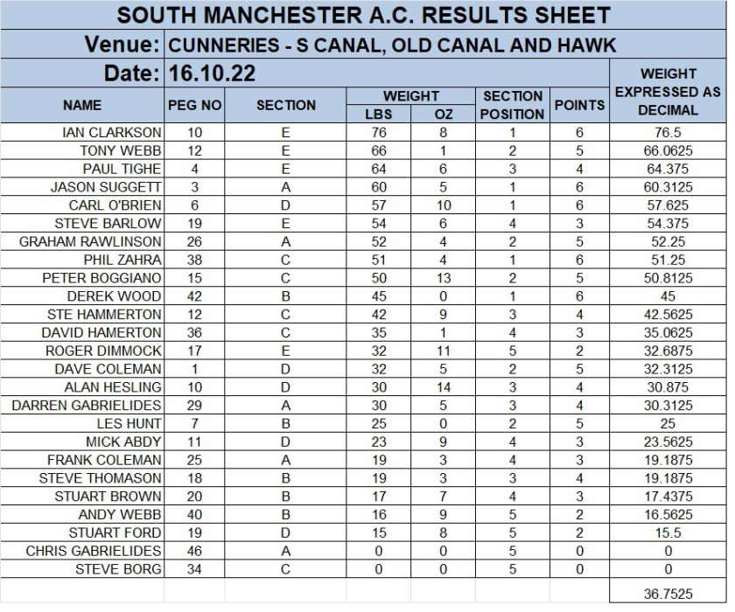

MATCH 13 - PARTRIDGE LAKES : COVEY 6, SPEY AND MARSH
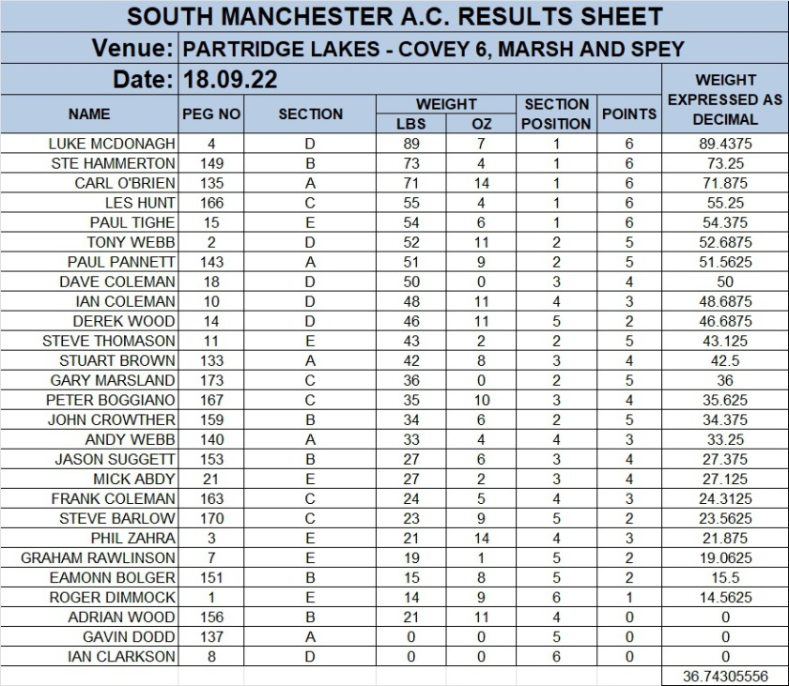

MATCH 12 - HAYFIELD LAKES - DANNIES ISLAND LAKE
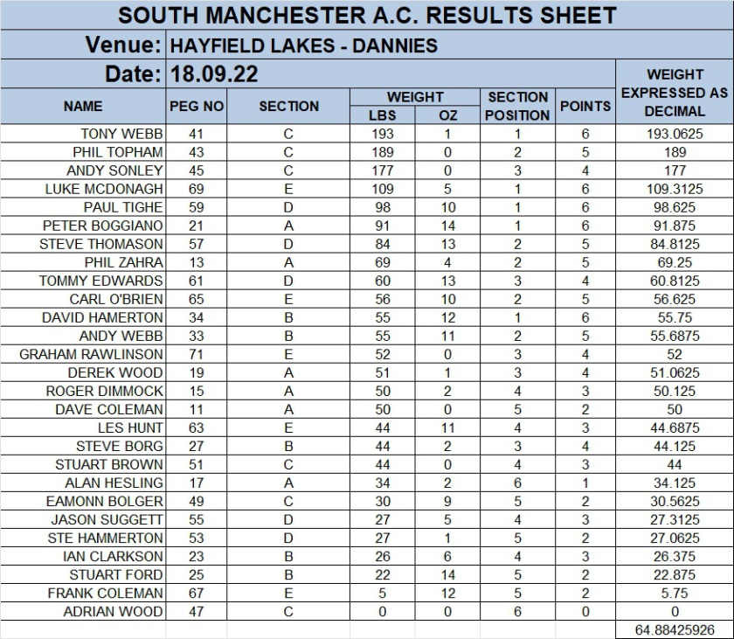

MATCH 11 - CUDMORE - SUEZ, MOORS AND PANAMA
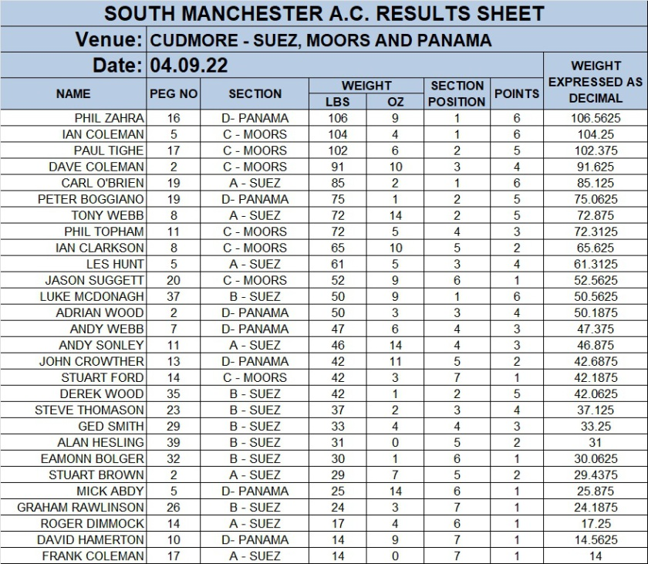

MATCH 10 - HERONBROOK - CANAL AND BRIDGE
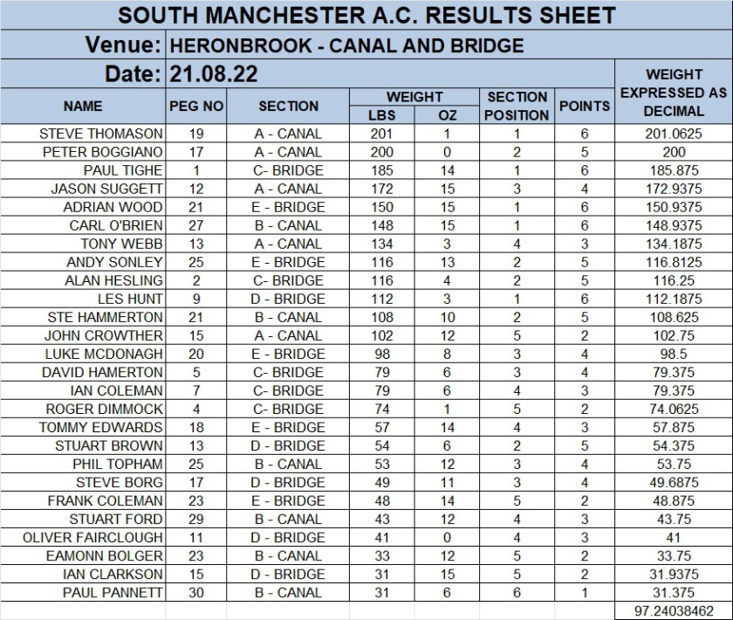

MATCH 9 - WESTON POOLS - CANAL AND BELVEDERE
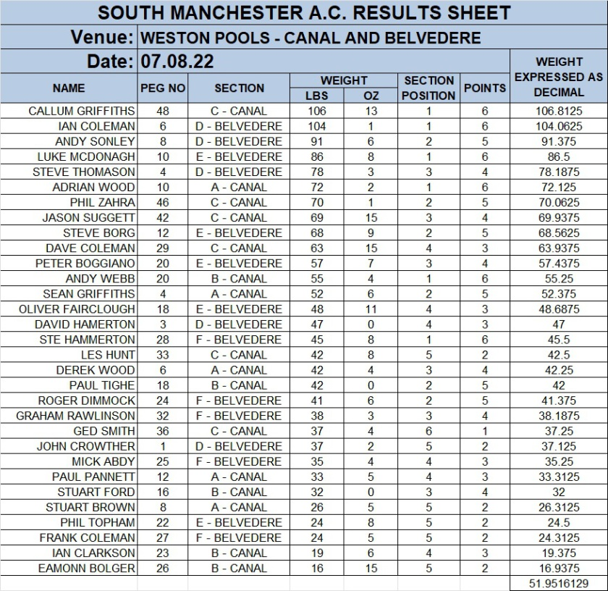

MATCH 8 - LINDHOLME - BENNY'S

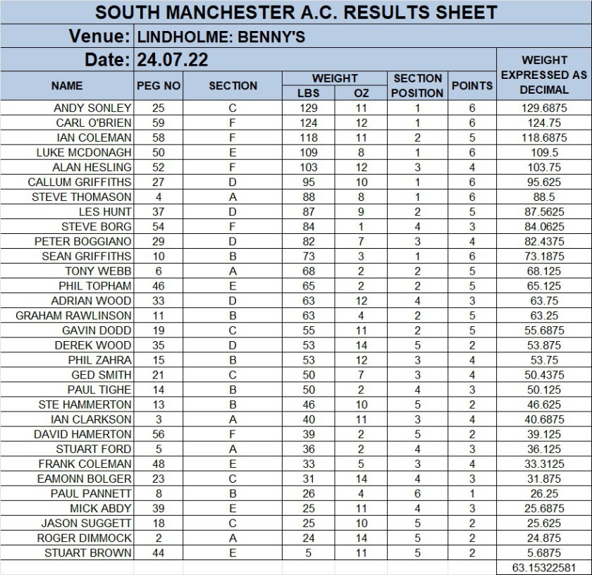

MATCH 7 - HERONBROOK CANAL AND MATCH LAKE

WELL DONE TO CARL O'BRIEN SETTING A NEW CLUB RECORD WITH 305lb 7oz FROM CANAL PEG 17, OUTSTANDING!!!
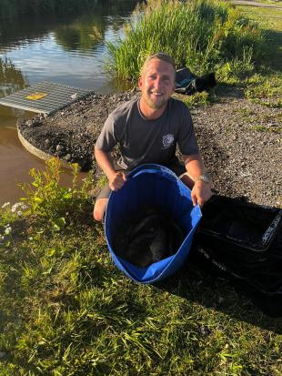
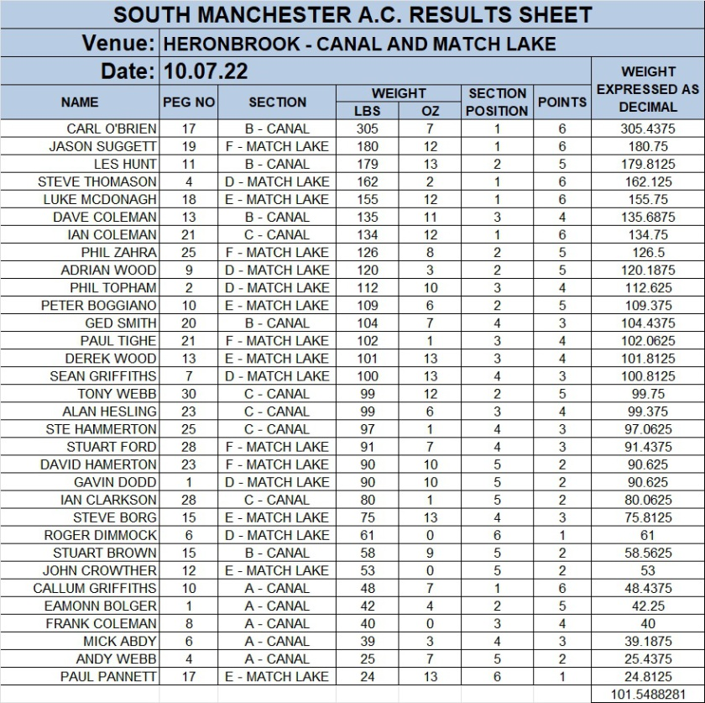

MATCH 6 - HAYFIELD LAKES ADAMS
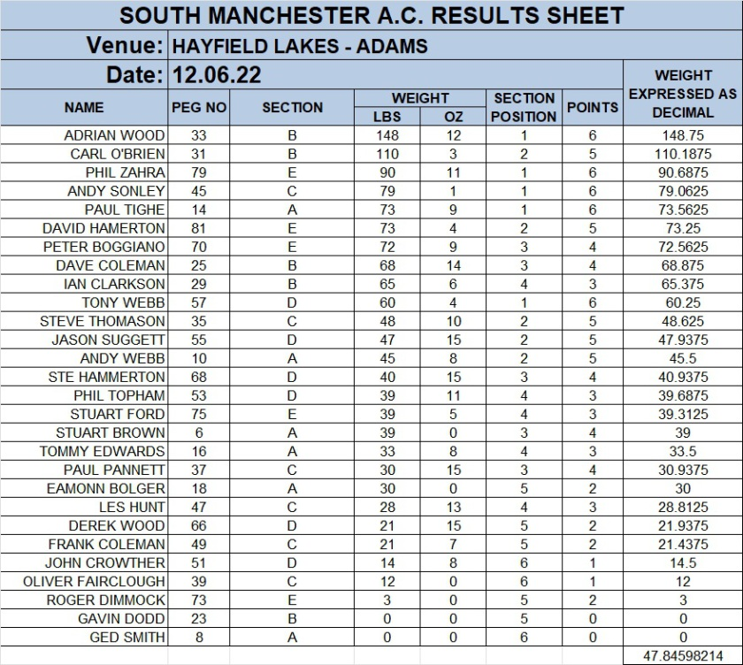

MATCH 5 - HERONBROOK MEADOW AND CANAL
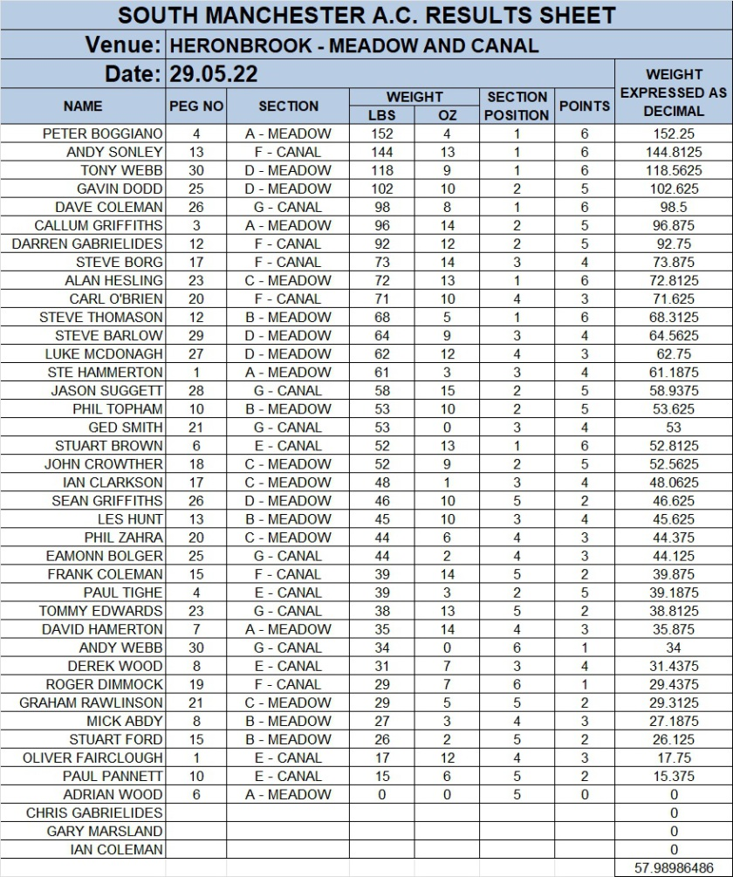

MATCH 4 - LINDHOLME LAKES LAURELS AND STRIP
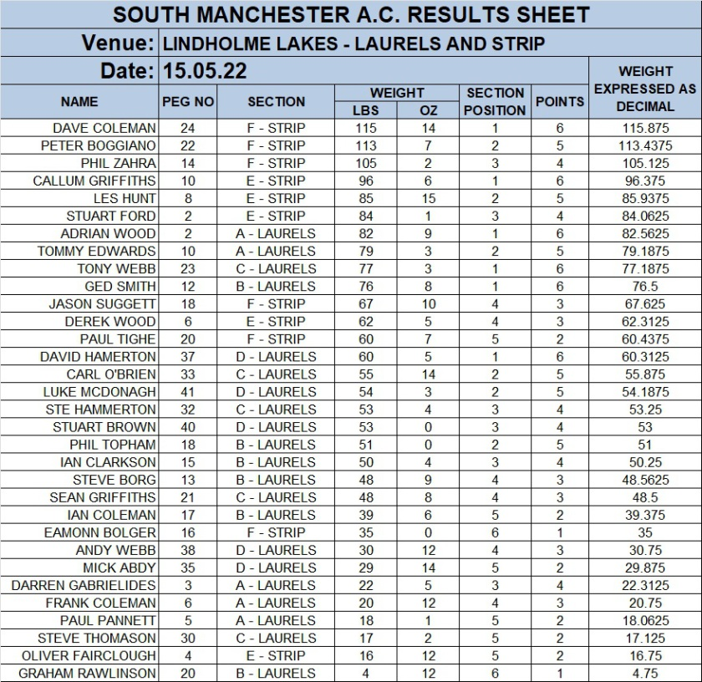

MATCH 3 - HERONBROOK - MEADOW, ISLAND AND MATCH POOL
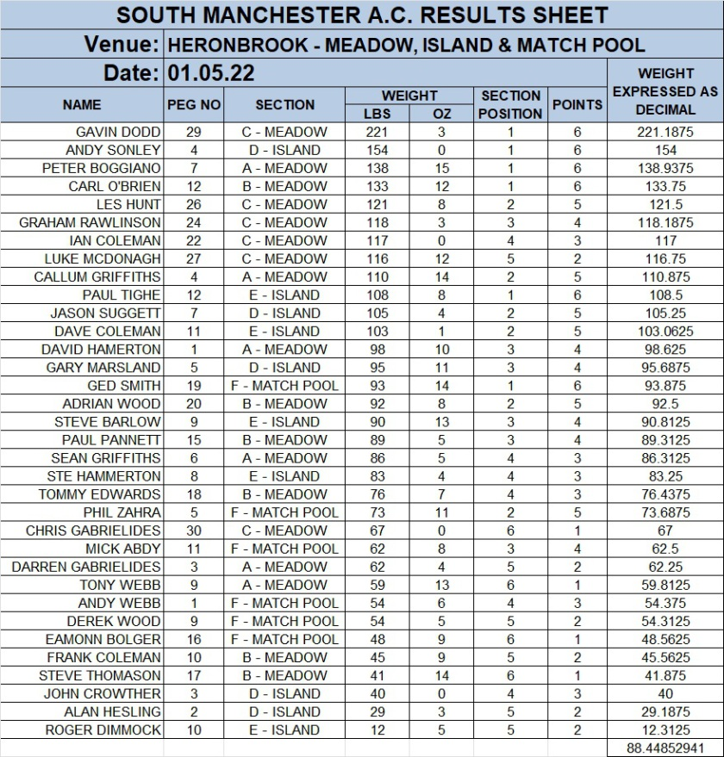

MATCH 2 - PARTRIDGE LAKES - COVEY 6, SPEY AND MARSH
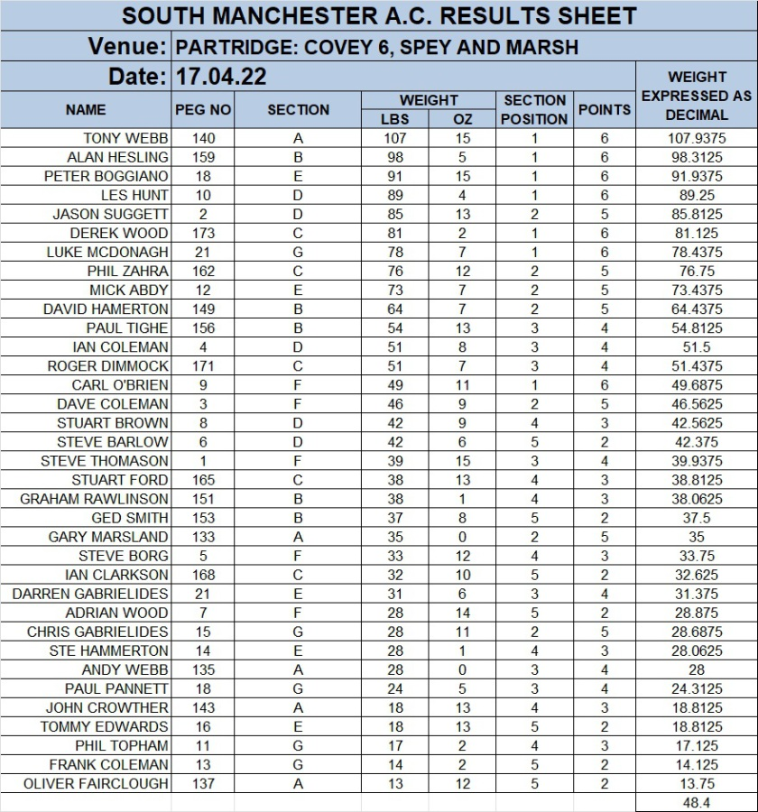

MATCH 1 - CUDMORE FISHERIES - SUEZ, MOORS AND PANAMA
