MATCH REPORTS
PARTRIDGE LAKES CLUBMAN CHAMPIONSHIP 31.10.15
SMAC were well represented at this great event hosted by Partridge lakes with Phil Zahra, Ian Coleman and Pete Boggiano being the fortunate members to attend after strong performances in the matches held on their lakes this year being the highest placed in each match who were able to attend.
A strong field of 60 anglers fished the match with some recognizable names from the local match scene competing it wasn't going to be easy. Phil was pegged on Ribbon lake peg 4 and after a manic first hour he was unfortunate to be fishless for the rest of the match, struggling to get bites from anywhere Phil weighed in 13lb 11oz which wasn't too far off the mark from the lake winner who had 32lb 11oz - unlucky Phil!
Ian Coleman drew peg 17 on Marsh which he didn't fancy too much but ended up with a section win from a very tightly contested lake. Ian caught on single maggot down the track and across to the far bank to weigh in 34lb 14oz and walked away with £40 and a goody bag - well done Ian, a top result!
Pete was pegged on 169 on Covey 6 which was a much more fancied area, Pete fished pellet across and maggot down the track to weigh in 65lb 5oz which was good enough for 4th overall in the match but resulted in a section win only for Pete who also claimed £40 prize money and a goody bag.
Overall it was a great day and we'll be looking forward to next years event as we'll no doubt be having a few matches at partridge this year and we'll see who can do well enough to qualify - this will be another event to add to the Garbolino club angler match which gives our members something different to look forward to.
Pictured below are Pete and Ian flashing their winnings about, well done lads!
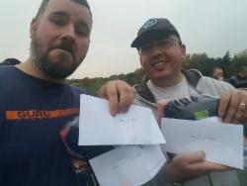
2015 Season Match 14:

Venue: FIR TREE FARM – FIR WATER
Date: 18.10.15
The final match of the 2015 season saw us return to Fir Tree farm on the fir water lake for the second time this year and thankfully conditions were a little better than earlier in the year which gave anglers more scope as they were able to hold the pole beyond 3 sections which also increased the average weight across the lake.
I’ve had some help from our match secretary to write this report and at the end of the report is his full season roundup.
Section A – Winner: Ian Clarkson 36lb 2oz
Ian Clarkson had a solid end to a solid season winning his section with a tidy net of pellet caught carp from peg 3 which was a very tight section with only 8lb between the top 4 – well done Ian on a cracking season, finishing in third place with a final total of 55 points, 260lb of fish and more camera poses than you can shake your hat at……….
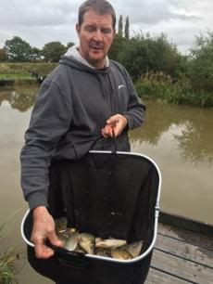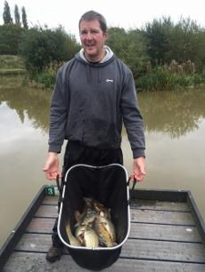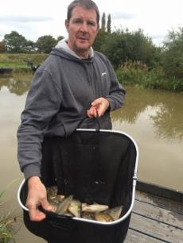

Section B – Winner: Pete Boggiano 42lb 8oz
Written by Phil Zahra……
Pete finished his season off with yet another section win catching silvers on maggots short and carp on expander pellets across to the far bank, this was enough to win the match overall and take home another trophy along with the popular Daz Gabz in the pairs (more on this later) Back to Pete I've gotta say he's been on fire this season he's managed an incredible 9 section wins with 4 of them winning the overall match on the day! If we worked out Pete's overall total based on the previous points system he would of put us all to shame as he was the clear winner.
Since joining the club 4 seasons ago Pete has been big favourite amongst the lads and I could only imagine the amount of work he has done behind the scenes to help make the club what it is today and this year he wanted his reward! And boy did he get it Pete's picked up a massive £789 but if you ask him the money doesn't matter he only wanted one thing this year and that was for that club champion trophy to say.......PETE BOGGIANO 2015.....

Well done mate
Top guy.......top angler.......club champion
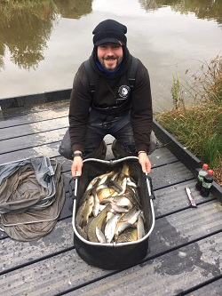
Section C – Winner: Phil Zahra 31lb 10oz
Phil Zahra clinched the runners up trophy for the second season running with a hard earned section win – it’s usually around now I make some sly remarks about him fishing top 2 all day but my conscience is getting the better of me. After a really poor start to the season by his standards Phil really turned it around averaging 3 points per match from his first 7 then averaging 5.6 per match for the second 7 shows that form is temporary, but class is permanent. Phil finished on 59 points with 346lb of fish and was clear in second place by 4 points, well done mate!
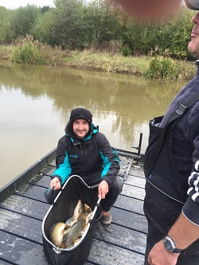
Section D – Winner: Ian Coleman 32lb 15oz
Ian Coleman leaps from 6th in the table to 4th with his third section win on the bounce. Ian ends the season on the same points as Alan Hesling and Derek Wood [53] but edges himself into 4th place on weight with 309lb! All very close indeed! Ian fished meat and corn across to win the section. Well done Ian – a great end to the season for my favourite doctor…… while we’re on the subject I still need to talk to you about this rash.
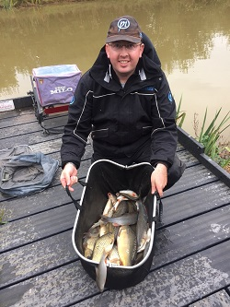
SMAC Pairs Final
As previously mentioned the final of the Pairs competition was fished between Alan Hesling / Derek Wood and Pete Boggiano / Darren Gabz. It couldn’t have been any closer with all 4 anglers chipping in with vital weights but unfortunately there had to be a winner and with a total combined weight of 57lb 1oz Pete and Darren clinched the title beating Alan and Derek who netted 50lb 2oz – just 7lb separating the two pairs!!! Special mention must go to Derek who had a rather large carp take his top 3 across the lake which he netted but threw back as he left his peg – a proper sportsman as this fish could have won the trophy – well done to everyone who entered this year and well done to the finalists, a truly great event!
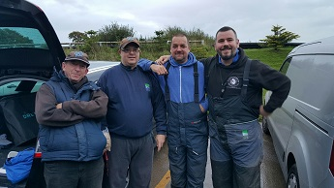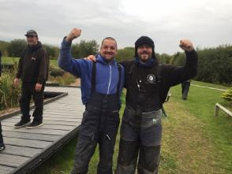
Super pools results:
1st Pete Boggiano £40
2nd Ian Clarkson £30
3rd Ian Coleman £15
That’s me signing off for this season; we now have a report from our match secretary, I hope you’ve enjoyed the reports and I look forward to seeing you all either on the winter league or at the AGM. Cheers J

2015 Match Secretary report
Well that's it chaps, another record breaking season over that's seen us introduce a new points system which brought us one of the tightest league tables in the clubs history, a new pay-out system that has paid out over £4000 to 22 different members, 9 of which completely covered their match fees and 14 members earned over £100!! A pairs league that kept everybody in suspense until the last minute of the last match of the season and a trip to Manor farm to be remembered for a lifetime! All in all I think you will agree that this season has been a massive success we've had our highest attendance in recent years with an average of 76% who collectively have caught over 6500lbs of fish.
Next seasons matches are booked and waiting with some cracking new venues and a club fishing holiday that will make you shiver with excitement! All will be revealed at the membership meeting on Friday the 27th November please do your best to join us and celebrate afterwards with a few pints, in the meantime don't forget the clubs new winter league starting on the 8th November at Old Hough Fishery.
Thanks for your commitment and support
Phil

2015 Season Match 13:
Venue: OLD HOUGH UPPER AND LOWER BENBO
Date: 04.10.15
The penultimate match of the 2015 season was held at the sparklingly clean Old Hough fisheries on both Benbo lakes. A gloriously sunny day saw 22 Anglers turn out who had plenty of room with 48 pegs to play with! Everyone was hoping for a draw on Ubber benbo as the fishing is better and more comfortable with only a 14m reach to the island. This turned out to be the case as the weights were much better on this lake.
Section A – Winner: Ian Coleman 60lb 8oz
The story of the day came from section A on Upper Benbo where there were some cracking performances not to mention Paul Hirst who is pictured below being photo bombed in return for all his antics this year – Paul weighed in 45lb 8oz which unfortunately was a little short of a section win – Paul has now offered his services to Stuart Brown who he’d like to take for a day’s coaching!
Phil Zahra and Ian Coleman were placed on peg 1 and 3 respectively and Phil was also sat on the bonus peg for only the second time in his SMAC career. The scales came to Ian who weighed in 60lb 8oz and from the talk round the lake Phil was looking likely to beat this weight and take home the £200 bonus funds, it was not to be however as Phil could only tip the scales at 59lb 1oz losing out by only 1lb 5oz; oooooohhhhhh that’s gotta hurt!!! Unlucky Phil but well done Ian who has had a cracking run over the past few matches and is now a contender for 3rd place in the league. Ian fished corn shallow, feeding 4mm and 6mm pellets to the far bank – where he pulled this method from is anyone’s guess!!
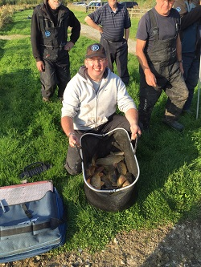
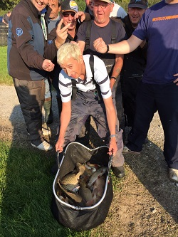 PAYBACK TIME!!!
Section B – Winner: Pete Boggiano 39lb 1oz
Pete Boggiano had to work his peg hard and caught fish from 6 different areas on a variety of baits and methods to clinch the section win. The section win (which is Pete’s 5th on the bounce) secures the 2015 SMAC title for the best looking guy in the club, no prizes for guessing who is writing this.
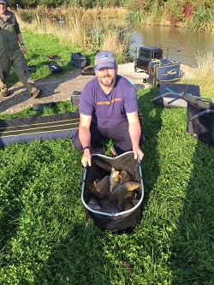
Section C – Winner: Ady Wood 21lb 9oz
Ady Wood was on call and had to deal with his phone going all day but still managed to win a tough section with 21lb 9oz of F1’s from peg 10 on lower benbo. Ady fished 4mm expanders over micros to the far bank with a 16.5m reach all day and deserved the win for his efforts – well done Ady!
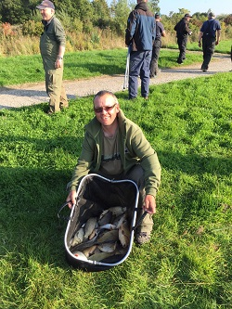
Section D – Winner: Tony Martin 19lb 13oz
Tony Martin ounced out Phil Topham for the top spot in section D – another poor performing area was won by an angler who’s fished a really good season currently standing in 7th in the league does Tony no favours but his average points per match puts him 3rd in the league – nice one Tony, a great performance.
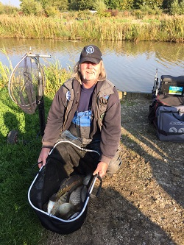
Onto the last match of the season at Fir Tree where Alan Hesling and Derek Wood will take on Pete Boggiano and Darren Gabz for the pairs title and the battle for 2nd and 3rd in the league will be decided.
Super pools results:
1st Phil Zahra £35
2nd Pete Boggiano £25
3rd Shaun Gallagher £10

2015 Season Match 12:
Venue: BORDER FISHERIES MATCH LAKE
Date: 20.09.15
Coming towards the end of the 2015 season saw us landing at Border Fisheries on the match lake with hopes of better fishing than on meridian canal where sport was pretty terrible to be honest. 4 hours into the match and it seemed to be following suit however someone hit the switch and some cracking weights were had in the last two hours of the match with some proper donkey fish coming out.
The Pairs tournament has now completed and the two finalists have been decided with Pete Boggiano/Darren Gabrielides and Alan Hesling/Derek Wood being the successful pairs to go forward and fish the final which will be held at Fir Tree Farm on the last match of the season, well done and good luck to the finalists and well done to all entrants making this the closest pairs tournament to date.
Section A – Winner: Shaun Gallagher 50lb 11oz
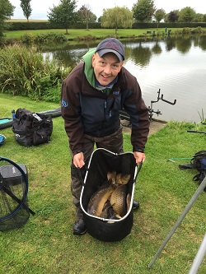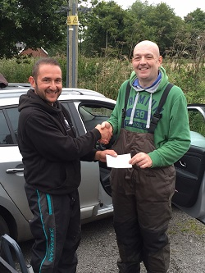
Shaun Gallagher had a slow first 4 hours of the match with only about 15lb in the net with 90 minutes to go Shaun then switched back to his meat, hemp and corn line to put together a cracking run of fish weighing in 50lb 11oz to win the section handsomely. Not only did Shaun win his section, he also won the super pools and to top off the day he was sat on one of 7 bonus pegs and as he won the match overall took home the bonus funds of £200 totalling £271 for the days fishing!!! Not a bad day at the office, well done Shaun picking up the bonus funds in your first season with SMAC is a great achievement, nice one mate!
Section B – Winner: Pete Boggiano 47lb 4oz
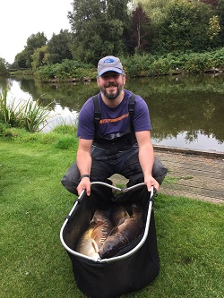
Pete Boggiano had a nervous 4 hours also and with only a 3lb carp in the net with 2 hours to go things were looking grim for the current league leader, Pete then switched to his margin line and got busy catching some proper lumps down the edge on corn over ground-bait landing 5 fish to make up his section winning weight of 47lb 4oz. This now puts Pete 5 points clear at the top of the league, needing 8 points from the last 2 matches to be assured of the title, no pressure!
Section C – Winner: Mick Abdy 46lb 6oz
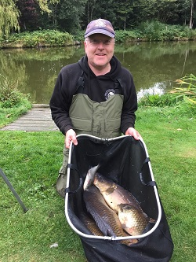
Mick Abdy picked up his 3rd section win of the year with a hard earned 46lb 6oz. Mick switched lines throughout the day to net a mixed bag including a couple of lumps from various areas of his swim. Mick actually lost 2 feeders before the all in due to a snaggy far bank feature, well done Mick!
Section D – Winner: Ian Coleman 44lb 2oz
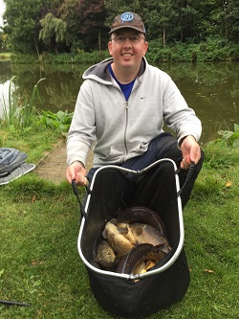
Ian also found himself on a bonus peg but was unfortunate not to net another fish or two to catch Shaun, Ian fished a difficult first half of the match like many others and then turned on the class as he plundered his margin swim to finish off with a cracking net of fish beating off some classy competition in the form of Zahra and Clarkson!
Super pools results:
1st Shaun Gallagher £35
2nd Pete Boggiano £25
3rd Mick Abdy £10

2015 Season Match 11:
Venue: PARTRIDGE LAKES COVEY 5
Date: 06.09.15
An unusually low attendance for the in-form covey 5 lake at the immaculate partridge fisheries with just 21 turning out for one of the most anticipated matches of the 2015 calendar, 6 bonus pegs were drawn but the 200 nicker stayed safe for the day when the absent Pete Boggiano is sat on one
Cool temperatures overnight dashed a few hopes of catching shallow and a fairly pleasant start to the match soon turned into mild gales making it difficult to feed accurately, never the less at the all in fish were showing from various pegs
Section A – Winner: Pete Ransome 22lb 13oz
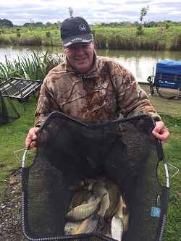
Pete (the meat) continued his recent good form by catching down the edge on single caster for his 1st section win of the season, job well done considering he'd only had an hours sleep after another Bacardi fuelled night on the town
Section B – Winner: Phil Zahra 42lb 04oz
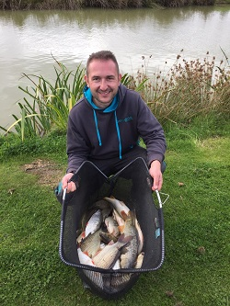
Phil managed another section win from fancied peg 114 catching mainly shallow on maggot, occasionally switching to pellet down the edge when the wind was too strong keeping things tight at the top, it's also worth mentioning that Phil only caught 2 fish on his beloved paste
Section C – Winner: Ian Clarkson 19lb 02oz
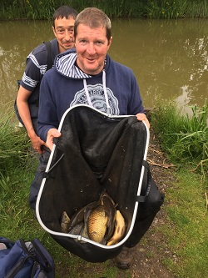
Section C was the worst performing section on the day, and when the fishing is tough Clarkson gets tougher, Ian managed to catch across on pellet when the many plastic bags that were blown in cleared off from his mud hole, this result keeps Ian in joint 2nd place
Section D [Ash] – Winner: Julian Pitlovits 26lb 2oz
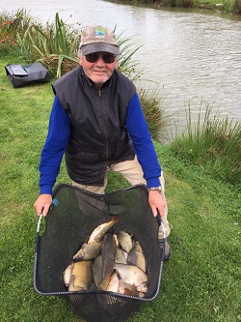
Julian drew the flyer 131 according to the bailiff and he didn't disappoint, within seconds of the all in Julian was into a decent carp and continued to catch steady all day fishing red maggot on top 2 plus one to also give him his 1st section win and his 1st taste on the super pool tax free money! finishing 2nd overall
Daz gabz managed to keep himself and Pete Boggiano at the top of the pairs league, with Alan and Derek tight on their tail closely followed by Stu and Ian, All very tight up there with Just one match to go before the final pairs are decided, bring on border and a record 7 bonus pegs
Super pools results:
1st Phil Zahra £30
2nd Julian Pitlovits £20
3rd Ian Coleman £10

2015 Season Match 10:
Venue: BLUNDELLS FISHERY PINE AND ASH
Date: 24.08.15
5 Bonus pegs were in the draw bag for today but yet again the £200 spoils were not won – the next match we have 6 bonus pegs which is about the time every year it is won, let’s see who’s got the bottle!!
We are now 2 matches away from deciding who gets into the pairs final which is probably a good time to run through how it’s decided again. Basically the combined weights are totalled up after 12 matches; each angler’s two worst weights are then removed from the accumulative total and the two pairs with the highest combined weight then fish off in the final which is held on either the 13th or 14th match of the season. The overall winner is decided on the day with the highest weight winning. Pete Boggiano and Daz Gabz have now moved into the lead after difficult days for Alan Hesling whose partner was away and Ian Clarkson / Stu Brown who both struggled.
Whilst on the subject of Stu Brown and Ian Clarkson, Stuart has asked me to point out he beat Ian by almost 2lb which certainly put the nail in the coffin for Ian’s hopes for a good day after losing 2 lumps due to landing net issues, unlucky mate!
Pete Ransome has now got one hand on the biggest fish trophy after netting a 14lb monster as pictured below – this is the best picture we could get as the fish wasn’t too happy about being handled – it could probably smell Bacardi.

Section A [Pine] – Winner: Pete Boggiano 64lb 15oz
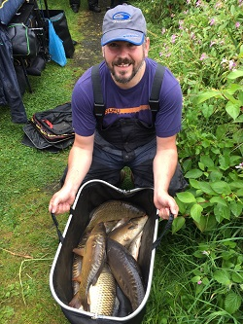
Pete Boggiano continues a fine run of form with his third section win on the trot; Pete fished Pellet shallow to pick up carp at varying depths throughout the day to weigh in an impressive 64lb 15oz. Pete is now clear at the top of the league by 7 points but misses the next match which is the perfect time for the 3 anglers in joint second place to claw some points back.
Section B [Pine] – Winner: Phil Zahra 34lb 10oz
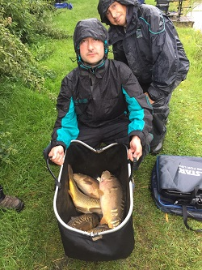
Phil Zahra is also fishing like a man possessed recently with 4 section wins back to back – Phil has moved from 14th to 2nd in the league in the space of 5 matches which is a sign that the two time champion is not to be discounted, Phil fished on the feeder for a few fish and then back to his favoured short paste line to win a difficult section, and reckons he could’ve weighed in more but his footplate with nets attached went for a swim after the match! Unlucky, but well done Phil.
Section C [Ash] – Winner: Steve Thomason 65lb 5oz
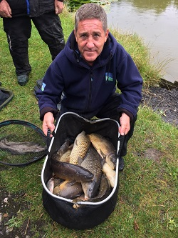
Steve Tomo was back to action after a 3 match hiatus much to the delight of his pairs partner Mick Abdy. Steve fished a good match with [in his own words] waggler, feeder, patience and expertise enabling him to achieve the best weight on the day by just 6oz! Well done Steve.
Section D [Ash] – Winner: Mick Abdy 46lb 9oz
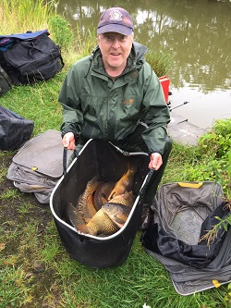
Mick Abdy picked up his second section win of the year with a positive display of shallow fishing using pellet and meat to amass a 46lb 9oz bag which was closely contested by Tony Martin on the very next peg. Mick and Steve have now shot up the pairs leader board putting on 112lb which shows everything is still to play for even if you’re feeling adrift of the leaders! Well done Mick.
Super pools results:
1st Steve Thomason £35
2nd Pete Boggiano £25
3rd Mick Abdy £10

2015 Season Match 9:
Venue: OLD HOUGH FISHERY BIG MAX AND PROSPECT
Date: 09.08.15
A reduced field of 23 Anglers turned out to fish the 9th match of the year and plenty of space was offered as we we’re split over Big Max and Prospect giving us 40 pegs to work with. The fancied draw was Big Max which would give the anglers more options however as you’ll see from below the most consistent sport was found on prospect.
I have now included dropped points in the league table as we are far enough through the season to take this into account – any weight recorded in the matches where you have dropped points will be deducted from your total weight recording – if you have any questions on how this is done then please give me a shout and I’ll be happy to explain. The individual league is looking even tighter now with the top 10 anglers within 10 points of each other and the pair’s tournament has now got a new leader with Alan Hesling and Derek Wood reclaiming top spot from Ian Clarkson and Stu Brown, however the top 3 are within 30lb of each other so it’s going to be too close to call!
Section A [Prospect] – Winner: Keith Thorne 43lb 6oz
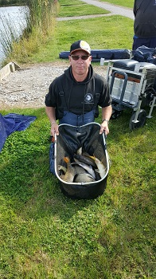
Keith Thorne picked up his first section win of the year from a section which was very closely contested, almost everyone in the section recorded over 30lb and Keith managed to fend off the close competition with a classy display of paste fishing on his short top 4 line resulting in a green left leg and a 43lb 6oz bag of F1’s and carp. Well done Keith – another feather in the cap after a cracking years fishing!!
Section B [big max] – Winner: Pete Boggiano 61lb 3oz
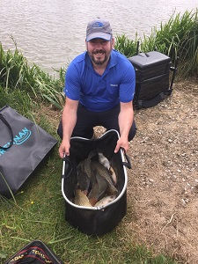
Pete Boggiano drew peg 3 which was a fancied area and netted 61lb 3oz of carp, F1’s and a few silvers fishing shallow to the aerator with pellet and casters once the pellets had ran out….. all 5 pints of them!! Pete now moves to the top of the table ousting the big man Clarkson!
Section C [big max] – Winner: Phil Zahra 45lb 11oz
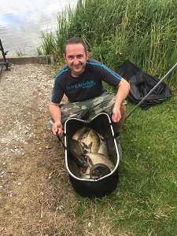
Phil Zahra had an eventful day, after catching well for the first half of the match Phil hooked a carp shallow and some of his sections must have been loose as the fish ran away with his top 6 sections dragging them across the lake, after a while trying to cast over his pole he decided it was time to take a dip, down to his G-string he doggy paddled it to his pole and unfortunately for him lost the fish at the net! Everyone was mightily amused by this sequence of events, thanks Phil! After drying off and re-applying his hair gel Phil managed to continue fishing to win the section – probably because he swam through everyone else’s pegs.
Section D [big max] – Winner: Derek Wood 53lb 4oz
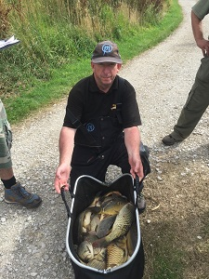
Derek wood struggled to fish at 16m all day in the side wind but caught consistently throughout the day on sweetcorn over a bed of micro’s, Derek’s having a cracking season so far [his first with SMAC] and he moves into second place on the back of a series of strong results. Well done Derek.
Super pools results:
1st Pete Boggiano £35
2nd Derek Wood £20
3rd Phil Zahra £15

2015 Season Match 8:
Venue: BORDER – MERIDIAN CANAL
Date: 26.07.15
With a number of our members having a practice match the week before we were pretty well informed on the methods which should produce however the weather took a turn for the worse and ruined the day with heavy, consistent rain coming down from start to finish it was much more appealing to be sat at home in front of a roaring fire, toasting marshmallows with a playboy bunny.
To cheer you all up – here is a picture of what a playboy bunny looks like.
Onto the fishing now and it is safe to say it was pretty dire. The water looked like it could produce fish but with 60.71% of the anglers failing to register weights over 10lb it fished more like a traditional canal.
Section A – Winner: Phil Zahra 16lb 13oz
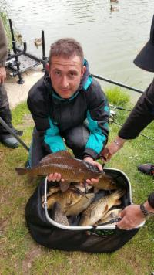
Phil Zahra picked up his second section win on the bounce and is now back in the sort of form we expect from him. Phil showed a fine example of his mathematical skills when asked about how he caught….. “I had most of my fish down the edge late on and had about 10lb of bits down the track” if anyone is getting a quote for electrical works – please double check. Well done on the result Phil, this now boosts you up to 6th in the table.
Section B – Winner: Pete Boggiano 35lb 14oz
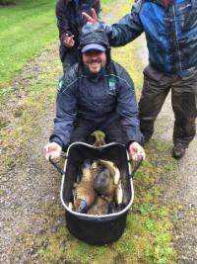
Pete Boggiano got back to winning ways with the days highest weight fishing caster and worm across – Pete also becomes the first angler this year to exceed 200lb in weight (fat bastard) and is now in second place in the individual league by just one point.
Section C – Winner: Alan Hesling 9lb 0oz
Alan won the worst performing section with just 9lb which also ruined Paul Hirst’s day as Paul was told moments before that he’d won the section! Unlucky Paul but well done to Alan who’s having a cracking season with 3 section wins so far he’s strongly placed in 3rd for the second half battle.
Section D – Winner: Ian Coleman 28lb 12oz
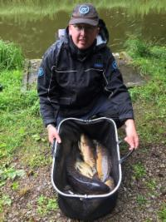
Ian Coleman was pushed close by Chris Gabz but came out on top netting some lumps from down the edge on corn and ended up with the second highest weight of the day – helped by the 10lb carp which was weighed for the biggest fish but unluckily falls short. Well done Ian.
Both the individual and pairs tables are looking very tight at the top with only 11 points separating the top 10 in the individual league and 150lb between the top 6 in the pairs.
can't sign off without a mention for Stu Ford who managed to net a giant nile perch weighing in at 2.5lb which, from the picture below bit the top half of his head off..... great photography!!! just so you know what Stu looks like he is also pictured from the previous match with a cracking net of fish - well done Stu!!
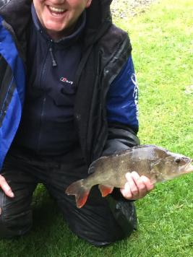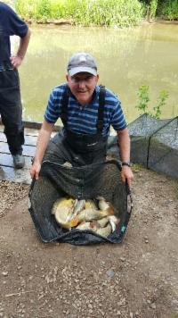
Super pools results:
1st Pete Boggiano £35
2nd Ady Wood £25
3rd Phil Zahra £15

2015 Season Match 7:
Venue: Fir Tree – Nooky and Match Lake
Date: 14.06.15
Match number 7 takes us halfway through the 2015 season with a very close top half of the individual league we should be in for an interesting second half. The pairs tournament is also very close with 4 pairs within 100lb of each other this could also go down to the wire.
27 anglers turned up with most hoping to be pegged on Nooky Hollow as many of us haven’t fished the match lake before and reports were much better from the canalised lake – this turned out to be the case as the fishing was miles better on Nooky with the average weight exactly double than on the match lake.
Section A – Winner: Stu Brown 42lb 2oz
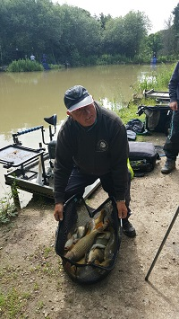
Stu Brown continues his cracking season with his 3rd section win of the year which catapults him to 3rd in the league, only being kept from second place on overall weight. Stu had to work hard for his catch working with what little space he had on peg 1 to tip the scales at just over 42lb with the match lakes best weight by over 15lb – well done Stu – you are my hero
Section B – Winner: Phil Zahra 26lb 4oz
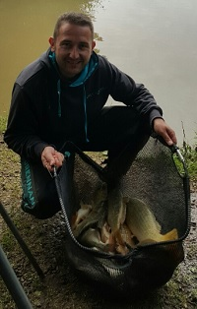
Finally we see Phil Zahra’s name on the section winners board – after a really slow start to the year for Phil he will be hopefully kicking into gear for the second half of the season, currently standing in 13th in the league is not where any of us expected the two time champion to be, but watch out, the Maltese Mule is never to be discounted [Maltese Mule is his own given nickname, I prefer Maltese Maggott] – well done Phil – you are my hero
Section C – Winner: Ady Wood 56lb 12oz
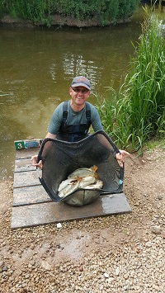
Ady wood picked up his second section win of the year with the highest weight on the day and his reputation as a decent angler may actually be true as his average points per match is the highest in the league, however his attendance is letting him down – that sounds like one of my school reports apart from it didn’t say he was caught in the Girls toilets last Monday with his willy out.
Section D – Winner: Ian Clarkson 48lb 1oz
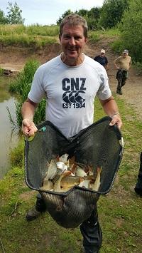
Ian Clarkson had a strange look on his face all day and is obviously taking this season very seriously as he is flying high at the top of the league – a position which was solidified with his 3rd section win on the bounce, Ian fished a cracking match to weigh in 48lb 1oz from a pretty unfancied peg – well done Ian - you are my hero.
Super pools results:
1st Ady Wood £35
2nd Ian Clarkson £20
3rd Stu Brown £10

2015 Season Match 6:
Venue: Heronbrook - Canal
Date: 14.06.15
The 6th match of the 2015 season took us to a highly anticipated match at the Heronbrook canal with a winning weight of 200lb+ a few weeks ago we were surely to be guaranteed some good sport. We are South Manchester Angling Club however and we managed yet again to ‘SMAC’ a venue. 32 anglers struggled along the length with even the most fancied peg managing to produce a lowly 13lb weight!
Section A – Winner: Eric Quinn – 25lb 7oz
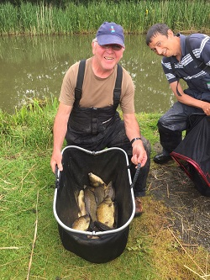
Eric was sat on peg 8 on a fancied length and fought off some strong competition from Geoff Poole to win the section by just over 2lb – well done Eric a good section win with the overall highest weight on the day!
Section B – Winner: 20lb 1oz
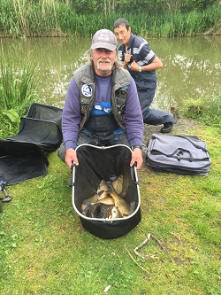
Tony Martin continued his good season with a section win with 20lb 1oz. Very closely followed by Paul Pannett and Alan Hesling Tony won the section by only 11oz!!
Section C – Winner: 16lb 12oz
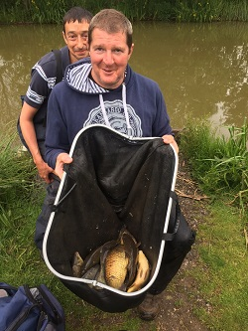
The giant Ian Clarkson won the first of two really hard sections on the back length of the canal – fishing long for most of the day Ian weighed in 16lb 12oz to pick up the winnings from section C which boosts him up to top of the league.
Section D – Winner: 17lb 10oz
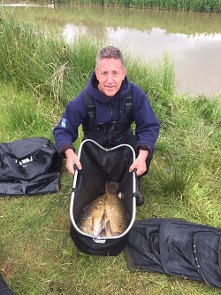
Steve Thomason netted a couple of lumps amongst some other bits in the closing stages of the match to clinch victory in the worst section on the lake with 17lb 10oz, nice one Steve, well done!
Super pools results:
1st Eric Quinn
2nd Geoff Poole
3rd Tony Martin
Were off to fir tree again for the next match where the pegging is as tight as the top of our league table..........

2015 Season Match 5:
Venue: Fir Tree Farm – Fir Water
Date: 31.05.15
Mega plop weather greeted us for the 5th match of the 2015 season with rain which died down after a while only to leave way for some extremely strong winds – I’m personally getting fed up of fishing in the wind.
The lake had recently been restocked with some tiny barbell and more silvers which some members opted to fish for close in with varying levels of success – others who managed to reach the island could target the carp stocks which resulted in the winning weights coming from the less windy areas. Both SMAC cameramen were away on holiday so apologies for the lack of pictures below.
Section A – Winner: Ian Clarkson 23lb 13oz
Ian Clarkson won an interesting section which included our resident professional Wayne Rooke who packed up after 3 hours due to the horrific conditions – this paved the way for Ian to win the section with 23lb 13oz of carp all caught on pellet over to the island. Well done Ian on your first section win of the year.
Section B – Winner: Martin Cook 20lb 5oz
Keith Harrison obviously didn’t want to challenge for the section as he kicked both his nets in during the match doh!! On the next peg however was Martin Cook who (in between walk rounds) put together 20lb 5oz of carp caught on the same method as Ian, nice one Martin, hopefully this makes up for your near miss at Cudmore!
Section C – Winner: Ian Coleman 19lb 9oz
Just as Daz Gabz put in his best performance of the year to weigh in 19lb 5oz Ian piped him by 4oz to win section C, unlucky Daz but well done Ian on your first section win of the year. Maggot across was the method employed by Ian.
Section D – Winner: Derek Wood 31lb 15oz
The in-form Derek Wood won section D with the highest overall weight of the match which was an impressive performance from a relatively poor area of the lake. Derek fished pellet across to compile his 31lb 15oz net of carp and also pushes himself into second place in the league – only 1 point behind the incredibly good looking angler who is topping the league.
Super pools results:
1st Derek Wood £35
2nd Ian Clarkson £20
3rd Tony Martin £15
2015 Season Match 4:

Venue: Cudmore, Moors and Edwards
Date: 03.05.15
The lakes we were fishing at Cudmore were far from picturesque – both looked like they were several years away from maturity and reports from the Moors canal were showing that 30-40lb of tiny fish were winning matches whereas information on Edwards was as sparse as the landscape.
Speaking of not being very picturesque – here’s a picture of Pete Ransome after a night out turning up to fish with zero hours sleep, get in Pete, show the youngsters how it’s done!!
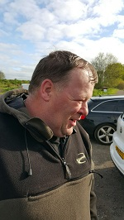 Can Someone order me a kebab please?
Section A [Edwards] – Winner: Alan Hesling: 29lb 2oz
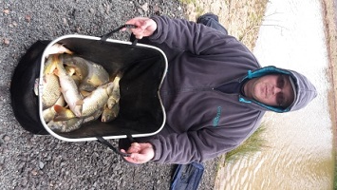
Alan Hesling picked up his second section win of the year and pushes himself into joint second place on 17 points alongside Derek Wood and Stuart Brown. Pegged on Edwards 21 Alan made good use of the island chuck and fished the method feeder with maggot hookbait to edge victory in a very tight section with another 3 anglers within 5lb of his winning weight. A great performance from the best performing section with close to 200lb of fish caught between the 8 anglers in the section.
Section B [Edwards] – Winner: Pete Boggiano: 40lb 0oz
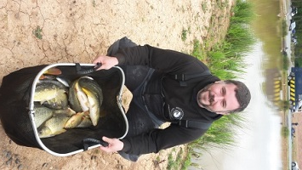
Pete Boggiano got back on form after a disastrous match at Old Hough picking up his 3rd section win of the year and is now top of the table by 3 points. After fannying around for an hour fishing the bomb and pellet waggler Pete moved onto the pole line and picked up carp at 11m steadily throughout the remainder of the match fishing expanders over micros at dead depth to weigh in a decent 40lb dead in an otherwise poor section.
Section C [Moors] – Winner: Ady Wood: 32lb 7oz
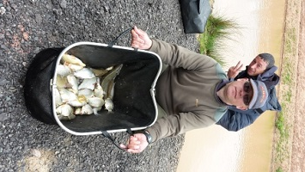
Ady wood was pushed right to the line by Phil Zahra in section C where he came out on top by just 3lb which actually equates to about 40 fish on this lake. Ady fed crushed pellet down the track and across and fished maggot on the hook to amass and very respectable weight of 32lb 7oz made up of pretty much everything that swims – or in this case everything that is still learning to swim. Well done Ady on your first pick up with South Manchester and also your first photo bomb with South Manchester!
Section D [Moors] – Winner: Shaun Gallagher: 10lb 11oz
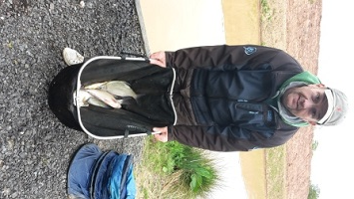
Another new face picked up the winnings from section D as Shaun Gallagher weighed in 10lb 11oz to win by far the hardest section on the day with only 37lb caught between 7 anglers!! Shaun fished double maggot at 13m to win the section comfortably – nice one Shaun, well done mate!
Overall it was a much better day for most on Edwards than on Moors and I think everyone is looking forward to Fir Tree and I think there may be a few tins of meat on show after Wayne’s record breaking performance last year.
Alan Hesling and Derek Wood are now Top of the Pairs tournament with a grand total of 172lb however the chasing pack are all within a decent weigh of them!
Super pools results:
1st Peter Boggiano £35
2nd Ady Wood £25
3rd Phil Zahra £15

2015 Season Match 3:
Venue: Old Hough – Goose, Boulders, lucky Dip and Prospect
Date: 03.05.15
A nice bit of match secretary work by Phil Zahra saw us secure 4 lakes on the popular Old Hough complex which enabled the most spaced out pegging this year with every angler having at least 1 spare peg between himself and the next angler. The weather was dire in the morning with heavy rain and once the rain stopped the wind picked up which made some pegs on the lower lakes un-fishable beyond 5 sections. The fishing for most was pretty good with over 600lb of fish between 28 anglers and a good busy day as most of the fish were around the 6oz – 1.5lb bracket.
Section A [Boulders] – Winner: Danny Morriss: 34lb 8oz
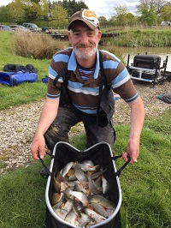
After narrowly missing out on the section win at the last match Danny had a look of steel in his eye when I saw him in the morning – I’m sure when he pulled up in his car Wayne Rooke was singing ‘eye of the tiger’ to psyche his partner up for the match, whatever happened worked as Danny put in a great performance fishing shallow on sloppy worm and caster and maggot to weigh in 34lb 8oz – nice one Danny, a well-deserved section win!
Section B [Goose] – Winner: Derek Wood: 53lb 07oz
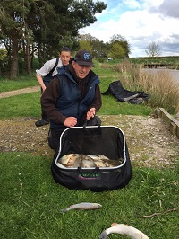
Derek picked up his first SMAC pay out with the best weight on the complex from peg 4 on Goose, Derek put himself almost 20lb in front of his nearest competitor fishing really short on his top 2 next to his keep net netting a real mixed bag of fish with plenty of barbel thrown in to up the weight. A great days fishing from a sound guy, well done Derek.
Section C [Lucky Dip] – Winner: Tony Martin: 35lb 12oz
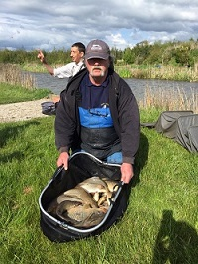
The better performing of the lower two lakes was conquered by the mighty power that is Tony Martin – Tony turned up – flashed his handlebar moustache and the fish (all female) dived in his net, simple really! Seriously though, when I see the moustache it makes me feel like puberty is about ten years away for me, with my puny little bum fluff top lip! I’m saying all this as I forgot to ask how Tony fished the match, I reckon he was wielding his pole in the wind though, using only his little finger to steady it. Well done Tony!
Section D [Prospect] – Winner: Wayne Rooke: 33lb 09oz
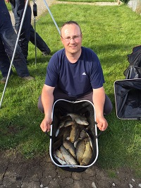
Wayne turned up for his first match this season and happened to draw in the same section of some class anglers, including me (haha!) they weren’t to trouble the semi-pro though as Wayne fished meat down the edge and maggot across to easily win the most difficult lake on the complex with a 33lb 9oz mixed bag, welcome back Wayne we’ve missed you!
The pairs competition is really looking good with the top 5 within 40lb of each other and Stu Brown manages to hold on to the individual top spot with another solid performance. I think Paul Hirst must have been a bit upset we missed a picture with him at the last match with the current biggest fish however he seems to have made up for it by getting his ugly mush on the pics above!
We're on to Cudmore again for the next match - let's hope the fish aren't all still dead!!
Stu Brown - Top of the league with a strange creature on his shoulder:
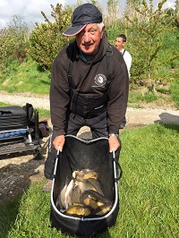
Super pools results:
1st Derek Wood £40
2nd Tony Martin £30
3rd Julian Pitlovits £15
2015 Season Match 2:
Venue: Partridge Lakes – Marsh and Spey
Date: 19.04.15
A light overnight frost left a slight chill to the air as another record turnout of 33 anglers drew across two lakes for the second match of the 2015 season. Talk at the draw was that spey was the place to be however it turned out the lower numbers on both lakes were going to produce the more consistent weights.
Section A [pegs 2-11] – Winner: Stuart Brown: 29lb 8oz
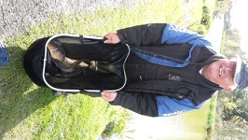
Stuart Brown kept up his 100% performance this year with a great performance beating some good anglers in his section including his partner Ian Clarkson who he annihilated off the next peg! Stuart had to chop and change throughout the match with a variety of different baits and worked hard for his section win – well done Stu.
Section B [pegs 31-41] – Winner: Pete Boggiano: 44lb 12oz
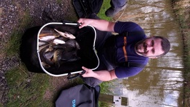
Pete Boggiano also keeps up his 100% record for the season winning his section from the best peg on the lake – Pete switched between pellet across and maggot down the track to tip the scales at 44lb 12oz with a nice mixture of F1’s, carp and ide.
Section C [pegs 13-22] – Winner: Mick Abdy: 65lb 03oz
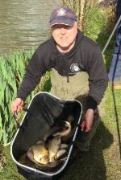
Mick Abdy made good use of the information he received from a local venue expert to absolutely smash the match and his section with a cracking net of f1’s all taken on chopped worm and caster from an otherwise non performing section Mick fished a great match to put himself 3rd in the table on 11 points – well done Mick, a top performance from the former embassy pairs finalist as we are all reminded of whenever Mick has the opportunity!!
Section D [pegs 43-52] – Winner: Phil Topham: 18lb 07oz
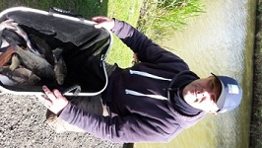
After losing out on a day’s work to fish the match due to being hounded by his partner Phil won the hardest section of the match with a hard earned 18lb 7oz Phil switched between maggot and pellet to pick off fish and edged out Derek Wood who pushed him close – well done Phil hopefully the winnings cover some of your days’ pay you lost out on!
Paul Hirst has made an extremely welcome return and after a year without his comedy genius we’re all glad to see him back on the matches and he has put in the first bid for the biggest fish award with a 7lb 1oz mirror carp – Nice 1 Paul, unfortunately we missed the opportunity for a picture.
Super pools results:
1st Mick Abdy £45
2nd Pete Boggiano £30
3rd Stuart Brown £20

2015 season Match 1:
Venue: Cudmore Arena
Date: 05.04.15
A busy draw as always at the first match of the 2015 season with the new pairs draw taking place throwing up some cracking pairs and the new seeding’s should see this competition being much fairer and interesting for all this year – good luck to everyone who entered the pairs tournament and remember – no fighting!!
The new points and pay-out system is now in place and will probably take a bit of getting used to however it proved to be worthwhile as 4 out of the 5 top weights came from one section and 9 out of the top 10 came from two sections – thus offering the guys in the poorer areas something to fish for.
We had 29 anglers on the lake leaving just 3 spare pegs however the fishing has been very poor lately on Arena, according to those in the know weights below 20lb have been winning matches which is very unusual, I wonder if all the fish have gone on holiday until the real fish’o’mania comes round?
Section A [pegs 1-8] – Winner: Pete Boggiano 9lb 11oz - Pete fished method feeder with corn on the hook and was pushed close by Chris Gabz and Julian Pitlovits however his 4 carp and 2 barbel were enough to clinch the section win and 6 points
Section B [pegs 10-16] – Winner: Alan Hesling 11lb 11oz - Alan was sat in the best section on the lake and managed to weigh in the overall biggest weight of the day which is astoundingly low for the Arena Lake however Alan fished a hard match and was pushed very close by Martin Cook and new member Steve Thomason who both had the second and third highest weights on the lake.
Section C [pegs 18-24] – Winner: Eric Quinn 4lb 5oz - New member Eric Quinn started his SMAC campaign well with a very, very low section winning weight which was closely followed by Louis Mansfield who was only 3oz behind – thank god for them beam scales eh lads!
Section D [pegs 26-32] – Winner: Stuart brown 5lb 6oz - Stu Brown won the hardest section on the lake from peg 32 being the only angler in the section to weigh in more than 2lb of fish! Well done Stu – your biggest SMAC payday – well earned!
Steve Thomason, Pete Boggiano and Tony Martin picked up £40, £25 and £15 respectively in the new super pool which seemed to be a big hit with 16 entrants enabling 3 decent payouts to be made.
Overall it was a very poor start to the season but hopefully things will pick up as we move onto some bigger lakes – below is the only picture worth taking which pretty much sums it all up – Ian Colemans giant chub which earned him 4th in section!!!

Billy Barker Memorial Match
Venue: Partridge Lakes Covey 6
Date: 29.03.15
A magnificent turnout for Billy’s memorial match on one of the worst days fishing weather experienced by most – never mind those crab fishermen on deadliest catch, they don’t know how easy they’ve got it compared to us, first being drenched to the bone with non-stop rain then being blown to pieces with howling gales…. Not very nice fishing weather at all!! There must have been at least 6 trashed umbrellas, and a couple of broken poles caused by rollers blowing over! In the words of Mick Abdy; “They were the worst conditions I have ever fished in, in over 40 years of angling, be it all over England, exposed Scottish loughs, Irish lakes, Denmark or the Ebro in Spain”
From those who fished, we raised £141 on the day through charitable donations. South Manchester Angling Club Pleasure Group Committee members also attended on the day, and made a charitable donation of £50 from their funds. A total of £191 was raised for Macmillan Cancer Support, the chosen charity for Billy's family.
The fishing was poor all around the venue with very low weights for those who could endure the conditions long enough to weigh in, local venue expert Eddie Battersby topped the match as expected with 23lb and had a few nice words to say regarding Billy; “Billy was not only a good angler but also a special human being and I know that he will be greatly missed not only by his family but all his fishing mates at South Manchester. It would have been nice if one of his club members had won today but that's fishing, and I was honoured to be the winner today”
Louis Mansfield came second and Andy Steels came third – well done guys – the framing anglers along with some section winners are pictured below along with the legendary Zahra brolly which we all though was destroyed at bradshaws last year is now well and truly in the knackers yard after taking another beating John Mattehws picked through the wreckage and salvaged any part he could for banksticks etc – ah well it gave us some laughs over the last two years!
Thanks again for everyone who turned up and donated, it was a memorable day to say the least!
