2013 SEASON REPORTS AND RESULTS
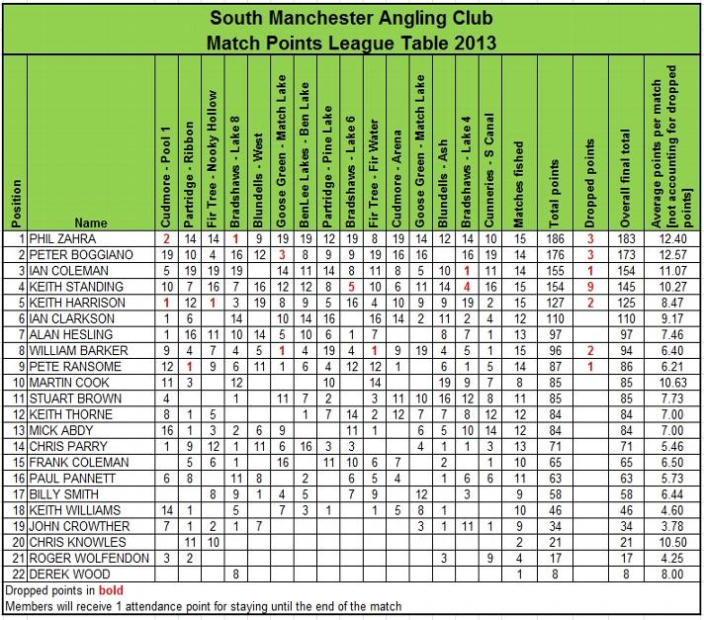
FINAL LEAGUE TABLE

2013 Match Secretary's Annual Report
Well that's it another SMAC season over with, thank you all for contributing to another fantastic season, 15 matches that we will all remember with more highs and lows than you can count. We've had new Venues, old favourites and places shoved in when nowhere else is available that have all contributed to each of us telling tales of how we did it or the one that got away.
The weather this season has been completely different to last year and played its part in how we approached venues and tactics used to catch fish, the winter stayed with us for the 1st four matches but after that we've bathed in glorious sunshine and very mild conditions, I think it's only rained on us a few times…… How did we get away with that?
For a small club we are certainly well organised and a big thanks goes out to the steering group who regularly get their heads together over a pint or two, Collectively these guys store and record the finances, book the matches, run the membership and of course bring you an amazing website with more information and reports than most clubs 5 times our size, I also would like to thank our other members that fill vital roles like the weigh in team who do a very fair and efficient job and our match day money collector/pay out dude who's always on the ball.
My final thanks go to you! The members who make this club the number 1 match club in the North -West, some of these guys have been at the club since before I was born others have joined in the last two seasons but slotted right in like they've been here for years.
Time to look forward now, what will next season bring you ask? Well I can tell you we have now fully booked next seasons matches, we have a fantastic 2014 match calendar with bigger and better venues booked to suit our expanding club, chuck in a week’s trip to manor farm leisure in Evesham and we've cracked it.
Can't wait................
Tight lines,
Phil Zahra.
Match: 2013 Match Reports
20 October 2013: The Cunneries 'S' Canal
Much more autumnal weather greeted the SMAC match group as we arrived at a new venue for the last match of the 2013 season. Strong blustering winds and much cooler temperatures than our last outing were sure to affect fishing. The talk at the draw was Gudgeon and wind direction with all anglers needing to use 2 nets with one especially for the influx of Gudgeon that have recently arrived at the fishery! The fancied pegs were towards the bottom end where the wind was blowing as the F1’s follow the wind.
Chasing Ian Coleman for third place in the league was Keith Standing – Keith was housed on peg 34 and managed to clinch third place overall and a SMAC second place with 20lb 4oz of F1’s caught down the track on maggot – it wasn’t enough to catch Ian Coleman though who finished with a SMAC 6th place which earns him third place in the league for the second year running – well done to both anglers who have been very consistent all year – Keith dropped more points than anyone at the club which is testament to this and also wins the biggest fish trophy, Ian had three wins on the bounce early on in the season to kick off the year in style!
Second place went to Paul Hirst who is one to watch for next year – in the appearances he’s made as a visitor this year he’s done well and will definitely be a contender next year. Paul fished a variety of baits from end peg 24 to compile a net of F1’s weighing 24lb 11oz – well done Paul, a good weight from a strange looking peg with a bridge, an aerator and a canoe for company – not to mention Stuart Brown and Ian Clarkson having a Gudgeon swinging competition!!
First place went to Pete Boggiano who’s last 5 matches have resulted in 2 wins and 3 second place finishes which is enough to clinch the runner up trophy for the second year running. Pete fished corn over pellet on the far bank and the nearside margin to put together a cracking net of F1’s weighing in 60lb 13oz. It could have been an even bigger weight if the wind hadn’t effected presentation but Pete was still extremely happy with the result.
Sections were taken By Mick Abdy with 20lb 4oz and Stuart Brown with 9lb 12oz – well done gents!
As promised the final word has to go to our ever modest match secretary Phil Zahra – he’s retained the club championship for the second year running with an average score of 12.40 per match resulting in a total score of 183 including 4 wins, 4 third place and 2 fourth place finishes. Averaging just over 25lb per match and weighing in a total of 380lb of fish! Along with the club championship trophy Phil has secured the Knockout cup trophy and the biggest match weight trophy, well done Phil, another cracking season – this is what we’ve got to beat lads, good luck for next year!
A text will be sent out soon from our match secretary with dates for our close season meetings which include the presentation evening and 2014 joining meeting – Phil will also be writing a ‘Match Secretary’s review’ which will be posted on here within the next week or so.
Roll on 2014!!!
Below are the usual pictures from the match along with a weight review table so you can see how you’ve done throughout the season – if you were a member last year your 2012 average is also on there so you can see your progression.
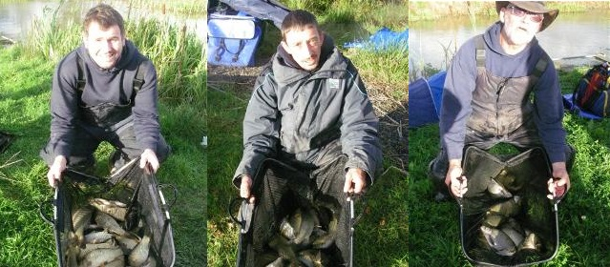
1st Pete Boggiano 60lb 13oz 2nd Paul Hirst 24lb 4oz 3rd Keith Standing 20lb 11oz
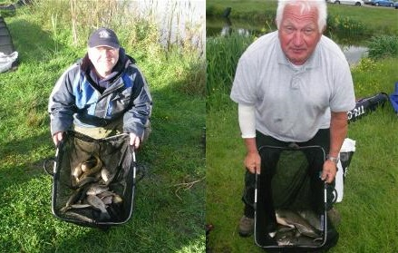
section winners Mick Abdy and Stuart 'archive photo' Brown!!
Weight Review Table
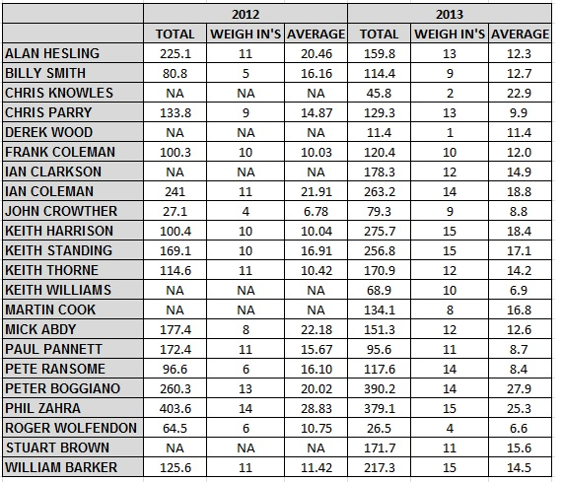
06 October 2013: Bradshaws Lake 4
Further unseasonal warm weather greeted 18 SMAC regulars for the penultimate match of the 2013 calendar – there were big things at stake today with the knockout cup coming to a conclusion and also the possibility of the championship being decided.
Pegs were laid out evenly across the two banks with the causeway being missed out much to the appreciation of some members and even though we’re into October the pellet waggler was expected to produce on the day which was a method plenty started on.
Along the wall side of the lake a variety of methods were taking fish straight from the off with pellet waggler, method feeder and pole all picking up early fish – on the other bank from pegs 4-14 sport was much slower and made even more difficult by having to watch the members on the other bank catching at a decent rate, although as is always the case with number 4 there were plenty of fish being lost with everyone after the match claiming only a 50% success rate.
To secure the championship mathematically Phil Zahra had to score at least 14 points which pushes him just out of reach of Ian Coleman and Pete Boggiano – this is exactly what he did. Switching between pole and feeder Phil put together a net of 43lb 6oz from peg 27 which was enough to secure third place on the day and is enough to secure the title for the second year running – Phil will be the first to admit it wasn’t as plain sailing as last season but after a shaky start was the clubs most consistent performer – well done Phil – I’ll save the congratulations and championship winning statistics until after the last match but you can go into it knowing you have retained the title!
Second place was picked up by the in-form Pete Boggiano. After missing the last match Pete was keen to try to apply the pressure to the league leader. For the first 4 hours Pete switched between pole at 13m and method feeder to pick up a few carp to 4lb and a smattering of silvers and then picked up the pellet waggler with 2 hours to go and latched into a string of nice carp to weigh in 50lb 10oz which was only 8oz shy of first place which went to Keith Harrison who claimed his second match win of the season with 51lb 2oz from peg 25 – Keith fished pellet and meat on the pole all day at varying depths to pick of carp to 4lb and was one of the unlucky members to lose almost as many as he caught – not too many though unfortunately for Pete! – Well done Keith a great result and proof that the 2011 champion has still got it.
The knockout cup final was fished between Martin Cook and Phil Zahra – Martin and Phil fished a great final and the outcome was as close a final as we have seen in a while with Martin weighing in first on the bonus peg with 36lb 14oz which was close but no cigar as Phil Weighed 43lb 6oz to secure his third trophy of the season – congratulations firstly to Martin for reaching the final in his first year as a SMAC member and then to Phil who’s secured his third trophy of the year.
Sections were picked up by Stuart Brown who’s fished well in his first year at SMAC and seasoned member Mick Abdy who’s had a poor 2013 by his standards and like most Man United fans starts looking at the table from the bottom up to find his name.
We’re off to the cunneries S-canal on the next match for Phil to bask in his glory and once again the battle for second place goes down to the wire with Pete Boggiano and Ian Coleman doing battle for the second year running – the odds are in Pete’s favour this year but Ian’s out for revenge after last year’s upset, Keith Standing is also fishing for a place in the top 3 so it should be an interesting match all round on a new venue!
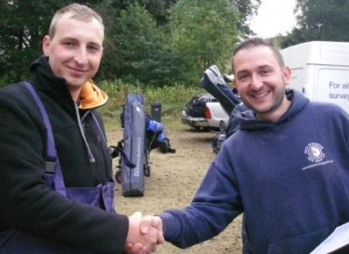
Martin Cook and Phil Zahra prior to the Knockout final
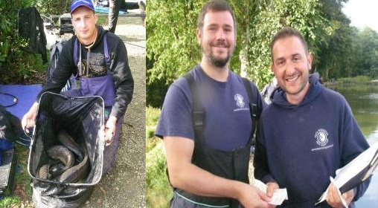
Martin with his 36lb 14oz net and Phil Zahra receiving his knockout cup winnings
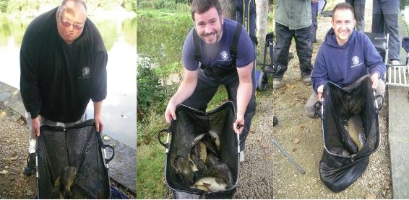
1st Keith Harrison 51lb 2oz 2nd Pete Boggiano 50lb 10oz 3rd Phil Zahra 43lb 6oz
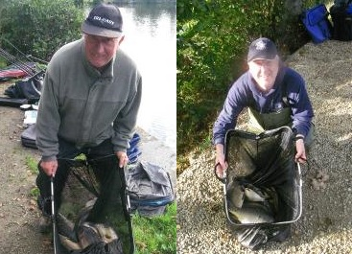
section winners Stuart Brown and Mick Abdy
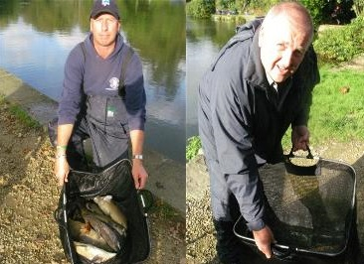
Memorable days for Keith Thorne and John Crowther [there is actually 40lb of fish in Johns net!]
22 September 2013: Blundells Farm - Ash
Sunday saw un-seasonally warm weather greet 18 anglers and expectations were high for a good match. Sadly the fish hadn’t read the script and the whole field struggled for bites for most of the day. Fish were in pockets, and with silver fish almost completely absent, those who managed to snare a few carp finished in the frame or thereabouts.
Winner by a single carp was Martin Cook on peg 16 with 34lb 14oz of carp on the pellet feeder tight across with popped-up pellet hook baits. Martin wrecked several feeders during the match as he had to hit the bare far bank to get bites – dropping it a foot short caught nothing, and he ended up with 8 or 9 carp in total. Second was in-form Stuart Brown from end peg 19 with 32lb 5oz, pole and pellet-caught carp at around 10m. Third was Keith Standing on peg 11, also the bonus peg, narrowly missing out on a bumper £200 payout by a couple of fish, weighing in four fish for23lb 9oz, including a 12lb 3oz carp on semi popped-up baits on the feeder.
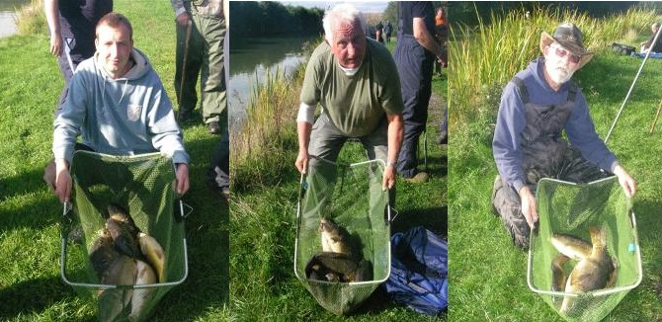
1st Martin Cook 34lb 14oz 2nd Stuart Brown 32lb 5oz 3rd Keith Standing 23lb 9oz
08 September 2013: Goose Green Match Lake
Our second trip to Goose Green this season came just after a slight downturn in temperatures and after speaking to venue expert Keith Standing I was hopeful that the fish would get their heads down to feed – it turns out Keith isn’t just a pretty face he actually knows a thing or two about Goose Green as the fishing turned out to be great – one of the highest average weights per angler this season. This isn’t to say everyone caught well though and some of the clubs top anglers…… Coleman….. Clarkson….. Abdy all pegged along the field side really struggled all day – Mick Abdy even fished the 4m whip feeding hemp with hemp on the hook to pick up roach but struggled to keep them coming without tares for the hook…….. Classical fishing methods!!
3rd place on the day went to current championship leader Phil Zahra who fished at 6m with pellet and paste to net 42lb 10oz from peg 6 – nothing unusual here then until I tell you Phil actually caught 2 fish using rod and reel – a short underarm chuck with a cage feeder brought Phil a couple of fish halfway through the match and gave everyone a laugh when he was stood up next to his box and struck into a fish and let out a huge whoohooo as if he was bass fishing in America!!!
Second place went to Pete Boggiano who is enjoying a good run at the moment with 3 frames from 3 matches – Pete was the only angler who managed to pick up regular fish from the island, pegged on peg 1 Pete picked up 13 carp fishing the method with banded 6mm pellet to tip the scales at 53lb 4oz – a weight which put him in front right up until the second to last weigh in.
Peg 14 was home to Billy Barker and was also the 7th bonus peg on the day – after a pretty blank first two hours Billy’s hopes of picking up the dosh were dwindling so he decided to fish paste down the edge to look for some lumps – this turned out to be a mastermind tactical change and resulted in 4 hours of non-stop action. When the scales reached Billy he had 53lb 4oz to beat – his net appeared from the water and it looked close – very close….. Onto the scales they went and sent the figures flying to 57lb 2oz to net Billy 1st place on the day and a cool £200!!! Nice one Billy – a very popular winner of the bonus funds especially on his Anniversary.
Sections were Picked up by the expert Keith standing with 26lb 9oz of his very own bream and new member for next year Paul Hirst who managed to weigh in 37lb 7oz even though he broke his no3 section and could only fish his top 2 all day!! Well done lads!
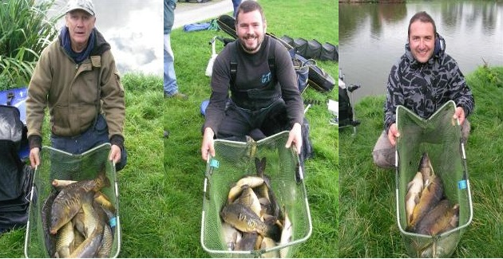
1st Billy Barker 57lb 2oz 2nd Pete Boggiano 53lb 4oz 3rd Phil 'no ears' Zahra 42lb 10oz
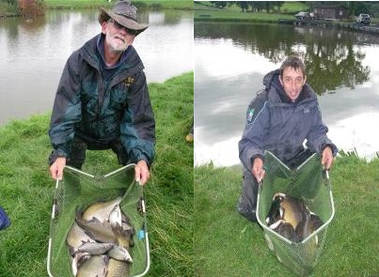
sections Keith Standing and Paul Hirst
25 August 2013: Cudmore Arena
13 SMAC members were joined by 7 visitors to make up a healthy field of 20 to fish the SMAC version of fish’o’mania....... “SMAC’O’MANIA” on the ever popular cudmore Arena.
It turned out to be a tale of two half’s with the lower numbered pegs being inconsistent but beyond peg 17 everyone had a cracking day – as you can see from the above there were 6 bonus pegs and the money still remains untouched! – I won’t name and shame the anglers on these pegs – you know who you are!!
The second round of the knockout cup phase two can be found on the knockout cup page with a surprise exit for Ian Coleman who was unfortunate to miss out in the phase 1 final.
It turned out to be memorable SMAC match with the addition of Tyson the 10 stone Rottweiler to entertain us with his partner Keith Thorne pulling off his personal best match weight – well done Keith – you and your mate have you pictures below!
Sections were taken by Ian Clarkson and Keith Harrison – Ian finished top of the pile in the later pegs and managed third in the club standings overall – keith topped the lower pegged section and finished sixth overall in the club standings showing the difference in the two sections.
Third place overall went to Pete Boggiano who backed up his 19 points on fir tree with 16 points for club second on this match – Pete fished dead red maggots on the method line for 95% of his catch picking up carp to 8lb throughout the day to weigh in 47lb 7oz from peg 21.
The battle for top spot was an interesting one with Phil Zahra and non-member Wayne Rooke battling it out from adjoining pegs – it looked like an extremely close battle but Phil Zahra managed to pip Wayne at the post by just short of 10lb – both anglers were fishing similar methods, short pole with pellet, paste, corn and caster and both picking up a similar stamp of fish all day – Phil weighing in 83lb 7oz for the current top match weight this season and Wayne putting 74lb 9oz on the scales for second place.
Last mention on the day has to go to visitor Gav Dodd who lost his top kit to a carp halfway through the match and after the all-out managed to blag a dingy, set sail and retrieve the top kit with fish still attached – he then managed to land the fish but was unable to weigh it in due to the strict sky sports rules being fished to at smac’o’mania.
We’re off to Goose Green again in a couple of weeks where there will be more bonus pegs than we can fit on the lake – someone is going to be £200 richer – definitely, I can feel it coming my way!!
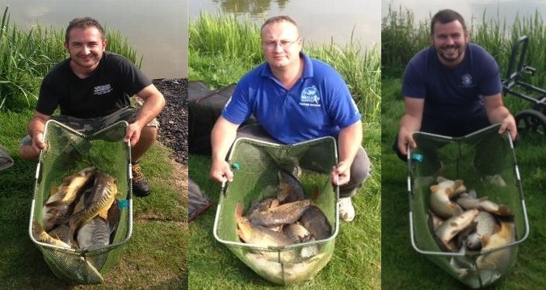
1st Phil Zahra 83lb 07oz 2nd Wayne Rooke 74lb 09 3rd Pete Boggiano 47lb 07oz
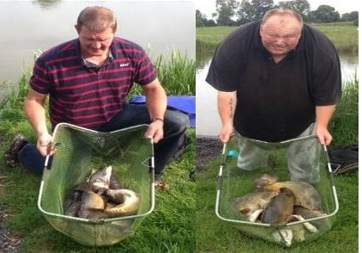
sections Ian Clarkson and Keith Harrison
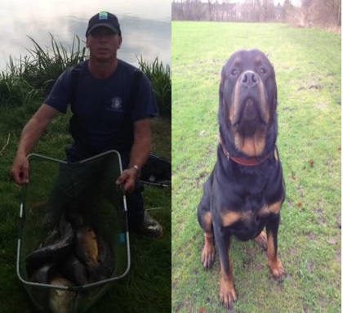
personal best Keith Thorne 35lb 14oz with his 10 stone buddy!!
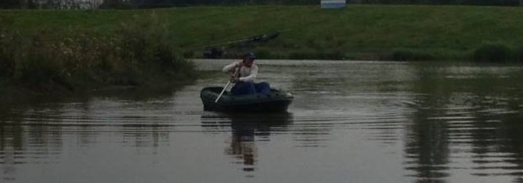
Gav Dodd - off on an adventure for his top sections
14 August 2013: Fir Water
5 bonus pegs, yes 5 bonus pegs are now in the hat – and guess what…… no-one won the dosh again with Alan Hesling, Frank Coleman, Ian Clarkson, Keith Williams and Martin Cook failing to take the pot [although to be fair Martin and Ian did get close!] – We’re up to 6 next match which is higher than we reached last season! The Phase 1 Knockout cup final and Phase 2 first round proper was fished and the report will be on the separate page soon.
Third place on the day went to Martin Cook who fished most of the day using pellet at 17m to reach the far bank netting carp to 12oz to weigh in 13lb 5oz which is just short of his mate Ian Clarkson who again had to extend to 16m to catch on the far shelf but using meat managed to weigh in 15lb 13oz – it was a difficult day for most anglers as gusting winds prevented proper presentation especially as its over 16m to reach the island – anyone who could reach caught well – anyone who struggled didn’t manage to catch with any consistency and bites were too fast to hit on the tip.
Top spot went to Pete Boggiano who had to battle with the wind and the barrage of abuse from Keith Standing and Billy Barker! Pete caught steadily from the off to weigh in 39lb 2oz his first fish of the day was a 4lb carp – the rest were around the 8-12oz mark all caught on pellet at 16m on the far shelf.
Sections went to Ian Coleman and Pete Ransome this now puts Ian back to the top by just 1 point above Phil Zahra.
The SMAC cameraman Mick Abdy had a poor days fishing and so entertained himself by roving and taking some ‘action’ shots which are below.
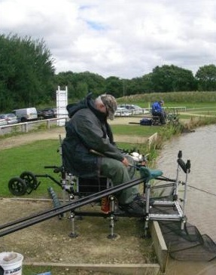
Keith Williams - All out, non-stop action!!!
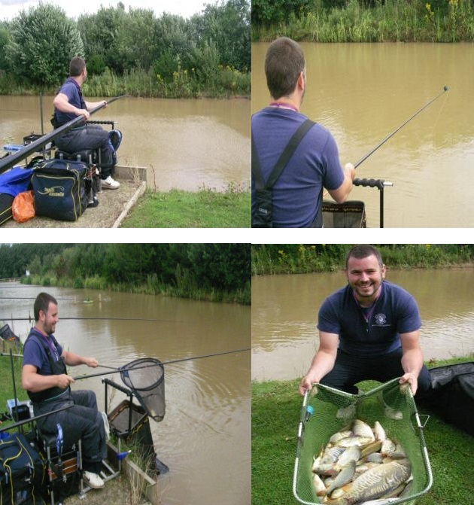

Pete Boggiano takes first place with 39lb 2oz
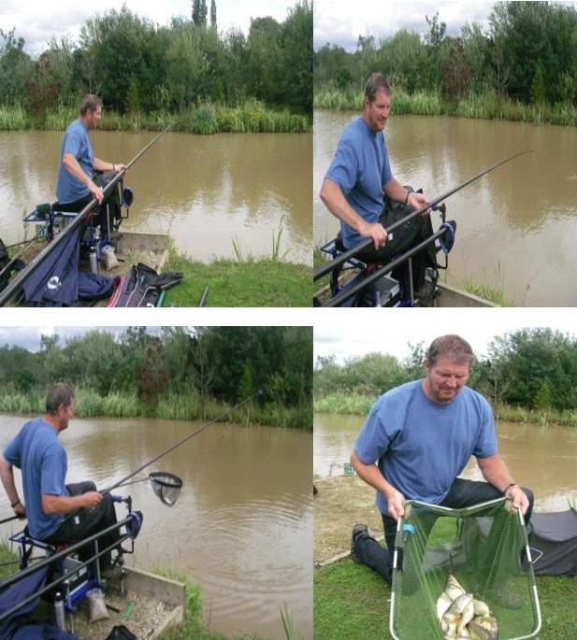

Ian Clarkson on his way to Second place with 13lb 15oz
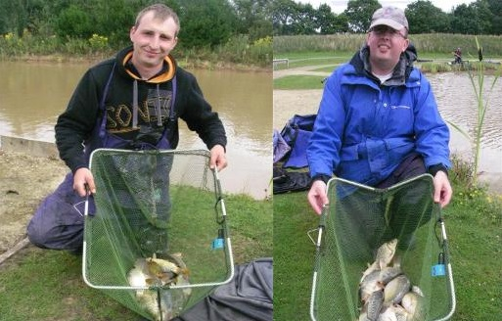
3rd Place Martin Cook 13lb 5oz and Section Winner Ian Coleman [Apologies Pete Ransome!]
28 July 2013: Bradshaws Lake 6
A trip to the ever popular lake 6 at Bradhsaws saw 16 SMAC regulars turn up looking forward to finding the monster carp amongst the millions of silvers in the venue - 4 bonus pegs were added to the draw and once again no-one could pick up the spoils - we all must be too rich and have no use for £200!
It was quite a slow start for most who had the pleasure of watching Pete Ransome wrestle with a foul hooked beast almost straight away from the all in – it took him a good 20 mins to land the fish which made up the majority of his 19lb 3oz weight which was good enough for a section win on the day – the other section going to Frank Coleman with 18lb 2oz once again most of this weight was made up with one fish showing the size of the fish in this lake!
Third place on the day went to Keith Thorne – who has recovered from his injury earlier in the season and managed to achieve his first frame of 2013 fishing corn and pellet down the edge from corner peg 18 Keith amassed 26lb 12oz of chub and carp – Keith lost a decent carp near the end of the match which could have boosted him above Keith Harrison who weighed in 27lb 5oz fishing corn down the edge which was good enough by less than a pund for 2nd place.
First place on the day went to Phil Zahra – after recent success in a manor farm open with 163lb which he kept quiet [not] Phil fished at 13m using pellet and paste shallow and at depth to net 32lb 13oz – this now puts Phil at the top of the table for the first time this season and it’s all getting very close now!!
The current biggest fish has now been beaten with an 11lb 1oz carp from Paul Pannett now taking the top spot. I’ve also noticed Frank Coleman has won his second section of the season and once again we’ve missed him on the pictures –Apologies Frank – I think a Frank Coleman Montage at the end of the season is in order!!
1st Phil Zahra 32lb 13oz 2nd Keith Harrison 27lb 5oz 3rd Keith Thorne 26lb 12oz
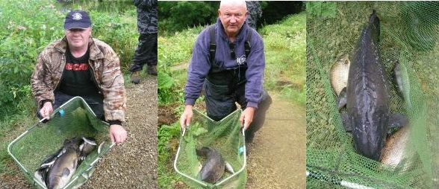
sections Pete Ransome [apologies Frank] and Paul Pannett with his big fish
14 July 2013: Partiridge Lakes - Pine
A glorious day to go fishing on a really nice venue after a week-long heat wave – I don’t really know how to follow this it just feels good saying it after it rained all year in 2012! The knockout cup phase 1 semi-finals were finally fished and a separate mini report is on the knockout cup page.
There were 3 bonus pegs drawn on the day with Alan Hesling and Keith Williams occupying two of them and Pete Ransome occupying the other who was especially keen to pick up the bonus as his partner who would have shared the money was a no-show – unfortunately it was not to be for Pete and fortunately it was also not to be for Alan or Keith – unlucky guys…. Alan apparently camped out and practiced for the week prior to the match, not hard enough obviously!!!
Third place on the day went to Mr consistent Ian coleman. Ian weighed in 24lb 13oz from peg 9 which was a good result from an area just outside the fancied zone – this now puts Ian in a really strong position for the second half of the season!
The fancied pegs prior to the match were 1 and 2 and they didn’t disappoint – Ian Clarkson didn’t have a bite for two hours on peg 2 then managed to put together a net of F1’s fishing up in the water to weigh in 26lb 4oz to continue his current good run with second place. Billy Barker drew peg 1 and achieved his first frame of the season topping the match with a cracking net of F1’s fishing tip tight across on corn and pretty much anything down the side to weigh in 44lb 8oz – a convincing victory – well done Billy!
Frank Coleman and Phil Zahra picked up section wins but unfortunately I missed them with the camera – accidentally in Frank’s case [apologies] but purposely in Phil’s case as he beat me off the next peg.
The table now includes dropped points as we have entered the second half of the season and we move on to Bradshaws Lake 6 in a couple of weeks – let’s hope the sunshine lasts!
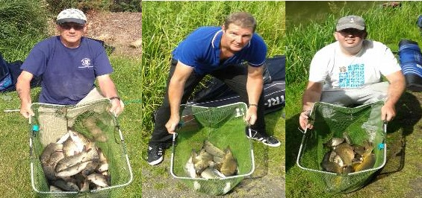
1st - Billy Barker 44lb 8oz 2nd - Ian Clarkson 26lb 4oz 3rd - Ian Coleman 24lb 13oz
30 June 2013: Benlee Lakes - Ben Lake
Unfortunately the semi-finals of the knockout cup weren’t fished due to several absentees so this will roll on to the next match! For the first time this year 2 bonus pegs were introduced but to no avail as Stuart Brown and Keith Thorne we’re unable to worry the £200 pot.
The water fished poor in comparison to reports of 80lb bags probably due to all but 2 of the pegs housing anglers. Non-member Tony Martin finished 3rd on the day with 18lb 5oz of carp caught on pellet meat and corn alternating between 11m & 13m from peg 20. Second place went to Chris Parry who was unconvinced he’d done well but weighed in 20lb 4oz from peg 2 which included the year’s biggest fish to date – a 10lb 15oz carp – well done Chris, let’s see if it can hold on to top spot!
Phil Zahra topped the match – his second on the bounce and is looking like he is finding his feet and returning to the sort of form that won him last year’s title, Phil weighed in 24lb 10oz fishing pellet and paste at 11.5m from peg 10 – well done Phil – this moves him into third place in the table and ever closer to Ian Coleman in top spot.
Sections were taken by Keith Standing and Ian Clarkson who both fished tidy matches in difficult conditions - and are also contenders for best poses of the year - Ian sporting his C&A catalogue model pose and Keith looking hard as nails for the camera!
Overall the general consensus was that with fewer anglers the water is a good prospect and finding out we could have ‘Lee’ lake also could work out as a nice venue for the future….. We shall see!
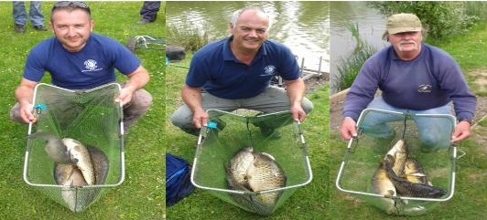
1st Phil Zahra 24lb 10oz 2nd Chris Parry 20lb 4oz 3rd Tony Martin 18lb 5oz
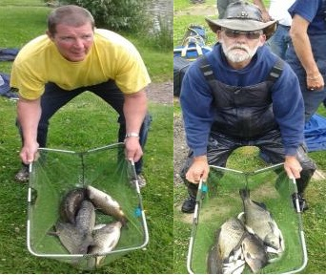
sections Ian 'catalogue pose' Clarkson and Keith 'hard man' Standing
16 June 2013: Goose Green - Match Lake
15 SMAC regulars turned out for the opening day match at Goose Green – reports of difficult matches in previous weeks were met with hopes that the spawning fish had finished bonking and were ready to feed!
First mention on the report has to go to Keith Williams [apologies Keith!]…… fishing on peg 3 Keith hooked into a nice carp halfway through the match and skilfully played the fish for some time using light gear but managed to land the ‘double figure’ fish. Sat on the Octo-box system Keith was extremely comfortable with everything to hand and everything seemed to be in place, however during the un-hooking process the monster fish managed to put up a further fight, they tussled for some time, calling each other names, exchanging blows which was too much for Keith to contend with and eventually the fish managed to wriggle free from his grasp……. A fleeting thought went through Keith’s mind “I have spent good money on my octo-box – the nets are in place and the carp will just land in my net……. Right?” Wrong – the fish managed to evade both nets and escape to freedom through the smallest of spaces, much to the amusement of the surrounding anglers – nice one Keith, this was a highlight of an otherwise bobbins days fishing! – see the picture below showing the well set up system with escape route highlighted for clarity.
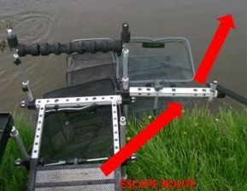
Third place on the day went to the in-form Ian Coleman – pegged next to his old man and on the bonus peg Ian used worm and meat down the edge to tip the scales at 17lb 8oz – his dad on peg 8 wasn’t to be outdone – Frank had the bit between his teeth and didn’t want another car journey home listening to Ian banging on about how good he is, chopping and changing methods throughout the day Frank latched into some nice carp eventually settling on the floating feeder with pellet and corn hook bait landed second place with 20lb 2oz – well done Frank!
Phil Zahra turned up for the match with a hangover and spent most of the time wandering round not doing much fishing – last year’s champion doesn’t need much time though and when he eventually returned to his peg [13] he put a tidy net of fish together from the edge using pellet and paste – seriously this will be on his headstone “here lies Phil Zahra, pellet and paste down the edge” Phil won the match with 23lb 12oz which was a low winning weight for this water but proof that the fish aren’t back to full feeding strength just yet!
Sections were taken by Stuart Brown on peg 1 and Keith Standing on peg 14 – well done chaps!
Ian ‘the chemist’ Coleman is sitting comfortably in top spot averaging a whopping 15.2 points per match. However, he is being chased closely by Keith ‘The Cowboy’ Standing, Pete ‘Johnny come lately’ Boggiano, Phil ‘the Blind Squirrel’ Zahra and Alan ‘Van’ Hesling all of who are ready to pounce if he falters!!
Don’t forget to check out the knockout cup page for the report and progress – see you all at the next match on a new venue......... BenLee lakes!!
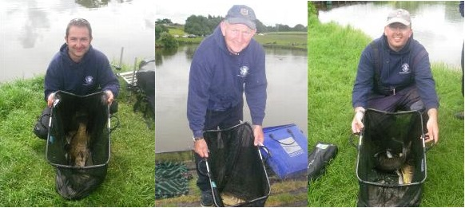
1st Phil Zahra - 23lb 12oz 2nd Frank Coleman - 20lb 2oz 3rd Ian Coleman - 17lb 8oz
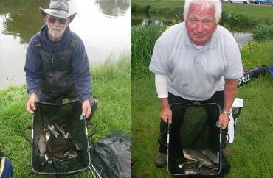
section winners Keith Standing and Stuart Brown
02 June 2013: Blundells Fishery - West Canal
A reduced field met up at Blundells Fishery, Rixton, Warrington on Sunday to fish West Canal. Intelligence gleaned from the fishery indicated that the resident ide had spawned, and with the temperatures on the up, the carp would surely be following shortly, but may be willing to feed...
Last year the club had some poor weights on the venue, so decided to maximise the chances of catching by leaving out certain pegs, to provide each angler with a spare peg to the left or right. At the all-in, ide and carp were topping along the entire length with many opting to fish shallow or long (or both). It was slow, with some small stiff showing to maggot and pellet baits, with only a handful of fish caught in the first hour. Margin swims had been primed by virtually every angler for later in the day, and Phil Zahra on 5 couldn’t resist the lure of an overhanging tree to his right and snared a carp quite early.
Keith Harrison on end peg 2 (permanent peg 22 for those that know the venue) had also primed his right side with meat and after a few fish across at the bottom of the far shelf, came short and started to catch. His orange 10s elastic and puller kit got a right work-out, as a precession of nice carp to 5lb responded to loose-fed small cubes. Mick Abdy on adjacent peg 3 had a Mr Crabtree-looking margin of rushes, roots and an overhanging bush down to his left at about 6 metres, but it was barren of fish. So were most other people’s pegs, as Keith on peg 2 continued to empty his peg on meat. At the other end of the match, Alan Hesling was putting a few together on peg 18, as was Pete Boggiano on the next peg. Others were hooking the odd lump, but having lightened up to attract bites, losses were common. Many at the weigh-in were complaining about the Houdini-gene the carp seem to have in the venue, with several decent fish lost under stages.
Keith Standing is a very competent and consistent angler, and continued to be competent for most of the match on peg 6, sticking to his favoured maggot-down-the-track approach to top 23lb 15oz on the scales for overall 2nd . Keith Harrison has previously shown that when drawn on a few fish he can be unbeatable, and again this was the case as he romped the match with 63lb 13oz, all carp down the side on meat. The fish were tightly shoaled and wouldn’t budge, and carp to 6lb fed consistently all day. Alan Hesling edged out close competition from the high numbers to claim third with 17lb 11oz.
The Knockout Cup wasn’t fished because 5 of the 8 quarter-finalists weren’t available, so will be held on the next match at Goose Green.
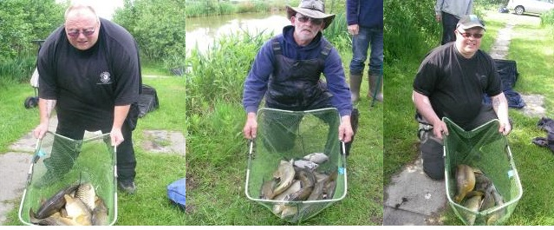
1. K Harrison 63lb 9oz 2. K Standing 23lb 15oz 3. A Hesling 17lb 11oz
18 May 2013: Bradshaws No 8, Bolton
The last 16 of the knockout cup was fished and the separate write up can be found on the new ‘knockout cup’ page on the tabs above along with full results.
Overall the water fished quite poorly with many weights under the 10lb mark being recorded – the majority of weights above this mark included 1 or 2 bonus carp, one of which resulted in Ian Clarkson picking up his first framing position with South Manchester and also putting himself in the lead for the biggest fish trophy with a 10lb ghost carp – fishing on peg 13 Ian used Pellet to tempt the fish and weighed in 15lb 12oz which was good enough for third place – fortunately the weight was beaten as Ian was sat on the bonus peg! – Ian is also in the lead for the ‘dodgy fishing boots’ award sporting his camouflaged timberland boots……… nice!!
Second place on the day went to bit bashing Pete Boggiano who put together 18lb 4oz of small chub, barbel and roach with a couple of bonus tench and skimmers thrown in using maggot and feeding heavily with maggot under the bridge from peg 18 which was pretty surprising seeing as the bridge was in full use all day by pleasure anglers making trips to and from lake 9!
Ian Coleman found himself pegged on end peg 22 and with an hour to go had about 5lb of bits in his net – he was snapped earlier on and subsequently made the decision to fish meat down the edge thinking there must be some big ‘uns in his swim……… the decision paid off and Ian managed to land 4 nice carp to pick up his third win on the bounce with 23lb 13oz! Nice one Ian – three cracking matches on the trot which puts you 13 points clear at the top of the league!
Sections on the day were picked up by Paul Pannett with 11lb 14oz from peg 8 and Martin Cook with 12lb 12oz from peg 12 – all the twelve’s!
Don’t forget to check out the knockout cup page over the next couple of days – see you on the next match at Blundells!
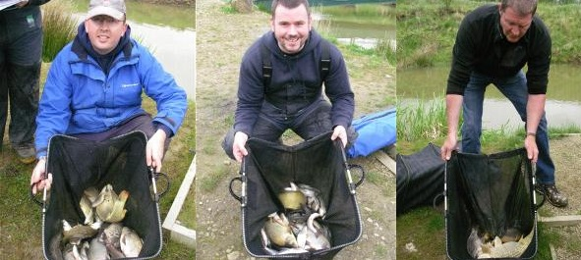
1st - Ian Coleman 23lb 13oz 2nd Pete Boggiano 18lb 4oz 3rd Ian Clarkson 15lb 12oz
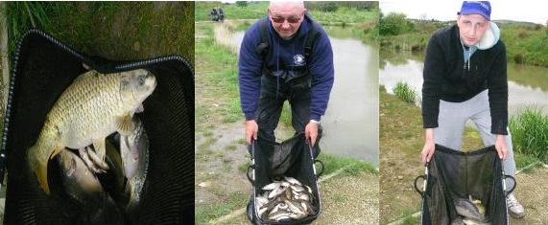
10lb Ghost carp - current biggets fish and section winners Paul Pannett and Martin Cook
05 May 2013: Fir Tree Farm - Nooky Hollow
Prospects were looking good for the third match on the SMAC calendar on the ‘sociable’ Nooky Hollow, reports of 75lb in 3 hours winning a midweek match was enough to whet the appetite of the 15 attending SMAC members.
The draw took place for the first round of the knockout cup – it was decided to wait until the next match to fish the round due to several members being absent from this match – we are putting together a special knockout cup page on the website with separate reports and pictures so watch this space!
Pegged on un-fancied peg 6 Phil Zahra equalled his result from the last match. Fighting off firm competition from Alan Hesling and Chris Knowles on either side Phil managed to put together a net of small carp using maggot and paste to weigh in 34lb 2oz which was enough for third place on the day.
Sitting on peg 1 ‘the cowboy’ Keith Standing managed to recover very well after losing two rigs in quick succession early on in the match, he then quickly figured out the fish were taking maggot on the hook and ended up weighing in a net of carp with some lovely looking fantail crucian carp to achieve second place with 35lb 7oz.
Ian Coleman rocked up for the match after his win on the last one obviously feeling confident as he had left half his tackle at home! After a quick phone call his wife was en-route with nets and bait trays at 8am on Sunday morning….. What a woman! Ian drew fancied peg 17 and didn’t let the side down – bagging up seems to be his speciality and Ian romped the match with 48lb 12oz caught on meat and corn – this now puts Ian at the top of the league after 3 matches with 43 points – well done Ian.
Sections on the day were taken by Chris Parry with 30lb 5oz and Alan ‘Van’ Hesling with 28lb 4oz – Mick Abdy was on the bonus peg but could only manage thirteenth place! Overall a good day was had by all with over 340lb being caught and a little bit of sunshine on your back to make you smile!
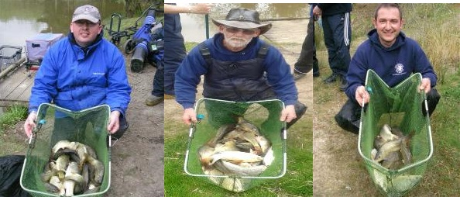
1st Ian Coleman 48lb 12oz 2nd Keith Standing 35lb 7oz 3rd Phil Zahra 34lb 2oz
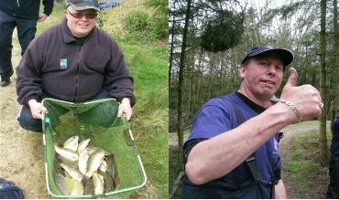
Section winner Alan 'van' Hesling and Keith Thorne who didn't frame but wanted to be on the website so here you go!!
apologies for no picture of Chris Parry the other section winner but I'm sure he'll be on here in the near future!
21 April 2013: Partiridge Lakes - Ribbon
Cloud covered partridge lakes for the second match of the SMAC season, with the onset of rain inevitable 19 anglers drew pegs to fish the ribbon lake and the talk was of the lake being under too much pressure and hopes were low for big weights with 30lb expected to be enough for the top spot. A new format for the knockout cup saw all anglers entered into the first phase to qualify for the last 16 positions with the top 16 weights from today making the cut – a second phase will be run later in the year to decide the second finalist – good luck to everyone entering!
Contrary to expectations the lake actually fished very well with all but 1 member weighing in and an overall total of over 250lb caught on the day!
The bonus peg was drawn by bonus peg regular from last season Pete Boggiano who failed to pick up the funds managing only 6th place on the day. In third place was Phil Zahra who finally seemed to hit some form after a poor run of results [by his standards anyway] fishing down the track on the bottom and shallow using maggot and feeding maggot Phil managed to put together a tidy net of ide with a couple of F1’s thrown in to weigh in 20lb 6oz from un-fancied peg 16.
Alan Hesling had the pleasure of fishing peg 2 and amassed a net of F1 carp using Maggot fished tight to the island to tip the scales at 22lb 8oz to earn him second place – from my position in the lake I thought the winner was a toss-up between Phil and Alan however unknown to myself Ian Coleman had bagged up from peg 5 putting together a cracking net of fish using maggot and pellet to the island weighing in at 34lb 12oz – well done Ian, exceeding expectations on the day, fishing a great match to fire him up to 2nd in the table! Section winners on the day were Keith Harrison with 20lb 2oz from peg 4 and new member Chris Knowles with 19lb 11oz from peg 14.
The following members have made it into the knockout cup first phase, congratulations to those who have but don’t worry if you’ve not made it there will be another chance later in the season, the way the competition is structured this year! - Ian Coleman, Alan Hesling, Phil Zahra, Keith Harrison, Chris Knowles, Peter Boggiano, Chris Parry, Paul Pannett, Keith Standing, Ian Clarkson, Frank Coleman, Billy Barker, Martin Cook, Roger Wolfendon, Mick Abdy and Keith Thorne.
See you on the next match at Fir Tree Farm, Nooky Hollow with the ‘friendly’ pegging!!
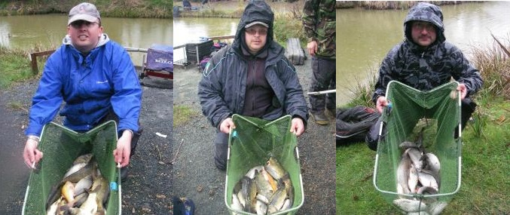
1st Ian Coleman 34lb 12oz 2nd Alan Hesling 22lb 8oz 3rd Phil Zahra 20lb 6
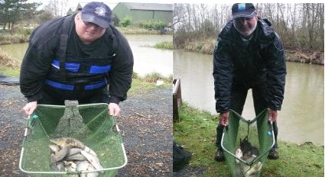
Section winners Keith Harrison and Chris Knowles
07 April 2013: Cudmore - Pool 1
It was bitterly cold for the start of the 2013 match season for South Manchester AC, as 19 anglers prepared to fish Cudmore Pool 1. As the whole pool was available, it was decided to fish the single bank to give everyone the chance of catching.
As the water temperature at the start was only around 5 degrees C, it was a softly-softly approach adopted by most, with Mick Abdy first off the mark on peg 3 with a lone carp to the bomb and bread down the middle. Odd roach were beginning to show but any signs of net fish were conspicuous by their absence. Mid way through and things were looking very grim, but then Pete Boggiano fishing peg 2 started to put together a string of maggot caught barbel and tench on the pole at 7 or 8 metres. Not wishing to be outdone, Mick responded with a tench of his own on poled maggot at 12m and another method feeder carp.
Very odd carp were starting to show throughout the field, with new member Keith Williams (peg 1) starting to catch on the method feeder using either krill pellets or tutti-frutti baits. Nobody, however, could catch the 2012 Championship runner-up Pete Boggiano when he started to pick off carp to 4lb on the banjo feeder tight across, banding hard pellets on the hook to weigh in 29lb dead for a convincing victory. A few late (small) barbel and carp to the straight lead fished across helped Mick Abdy to second with 10lb 12oz, with Keith Williams completing the frame on his South Manchester debut with 3 carp and some bits for 8lb 8oz.
Reigning champion Phil Zahra finished in 14th position.... but in his defence he was suffering with man-flu and was pegged in a poor area. Considering he won the championship last year by almost 50 points, any head start the membership can get on Phil will come in very handy!
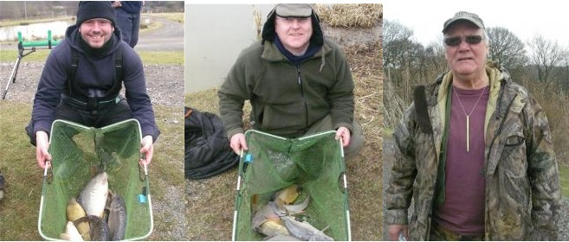
1st Pete Boggiano 29lb 2nd Mick Abdy 10lb 8oz 3rd Keith Williams 8lb 8oz
(sorry but there's no catch photo of Keith with his fish, an unfortunate oversight by the intrepid SMAC roving match reporter covering the competition!)

