MATCH REPORTS 2016
Venue: HALL LANE FISHERIES – BES’S

Date: 30.10.16

We were granted use of the entire lake for the final match of the 2016 season which gave us 75 pegs to play with and with a reduced field of 25 anglers this resulted in a hell of a lot of space for everyone – hopefully a taster of how next year’s matches will be pegged!
The weather in the run up to this match has been quite mild with temperatures on the day reaching 15 degrees which had a cracking effect on the fishing with an average weight of 41lb per angler and 3 100lb+ weights which has never happened on a SMAC match before – in fact looking through the history there have only ever been 5 100lb+ weights in the history of the club!!!

We ran a sub competition “random pairs” which was won by Tony Webb and one of our old members Keith Williams – well done guys!

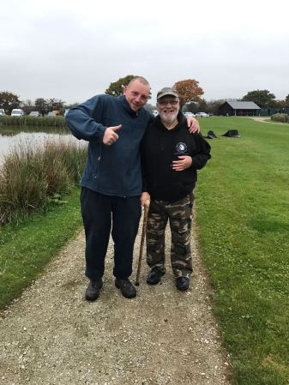

Section - A - 1st Tony Webb 131lb 13oz / 2nd Pete Boggiano 124lb 13oz
Well, what a section this was! Pete was first to weigh in with 124lb 13oz, then Tony Martin weighed in with 102lb 2oz…… then, mouth almighty, gobshite Tony Webb weighed in to win the section with the years highest weight at 131lb 13oz – unsurprisingly Tony won the overall match too and reclaims his grip on the highest match weight trophy as it was released for about 10 minutes when Pete thought he’d got it….. Hence the tirade of abuse above! Well done Tony, what a cracking season you’ve had – Pairs winner, bonus ball winner and biggest match weight winner – nice one mate, bang on!

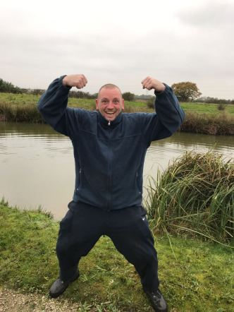

It has also been brought to my attention today that is was Tony Martins first ever Ton weight - apologies for not posting the pic before Tony, well done mate what a great catch!!

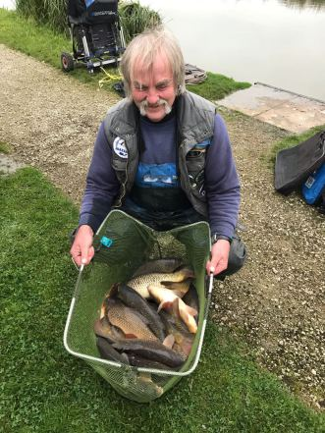

Section - B - 1st Phil Zahra 69lb 5oz / 2nd Stu Brown 56lb 2oz
Stu Brown picked up second place in section B with a cracking weight of 56lb 2oz – well done Stu, a great performance ending a really solid season.

Section B was topped by this year’s champion Phil Zahra with another fantastic section winning performance. Phil has only dropped 5 points all season which is testament to his consistency and ability, picking up 11 section wins along the way which included 3 overall match wins and a total weight of 822lb which averages out at about 55lb per match which is pretty immense!! I think I speak on behalf of everyone in the club when I thank Phil for the time and effort he expends in running the club, the work put in behind the scenes makes sure we all have cracking matches to fish on some of the best venues around which are run perfectly for everyone to enjoy, thanks Phil we all sincerely appreciate your work.

Top guy, Top Angler, Club champion [for the 3rd time!]

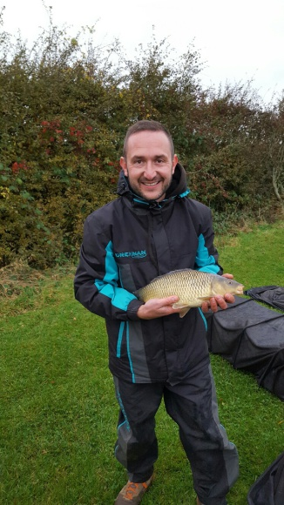

Section C - 1st Derek Wood 34lb 7oz/ 2nd Stu Ford 30lb 4oz
Section C was one of the hardest sections on the lake with the lowest winning weight – Derek Wood put in another great performance landing him his 3rd section win of the year – well done Derek. Stu Ford came second in the section which is great news! This is his first section frame of the year which is most pleasing, nice one Stu well done pal!

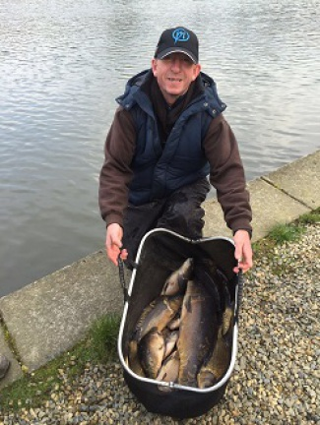

Section D - 1st Alan Hesling 65lb 1oz / 2nd Ady Woods 39lb 14oz
Alan Hesling made the most of a gorgeous looking corner peg to top section D with a tremendous weight for the area he was in – nice one Alan, picking up your 4th section win of the year, top man – he’s pictured below looking a bit like Tony Webb’s child!! Ady Woods came second in the section which secured 3rd place in the league – really consistent angling from Ady this season has got him to this position – nice one mate, good stuff!

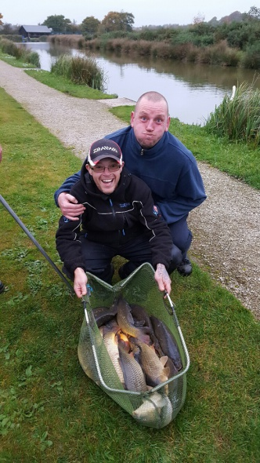

I’m signing off now for this season and what a season it’s been - I’ve really enjoyed the fishing and the new members who have joined have added some great competition and characters to the club – it’s nice to get guy’s joining who are really committed to fishing our matches so thanks to you guys for making the effort. Also a note to the current members who continue to make this club what it is, a great group of guys who really enjoy their fishing and of course the craic that comes with it. On a personal note I just want to reiterate my congratulations to Phil for winning the league – fantastic effort mate, really pleased for you!

I’ll be sending out winter league booking on texts over the next few days which I’m really looking forward to – we’ve also got some top matches booked for next year, for which I cannot wait!!! Phil will be writing his end of season match secratary report which will be uploaded real soon - watch this space!

Super pools results:

1st Nob Head Tony Webb £30

2nd Pete Boggiano £20

3rd Tony Martin £5

Venue: PARTRIDGE LAKES – COVEY 6

Date: 16.10.16

Terrible weather greeted a reduced field of 24 anglers at the penultimate match of the 2016 season, the rain was pouring and wind howling as the anglers set up with low expectations as reports have been really poor over the last few weeks with practice sessions not going the way we would’ve hoped for a premier fishery.

The fishing turned out to be really difficult for most and the highlight of the day was Daz Gabz falling in, after standing up to nip for a quick pee Daz slipped on the wooden platform and ended up in the drink – much to the amusement of onlookers – Daz is pictured below back at home still trying to warm up looking unhappy about his swim! Another highlight was Ady woods nearly losing a top kit to a thieving duck whilst on his way to his first DNW of the season – one of 4 DNW’s on the day, not good at all!!!! Winter is definitely on its way!

FREEZING COLD DAZ GABZ TRING TO WARM UP

Section - A - 1st Phil Zahra 34lb 0oz / 2nd Tommy Edwards 21lb 15oz
Phil and Tommy were positioned on what are usually the best pegs on the lake which failed to really produce the goods on the day – this didn’t stop Phil picking up his 10th section win of the year on his way to winning the title. Phil had to switch methods a number of times to keep the fish coming and had a couple of decent carp landed on knicker elastic to boost his weight. Well done Phil and well done Tommy on another solid performance which moves him upto 5th in the league.

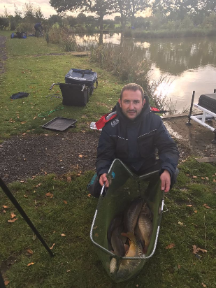

Section - B - 1st Derek Wood 34lb 14oz / 2nd Eamonn Boulger 15lb 4oz
Derek wood picked up the section win from a really difficult section more than doubling the weight of second place – Derek fished maggot and meat down the margins to clinch the top spot and second overall in the match – nice one Derek a great result, well done also to Eamonn who has joined the club this year and fished every match – really good commitment, this is his third section second of the year and his second on the bounce! Nice one mate :-)

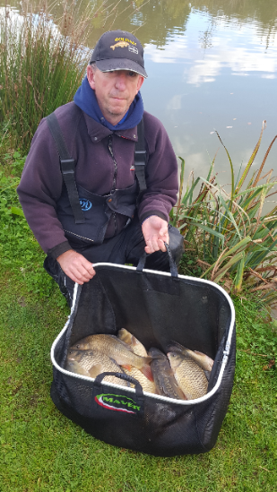

Section C - 1st Paul Tighe 18lb 15oz/ 2nd Tony Martin 15lb 15oz
By far and away the hardest section on the lake was topped by Paul Tighe with his first section win of the year! Nice one Paul – apologies I didn’t get a picture of you – I’ll hunt you down at the next match! Second place was picked up by the beast Tony martin – well done chaps!
Section D - 1st Pete Boggiano 64lb 8oz / 2nd Ian Clarkson 10lb 8oz
Pete Boggiano annihilated section D fishing maggot across and down the track in several different swims Pete weighed in the best weight of the day by a long way which clinches the runner up trophy for the individual league. Ian Clarkson came second from the next peg with a hard worked for 10lb 8oz! – well done chaps

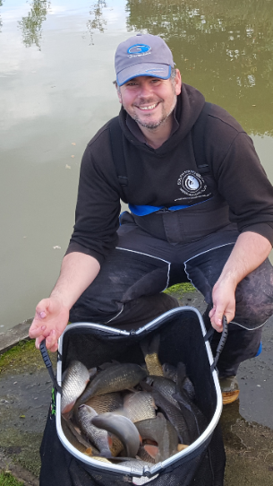

Super pools results:

1st Pete Boggiano £20

2nd Derek Wood £15

3rd Phil Zahra £5

Venue: ROSEMARY WOOD FISHERY – ISLAND LAKE

Date: 02.10.16

As we move into October the morning weather is beginning to feel a touch more chilly and as you can see from the image below a mist was hanging over the venue which cleared just in time for the match to get underway.

The pairs competition came to a fantastic climax with Tony Webb and Carl O’Brien being the victorious pairing beating Phil Topham and Phil Zahra by just 14lb – both pairings putting together 100lb plus weights resulted in a cracking final to a fantastic competition, well done to the victorious pair and well done to everyone who entered – it’s worth noting that this is the third time the top pair has been beaten by the second place pair since the competition was formed 3 years ago!

The finalists - Ready for battle!!!

Section - A - 1st Ian Coleman 44lb 0oz / 2nd Eamonn Boulger 27lb 15oz
I was sat around the corner from Ian and could hear his cries of desperation as he lost loads of fish during the first half of the match, Ian turned things around though to tip the scales at 44lb dead showing a class angler never loses his head, Eamonn came second in the section from the wrong end of the lake with a hard fought net of 28lb of carp mainly caught down the edge. Well done guys!
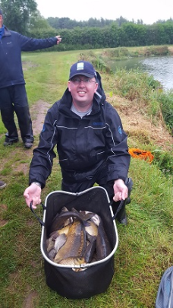

Section - B - 1st Tony Webb 92lb 07oz / 2nd Ady Woods 84lb 1oz
We added 2 bonus pegs into the draw bag and Tony Webb drew out an apparent flyer in peg 1 – Tony didn’t disappoint and fished tight up to the bridge to get off to a flying start, things slowed down in the second half but he’d already done enough to win the section, the pairs final, the super pools and also the bonus peg which is pretty much like winning the lottery in SMAC terms, we didn’t get a picture of tony but have added a video below with his celebratory dip [excuse the language but it was freezing] Well done Tony, what a cracking day for a really sound guy who’s joined the club this year and fished every match with enthusiasm and humour, getting his arse out at every opportunity, Brilliant mate!! Second in the section was Ady woods with another great weight of 84lb, nice one!

Section C - 1st Alan Hesling 50lb 1oz/ 2nd Tommy Edwards 42lb 11oz
Alan Hesling posted another good result following on from his section second at partridge lakes, this is Alans best weight of the year which edged out Tommy in second place who admitted to having 20lb in the net….. Another one to add to the list of under estimators!! Well done gentlemen, good fishin’!
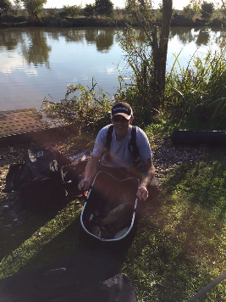

Section D - 1st Phil Zahra 87lb 12oz / 2nd Paul Tighe 63lb 1oz
The snag pit was home to section D which was also home to the unstoppable Phil Zahra, Phil had a really quiet first half of the match but showed his prowess to come back with a string of paste caught carp ranging from 2-4lb to win the section – this victory also wins Phil the individual league title for the third time in 5 years which is testament to his angling ability, I’ll save the stats and formal winners write up until the end of the year but I think everyone will agree it’s a job well done! Second in the section was Paul Tighe with a cracking weight of 63lb, well done mate

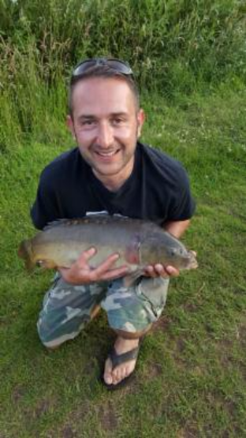

Our Champ!! - he loves fish!

Venue: PARTRIDGE LAKES, MARSH AND SPEY
Date: 18.09.16
Recent reports from the 2 canals were very poor with 20lb winning weights from the previous days matches leaving no-one with much hope of a bag up day, the actual fishing turned out to be pretty bobbins with a very low average weight for this time of year. The final match of the pair’s competition was fished and it was a race for second place as Phil Zahra and Phil Topham have already booked their place in the final. It was a close call between the 2nd and 3rd place teams with Tony Webb and Carl O’Brien pipping Pete Boggiano and Daz Gabz to the final. Well done to everyone who entered it should make for a cracking final which will be fished over the next 3 matches.

Section - A - 1st Pete Boggiano 39lb 7oz / 2nd Alan Hesling 18lb 10oz
Pete Boggiano picked up his 7th section win of the season picking up a variety of fish from 5 different lines throughout the day, the main lines of attack being maggot down the track and pellet across. Alan Hesling ended a poor run of results with 2nd in the section. Well done guys!
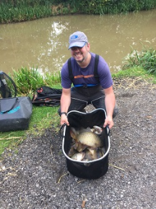

Section - B - 1st Phil Zahra 46lb 15oz / 2nd Tommy Edwards 26lb 8oz
section B was topped by Mr Zahra who remains 3 points clear at the top of the league – only a complete disaster could prevent Phil from clinching his third individual league title with only 3 matches to go – I won’t mention the fact Phil drew an end peg with more water to go at than the Atlantic ocean, I won’t mention it at all! Second in the section was Tommy Edwards who fought off close competition from several anglers – well done chaps.
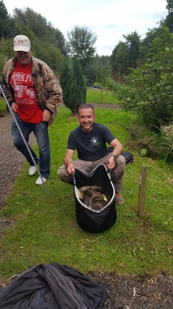
Section C - 1st Tony Webb 53lb 15oz/ 2nd Eric Quinn 25lb 0oz

Tony Webb clinched top spot in section C with the highest weight of the day, Tony had to fish tight across in between rushes to net his 54lb net, this is only his second section win of the year but it pushes Tony into 5th place in the league, well done Tony you are just amazing. Second in the section was mouth almighty Eric Quinn with 25lb, well done Eric!
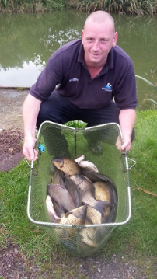
Section D - 1st Martin Cook 35lb 8oz / 2nd Mick Abdy 24lb 14oz

Martin Cook picks up his second section win on the bounce, anyone would think he’s had a recent lesson with Andy May…… they would be correct to think this. Martin fished pellet across and maggot down the track to win the section with 35lb, well done Martin. Last year’s match winner on this venue didn’t fare too well but managed second in the section, well done Mick, the inside information is obviously working (a bit)
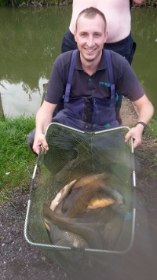
Super pools results:

1st Tony Webb £30

2nd Phil Zahra £20

3rd Pete Boggiano £10

Venue: FIR TREE FISHERY – NOOKY, BENSONS, MATCH AND FIR WATER
Date: 04.09.16
The first of the September matches was held at Fir tree fishery where we pretty much took over the whole complex! A fantastic turnout of 31 resulted in us booking extra pegs at the last minute to give us a bit more room. We’re now averaging 29 anglers per match which is fantastic so thanks to everyone for your efforts!
Everyone wanted to draw nooky hollow as this is the best water on the complex and it didn’t disappoint with some fantastic weights showing. Fir Water also fished pretty well but the other 2 lakes were a total let down and fished very very difficult indeed!
This was the penultimate match for anglers to post weights to get into the pairs competition final and things have just got really interesting – Phil Topham and Phil Zahra are way ahead in the lead and have been followed by Pete Boggiano and Daz Gabz all year – Pete and Daz have just been bumped into third place now by Carl O’Brien and Tony Webb – there’s only 13lb difference between the 2 pairs with 1 match left to count!!
Section - A - 1st Martin Cook 26lb 1oz / 2nd Keith Standing 18lb 1oz
Bensons was the home to section A with 7 anglers jousting with poles on the tiny little puddle – Martin Cook came out on top with 26lb fishing tight up to the far bank from peg 2 which was also the bonus peg but Martin was unfortunate not to win the match outright which would’ve been pretty impossible from this lake! Martin was followed by Keith Standing who’s had a difficult season – this is the first time he’s framed all year! Well done chaps
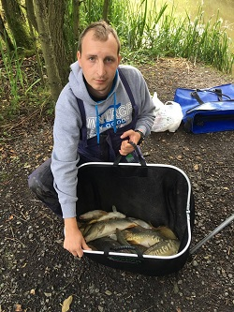
Section - B - 1st Phil Topham 38lb 13oz / 2nd Ady Wood 27lb 8oz
section B was housed on the match lake, with only 1 or 2 fancied pegs on this lake it wasn’t on everyone’s wish list at the draw bag. Phil Topham continues a cracking run with his 4th section win of the year which takes him to 4th place in the league, situated on peg 1 Phil fished a fine match fending off some stiff competition from Ady Woods who came second in the section. Well done guys!
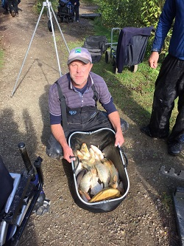
Section C - 1st Stu Brown 65lb 0oz/ 2nd Chris Gabz 62lb 12oz
with an average weight of 42lb per angler it was clear why Nooky Hollow was the most fancied lake on the complex, Stu Brown didn’t disappoint from the best peg on the lake (15) he tipped the scales at 65lb dead to pick up his first section win of the year – well done Stu, what a battle it must have been between Stu and Chris who was on the next peg – Chris weighed in close to 63lb for second in the section! 1 more fish would have done it!! Unlucky Chris!
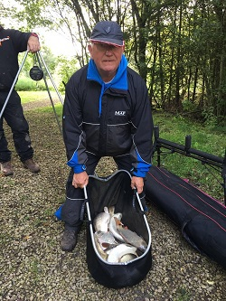
Section D - 1st Carl O’Brien 82lb 3oz / 2nd Phil Zahra 79lb 9oz
Carl fished a cracking match from peg 33 on the fir water lake to win the section and also the overall match with a massive 82lb of fish mainly caught on banded pellet at 16m and meat down the edge Carl's having a great season so far and will be a real contender for next year's title I reckon. Phil Zahra could only manage 2nd
in the section but it should be enough to firm up his grip on the championship trophy as Pete Boggiano completely cocked up his hopes of challenging for the top spot. Well done Phil and Carl – two great weights!
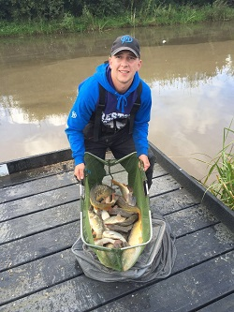
Super pools results:
1st Carl O’Brien £30
2nd Phil Zahra £20
3rd Stu Brown £10
Venue: HERONBROOK MEADOW
Date: 21.08.16
We know the score…. Reports of 200lb bags, massive festival weights and record breaking weigh ins generally results in a SMAC disaster! This time however it was different, with probably the highest ever SMAC average weight of 47lb per angler, which may mean the curse has been lifted! The highest match weight for the season has been toppled with Tony Webb’s cracking net of 123lb releasing Phil’s grip on that particular trophy.
The pairs tournament is massively hotting up with only 2 matches left to count towards the final tally I have now omitted the 4 lowest weights from each angler to give you a more realistic view of the table, the top spot is almost secured with Phil Z and Phil T combining with a massive 684lb however the second finalist place is still well up for grabs with the next 5 pairings all within 100lb of each other….. Who’s got the bottle to do it? Who’s got the nerve? Who’s got the eye of the tiger? Who’s writing this shite? Kick his head in!
Section - A - 1st Phil Zahra 73lb 5oz / 2nd Ged Smith 72lb 10oz
Something really strange happened on Sunday when Phil found himself pegged near other anglers, shock, horror, He didn’t have a full lake to himself like he has over the last couple of matches, Phil showed his ultimate prowess in winning the section with a 73lb bag of mainly edge caught F1’s by just under a pound from Ged Smith who was a couple of pegs away, really well done guys – a well fought section with an average weight of about 56lb!!! boomshakalaka
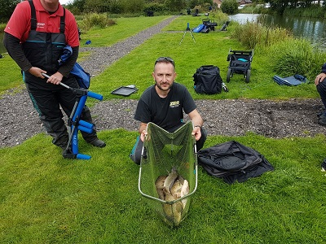
Section - B - 1st Pete Boggiano 89lb 12oz / 2nd Ian Clarkson 60lb 3oz
Pete Boggiano has finally stopped sulking like a girl after a disappointing last match and was spurred on by someone making a positive comment about the pegging out; which happens like, never! So much so he went on to win his section with an 89lb bag of mainly carp caught on meat over hemp and corn. The tallest man in the world Ian Clarkson picked up second in the section to finally put some decent points on the board after a poor season so far by his standards. Well done guys. Ian was closely followed by Tommy who broke his pole twice during the match like a right numpty, unlucky mate!
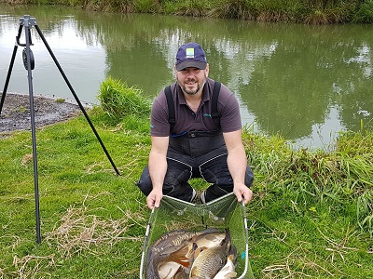
Section C - 1st Tony Webb 123lb 3oz/ 2nd Stu Brown 72lb 0oz
Tony Webb continues his fine season with a huge haul of 123lb of meat caught carp which secured him the section and overall match win, Tony has joined the club this year and to be honest is a bit of a nob. Second in the section was Stu Brown with his biggest weight of the year, nice one Stuart well done.
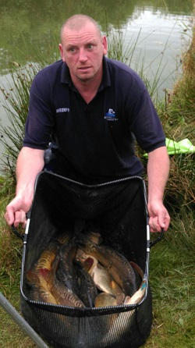
Footnote: just kidding Tony, I love ya really xx
Section D - 1st Phil Topham 54lb 5oz / 2nd Carl O’Brien 50lb 0oz
Phil Topham is on fire at the moment, no-one can get in his way, he shoots into 4th in the league with his 3rd section win of the year – I don’t know exactly how Phil fished but I’d put money on him chucking a feeder out whilst smoking loads of fags and drinking loads of brews was his chosen method – well done Phil. In a close second place was Carl with another top performance from the clubs youngest member, definitely not the best looking though, that’s me.
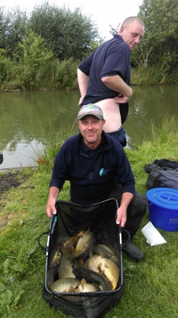
1st Tony Webb £35
2nd Pete Boggiano £20
3rd Phil Zahra £10
Venue: CUDMORE FISHERIES – MOORS AND EDWARDS
Date: 07.08.16
27 anglers joined us for the 9th match of the 2016 season to fish moors canal or Edwards lake, reports were pretty positive from the fishery and so hopes were high. The pairs competition is getting a mention this week as we’re down to the last 3 matches that will count towards the final, there are 4 weights dropped this year which will mean plenty could change in the table prior to the finalists being announced after match 12. Currently topping the league are Phil Zahra and Phil Topham who are way ahead of the following crowd – any of which could get to the final after the dropped weights have been deducted!
Section - A - 1st Carl O’Brien 43lb 11oz / 2nd Pete Boggiano 40lb 12oz
Carl had a terrible start to the match with only 6lb to show in the first 3 hours, he then made a switch to fishing down the edge to pick off a slightly better stamp of fish than second place Pete Boggiano, Carl had a cracking last 3 hours to turn it round and won the section with 3lb to spare, well done mate!
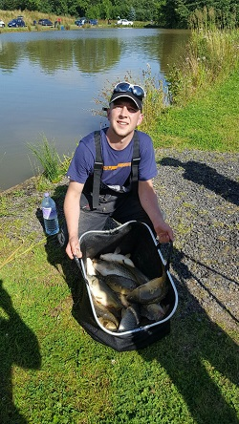
Section - B - 1st Phil Zahra 81lb 13oz / 2nd Frank Coleman 34lb 13oz
Phil Zahra is showing he’s the man to beat at the moment and gave another cracking display to show why he’s top of the league, Phil had to switch between a variety of methods to keep the fish coming in a very windy area to weigh in another huge weight of 81lb 13oz, well done Phil….. one hand on the trophy now mate, can you handle the pressure?!! Second in the section goes to Frank Coleman who secured his first frame of the year with 34lb of feeder caught fish – Nice one Frank, everyone was made up for you, well done pal!
Section C - 1st Ady Woods 42lb 1oz/ 2nd Tony Webb 31lb 9oz
Ady Woods picked up his 4th section win of the year and secured his 3rd place spot in the league with the 3rd highest weight on the day. Ady fished paste short for a mixed bag to weigh in an impressive 42lb from Moors Canal, Tony Webb was in second but I’m refusing to say anything nice as he nicked my car keys which resulted in me having to unpack my whole car to look for them. I will get you back!!!!!
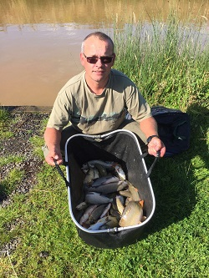
Section D - 1st Ged Smith 35lb 6oz / 2nd Derek Wood 29lb 1oz
Ged Smith picked up his 3rd section win of the season which moves him into 5th in the league, closely followed by Derek Wood. I’d like to write about how both caught but I was too busy emptying my car for the second time looking for my keys – well done anyway chaps, two solid performances from a difficult section.
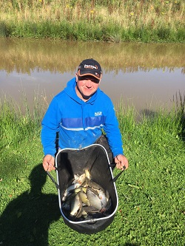
Super pools results:
1st Phil Zahra £35
2nd Carl O’Brien £25
3rd Ady Wood £10
Venue: HERONBROOK FISHERIES – BRIDGE POOL
Date: 24.07.16
Another cracking turnout of 28 anglers didn’t leave many spare pegs on the prolific Bridge pool at Heronbrook. This didn’t seem to affect the fishing as we recorded the highest average weight of the season of 37lb per man. This was made up with some good weights where there was a ripple on the surface but away from this it was a bit of a grind.
Section - A - 1st Pete Boggiano 75lb 0oz / 2nd Martin Cook 47lb 15oz
Pete Boggiano returned to action after missing a match to win the section with a 75lb net of shallow caster caught F1’s. Pete fought off competition from Martin Cook on peg 1 who came second in the section with 47lb 15oz. Well done chaps.
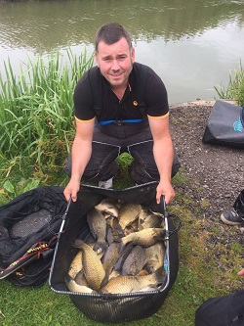
Section - B - 1st Ady Wood 27lb 2oz / 2nd Paul Tighe 20lb 14oz
The most difficult section on the day was away from the wind from pegs 8 to 14 which was won by Ady wood who tipped the scales at 27lb with a mixed maggot caught net. Paul Tighe clinched second place – his 3rd section 2nd on the bounce! Ady is 3rd in the individual league on 32 points with 222lb total weight however there is seriously no need to wear clothing like this and at the next meeting we'll be discussing deducting points for terrible fashion sense - especially when it's a bit nippy (excuse the pun) Mr Gay UK has been on the phone asking for his top back so hopefully we won't see it again.
.
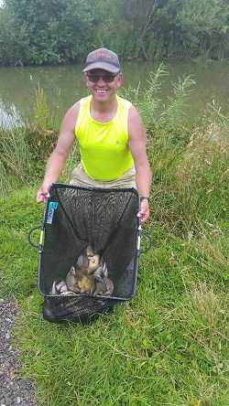
Section C - 1st Alan Hesling 69lb 0oz/ 2nd Phil Topham 64lb 4oz
Alan secured his 2nd section win of the season fishing meat across and catching a mixed net of carp and barbell, he’s at the beginning of a fine run of form which will hopefully take him through to the end of the season – well done Alan you’re now 6th in the league which is pretty good going after a poor start by Alan’s standards. Phil Topham continues a fine run also with a cracking weight of 64lb caught mainly on the tip – Phil is now 4th in the league and you can tell from the steely look on his face he’s got his sights set higher, or is it wind?
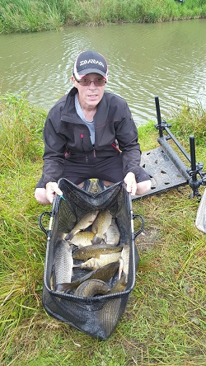
Section D - 1st Phil Zahra 112lb 14oz / 2nd Ian Coleman 72lb 12oz
Phil Zahra drew a flyer – I’m not going to lie, it was an immense peg where dreams are made – the 2 time champ didn’t disappoint though, he fished a cracking match catching shallow on maggot and at 14m on paste to weigh in the highest match weight so far this year of 112lb 14oz – absolutely brilliant fishing, well done Phil, he’s still 1 point clear at the top and is now 1lb ahead on weight – all very close! Second in the section was Ian Coleman with another great weight of 72lb 12oz. Well done guys!! I have included a picture of Phil looking rather sheepish in front of his 'flyer'!
There were 2 big fish caught on the day with Frank Coleman weighing in an 11lb 13oz Mirror only later to be topped by Ian Clarkson’s 12lb 13oz Mirror – nice one guys, there’s only 1 trophy though and big old lanky bollocks Clarkson has got one hand on it!
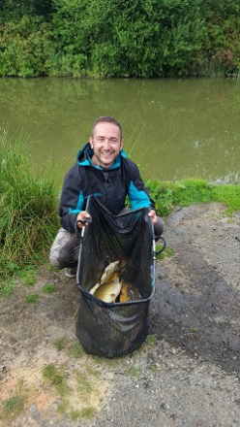
Super pools results:
1st Phil Zahra £30
2nd Pete Boggiano £20
3rd Alan Hesling £10
Venue: HALL LANE FISHERIES - MERLINS
Date: 10.07.16
A decent turnout of 28 anglers turned up for the very fishy looking hall lane (considering at least 4 "I'd die if I couldn't go fishing" members were on holiday). Spirits were high but any hopes of a real bagging up session were dampened when we realised that everyone was cramped up next to each other with only 1 or 2 spare pegs due to the owner putting another 15peg match on the same lake! On top of this we had some very unseasonable weather for the time of year with strong winds and rain forecast for most of the day. The corner pegs were fancied by many and most anglers agreed that these pegs would produce the winning weights.
The table has now been updated to include dropped points as we are half way through the season and is looking very tight at the top!
Section - A - 1st Ady Wood 52lb 6oz / 2nd Phil Zahra 26lb 4oz
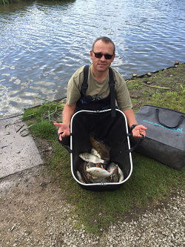
Ady drew peg 1 and instantly knew he was in for a good day. Fishing chopped worm on his top two and on the feeder and meat down the edge he absolutely smashed the section, catching more than double the weight caught by yours truly. This is Ady's 2nd section win of the season and pushes him into 3rd position in the league table showing what a class angler he is!
Section - B - 1st Carl O Brian 46lb 2oz / 2nd Ged Smith 30lb 1oz
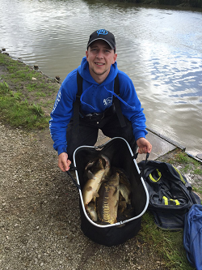
Carl is a new member to the club and already he is beginning to show his experience with his 3rd section win out of 4 matches. Carl braved the wind fishing 16m for most of the day with a 6mm banded pellet feeding 4mm and micros then switching to his method feeder for the last 30mins of the match to bring a very respectful 46lb to the scales. Considering Carl was "boxed in" with an angler either side of him this was a solid performance. 2nd in the section went to another new member this season - Ged; who again is another quality angler and tipped the scales above the 30lb mark and secures himself 5 points which boost him up a couple of places in the league table.
Section C - 1st Alan Hesling 30lb 1oz/ 2nd Eamonn Bolger 29lb 10oz
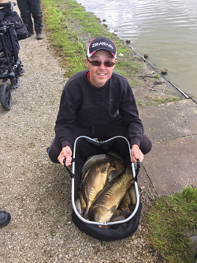
Alan secured his 1st section win of the season finishing top in a very tightly fought section. Feeling boosted after his fantastic recent performance down at Manor FarL leisure, Cob House and Larford Lakes. Alan fished 15meters using meat over micros and corn over meat corn and hemp, down the edge, taking advantage of the empty peg to his right. Eamonn was just pipped into 2nd spot by fat boy slim by a measly 7oz, Eamonn caught down the edge towards the reeds, this is Eamonns 1st frame of the season well done to a really nice chap keep up the good work.
Section D - 1st Phil Topham 55lb 11oz / 2nd Paul Tighe 21lb 14oz
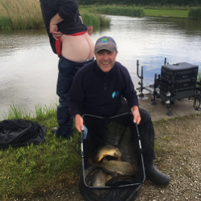
Phil fished from peg 26 in the top corner of the lake to win his section and win the match over all. This is Phil's 1st ever overall win for SMAC and it couldn't of gone to a nicer bloke - super reliable, honest and hard working are just some of his traits Phil brings to our club. On Sunday he also shown what a top angler he can be! Phil fished the method feeder to the edge of the island with pinpoint accuracy using 4mm pellet on the hook with groundbait and micros on the feeder and paste on his top 2 plus 1 straight in front of him to tip the scales to 55lb 11oz. This is his second section win of the season and pushes Phil right up into the top 5 when you take into consideration dropped points another fantastic performance by a fantastic guy. 2nd in the section goes to the'on form' Paul Tighe, this is Paul's 2nd frame on the bounce he's settling into the club nicely now and surely with his quality he will be flying up the table over the 2nd half of the season!
Super pools results:
1st Ady Wood £35
2nd Carl O’Brian £25
3rd Ged Smith £10
Venue: OLD HOUGH – LOWER BENBO, GOOSE AND BOULDERS
Date: 12.06.16
Another good turnout of 31 joined us to be split across 3 lakes offering plenty of room at the pristine Old Hough fisheries. The talk at the draw was everyone hoping for Goose and Boulders but these two lakes fished really hard in comparison with Lower Benbo which fished really well resulting in some cracking winning weights and some really good backup weights also.
Section A – 1st = Tommy Edwards 75lb 5oz / 2nd = Tony Webb 61lb 12oz
Tommy picked up his second section win of the year from end peg 11 fighting off some close competition from Tony Webb. Tommy picked up some decent fish on the method feeder over to some lily pads to tip the scales at a very respectable 75lb 5oz, well done mate!
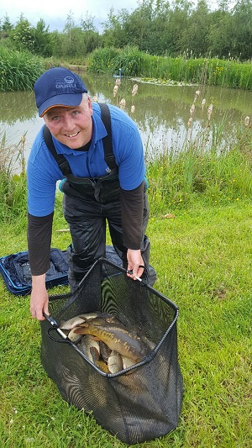
Section B – 1st = Pete Boggiano 81lb 11oz / 2nd = Ady Wood 59lb 10oz
Pete Boggiano picks up his 3rd overall match win of the year with the current highest match weight of 81lb 11oz, most fish were caught shallow on pellet with a few on meat down the edge late on, Ady Woods put in a good performance finishing second with 59lb 10oz, well done!
Note - there is no picture available of the section winner as he was getting too much grief at the weigh in for incorrectly estimating his weight.
Section C – 1st = Phil Zahra 33lb 14oz / 2nd = Bob Chapman & Paul Tighe 30lb 1oz
Phil Zahra continues his fine run of form netting another section win with a mixed net mainly caught on maggot shallow to fend off close competition from both Bob and Paul who came joint second in the Boulders section which fished much harder than anticipated.
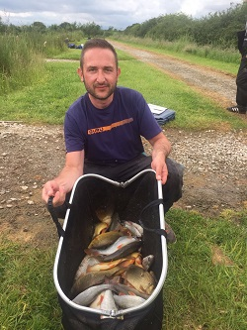
Section D – 1st = Ged Smith 26lb 10oz / 2nd = Derek Wood 22lb 1oz
Ged Smith won the hardest section on the day with just 26lb 10oz from peg 10 on Goose, this is Ged’s second section win of the year which moves him to 7th in the league. Second was Derek Wood from the next peg with 22lb 1oz, well done to both anglers for posting good results from a difficult section.
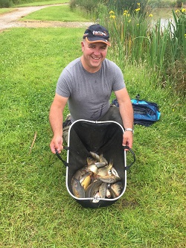
Super pools results:
1st Pete Boggiano £35
2nd Tommy Edwards £25
3rd Tony Webb £10
Venue: CUDMORE - SUEZ
Date: 29.05.16
A massive turnout of 34 anglers joined us at the end of May for the 5th SMAC match of the 2016 season, the weather was glorious with temperatures getting to a Mediterranean level it’s finally feeling a bit like summer, so much so that Tony Webb kept getting his arse out as you’ll see from the pictures below – good job he’d wiped properly that morning!
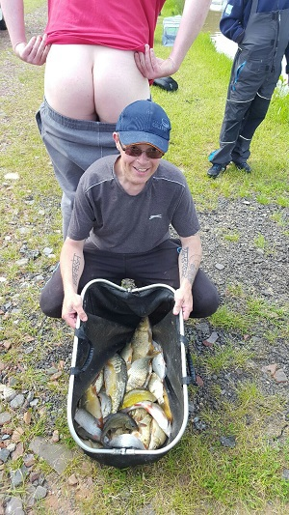
Section A – 1st = Tony Martin 38lb 13oz / 2nd = Derek Wood 38lb 7oz
The best section on the lake was topped by Tony Martin who was pushed very close by Derek Wood for the top spot, Tony picked up some nice fish catching on corn and meat to various far bank features making the most of an end peg, well done Tony, a great section win and overall match win!
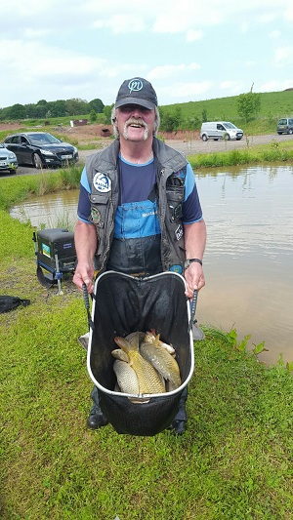
Section B – 1st = Ian Coleman 31lb 8oz / 2nd = Tony Webb 17lb 10oz
Ian Coleman glides into third place in the league thanks to his first section win of the year, Ian’s had a solid start to the season and finally reaps the rewards weighing in a more than respectable 31lb 8oz from an otherwise poorly performing section, well done Ian and well done Tony for the second place; obviously the fish weren’t too afraid of his white arse!
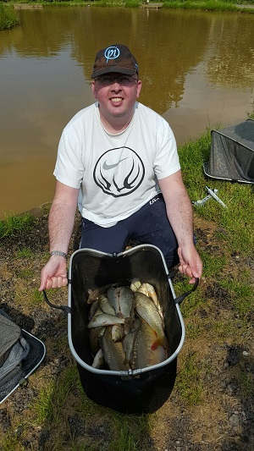
Section C – 1st = Carl O’Brian 29lb 1oz / 2nd = Shaun Gallagher 19lb 9oz
Carl O’Brian has fished 2 matches with SMAC so far this year and has won both sections he’s fished in, Carl made the most of an end peg draw to tip the scales at 29lb 1oz which was again a cracking weight in an underperforming section, well done Carl. Shaun continues a solid start to the season with second place in the section, well done mate.
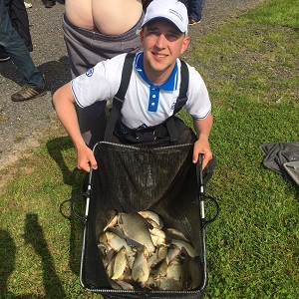
Section D – 1st = Martin Cook 27lb 8oz / 2nd = Phil Zahra 27lb 7oz
Martin Cook won section D by just 1oz pipping Phil Zahra to the top spot fishing long to the far bank on worm and caster. Martin was helped along the way by Phil accidentally throwing 3 fish back which would’ve secured the 6 points, unlucky Phil but well done Martin on your first section win of the year!
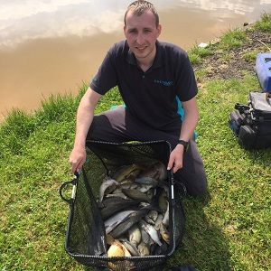
The pairs competition is getting interesting with the top 5 within 100lb of each other, the league is currently topped by Phil Zahra and Phil Topham on a combined total of 266lb closely followed by last year’s champions Pete Boggiano and Daz Gabz on 233lb.
Super pools results:
1st Tony Martin £40
2nd Derek Wood £30
3rd Pete Boggiano £20
Venue: OLD HOUGH – UPPER AND LOWER BENBO
Date: 15.05.16
29 Anglers attended for the SMAC bonus bonanza with recent reports of decent weight coming from the lakes we were hoping for a decent match. The fishing turned out pretty good for the anglers on upper benbo while lower benbo was a struggle for most. A total of £600 was put into the pools and with an additional £80 in the super pools there was plenty on offer and there ended up with 20 people being paid out on the day!! This was a great idea put to us from the members which will be used again in the future if the bonus money gets too high again.
Section A – 1st = Phil Topham 38lb 7oz / 2nd = Ian Coleman 28lb 11oz
Phil Topham fished a cracking match and ended up with the highest weight on Lower Benbo by some margin. Phil fished across to the island for most of the day after starting on the feeder he managed to pick up same decent fish to tip the scales at 38lb 7oz, well done Phil and well done Ian Coleman for coming second.
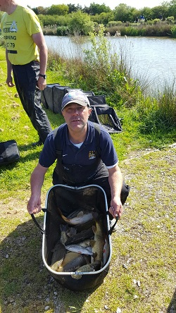
Section B – 1st = Phil Zahra 56lb 09oz / 2nd = Geoff Poole 41lb 0oz
Phil Zahra made the most of a good draw on upper benbo with the overall biggest weight on the day. After struggling for the first part of the match Phil managed to catch a few decent carp shallow pinging 4mm pellets with 6mm on the hook, a solid start to the season keeps Phil at the top of the league after 4 matches, well done Phil. Second in the section was Geoff Poole with a cracking weight of 41lb – well done Geoff.
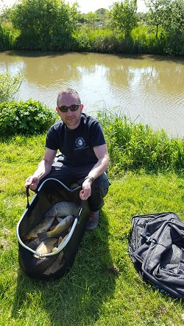
Section C – 1st = Pete Boggiano 25lb 0oz 2nd = Julian Pitlovits 17lb 0oz
Pete Boggiano picked up his 3rd section win on the bounce from the hardest section on the lake with some low weights being recorded, Pete caught mainly on maggot down the track to pip Julian Pitlovits who was at the other end of the lake. Well done chaps.
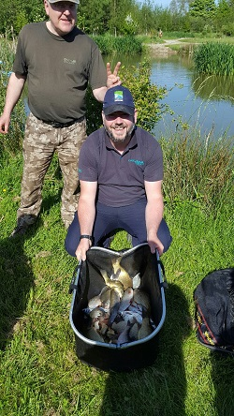
Section D – 1st = Paul Pannett 53lb 11oz / 2nd = Ian Clarkson 35lb 14oz
Paul Pannett picks up his first section win of the year with an impressive display which resulted in the second highest weight on the day, there were some cracking weights in this section but Paul fought off some close competition to pick up the spoils, well done to Ian Clarkson for finishing second also!
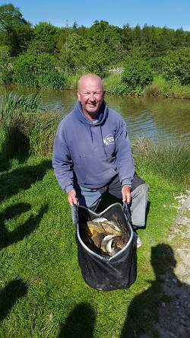
As it was the Bonus Bonanza here's a few other pics of the day:
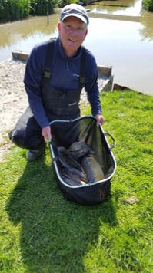
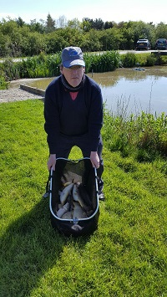
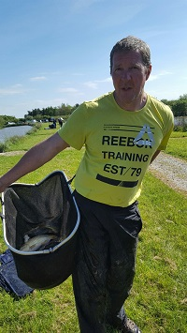
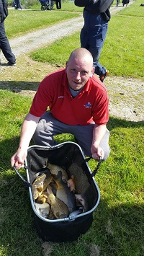
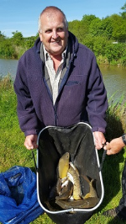
Super pools results:
1st Phil Zahra £40
2nd Geoff Poole £25
3rd Ian Clarkson £15
Venue: FIR TREE FARM – FIR WATER
Date: 01.05.16
Rain, rain, rain, ‘twas a wet old day up Wigan way, where a reduced field of 22 Anglers turned out for the 3rd match of the 2016 season. A large portion of members were down in sunny white acres getting a sun tan while us unfortunate ones we’re getting soaked to the bone! It turned out to be a tough old day fishing wise with a couple of really poor sections struggling to break into double figures – in other words this match was not really one to remember!
Section A – 1st = Tony Martin 23lb 1oz / 2nd = Shaun Gallagher 10lb 1oz
Tony Martin picked up his first section win of the year for the most difficult section of the lake with a respectable weight of 23lb 1oz made up of mainly carp with a couple of sizeable lumps in there to boost his weight, I really didn’t think there were fish this big in the lake so well done Tony! Well done also to Shaun who came second in the section even after a slight altercation with the EA bailiff who attempted to ruin his day.
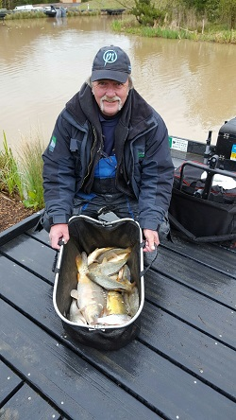
Section B – 1st = Pete Boggiano 41lb 12oz / 2nd = Steve Tomo 33lb 12oz
Pete Boggiano picked up his second section win on the bounce along with his second overall match win on the bounce with a net of mainly silvers caught on maggot short backed up with a few pellet carp for 41lb 12oz weight, Steve Thomason came second with another mixed bag mainly caught on corn and double corn. Well done chaps.
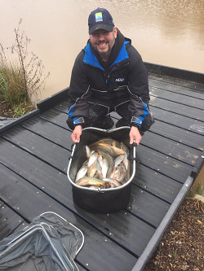
Section C – 1st = Carl O’Brian 20lb 0oz 2nd = Mick Abdy 16lb 12oz
New Member Carl O’Brian had a disaster halfway through the match as his 13m section of his new pole snapped for no apparent reason – he did however manage to go on and win the section with a mixed net of fish to beat second placed Mick Abdy to the top spot – well done Carl and welcome to the club!
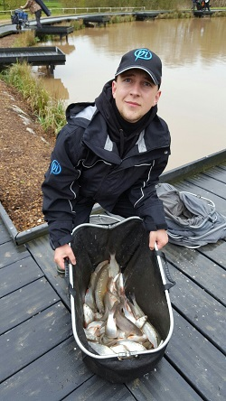
Section D – 1st = Phil Zahra 33lb 14oz / 2nd = Chris Gabz 19lb 1oz
Another poor section was topped by Phil Zahra who netted a tidy 33lb 14oz of carp caught on pellet to the island – Phil now moves into top spot in the league on joint points with Chris Gabz who co-incidentally finished second in this section – both anglers have had great starts to the year only dropping 2 points each from the first 3 matches
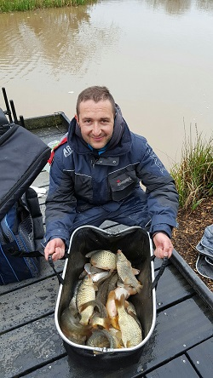
Super pools results:
1st Pete Boggiano £35
2nd Phil Zahra £25
3rd Tony Webb £10
Venue: BORDER FISHERIES – MATCH LAKE
Date: 17.04.16
An overnight frost and temperatures close to zero at the draw were dampening hopes for good weights as 29 turned out for the second match of the 2016 season at the pristine Match lake on the Border fisheries complex. It’s worth noting that when you look through the weekly angling times there are only 1 or 2 open matches with more anglers attending than our South Manchester club matches which is credit to our committed members for turning up every match, thanks guys!
Special mention this week goes to Stu Ford who bagged 39lb from peg 17 which was really unlucky not to frame in this section but Stu came 3rd overall on the match – well done Stu……
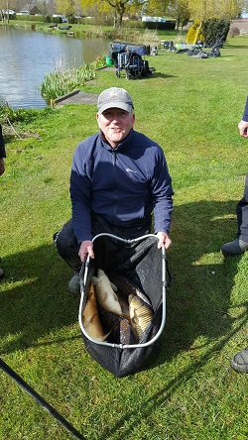
Section A – 1st = Adrian Woods 24lb 10oz / 2nd = Ian Clarkson 15lb 10oz
Adrian Woods worked hard for his 24lb in a difficult section, fishing shallow maggot for most of the match Adrian picked off small roach to win the section by a comfortable distance from Ian Clarkson, well done Adrian, a good couple of matches puts you top of the league as we head into May! The picture below is from a different match – our cameraman had a lazy day!
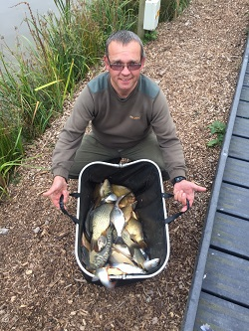
Section B – 1st = Pete Boggiano 53lb 6oz / 2nd = Stu Brown 42lb 3oz
Pete Boggiano had to watch Stu Brown picking up fish on the pellet feeder for the first 4 hours of the match. Stu was well in front at this point as Pete had only 3 pellet waggler carp to show for 4 hours effort. Pete managed to turn things round with some lumps caught down the side in the last 2 hours to edge in front of Stu and pip him at the post! Stu did stage a fightback in the closing stages landing a 10lb 8oz mirror carp on white hydro to put in his bid for the biggest fish award
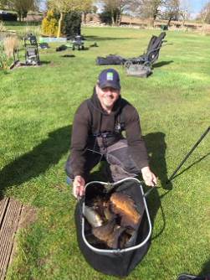
Section C – 1st = Tommy Edwards 28lb 11oz 2nd = Chris Gabz 22lb 6oz
Tommy and Chris switched places from the last match and fought a good battle from adjoining pegs. Tommy came out victorious this time fishing pellet at 13m and on his top 4 along with a couple of fish on meat down the edge. Tommy was on one of 6 bonus pegs and was unfortunate not to pick up the £200, unlucky mate but well done on the section win. 2 good performances for Tommy and Chirs put the joint top of the league on points with Adrian Woods, good start guys! Tommy’s picture below is also from a different match – we need a new cameraman!
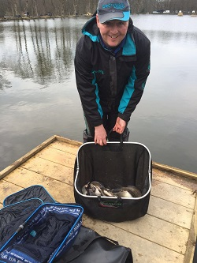
Section D – 1st = Danny Morriss 9lb 9oz / 2nd = Ian Coleman 9lb 1oz
Section D was by far the worst area of the lake with the wind blowing in the wrong direction it was always going to be a struggle. Danny Morriss stopped messing about like he usually does and managed to win the section with a measly 9lb 9oz with Ian Coleman only 10 Gudgeon behind!! Well done for persevering everyone in the section weighed in at least! Danny's picture is also from another match - there is obviously more than 9lb in this net!
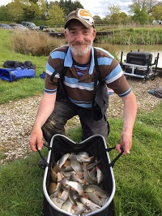
Super pools results:
1st Pete Boggiano £30
2nd Stu Brown £20
3rd Tommy Edwards £10
Venue: BRADSHAW HALL FISHERIES – LAKE 4 AND 6
Date: 03.04.16
Welcome to the first report of the 2016 season and Welcome to any new members reading this, you are all very welcome at South Manchester Match Group. Before we get into the report a special mention must go to Martin Keenan who’s new to the club for 2016 and fished his first ever match and managed a really good weight of 23lb 1oz and 3rd in his section, nice one Martin, well done!
Weights have apparently been up and down recently at Bradshaws so no-one really knew what to expect but it turned out to be a reasonable days fishing for most and a very good days fishing for some! Thanks to everyone for attending and getting there on time and we hope this is to be the start of a very good season!
Section A – 1st = Phil Zahra 45lb 8oz / 2nd = Adrian Woods 39lb 2oz
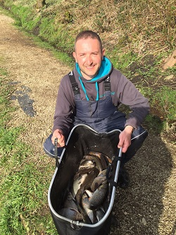
Section A was fished on Lake 6, the winner and second place coming from the fancied ‘inlet’ side of the lake with the rest of the lake struggling to get anything consistent Phil Zahra and Adrian Woods capitalised on this situation putting together nice nets of shallow caught chub, last year’s runner up Phil outweighing Adrian by just over 6lb to pick up the top prize for the section, well done Phil.
Section B – 1st = Ged Smith 62lb 5oz / 2nd = Daz Gabz 35lb 15oz
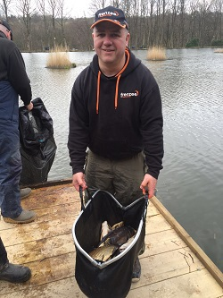
Ged Smith annihilated section B with a fine net of pellet waggler caught carp, most people in the section attempted to follow suit but it was too little too late as Ged topped the section even though he lost all his pellet wagglers and had to leg it to the shop to buy some more! Well done to Daz Gabz for coming second but it wasn’t enough to prevent Ged from winning the section with the overall highest weight on the day – this also secures the Billy Barker memorial trophy for Ged for winning the first match of the season
Section C – 1st = Chris Gabz 38lb 2oz / 2nd = Tommy Edwards 24lb 8oz
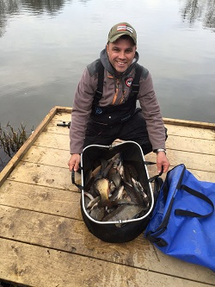
The causeway part of this section actually fished much better than expected with the top 2 in the section being pegged on here, it was Chris Gabz who took the spoils however with a nice mixed net giving a respectable 38lb 2oz weight, well done Chris and well done to new member Tommy Edwards finishing second with another decent mixed bag.
Section D – 1st = Derek Wood 46lb 2oz / 2nd = Tony Martin 25lb 1oz
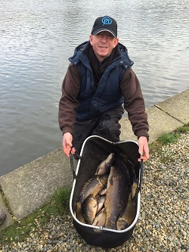
Derek wood’s class shines through again as he gets off to a flying start for the 2016 season weighing in a cracking 46lb 2oz from a really hard section which was unexpected as these pegs usually produce the goods, Tony Martin managed second place but was 21lb short of Derek’s net, well done Derek.
Super pools results:
1st Ged Smith £35
2nd Derek Wood £25
3rd Phil Zahra £15

