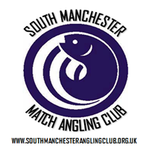
MATCH REPORTS 2017
Venue: MOSS FARM FISHERY – LILLIES AND MADDESONS
Date: 29.10.17
The final match of the 2017 summer season took us to Moss Farm fisheries on a bright autumnal day 29 SMAC regulars turned up for a hearty breakfast and some bit bashing with the average stamp of fish much smaller than were used too – them one or two bonus fish would be all important at the weigh in.
Before I get into the match report I would like to say a huge congratulations to Carl O’Brien who’s won the individual league. Carl joined the club last year and, in a nutshell is one of the best anglers to have fished for SMAC, he’s got a great range of skills in his armoury which enables him to make the most of every peg he draws. Carl has had an impressive 7 section wins at an average of 4.67 points per match and has weighed in 786lb of fish at an average of 52lb per match which is testament to his abilities. On top of this, he’s fished every match and has shown commitment to the club, helping out with pegging out and other duties when called upon, thanks mate! Well done buddy from all the members, a well-deserved league title for a really nice guy!

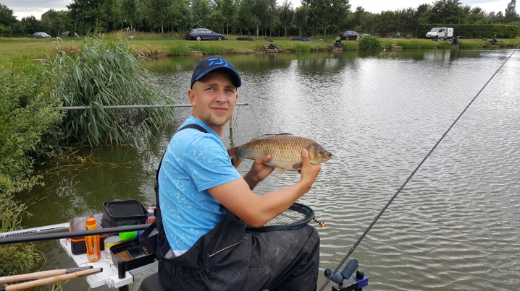
Section A – 1st = Tommy Edwards 18lb 10oz / 2nd = Ian Clarkson 18lb 5oz

Some very low weights in section A from Lillies resulting in a very close result – the top 4 in the section separated by only 1lb – this was probably about 100 fish though! Well done to Tommy Edwards for picking up his 3rd section win of the year which just about nudges him into the top half of the league and actually resulted in a rare smile from Tommy! Well done also to Ian Clarkson who ended a really poor run of results with his second in section.

Section B – 1st = Mick Abdy 27lb 12oz / 2nd = Joe Zahra 13lb 5oz

Mick Abdy made the most of an end peg picking up some decent fish on the small method feeder as well as some long pole caught stockies, this is Micks first section win of the year and also a lake win to boot, well done Mick a great finish to a difficult season! Well done to Joe Zahra also who joined the club a bit late in the season but has had some decent results.

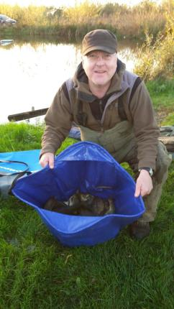

Section C – 1st = Dave Coleman 45lb 15oz / 2nd = Martin Cook 31lb 8oz

A massive well done to Dave Coleman on winning section C [his first section win this year] which puts him 2 places above his brother Ian in the league – what an embarrassment this must be for Ian! Dave fished a great match to weigh in a relatively huge weight for the venue which closes off his great season in style – the highlight of which must be making a right balls up in the pairs final to cost Phil Zahra the title for the third time hahahaha! Martin also fished a good match to pick up second in section.

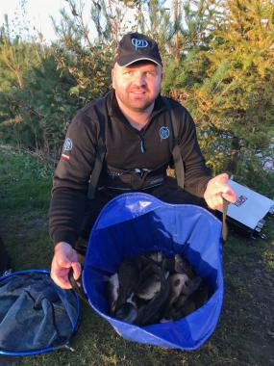

Section D – 1st = Tony Webb 62lb 6oz / 2nd = Jason Suggett 28lb 5oz

Venue regular Tony Webb weighed in the biggest weight by some way on a well performing section on Maddesons. Tony has had a great season and has the highest average points score in the league of 4.91, after missing some early matches Tony was unable to challenge for the title but will be one to watch for next year. Jason Drew yet another flyer to finish second in the section to end a really good first year with SMAC.

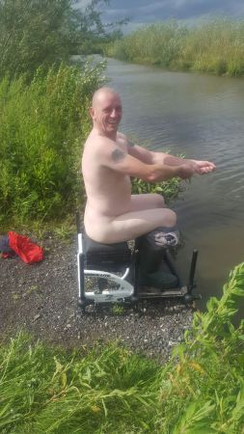

Well, that’s it from me for another year, it’s been a cracking season with plenty of laughs and memories, thanks to every member for making this club what it is, next year will be amazing and I’m looking forward to it already. Hopefully you’ve enjoyed the reports and website. Thanks. Pete

Below is the match secretary's report written by our very hard working match secretary Phil Zahra - thanks for runiing a cracking season Phil!

MATCH SECRETARY'S REPORT 2017

Well guys that’s the 2017 summer season all wrapped up, and what a season it’s been I’m sure you’ll all agree, looking back over the season I’m truly amazed at the statistics! when you compare it to previous years not only have we had much more space on venues we’ve had a massive improvement in members average weight per match which just goes to show that increasing the number of pegs we fish makes a huge difference, I’ve literally lost count on how many 100lb+ bags we’ve had this year and the amount of times someone hasn’t even been in the top 3 in their section with a 40-50lb bags.

This really is an amazing match fishing club our popularly just keeps growing other clubs seem to be losing anglers who turn to open matches for competition but I say no way to that we are bigger than most open matches, And it’s true! when I call a venue to book a match the fishery owners can’t believe how many pegs I’m booking, which brings me on to talk about next year what can you expect? Well all will be revealed at the presentation meeting on November 17th but I can tell you that we have even bigger venues, more pegs and all the other usual fantastic fun that makes us without a doubt the best match fishing club in the north west

I’d like to thank my fellow steering group members each and everyone plays a crucial part in the running of the club and we really do work hard putting ideas together to improve the general running and up keeping, on top of this we maintain our website, maintain our equipment, keep records and track club funds and work tirelessly taking bookings and pegging out.

Finally good luck to everyone fishing the winter league and I will see you all at the meeting

Tight lines

Phil Zahra

Venue: HAMPTON SPRINGS FISHERY – MEADOW & ROCK POOL

Date: 15.10.17

The penultimate match of the 2017 season took us to Hampton Springs for the second time this year – 29 anglers hoping the fishing was better than our last visit, the weather certainly was with unseasonal high temperatures making for an extremely pleasant days fishing. The fishing was actually pretty good for most with the better weights coming from Rock pool but Meadow was pretty consistent which made for a good tight match!

The last leg of the pairs final was fished with Dave Coleman taking a 37lb lead it looked like it could be a bridge too far for Jason Suggett to catch him, unfortunately for Dave Jason fished like a man possessed and pitched in with enough to clinch the title for himself a Dave Bennett – both members in their first year picking up the pairs trophy is no mean feat! Well done guys and thanks to everyone who entered, it’s a cracking competition and gets better and better every year!

Mick Abdy gets a special mention after a foul hooked carp broke his top kit and took it halfway across the lake – at the end of the match Mick got stripped down to his brown Y-fronts and went for a swim to go and get it – really Mick, you are probably the whitest human being I’ve ever seen – we need to book you a few sessions at Tanneriffe or Tantastic – which ever you prefer!!

Section A – 1st = Tony Webb 93lb 5oz / 2nd = Stu Ford 72lb 4oz
Tony Webb takes a bit of stick on these reports but it turns out he’s a really nice guy – he helped me out today so I’ll be nice to him – just like he was nice to Daz by sticking his finger up his bum when receiving a taste of his own medicine at photo time. Tony fished a top match catching some huge lumps down the edge to weigh in the days highest weight of 93lb 5oz – well done Tony, you’re the best. Second place was picked up by Stu Ford who’s fishing amazingly at the moment – this is his highest ever match weight beating his previous best which was only 2 weeks ago! Well done Stuart – top effort.

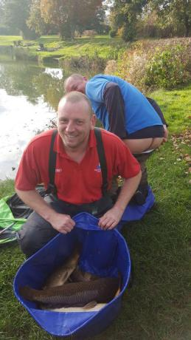

Section B – 1st = Jason Suggett 65lb 12oz / 2nd = Rodger Dimmock 31lb 2oz

Jason had the eye of the tiger today knowing he had to put in a beast of a performance to win the pairs he fished a cracking match on the method feeder between 2 islands on Rock Pool – this is Jay’s second section win of the year and he secures himself a top half finish which is really good for a new member – well done dude! Second place was Rodger Dimmock who’s in the money for the second match running! Well done Rodge!

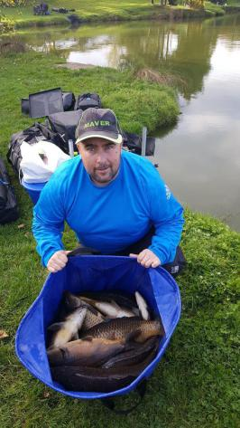

Section C – 1st = Phil Zahra 34lb 3oz / 2nd = Ian Coleman 24lb 11oz

The weights were a little lower on Meadow pool and Phil Zahra managed to win section C by a comfortable margin with 4 carp and a few silvers – Phil used his trusty paste method to net the 4 carp which pipped Ian Coleman to the top of the section, well done to both anglers – this puts Ian 2 points in front of brother Dave with only 1 match to go – will he save the embarrassment? I really hope not hahaha. Unfortunately the cameraman covering this lake forgot to photograph Phil Zahra so there is no picture available, whoops!

Section D – 1st = Steve Tomo 48lb 12oz / 2nd = Ged Smith 39lb 8oz

Steve Tomo tipped in the best weight overall on Meadow Pool which guarantees him the runner up trophy for 2017 – what a cracking season Steve has had – not as many outright section wins as some but proper consistent throughout the year resulting in a healthy average of 4.71 points per match – well done Tomo really please for you! Second place was taken by Ged Smith who’s also had a decent year and is looking at a top 10 finish. Well done mate!

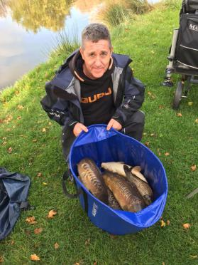

Venue: OLD HOUGH FISHERY – BIG MAX AND UPPER BENBO

Date: 03.10.17

Match 13 took us to Old Hough with the match being split over Big Max and Upper Benbo the better weights were expected off Upper but the majority of anglers fancied a crack at Big Max as there was more variety of methods able to be used. It turns out both lakes fished really well with an overall average of 45lb per angler making it a very successful match!

The final of the pairs match has been split into 2 separate matches due to angler availability – Phil Zahra and Dave Bennett fished off in this match with Phil putting his team around 37lb ahead which leaves Jason Suggett a lot to do when he fishes off against Dave Coleman at the next match! Good luck guys.

Section A – 1st = Phil Zahra 98lb 14oz / 2nd = Ged Smith 63lb 0oz

Phil Zahra makes it 6 section wins for the year with another stellar performance from the car park side of Upper Benbo, this keeps Phil in contention for the runners up trophy with the title all but secured for Carl. Second in the section was Ged Smith who now moves in to the top 10 with another solid performance – well done guys two great weights.

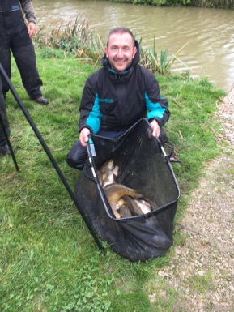
Section B – 1st = Steve Thomason 54lb 15oz / 2nd = Joe Zahra 48lb 6oz

Strangely enough section B is a carbon copy of section B result from hall lane with Steve Tomo topping the section and Joe Zahra coming second – two really good performances from Steve over the last two matches have given him the best opportunity to pick up the runners up trophy and new member Joe Zahra shows he’s got what it takes to get in the money – nice work guys!

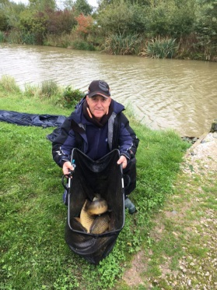
Section C – 1st = Phil Topham 88lb 0oz / 2nd = Tony Webb 62lb 7oz

Phil Topham fished a cracking match from peg 17 on Big Max fishing his favourite feeder method and some good margin work resulted in Phil’s second section win on the bounce which will hopefully spur him on to end the season in style after a difficult year by his high standards. Second in the section was picked up by the club jester Tony Webb, well done bell end.

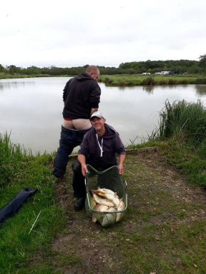
Section D – 1st = Stu Ford 71lb 9oz / 2nd = Chris Gabz 59lb 9oz

Stu Ford, Mr Potato man picks up his first section win of the year…. What a guy!! Stu fished a great match hammering the margins on his favourite paste method to win the section handsomely – nice 1 Stu, a cracking result for a proper nice chap! Chris Gabz also fished a great match to pick up second place – well done dude!

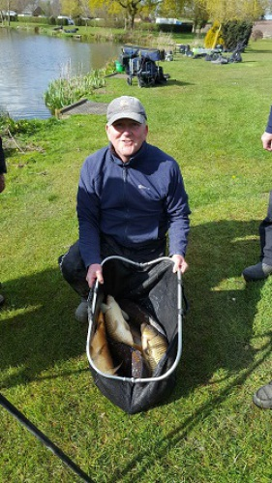

Venue: HALL LANE FISHERIES – BESS’S

Date: 17.09.17

After a poor match at border everyone was looking forward to netting a few fish at the popular Hall lane fisheries – the final leg of the Pairs semi-final was fished and the anglers qualifying for the final were Phil Zahra and Dave Coleman and Jason Suggett and Dave Bennett – 3 new members making it to the final which is great news – well done to them.
The fishing turned out to be pretty patchy throughout with the better weights coming from the late 20’s where the wind was blowing – a reasonable average weight across the venue of just over 35lb made it the 5th best match of the year and also relieved the match secretary from getting too much grief after some poor recent matches!

Section A Upper – 1st = Paul Tighe 34lb 15oz / 2nd = Dave Coleman 26lb 12oz

Paul Tighe marches on having a fantastic season picking up his 4th section win which now pushes him into 7th place in the league which is a cracking performance after being 33rd after 4 matches – nice one Paul – next year you’ll be pushing for the title!! Dave Coleman also turned in a positive performance with a pairs final place at stake finishing second in the section – this result pushes him 1 point in front of brother Ian – oh my God imagine that, Dave not been fishing for years in front of Ian who spends hours preparing for every match and has years more experience!! I’ve got some golf clubs for sale Ian if you are interested!

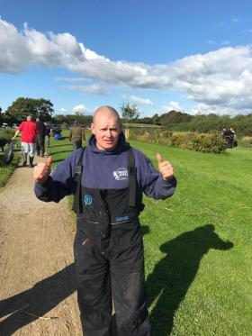
Section B – 1st = Steve Thomason 73lb 10oz / 2nd = Joe Zahra 45lb 3oz

Steve Tomo is now 1 point clear in second place and is showing testament to consistency being the key to success – Steve has only won 2 sections all year but has put in solid performances throughout which justifies his league position – well done so far Steve, let see if you have what it takes to secure the runner up trophy! Well done to new member Jow Zahra with a great performance weighing in 45lb.

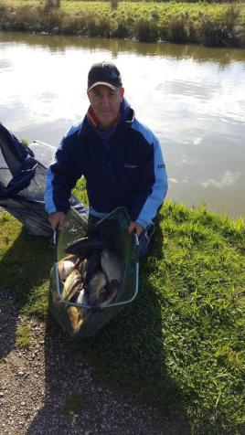
Section C – 1st = Carl O’Brien 77lb 1oz / 2nd = Jason Suggett 70lb 1oz

Carl O’Brien now has one hand on the league trophy needing only 4 points from the last 3 matches to be mathematically secure the league – the way he’s fishing he’ll have it in the bag at the next match – Carl picked up his 7th section win of the year which is pretty amazing if you ask me [former champion hehehe] Jason fished a cracking match to finish a close second in the section with just over 70lb which also secured his place in the pairs final – well done guys

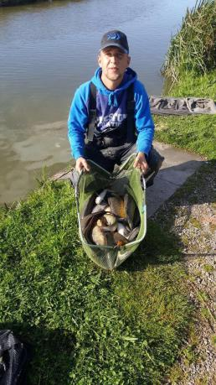
Section D – 1st = Adrian Woods 67lb 12oz / 2nd = Dave Bennett 54lb 4oz

Adrian moves up to joint 3rd in the league with his 4th section win of the year from end peg 63 Ady made good use of the water available to him to win the section comfortably. Second was Dave Bennett who’s pushed himself into 6th in the league with another solid performance – he’s also made the final of the pairs match which is a cracking achievement in his first year at SMAC – well done mate!

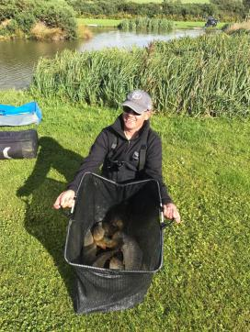

Venue: BORDER FISHERIES – MERIDIAN CANAL

Date: 03.09.17

Hopes weren’t high for match 11 as recent weights on the meridian canal were looking terrible, we were expecting a tough match and got one with only 9 out of 33 anglers weighing in double figures on a very autumnal day resulting in possibly the worst SMAC match of all time! The first leg of the semi-final was fished however I doubt very much so that any of the weights posted will go towards the final tally which means it’s all to play for at Hall Lane for a place in the final.

Section A Upper – 1st = Tommy Edwards 11lb 14oz / 2nd = Carl O’Brien 9lb 10oz

The lowest section winning weight on the day [and probably of all time] came from the lower number where Tommy Edwards managed to winkle out 11lb 14oz followed closely by Carl O’Brien with 9lb 10oz – 2 fish, 1 bite – not good…. Tommy is pictured below letting his feelings be known to all about the days fishing he’d had!

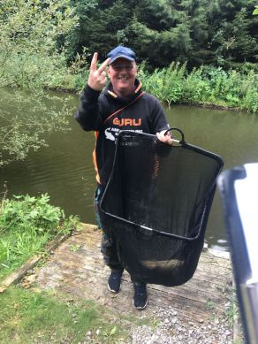

Section B – 1st = Tony Webb 34lb 12oz / 2nd = Keith Thorne 8lb 13oz

Section B was won by Tony Webb from peg 33, Tony asked me to stop referring to him as Bell End however that won’t be possible until he stops being one, sorry Bell End! Haha, Tony actually fished a really good match to weigh in the second best weight of the match - nice one mate :-) second in the section was Keith Thorne with 8lb 13oz well done to both anglers for sticking it out.

Section C – 1st = Phil Topham 21lb 4oz / 2nd = Adrian Wood 20lb 1oz

Phil Topham took the spoils from section C with 21lb 4oz narrowly edging out Ady Woods who had 20lb 10oz – very close indeed! Well done to Phil for picking up his first section win of the year which has been a bit of a struggle for last year’s pair’s finalist – hopefully a strong finish to the year will boost him up the league a bit.

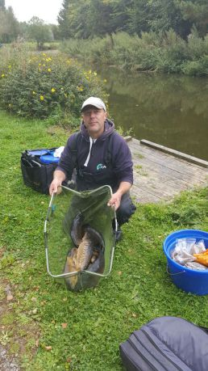

Section D – 1st = Paul Tighe 44lb 3oz / 2nd = Paul Pannett 16lb 15oz

Section D was a little more highly populated as the scum on the water looked like it could hold some fish which proved to be correct as the day’s biggest weight came from peg 57 which was occupied by Paul Tighe – this is Pauls first ever overall match win with SMAC and continues his fine season – this is his third section win of the year and moves him to the handsome position of 9th in the league – nice 1 Paul, well done. Second in the section was Paul Pannett from peg 54 with almost 17lb – a huge weight on the day haha!

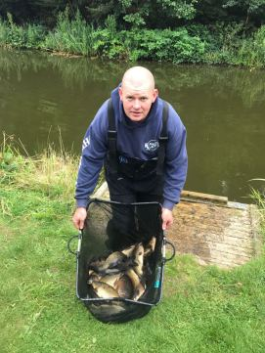

Thanks to everyone who turned up a stuck it out – we try to book the best matches possible for the club and every now and then we get let down, it’s inevitable it’ll happen throughout the course of a year but it’s no fun for anyone when it does!

Let’s all bag up at Hall Lane and forget about this one!

Venue: OLD HOUGH FISHERY – UPPER AND LOWER BENBO

Date: 20.08.17

Hopes were high for the 10th match of the SMAC 2017 calander as some cracking weights had been recorded in the preceding weeks at old hough, as always the top side of upper benbo was expected to produce the best sport however it became the section of doom as several of the top placed anglers drew on some out and out flyers!
As this was the 10th match it was the last chance to post a weight towards the pair’s competition prior to the knock out stages and there was a real change in the leader board after some big weights were produced, well done to the 4 pairs who have qualified for the semi-final who are listed below:

- David and Goliath… aka Dave Coleman and Phil Zahra
- Caster master and Maver salesman… aka Dave Bennett and Jason Suggett
- Beauty and the Beast… aka Pete Boggiano and Mick Abdy
- Poser Boy and his accomplice… aka Carl O’Brien and Mike Crowther

Well done to everyone who had a crack at entering and well done to the 4 semi-finalists – they will now have 2 matches to post 1 weight each towards their combined total; the top 2 pairs will then go through to the grand finale!

Section A Upper – 1st = Phil Zahra 131lb 12oz / 2nd = Carl O’Brien 118lb 3oz
Sections 4-10 on Phil Zahra’s pole remain untouched as we enter the final 3rd of the season but who needs them when you can nail 131lb under your feet! A top day’s fishing for Phil off peg 2 on upper resulted in his 5th section win of the year after a close battle with current league leader on peg 1. Phil is now second in the league and is in a good position to be challenging for his 4th title although Carl isn’t giving up. Well done to both anglers on a cracking battle of the flyers!

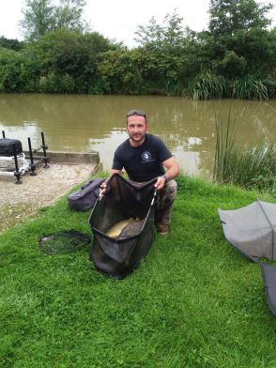
Section B – 1st = Tony Webb 69lb 1oz / 2nd = Adrian Wood 64lb 10oz

We all know Tony is a bit of a bell end and it was fun for all of us to see him struggling with the far bank vegetation, he hooked into the rushes so many times Dave Coleman on the next peg thought he was collecting parts for a Christmas tree! Well done to Tony for carrying on after losing numerous hook lengths and rigs to win the section with 69lb. congrats also to Ady with a good weight from end peg 24.

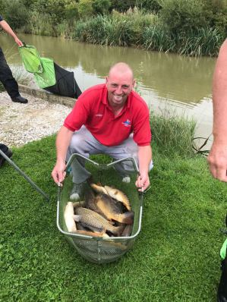
Section C – 1st = Pete Boggiano 56lb 5oz / 2nd = Dave Bennett 50lb 10oz

Pete Boggiano is back to his best after properly cocking up the last 2 matches, he remains the best looking guy in the club and has got a huge dong. Dave Bennett came second in the section with an amazing haul of silvers caught at 14.5m shallow on maggot. Well done guys!

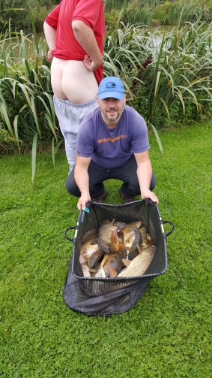
Section D – 1st = Shaun Gallagher 108lb 7oz / 2nd = Steve Tomo 51lb 6oz

Without a doubt the best performance of the day award goes to Shaun Gallagher with an unreal performance from what is usually the worst section on these lakes, Shaun fished a cracking match netting carp from the all in to weigh in his best ever SMAC match weight [possible his best ever match weight TBC] of 108lb 7oz. what an unbelievable performance, really made up for you Shaun, well done. Steve Tomo continues his fine season with his 4th section second of the year, nice one mate!

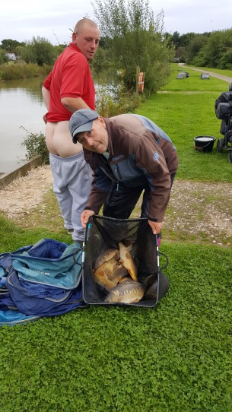
The average weights were 52lb which makes this the second best match of the year and so below are some extra pics for you to enjoy!

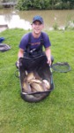
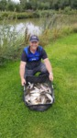
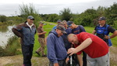
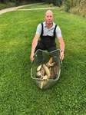
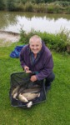
Venue: HAMPTON SPRINGS - LONG ISLAND

Date: 06.08.17

Apologies for the delay again in getting the report uploaded – the match reporter has got a new job and is finding it difficult to spend 7 hours a day skiving rather than working!!
Match 9 took us to a brand new venue for the club at Hampton springs on long island lake and we managed to secure oasis lake also as the ‘long island’ was no longer accessible!

Reports from a couple of guys that went for a practice were reasonably positive so hopes were high….. hmmmmm Pete Boggiano won’t agree with this after having a disaster of a day only catching 2 fish which for an angler of his spectacular ability is not a laughing matter – everyone else thought it was hilarious however!

Pete Boggiano showing even the best anglers in the world can f*ck it up sometimes
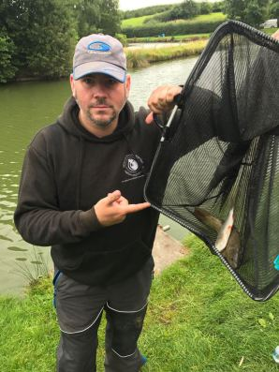

There is one match to go to qualify for the semi-final of the pairs competition with the top 4 going through it’s going right down to the wire – I reckon anyone out of the top 7 or 8 could steal a place with a decent combined weight at old hough! Who’s got the bottle to do it!!!!

Section A – 1st = Steve Tomo 41lb 7oz / 2nd = Ged Smith 35lb 11oz

Steve Tomo made use of some local knowledge fishing mushed pellets down the edge to weigh in a section winning weight – only his second section win of the year but it boosts him to joint second in the league – nice one Tomo; solid consistent performing. Second was Ged Smith with 35lb who also deserves a well done from a difficult area.

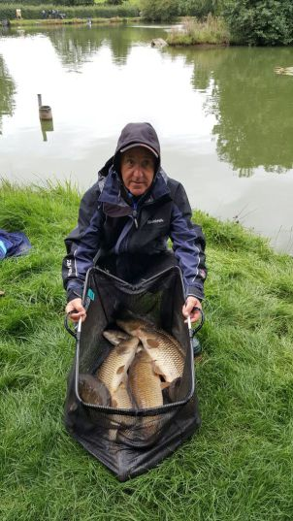

Section B – 1st = Jason Suggett 51lb 14oz / 2nd = Keith Standing 24lb 3oz

Jason Suggett made good use of a nice peg weighing in the best weight on the lake giving him his first section win of the year – this boosts him from 28th to 21st in the league! Nice one mate. Second was taken by Keith Standing who’s been out of action for a while – welcome back shaggy!!

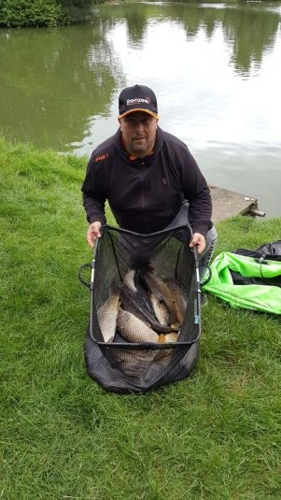

Section C – 1st = Phil Zahra 41lb 4oz / 2nd = Adrian Wood 34lb 9oz

Phil Zahra continues a nice run of form rescuing his season and is now joint second in the league after fighting off some proper competition in the section of doom with the league leader Carl o Brien having a shocker! Second was taken by Ady Woods who focussed on the silvers for a nice net of fish and another solid performance. Well done guys.

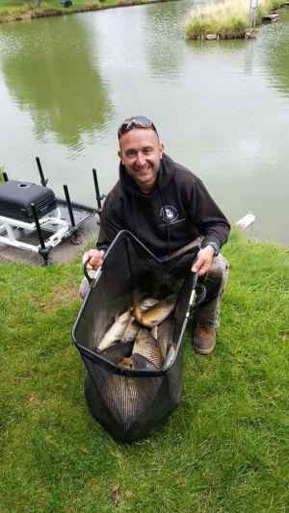

Section D – 1st = Dave Bennett 78lb 1oz / 2nd = Martin Cook 29lb 3oz

Dave Bennett annihilated section D on oasis lake and took home the spoils for the match win with a cracking net of fish mainly caught on maggot down the track – top performance Dave, well done! Second was taken by Martin Cook with 29lb from the next peg.

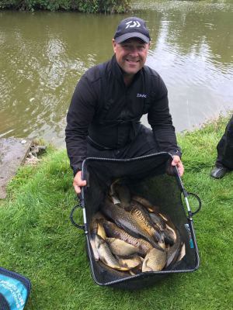
Venue: LINDHOLME LAKES - WILLOWS

Date: 23.07.17

Before the match report begins I’d just like to point out that dropped points and dropped weights have now been included in the individual league and also the pairs league – below is a brief description of how this works for the guys that may be a bit unsure:

Individual league – the anglers worst 2 points scores have been deducted from their total along with the weight of fish associated with these worst 2 scores – this will be adjusted throughout the remainder of the season if necessary.

Pairs league – the worst 2 weights of each angler have been deducted from the total weights – this again will be adjusted if necessary. There are only 2 matches remaining for everyone in the pairs competition to try to get into the top 4 to be included in the semi-final which will consist of each angler in the top 4 pairs posting one weight from matches 11 and 12 to make it to the final which will be fished on either match 13,14 or 15 – good luck to everyone involved it’s looking pretty tight at the top!!
Hopefully the above makes complete sense but if anyone has any questions please let me know!

Our outing this week took us on the longest journey of the season to Lindholme lakes – breakfast was provided by SMAC which we all enjoyed and appreciate! A few of the guys headed down to the fishery the day prior to our match to get a feel for the water and reports were that it wasn’t fishing brilliant with 50lb winning the mini knock up and only 30lb winning another club match on the lake…… not too promising! There were areas which really fished hard on the day of the match but some reasonable weights were produced from some areas resulting in an average weight of around 28lb – not too bad although some of the guys would disagree with Stu Ford only managing 1 fish all day, he did however win the bonus prize of a Garbolino feeder rod which was very kindly donated by the guys at Lindholme and put to one side by the SMAC master of payments for the angler finishing last on the day – unlucky Stu but every cloud has a silver lining eh!! Every cloud unfortunatley doesn't have a silver lining for Ian Coleman after breaking his number 4 section trying to hoist out a beast he went onto break his power kit about 30 seconds later - oh dear!

Section A – 1st = Phil Zahra 53lb 5oz / 2nd = Tony Webb 48lb 5oz

Phil Zahra picked up his second section win on the bounce from peg 52 in the basin – Phil thought he had nowhere near this weight after having to chop and change between 9 different lines throughout the day – Phil Thought Tony had the section well in the bag from flyer peg 2 but it turns out Phil just had enough to win the section – well done mate this boosts you up to 4th in the league after a shocking first 3rd of the season by your standards. Well done to Tony Webb on second but in reality he should of hammered it from that peg, what a bell end!

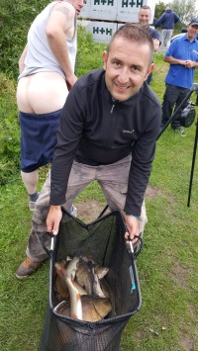
Section B – 1st = Carl O’Brien 70lb 10oz / 2nd = Dave Coleman 34lb 12oz

Carl has now really opened up the gap at the top of the league to 3 points after another exquisite display from the man in form – Carl fished shallow shprt for the first part of the match and was on for a really big weight but the rain put an end to that – he then had to spend the rest of the match scratching around to keep bites coming – not to worry though he’d done enough to double second the second place weight and picks up his 6th section win of the year. Well done to Dave Coleman who is beginning to show us he’s probably the best angling Coleman there is – Ian is just bobbins hahaha!!!

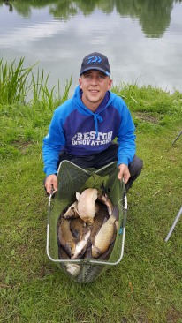
Section C – 1st = Stu Brown 47lb 0oz / 2nd = Adrian Wood 38lb 15oz

Stu Brown used the knowledge he had gleaned from the previous days match to pick up the 6 points from section C. Stu had a great start to the year with a section win at the first match but has really struggled since so it’s nice to see him back to the top, well done mate. Ady also had a reasonable days fishing finishing second in the section, well done Ady!

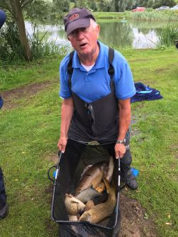
Section D – 1st = Paul Tighe 55lb 12oz / 2nd = Steve Tomo 51lb 2oz

Probably the best performing section on the day was won by the man on fire at the moment Paul Tighe – with 2 section seconds and 2 section wins in the last 4 matches Paul is showing us which months he prefers and is taking no prisoners, even having his pole broke by a huge carp didn’t stop him! – Paul marches on to 9th in the league which is pretty mint after a terrible start! Well done to Steve Tomo on second place with a weight which included a 13lb 2oz common carp!

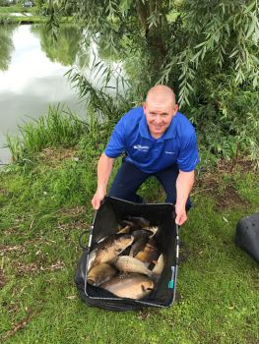

Venue: HERONBROOK FISHERIES - CANAL

Date: 09.07.17

A bright and sunny summer’s day greeted 27 SMAC anglers who were anticipating a great match following on from the last visit to Heronbrook which resulted in an average weight of 60lb per angler and 2 ton up weights! The conditions weren’t ideal for fishing and we were a little more tightly grouped together being on only 1 lake however we still managed to achieve an average of 50lb per angler with another 2 ton weights and a record breaking one at that!!

Section A – 1st = Phil Zahra 156lb 120oz / 2nd = Shaun Gallagher 74lb 0oz

Phil Zahra shook off a hangover to win section A with not only the highest weight of the year but the highest ever recorded SMAC match weight!! Well done Phil – the crown has now been passed from Billy Barker, through Wayne Rooke onto our 3 time champ Phil – well done mate lets hope it holds out until the end of the year so you have a trophy to mark your achievement. Phil fished shallow at 14.5m, short on paste and tight down the edge to amass the huge weight from peg 8 with a mixed bag of carp and F1s – what a weight!! Well done to Shaun Gallagher with his second section second of the season with 74lb.

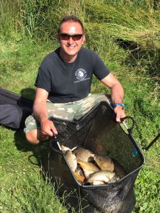
Section B – 1st = Carl O’Brien 74lb 08oz / 2nd = Andy Webb 68lb 1oz

Carl Marches on in style with his 5th section win of the year securing his top spot in the league – Carl left it really late to start his assault having only 15lb in the net with an hour to go Carl potted in casters down the edge to catch an F1 every put in for the last hour to secure top spot in the section – well done carl; looking unbeatable at the moment! Congrats to Andy Webb for second in the section also with a really nice net of fish and some horrendous sunburn to boot!!

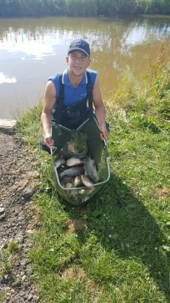
Section C – 1st = Pete Boggiano 103lb 14oz / 2nd = Derek Wood 45lb 8oz

Pete Boggiano is back in action after missing 2 matches on the trot securing his 5th section win of the year with a shallow caster net of F1’s and a couple of late edge carp to complete the days second ton up weight. Derek Wood was further down the stretch and put in a solid performance yet again – always in the points and always in the money! Mr consistent – Mr Wood! Steve Tomo also gets a mention as he rested his pole whilst fishing in the margins and off it shot with his biggest fish of the day attached - stripped down to his boxers in no time Steve recovered his pole with fish still attached only to break his top kit whilst exiting the canal, oh dear! what a calamity, unlucky mate!

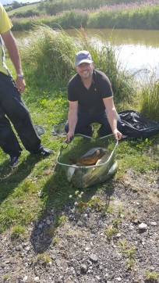
Section D – 1st = Paul Tighe 57lb 12oz / 2nd = Ian Clarkson 52lb 2oz

After 2 section second places on the trot it was Paul’s turn to pick up first place – he did exactly that from a really nice looking but unfancied peg 41, well done Paul that’s a great result from there which boosts you up to 13th in the league – a good run of form over the last 3 matches has taken Paul from 33rd place to 13th! Not bad at all good sir! Big man Ian Clarkson came second which secures his second place in the league and he is one to watch out for as when he gets up a head of steam he’s difficult to challenge – well done Ian!

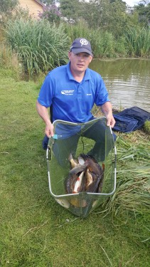

SOUTH MANCHESTER MATCH ANGLING CLUB

Venue: MOSS FARM FISHERY – LILLIES AND MEDDESONS

Date: 11.05.17

Apologies for the delay in getting this report and Tables online guys! It was a bright and breezy day with a few showers which greeted 29 SMAC anglers for the 6th match of the 2017 season – weights were expected to be nowhere near the last match and the stamp of fish was tiny in comparison, however plenty of bites and a close match were expected! Apologies for the lack of detail in the report as I was only a spectator for an hour or so.
Pictured below is Dave Bennett picking up the bonus cheque off Phil Zahra for his cracking weight of 130lb at heronbrook on the last match – well done Dave!

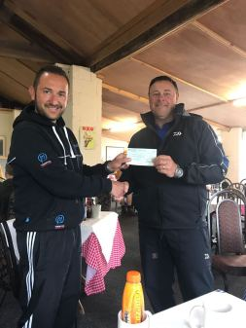

Section A Lillies – 1st = Tony Webb 30lb 9oz / 2nd = Dave Bennett 29lb 2oz

Tony Webb is back in action winding everyone up although a few people mentioned he was quite quiet at this match – this is strange Tony what’s wrong? Haha!! Tony put in a usual solid performance to win the section and although his league position doesn’t suggest it he’s a tough nut to beat with an average of 4.33 points per match. Well done to Dave Bennett on second in the section also.

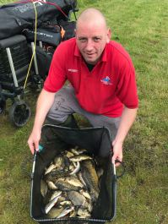

Section B Lillies – 1st = Paul Pannett 32lb 12oz / 2nd = Paul Tighe 29lb 2oz

Paul Pannett is having a cracking season so far with 3 section seconds and this is his first section win of the year – Paul marches on to 9th in the league with another cracking average of 4.6 points per match – superb Mr Pannett, Superb! Paul Tighe picks up his second section second on the bounce – well done Paul – next one will be a win!!

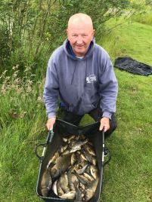

Section C Maddesons – 1st = Steve Tomo 30lb 14oz / 2nd = Paul Hirst 29lb 11oz

A first section win of the year for Steve tomo boost him up to 3rd in the league – level on points with second place and only 35lb behind in weight – a solid season so far from Steve, nice one mate. Second was Paul Hirst who decided not to go in the pools and so misses out on a huge £25 payday! Haha!! Well done guys J

Section D Maddesons – 1st = Adrian Wood 45lb 10oz / 2nd = Carl O’Brien 40lb 13oz

Ady Wood put his embarrassment at Heronbrok behind him to Pip Carl to the section win with the day’s biggest weight of 45lb – nice one Ady a solid performance with your third section win of the year – missing two matches already and the Heronbrook incident give a false reading on the table – it will all change next match when dropped points are included! Carl picked up second in the section by the narrowest of margins beating Stu Ford off the next peg by 1 ounce!! Well done guys – a close battle!

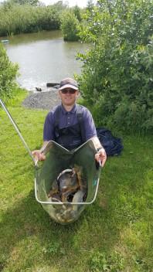

Following on from the warning I issued at Blundells we have had another instance of dirty boy Tony getting his bum on other peoples stuff, dirty Tony, dirty – please watch out for him lurking in the bushes near your stuff – it could happen to anyone – Phil Zahra was the unfortunate recipient of Tony’s unwashed arse this week…………..

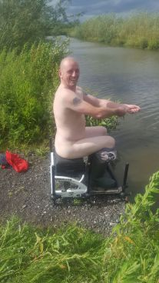
Another picture below features Daz Gabz with a little fancy coloured carp - nice one Daz, beautiful..... the fish that is - definately not you :-D

Venue: HERONBROOK FISHERY – CANAL AND BRIDGE

Date: 28.05.17

A few big-hitters were unable to make this match, so a slightly reduced field of almost 30 tackled Bridge pool and the canal at Heronbrook on a warm, overcast day. The waters had been match fished the previous day, which is normally the kiss-of-death, with good weights being produced, so nobody was supremely confident it would fish well. No need to worry, a total weight of 1745lb was caught, with an average of 62lb per angler, probably the most productive match South Manchester have ever fished.

Section A Bridge – 1st = Ian Clarkson 72lb 9oz / 2nd = Paul Hirst 48lb 14oz

Ian Clarkson continues his great start to the season with a third section win which now pushes him up to 4th in the league on 22 points – Ian has got the 3rd highest average in the club recording 5.5 points per match – after a disappointing year last year by his standards it’d be good to see the big guy back at the top where he belongs! Well done to Paul Hirst for second in the section also – his first frame for a while – well done mate.

Section B Bridge – 1st = Dave Bennett 130lb 12oz / 2nd = Ged Smith 99lb 15oz

Winner was Dave Bennett, fishing Bridge 32, only recently joined but already showing he’ll be a contender for the league at the end of the season, with 130lb 12oz of mainly F1s with the odd small carp. He started across and had a few fish, but was also feeding his 2+2 shallow caster line and as soon as he dropped on this, it was consistently producing for the rest of the match. Not massive fish, most between 1.5 and 2lb with a few larger, but they kept on feeding. Not only did he win the match, he was also sitting on a bonus peg, so cleared up on that as well to make it a nice pay day. Well done also to Ged Smith who was Third overall. Ged was fishing Bridge 23. Here, it was quite wide and Ged fished the whole match long at 14 to 16 metres for a steady session and fed intelligently to keep them coming for the whole match. The weigh-in was interesting. First weigh from one and a half nets (he used 3) was called at 56lb 8oz, only to be corrected down to 56lb 6oz when the fish had settled. After the remaining 43lb odd was weighed, the final weight was an agonising 99lb 15oz. Unlucky not to record the ton.

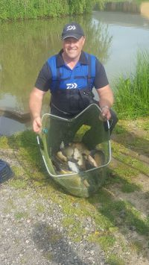
Section C Canal – 1st = Martin Cook 79lb 6oz / 2nd = Shaun Gallagher 55lb 6oz

Martin Cook has had a top run so far this year with a 100% attendance record proving invaluable in pushing himself into 3rd in the league. A cracking weight of 79lb picks up his second section win on the bounce, nice one mate! Second place was taken by last year’s bonus winner Shaun Gallagher, another member who’s had a difficult run of form which is hopefully coming to an end. Well done guys!

Section D Canal – 1st = Alan Hesling 87lb 11oz / 2nd = Phil Topham 62lb 8oz

Skinny man Van Helsing marches on in fine form with a cracking weight of 88lb to top section D. Alan pushes himself up to 7th in the league which is only 1 place behind his beloved man united in 6th hahaha! Second in the section was the stand in match secretary Phil Topham who did a fine job in Mr Zahra’s absence, thanks Phil and well done!

Section E Canal – 1st = Carl O’Brien 51lb 9oz / 2nd = Paul Tighe 76lb 0oz

Second overall was Carl O’Brien off canal peg 39 with another ton-up haul of 113lb 9oz. After 2 hours Carl had only registered 9lb on his keep net clicker fishing long, so a radical change of tactics to fishing short and both margins made a massive difference. Chunky F1s into the net on a regular basis, using a variety of baits including meat and pellet. Not a bad result considering he gave everyone else a 2-hour head start. This section win (Carl's 4th of the season) pushes him to the top of the league! nice one mate :-) second in the section was Paul Tighe with another cracking weight of 76lb - well done Paul a great result!

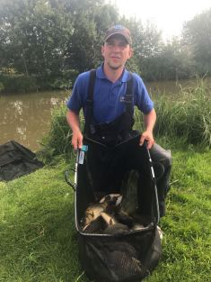

Ady Wood was disqualified for fishing the wrong pool. He drew 6 on the canal but unfortunately sat on peg 6 on Bridge, but by all accounts fished a tidy match and was emptying it down the side on meat and paste at the end, before tipping back 60lb+. For these multiple-water matches, if you’re not 100% certain you’re on the right peg, CHECK with the Match Secretary or his deputy before setting up.

As it was such a good days fishing I’ve included some extra Photo’s below of some great catches – well done everyone!!

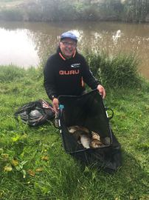
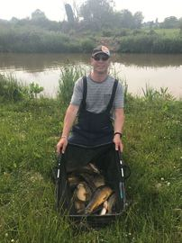
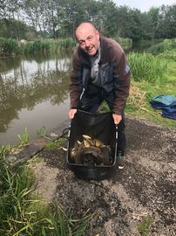
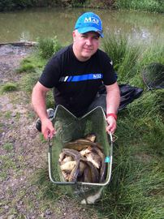
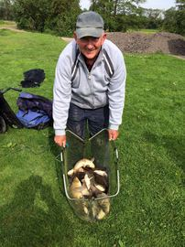

Venue: OLD HOUGH FISHERY – LOWER BENBO, GOOSE AND BOULDERS

Date: 14.05.17

A pleasant spring day greeted the 30 SMAC members who arrived at the pristine Old Hough fishery for match 4 of the 2017 season, once again we were able to offer great peg spacing’s with a total of 62 pegs to play with.

Section A Lower Benbo – 1st = Carl O’Brien 62lb 8oz / 2nd = Paul Pannett 38lb 15oz

Carl O’Brien continues his fine start to the season despite breaking his 13m section which resulted in most of the match being fished at close range! Carl used meat to amass a total weight of 62lb 8oz which topped the section and also left him second overall – nice 1 Carlos. Paul Pannett picked up his third section second on the bounce which takes him to 10th in the league even though he’s missed a match, could it be the year for Paul?!
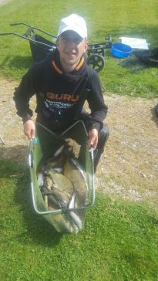
Section B Lower Bonbo – 1st = Dave Bennett 75lb 12oz / 2nd = Ian Coleman 48lb 5oz

New member Dave Bennett is proving to be one to watch after weighing in the best overall weight of the day from peg 20 on Lower Benbo, Dave fished 14m just up the far side shelf and cautiously fed 4mm pellets fishing 6mm banded to catch 75lb 12oz of carp and f1’s, top performance Dave, well done! Second in the section was Ian Coleman, ‘the Chemist’ now moves up to 3rd in the league – good going chaps, well done!

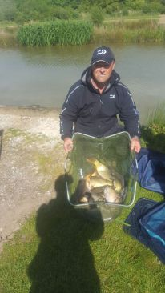
Section C Boulders – 1st = Adrian Woods 51lb 7oz / 2nd = Ian Clarkson 40lb 7oz

Ady Woods returns after a 2 match hiatus with a section win from peg 17 on Boulders, fishing meat across and paste down the edge Ady pipped ‘Lanky Bollocks’ Ian Clarkson who was just across the way on peg 16 – well done to both anglers, incredible competitiveness whilst remaining close, loving friends – it’s such a delight to see.

What isn't a delight to see is Ady in his hi-vis vest - I have re-published this image below just in case we forget how horrendous it was

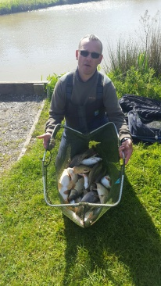
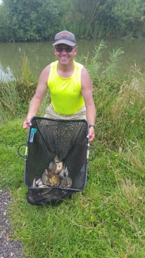
Section D Boulders – 1st = Martin Cook 48lb 8oz / 2nd = Keith Thorne 36lb 12oz

Another close battle ensued on pegs 12 and 14 of boulders with Martin Cook coming out victorious over Keith Thorne. Martin and Keith are also very loving of each other however they didn’t let their brown love get in the way of battling it out for the points. Martin fished at 16m for most of the day which must have been difficult as the lake is only 12m wide [were you dangling it in the stock pond martin?] He then switched to his short line on Maggot to take the honours – well done to both you gay’s……. sorry, guy’s.

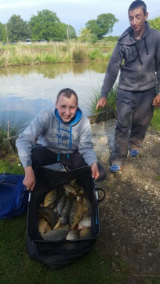
Section E Goose – 1st = Pete Boggiano 51lb 9oz / 2nd = Tommy Edwards 35lb 1oz

Pete Boggiano drew another flyer and won the section – wanker.

Well done to Tommy for coming second and also for calling me a c*nt – very kind of you

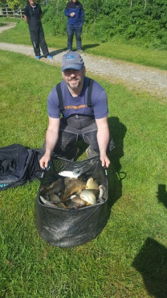
Section F Goose – 1st = Phil Zahra 52lb 13oz / 2nd = Derek Wood 37lb 2oz

Stop the press; Hold the front page….. It must be summer time as Phil Zahra’s won his section!! Well done to last year’s champ Phil who’s picked up his first frame of the year, Phil fished mainly across on pellets and then…… wait for it…… had a few short on paste OMFG. All joking aside, well done mate a really nice mixed bag of fish – watch out league leaders, the champ is back. Derek Wood continues his fine run of form and solidifies his place in a champions league spot picking up second in section F!

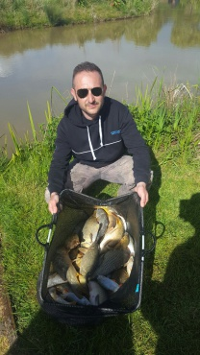
Venue: BLUNDELLS FISHERY – EAST, WEST, ASH AND PINE

Date: 30.04.17

With several members away at Whiteacres a reduced field of 26 anglers turned up for the most spaced out pegging SMAC has been able to offer, with 78 pegs at our disposal we were all looking forward to a good days fishing, unfortunately the two larger canals, ash and pine didn’t really produce as well as we hoped with winning weights and backup weights well below par, East and West canals fished OK with some reasonable weights being put together.

Have a close look at the pairs table – it’s looking like it’s going to be a cracker of a competition this year – remember you need to get into the top 4 for a semi-final place.

Section A East – 1st = Pete Boggiano 61lb 15oz / 2nd = Steve Tomo 45lb 8oz / 3rd Derek Wood 40lb 6oz

Pete Boggiano picked up his 3rd section win on the bounce and narrowly missed out on the bonus money which was robbed from him by Tommy Edwards! Pete started on the method feeder then switched to the margins late on to weigh in 61lb 15oz which contained the biggest fish of the season so far, a 14lb 3oz mirror carp. Steve Tomo came second fishing a shotgun feeder to the far bank and third place was taken by Derek Wood who showed his ultimate strength fishing 17m for part of the day! Well done to all.
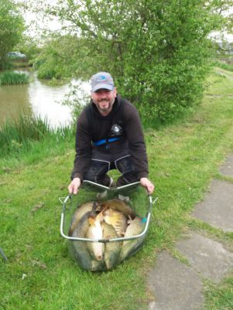
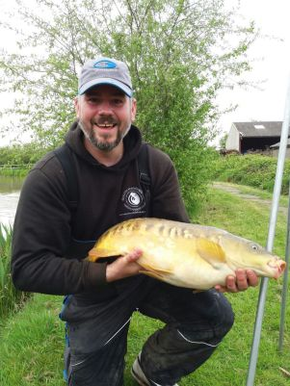

Section B West – 1st = Tommy Edwards 68lb 4oz / 2nd = Tony Webb 28lb 6oz /3rd Pete Ransome 18lb 8oz

Tommy Edwards fished a cracking match with 8mm banded pellet over corn to weigh in the overall biggest weight of the day with 68lb – he was noticed running through the bushes at one point to remove a fallen tree from his swim, Paul Tighe was unpleased with this action however I caught a glimpse of Tommy squeezing Pauls bum later as an apology so hopefully their love is still intact. Second place was taken by the club jester and in third was many time past champion Pete Ransome, well done fellas!

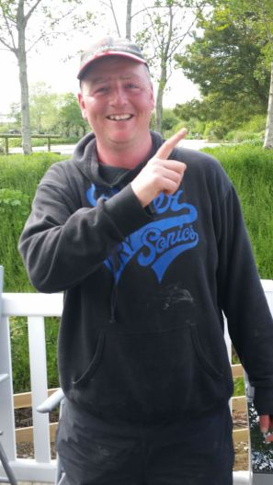

Section C Ash – 1st = Ged Smith 39lb 2oz / 2nd = Carl O’Brien 35lb 5oz / 3rd Daz Gabz 7lb 13oz

Ged Smith topped section C with a pellet waggler net of carp from peg 41 on Ash which moves him up to Joint 3rd in the league after a strong start to the season, Nice one Ged – love it when City fans beat Dirty red’s hahahaha! Second Was Poster boy Carl O’Brien [dirty red] and third in the section went to the semi-pro specimen angler Daz Gabz – well done to all you guy’s, you’re amazing.

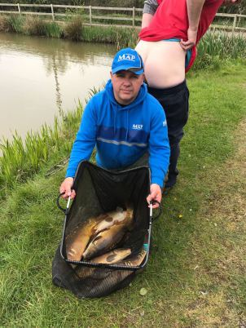

Section D Pine – 1st = Alan Hesling 37lb 1oz / 2nd = Keith Thorne 31lb 11oz / 3rd = Martin Cook 19lb 11oz

Pine Lake was home to the most difficult section of the day which really surprised me as I expected it to fish really well, Alan Hesling topped the lake with a mixed bag of big skimmers and Carp, Keith Thorne was a close second with a Banjo net of carp after breaking his pole! Martin Cook managed third with 19lb, well done guys – Last Year’s champion Phil Zahra was on this lake, I asked him how it went and he just replied with a list of expletives so I presume it wasn’t great!

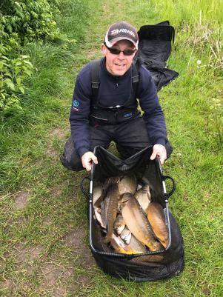

On a more serious note - a message to all members - please ensure all car doors are locked and secured as we found a dirty animal in someones driving seat the other day - we'd hate for this to happen to you - please be aware!

Venue: HALL LANE FISHERIES – BES’S LAKE PEGS 1-50

Date: 16.04.17

The brief summer we experienced at the first match of the season has now deserted us and we’re back to good old April pissing rain and howling winds, oh how wonderful! Despite the terrible forecast hopes were high for this match as last Octobers match threw up 3 tons and plenty of strong backup weights – unfortunately the fishing turned out to be really difficult for most with the gusting winds making life difficult for all.

Section A – 1st = Pete Boggiano 90lb 4oz / 2nd = Ian Clarkson 46lb 14oz / 3rd Frank Coleman 30lb 5oz

By far the best performing section was the early pegs which was topped by Pete Boggiano, Pete fished maggot for most of the day and switched to the margins for the last hour to tip the scales at 90lb 4oz securing his second overall match win on the bounce. Ian Clarkson put in another solid performance following on from his lake win at Bradshaw’s to come second ion the section and 3rd on the day went to Frank Coleman – a welcome return for Frank after a bit of time out, well done to all.

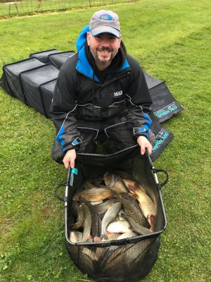

Section B – 1st = Derek Wood 42lb 6oz / 2nd = Bob Chapman 22lb 5oz /3rd Paul Hirst 17lb 14oz

Derek wood also follows a strong performance at Bradshaw’s with a convincing section win, Derek reverted back to his winter league winning tactics to top the section, nice 1 Derek! – the weights really dropped off in this section as the wind seemed to be catching this end of the lake much heavier than the early pegs and very few carp were to be seen beyond Derek’s peg. Well done to Chappy for coming second in the section and also to Paul Hirst for coming third – well done for sticking it out guys!!

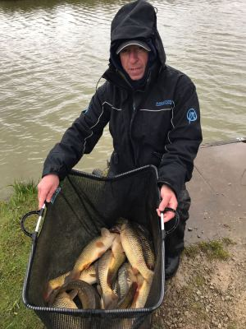

Section C – 1st = Carl O’Brien 40lb 4oz / 2nd = Paul Pannett 9lb 8oz / 3rd Andy Webb 7lb 13oz

Section C was a tough old area to fish, getting battered by the wind and rain is no fun way to spend a day – so bad it resulted in the early departure of a couple of guys, can’t fault them really! Carl O’Brien put in an outstanding performance topping the section with a huge margin, Carl used expanders and Micros to pick up some early carp but then struggled for the last couple of hours, however he had enough to top the section which takes him to joint top of the league, well done Carl, maximum points so far! Second place was Paul Pannett who resorted to old bridgewater canal tactics to winkle out 9lb of fish and third went to Andy Webb picking up his first section frame with SMAC, well done all!

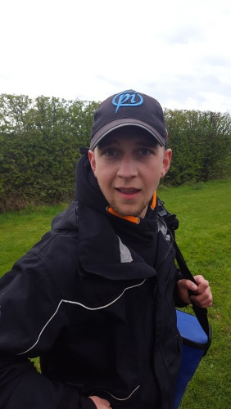

Section D – 1st = Ian Coleman 50lb 0oz / 2nd = Steve Thomason 24lb 10oz / 3rd = Dave Coleman 24lb 4oz

The fishing definitely picked up as we move down back towards the car park area of the lake and Ian Coleman topped the section with the second highest weight of the day, fishing a very similar match to Pete, Ian fished maggots for most of the match switching to pellet in the margins when the wind picked up later in the day, well done Ian, a really strong performance to put you joint second in the league after 2 matches. Second and third place in the section was a really close call with Steve Tomo ouncing out Dave Coleman to take the 5 points – nice one guys, a really close call!!

Venue: BRADSHAW HALL FISHERIES – LAKE 4, 6 & 7

Date: 02.04.17

Welcome to the 2017 season guys – this season is looking like it’s going to be the biggest one yet and we hope you are as excited as we are to see how the year unfolds. First up was a trip to Bradshaw Hall Fisheries, our match secretary’s number one choice for the first match of the year and with an average weight of 35lb per angler it’s easy to see why this is the case. There were 35 anglers who turned out to make this the highest attended SMAC match in recent history, nice one chaps, let’s make this the best year yet!!

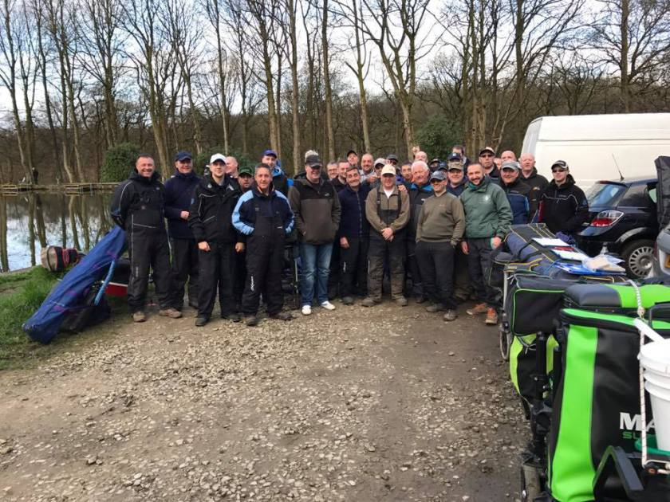
Section A [lake 7] – 1st = Ian Clarkson 49lb 14oz / 2nd = Paul Pannett 36lb 13oz

Probably the least fancied lake in the drawbag was Lake 7 – it was especially unfancied by Ian Clarkson who put his feelings to one side and let his professionalism shine through to come out on top with a cracking weight just shy of 50lb mainly made up of silvers with a few small carp which must have been a very busy day fishing expanders over micros [for a change!!]! Well done Ian and well done Paul on second place with another cracking weight of silvers!

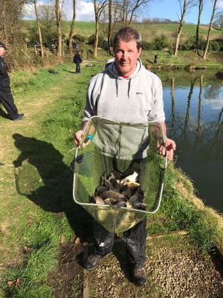
Section B [Lake 6] – 1st = Carl O’Brien 41lb 3oz / 2nd = Ian Coleman 22lb 12oz

Carl O’Brien is a definite contender for this year’s league title and he’s started the season in style with a great weight of silvers and small F1’s tempted with caster, worm and pellet at varying lengths from peg 6 on Lake 6, nice one Carl a great performance. Ian Coleman picked up second place from the next peg and Mick Abdy put in his claim for the biggest fish award with a 10lb 8oz mirror which made up half his weight! Well done guys!

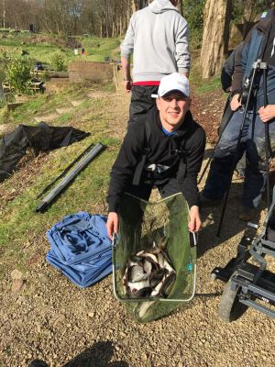
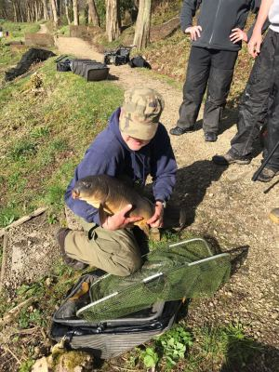
Section C [Lake 6] – 1st = Ady Wood 60lb 11oz / 2nd = Alan Hesling 37lb 3oz

Section C seemed to fish much better than section B with better weights all round – Ady Wood took the top spot with another mixed net of silvers and F1’s again using worm and caster but with some fish short on corn, second in the section was skin and bones Alan Hesling – well done chaps some great weights of smaller fish – a busy day!

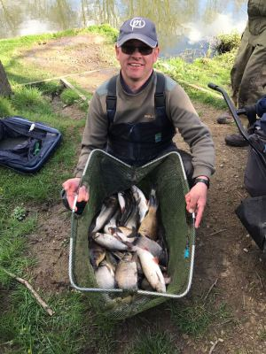
Apologies for the lack of catch pictures from Lake 4 - the cameraman was too busy banging on about catching a few himself and didn't concentrate on the task at hand - idiot!!

Section D [Lake 4] – 1st = Pete Boggiano 120lb 0oz / 2nd = Dave Bennett 79lb 1oz

Pete Boggiano drew a fancied area in peg 7 on Lake 4 and made the most of the day fishing shallow 6mm catching F1’s for most of the day to amass the day’s biggest weight by some way – Pete was docked 40lb for going over the net limit which would’ve took him to 160lb and the SMAC record – he will rue the day he didn’t bring a third net…. Numpty! Second in the section with an amazing performance was new member Dave Bennett with close to 80lb of silvers caught on chopped worm and caster, a top performance Dave well done!

Section E [Lake 4] – 1st = Stu Brown 37lb 2oz / 2nd = Phil Topham 36lb 0oz

A really close section was topped by Stu Brown, pegged on 26 on the wall side Stu fought off close competition from Phil Topham who was pegged on the causeway – a much tougher section this one so well done to the guys who weighed in decent weights!

Section F [Lake 4] – 1st = Chris Gabz 46lb 14oz / 2nd = Ged Smith 44lb 11oz

Another close section was the wall section of lake 4 – well done to Chris Gabz on topping the section with a net of mainly silvers caught on his top 5 on expanders over groundbait – another cracking weight of silvers!! Second place went to last year’s Billy Barker Memorial winner Ged Smith, well done to both on competing a very close section!

