2018 MATCH REPORTS

2018 Match Secretary’s Review

Well what a year! Where do I start on such an amazing season?

2018 started as if we were fishing in winter the 1st couple of matches absolutely freezing but nevertheless decent weights were starting to be caught, new members were being welcomed and there was a buzz in the air with the new teams of 4 competition, as we moved into May the temperature started to rise and things really started to heat up!

A master class feeder session on Bess’s Hall lane saw Phil Topham produce the 1st 100lb+ match weight, 150lb actually which was a great achievement in spring, was this the 1st major trophy won already or a sign of promising fishing ahead!

As we move towards the end of May the Sun blessed us with wall to wall sunshine for weeks on end our annual visit to manor farm was more like a sunbather’s paradise than a lads fishing trip. 1st match back after holiday and 1/2 way through the season saw us at Lindholme lakes with the sun still beating relentlessly I wasn’t sure what to expect, as I called the all-out I’d seen a few fish caught and I was quite pleased with myself knowing that I’d caught over 100lb but what happened next absolutely blew me away! Astonishing enough twelve 100lb plus match weights were caught and the current club match record was smashed not once but twice as well as many lads beating their personal best Ady Wood topping the list with a staggering 189lb surely securing the best match weight trophy.

On we went onto the 2nd half of the season and at last the high that had brought us endless sunshine moved away and some rain fell which topped up the depleted water levels and just a mere 6 weeks after the record breaking lindholme match saw us at heronbrook, this place is a fantastic fishery one of my all-time favourites! I was hoping for another all-round good day after a bit of a mixed match previously at border and I couldn’t of asked for more! I never thought in a million years that we could top the mighty lindholme match with so many records broke in 1 day but was I wrong both meadow and bridge fished their heads off and record breaking time came again and again and again, a whopping eighteen 100lb match weights this time with two of them being 200lb plus the statistics were incredible and Adys lindholme weight of 189lb got broken 3 times with Paul Tighe this time recording the highest ever weight of 225lb, matches and seasons like this always make me happy because it makes me feel like we’re doing a good job I hope you’ll all agree

All the statistics from the 2018 season are available to view of the news page please take the time to read through these they have took lots of time and hard work to put together.

Our club champion this year was Pete Boggiano he’s fished a brilliant season being utterly consistent throughout he puts a lot of thought and planning into his fishing which has made him top dog this year and I’m giving him a special shout out because he put more work into the running’s of the club than anyone else good work mate on both accounts.

Finally I hope you’ve all enjoyed this year and I can only see this getting better, the 2019 match list is out and I personally think it’s the best we’ve ever had, big thanks to the other members on the steering group we are a great team and we all play our roles in making this club without a doubt in my mind the best match fishing club in the country

Tight lines

Phil Zahra

Venue: HALL LANE BESS’S
Date: 28.10.2018

The final Match of the 2018 season was attended by 31 SMAC anglers on Hall Lane fishery in Wigan – a venue which can throw up some massive weights but also a very frustrating venue as the fish seem to locate themselves in one or two areas rather than all over the lake, this usually results in big winning weights but pretty poor backup weights which was the case today.

The pair’s final came to a climax with Chris Gabz and Carl O’Brien taking on Pete Boggiano and Rodger Dimmock in the final, it turns out the latter 3 didn’t even need to turn up as Chris Gabz smashed it on his own with a huge 97lb! this won the pairs title for Chris and Carl who have performed fantastically this year and the title is well deserved – well done to you both!

The teams of 4 competition was on a knife edge going into this match with team G consisting of Pete Boggiano, Tommy Edwards, Daz Gabz and Eric Quinn just 2 point ahead of team C consisting of Carl O’Brien, Ged Smith, Joe Zahra and Pete Ransome. Team G managed to extend their lead at the top resulting in them winning the inaugural teams of 4 competition by 7 points; they have led from match 1 and so it’s a well-deserved title, congratulations to team C on the second place finish also. There was a proper battle for third place also with team H consisting of Steve Tomo, Phil Topham, Andy Sonley and Frank Coleman going into the match with a slender 1 point advantage over team E consisting of Ady Wood, Paul Pannett, Alan Hesling and John Crowther – Alan and John put in mega performances to push their team into the last money spot by 3 points, fantastic team play from everyone involved. It’s been a cracking first year for the competition and will be continued next year!

The final trophy up for grabs was the runner up trophy for the individual league which saw Carl O’Brien, Ady Wood and Ged Smith all on the same points separated only by weight. Carl and Ady both had the better weight advantage going into the match but both had really poor matches and finished 4th in their respective sections – this opened the door for Ged who knuckled down and picked up 3rd in a really tough section to get himself into the runners up spot – cracking result Ged well done, especially after a terrible start but with 7 section wins, 6 section seconds at an average of 4.8 points per match and 780lb of fish you proper turned it round for the blues!! Nice one matey☺

Section A – Pegs 27 - 38
1st = Alan Hesling 143lb 15oz
2nd = Dave Coleman 111lb 12oz

Section B was a strong section with fantastic a fantastic winning weight backed up by very good back up weights, Alan Hesling took the top spot from peg 33 which was 2nd overall on the day with 143lb 15oz fishing the long pole over in the mud hole feeding in a full cad pot of maggots with maggot on the hook this secured alan a top 10 finish with his 1st section win of the season after multiple 2nds, well deserved. 2nd in the section from peg 34 was winter league champion Dave coleman, dave fished similar to Alan and said if he missed a bite then it was pointless sitting there you had to ship back in and feed again, dave pulled out a very impressive 111lb 12oz to take his 2nd section win of the season. Well done lads

Section B – Pegs 40 - 47
1st = Dave Bennett 78lb 14oz
2nd = Eric Quinn 32lb 2oz

Section B was another tough section, some people hate this area but on its day it can fish well, not this time I’m afraid, Dave Bennett produced the only decent weight from end peg 47 fishing pinkies yes pinkies across pulling out mainly carp for 78lb 14oz, very impressive seeing as the wind was blowing down the other end of the lake, 2nd on the day went to Eric“pit bull”Quinn he fished just off the far bank and down the track to pull out 32lb 2oz this give Eric a top half of the table finish that I’m sure he will be proud of.

Section C – Pegs 49 - 56
1st = Tommy Edwards 124lb 15oz
2nd = Steve Barlow 65lb 11oz

Tommy Edwards was 100% focused for the teams of 4 competition knowing how much every point would count in this final match, he put in an amazing performance to clinch the section win and the vital 6 points for his team. This is Tommy’s 5th section win of the year and he just about gets in front of Tony for 5th place – level on points but Tommy’s 1lb ahead on weight! Extremely close! Without dropped matches Tommy’s overall weight is 1015lb which puts him with Carl O’Brien, Ady Woods and Pete Boggiano in the 1000+ club – well done guys! Second in the section went to new member for 2018 Steve Barlow who definitely knows what he’s doing with an average points per match of 4.08, nice one Steve!!

Section D – Pegs 58 - 64
1st = Tony Webb 190lb 6oz
2nd = Ste Hammerton 81lb 13oz

Unbelievable weights from this area of the lake especially from mouth almighty Tony Webb who annihilated the section and also the match with a huge 190lb 6oz…. Tony was unfortunately docked on 3 of his 4 nets which has cost him the biggest match weight trophy as his weight would have been 233lb!!! Unreal for this time of the year – Tony fished maggot across to the far bank feeding exactly 3 maggots every put in, he found it difficult to plumb up because of the number of fish in his swim! This is Tony’s first overall match win of the year so well done to him on the win and his 6th place finish in the league! Second was Ste Hammerton who’s had a fantastic first season with SMAC finishing 11th in the league nice one Ste, well done!

Section E – Pegs 66 - 74
1st = Pete Boggiano 26lb 9oz
2nd = John Crowther 24lb 3oz

In stark contrast to section D the last section was absolutely dire with 4 out of the 6 anglers giving up and packing up before the all out, one didn’t even bother to weigh in! Pete Boggiano tipped JC to the section win by just over 2lb which is Pete’s 10th section win of the year in his title winning campaign, amazing performance from a properly handsome young chap! Second in the section was John Crowther who picked up his first section frame of the year so a big well done to him!

That’s me finished now for the 2018 season, I hope you’ve enjoyed the reports and I hope you’ve all enjoyed the fantastic season we’ve just experienced, it's a pleasure being part of a great club with a great set of lads and the standard of angling is going through the roof, everyone in the club is upping their game and the competition is great - nobody knows who is going to win the next match and nobody is guaranteed section wins, this is what we set out to create and it's down to the members that this has become a reality!! ….. if you thought the fishing this year was good just wait until you see the match calendar for 2019!!! Phil will be writing his match secretary’s report over the next week so watch this space! Cheers, Pete.

Below are the photos taken on the day:

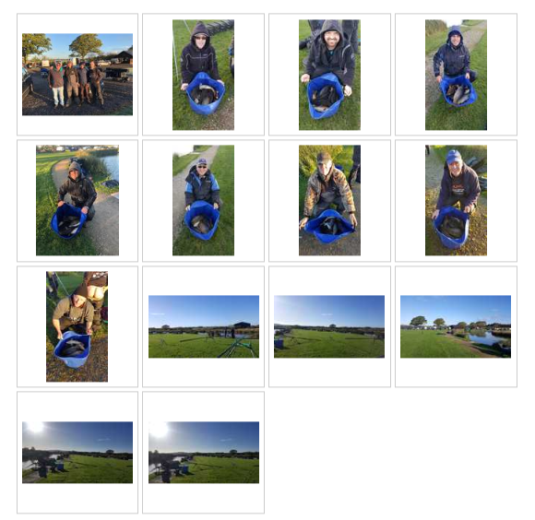
Venue: CUNNERIES – S CANAL AND KESTREL
Date: 14.10.2018

The penultimate match of the 2018 season took 31 members to the Cunneries fishery – a venue we visited some 5 years ago but haven’t been back since. Open results over the last couple of years have suggested this venue can really produce a good match and even though the time of year was against us the fishing was promising for future summer matches; the lakes are obviously well stocked and we we’re offered plenty of space – the scenery could do with sorting out a bit as some areas were like fishing in worn torn Beirut in the 80’s….. But then again some of the guys fishing in these areas wouldn’t look out of place in Beirut so it suited them….. No names mentioned!

The teams of 4 competition is coming to a fantastic climax with the outcome to be decided at the very last match of the season; the top 2 teams are separated by just 2 points and 3rd and 4th teams are separated by just 1 point – my suggestion is that if you are in one of these teams don’t miss the last match or you’ll forever be given grief!

With the individual title being sewn up the chase is on for the runners up trophy….. It couldn’t be any closer with 3 anglers (Carl O’Brien, Adrian Wood and Ged Smith) all on the same points with only weight separating them.... Who will have the bottle to finish the job and bring home the trophy?!

The Pairs final will also be fished at the last match with Carl O’Brien and Chris Gabz taking on Pete Boggiano and Rodger Dimmock. The whole match is set to be a cracker with some top prizes, trophies and prestige to be won and lost. Good luck to everyone at Hall Lane in a couple of weeks!

Section A – S Canal Leg 1
1st = Phil Zahra 32lb 12oz
2nd = Steve Tomo 31lb 9oz

Pegs 9 and 12 on leg 1 gave us a cracking battle between venue regular and past multiple champion Phil Zahra and last season’s runner up Steve Tomo….. Battle of the midgets we’ll call it. It was Phil who narrowly came out on top by just over a pound with a hard earned net of F1’s. Phil switched swims regular to keep the fish coming and used his knowledge of the venue well to beat Tomo to the top spot. It’s been a tough year for the Maltese midget, this being only his 3rd section win of the year, I’m sure he’ll be back to his best in 2019. Tomo fished caster down the margins to pick off the venues specimen Gudgeon to weigh in 6000 fish for his 31lb….. I’m not sure this is true but it’s all I heard all day so it’s the only information I have to go off.

Section B – S Canal Leg 2
1st = Ian Clarkson 35lb 8oz
2nd = Tony Webb 32lb 10oz

Ian Clarkson drew his second amazon looking peg on the trot but was confused as he couldn’t fish 16m which would have taken him into Tomo’s swim on the other side of the canal…. Ian found a way though picking of the odd fish from different swims to pip Tony Webb to the top spot by just 3lb – another close section. Well done Tony on the second place. Bell End. (that’s for getting your arse out on my league winning photo!!)

Section C – S Canal Leg 3
1st = Pete Boggiano 55lb 0oz
2nd = Phil Topham 28lb 8oz

Pete Boggiano fished 3ft soft pellet approach towards the far bank and pellets in the margins late on to pick up his 9th section win of the year – This section win secures the individual league title for the second time for Pete. What a guy. Phil Topham came second fishing the method feeder [yeah you read that right – the canal is about 10m wide and he gets his rod out!] well done Phil…..new draw master!!

Section D – S Canal Leg 4
1st = Dave Bennett 58lb 1oz
2nd = Derek Wood 34lb 12oz

Dave Bennett fished a cracking match to win his section and the lake from peg 40. Dave fished worm and caster and waited it out for the F1’s – slow and steady throughout the day Dave caught fish – avoiding the nuisance fish with a slightly bigger bait, well done Dave a cracking result. Derek Wood took off like a steam train with 3 fish in the net before most had baited up their swims, it then died for 3hrs on him before it picked up again and Derek finished with a flurry to get second in the section.

Section E – Kestrel Pegs 2 - 16
1st = Tommy Edwards 63lb 6oz
2nd = Carl O’Brien 50lb 0oz

Tommy Edwards fished a cracking match and not only won his section but won the overall match from peg 13 on kestrel Tommy fished hard pellet on the pole to weigh in a bigger than expected stamp of fish – his number 8’s elastic getting a proper workout…. Who told him it was full of stockies!? Nice one Tommy – good team player points and well done on your first match win of the year! Carl finished second in the section going all out for the individual title left him short on weight but sets it up for a right good finish for runner up at Hall lane.

Section F – Kestrel Pegs 18 - 28
1st = Ged Smith 60lb 11oz
2nd = Ady Wood 55lb 7oz

Ged and Ady went toe to toe on adjacent pegs 26 and 24 respectively and had a proper close showdown – Ged coming out on top meaning he draws himself in line with Carl and Ady on 64 points. Ged fished short at 5m on expanders and also caught on the method feeder to the island edging in front of Ady by just 5lb. well done guys and good luck at the next match!

Below are the photos taken on the day:

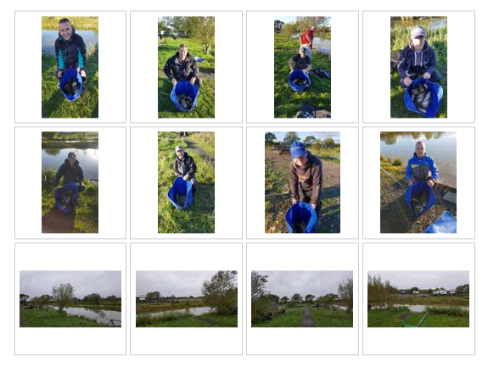

Venue: HERONBROOK FISHERIES – ISLAND, MATCH POOL & MATCH LAKE
Date: 30.09.2018

Entering the final 3 matches of the 2018 season and everything is getting tight in the 2 running leagues. The teams of 4 league is looking very interesting with the top 2 teams battling it out for first place only 3 points apart and the third place spot is being hotly contested with 4 teams all within 8 points of each other, it’s looking like a very tight finish for all involved in what has been a cracking first year for the competition, hopefully many more to come! The individual league is also coming to a close finish; Pete Boggiano has pulled 4 points clear at the top but Carl O’Brien, Adrian Wood, Ged Smith and Chris Gabz can all catch up over the next 2 matches so it’s far from over! Good luck to all anglers in the last two matches and their bid for either team success or individual success.

Heronbrook was home to match 13 on the calendar, a favourite for many SMAC members and the fishing (although nowhere near as good as last time) based on average weight per angler was the 4thbest match of the year which is pretty good considering the time of year and 3 frosts in the week leading up to the match. A lot of talk at the draw was based around Island winning the big match the day before with a huge 240lb and members wanting to get a rod and line out of the bag for a change, it’s a bit difficult in the North West as most of the big match venues are canalised lakes so getting the variety in our match venues is difficult but I think you all appreciate the efforts our match secretary goes to ensuring we have as many open water venues as possible – this year 8 out of the 15 matches on our calendar have open waters on them which considering the area and size of match turnouts is spot on.

Section A – Island Pegs 3 - 10
1st = Tony Webb 95lb 9oz
2Nd = Derek Wood 60lb 12oz

Section A on Island pool was won from peg 3 by motor mouth Tony Webb who started slow on the method and long pole but half way through the match switched to the edge to catch proper carp and big F1s pulling out an impressive 95lb 9oz which was the highest weight on that lake on the day, second in the section was Derek Wood who had a moan after a local told him they never put his peg in on the open matches because it never fishes well but a strong last hour give Derek a respectable weight of 60lb 12oz, well done guys

Section B – Island Pegs 12 - 20
1st = Ady Wood 87lb 12oz
2nd = Gary Marsland 84lb 11oz

Section B was topped by inform Ady Wood who kept his title challenge on track with his 4th section win on the trot and puts him on level points with last years champion Carl, Ady weighed 87lb 12oz from corner peg 20 fishing dead reds over groundbait. 2nd in the section after multiple holidays was Gary Marsland who has the 3rd best average points per match score! he’s put in a great performance in his 1st season.

Section C – Match Pool Pegs 1 - 9
1st = Pete Boggiano 51lb 9oz
2nd = Ste Hammerton 46lb 9oz

The Match pool wasn’t the lake of choice for most anglers, with a strong wind blowing right down the length and 4 nice looking corner pegs it was going to be tough going. Pete Boggiano racked up his 8thsection win of the year from peg 5 with 50lb of tiny F1’s caught mainly down the track on Maggot and down the margins on corn over groundbait. Ste Hammerton put in a really good performance from the wrong end of the lake to secure second place with 46lb – well done Ste!

Section D – Match Pool Pegs 11 - 20
1st = Ian Clarkson 98lb 6oz
2nd = Alan Hesling 47lb 12oz

Ian Clarkson was well happy with his draw…. The wind was pushing right into an amazon like corner peg and Ian made the most of it catching on both the pole and tip Ian won the section comfortably and narrowly missed out on his first ever SMAC ton, well done and unlucky mate. Second in the section again came from the wrong end of the lake with Alan hesling tipping 47lb on the scales for his 7thsection second of the year! If only Alan could convert these seconds he’d be 5 places higher in the league! Well done chaps ☺

Section E – Match Lake Pegs 2 - 12
1st = Ged Smith 109lb 8oz
2nd = Mick Abdy 54lb 2oz

There were a couple of ton-up weights on Match lake, but most of the anglers struggled for the first three hours of the match, with most only claiming a few carp up to the match mid-point. Bucking the trend big-time was Ged Smith with 109lb 8oz for a clear section and lake win and his first ever SMAC ton+ weight. Ged started on the method on the island chuck that everyone had, due to the sensible pegging and was also feeding a caster line at 13m for later. Not that much later, as the F1s turned up almost instantly and after a lone carp to the feeder, a tactical early switch after only 40 minutes saw a precession of chunky F1s landed between 6 and 18 inches shallow. This continued for the rest of the match. Second in section was Mick Abdy on the opposite side of the lake to Ged with 54lb 2oz. After being told that an "un-named" England International had only managed 75lb off the peg the previous day, this was considered a fair return. This was mostly proper carp with a few F1s to 4lb tight to the island reeds, topped up with some margin zoo creatures to double figures on dead reds over groundbait.

Section F – Match Lake Pegs 15 - 24
1st = Stu Brown 101lb 7oz
2nd = Carl O’Brien 72lb 10oz

Stuart Brown started the match flinging a feeder here, there and everywhere according to eye-witness accounts. This was probably a calculated tactic to maximise the catch rate for cagey fish in the first half of the match though.....and then a change to the 2+2 pole line fishing dead reds over groundbait kept the F1s and carp coming very regularly for a final section-wining weight of 101lb 7oz also his first ever SMAC ton+ weight. In-form Carl O'Brien was second -in-section with a good 72lb 10oz, a mix of F1s and decent carp. With just a few fish on the tip at the half way mark, after whinging a few more on by standing behind his peg waiting for the rod to wrap round (whilst doing other things!), a very precise margin baiting attack had some lumps queuing up to be caught. Most of the damage was done in the last hour, when keeping both long margin swims topped up and alternating was the key to building the weight. This is a very significant weight from Carl as he is now the first EVER SMAC angler to weigh in more than 1000lb+ fish in a season - a cracking acheivement, well done Carl!

Below are the photos taken on the day:

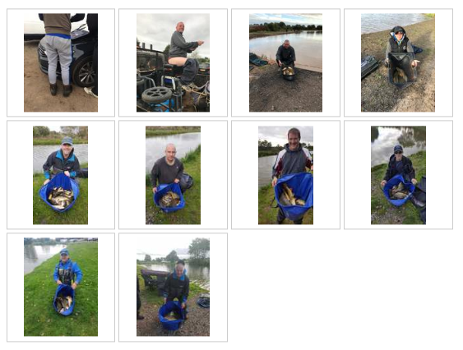
Venue: HAMPTON SPRINGS – MEADOW AND WILLOWS
Date: 14.09.2018

A really low turnout of 22 anglers turned up for the 12th match of the 2018 season which meant we could ditch Oasis lake and still have plenty of room across willows and meadow. The final leg of the pair’s semi-final was fished with the 4 pairs having everything to play for after a disastrous match at field’s farm. Carl O’Brien fished a top match without his partner present to ensure himself and Chris Gabz made it to the final and Pete Boggiano and his partner Rodger put in solid performances to take the other final place – well done guys. Unlucky to the other semi-finalists for not making it but well done on getting to the knockout stages! The final will be fished on one of the next 3 matches - good luck to all finalists.

The teams of 4 competition is properly hotting up now with only 3 matches left to push for the top 3 spots, there are still 72 team points left to play for so it's going to be a cracking finish to the first year of this competition. Just a reminder; the winning team will receive £60 each, second place will receive £50 each and third place team will receive £40 each!

A couple more ton plus weights were posted at this match taking the club season tally to 38 ton plus weights. Unbeleivable really, especially when you consider there was only 16 prior to this in the entire 50+ years of the clubs existance!

Section A – Meadow Pegs 3–5 and 22-29
1st = Pete Boggiano 93lb 14oz
2Nd = Joe Zahra 48lb 2oz

Pete Boggiano made the most of peg 5 on meadow, picking up a few fish from around his swim and then plundering the margins for the last 2.5hours on pellets and dead reds to pick up his 7thsection win of the year which moves him 3 points clear at the top of the league with 3 matches to go has he got the nerve to hold on?! Well done to Joe Zahra narrowly beating his nephew Phil to second in the section.

Section B – Meadow Pegs 8-19
1st = Tony Webb 61lb 3oz
2nd = Alan Hesling 49lb 9oz

Tony Webb worked his margins throughout most of the match to win a difficult section which consisted of 4 other decent anglers – this section fished a lot poorer than expected so well done to the guys who stuck it out – especially those who chose not to bother with a brolly!! Nice one Alan Hesling for coming second – he seems to be an expert at section second – this one being his 6th of the year!

Section C – Willows Pegs 2-9 and 33
1st = Ady Wood 124lb 8oz
2nd = Carl O’Brien 117lb 4oz

Ady Wood and Carl O’Brien battled it out big time for the honours in section C – both anglers with their sight set on the league title. It was Ady who took the spoils following on from a good spell in his margins which died on him Ady fished on his top kit having a great last hour beating Carl to the top spot and also winning the overall match - his 3rd overall match win of the year. Unlucky Carl, a cracking effort though! Both anglers have been added to the SMAC hall of fame posting their 4th ton plus weights of the year - Amazing!

Section D – Willows Pegs 13-23
1st = Tommy Edwards 90lb 0oz
2nd = Andy Webb 67lb 11oz

Tommy Edwards continues a great season with his 3rd section win of the year. Tommy fished long down the margin on the method feeder to put a cracking 90lb on the scales which secured the 6 points for him – well done buddy. What a season Andy Webb is having – picking up 16 points from his last 3 matches with some great performances, well done Andy nice one mate.

Section E – Willows Pegs 26-31
1st = Derek Wood 45lb 0oz
2nd = Eamonn Bolger 21lb 13oz

Section E on Willows was the poorest area with some pretty low weights in comparison to the rest of the lake. Derek Wood put the best weight on the scales with 45lb enough to win the section for him, well Done Derek. Well done also to Eamonn for the second place finish, nice result pal!

Below are the photos taken on the day:

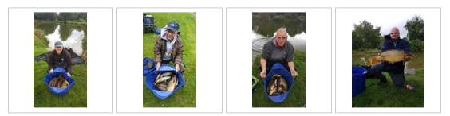

Venue: FIELD FARM FISHERY BIG BEAM AND FAR HOPE
Date: 04.09.2018

I’ll start this report the same as the last one…… Holy shit, where do I begin!

Completely the opposite context though as this match was horrendous to say the least. Horrible little fishless snag pit which we won’t be booking again unless the owner promises to reimburse us for broken poles, lost floats, snapped elastics and lost feeders!

The first leg of the pairs semi-finals was fished but I really can’t see many of them weights being used towards the totals as they were bobbins!

Section A – Far Hope Pegs 3 – 11
1st = Adrian Wood 65lb 1oz
2Nd = Andy Sonley 50lb 13oz

Well done to Ady Wood for the section win and overall win from peg 8 on far hope, Ady caught 3 decent carp at the end to secure the section win which is his 6th of the year which moves him upto 5th in the league tied on points with Andy Sonley who came second in this section with 50lb 13oz – well done!

Section B – Far Hope Pegs 14 – 21
1st = Dave Bennett 33lb 14oz
2nd = Joe Zahra 20lb 2oz

Section B on Far hope was nowhere near as good as section A and Dave Bennett managed the section win with 33lb followed by Joe Zahra on 20lb so well done to Dave who shows that when he turns up can be a contender with an average of 4 points per match his league position of 33rd does his ability no justice.

Section C – Big Beam Pegs 4 – 13
1st = Dave Coleman 50lb 0oz
2nd = Ged Smith 32lb 9oz

Section C on big beam was won by big Dave Coleman [winter league champ] with the second best weight on the lake, Dave had to chop and change methods and baits throughout the day to keep fish coming, calling on his winter fishing skills to carry on putting fish in the net whilst others sat there waiting, nice work Dave, your first section win of the season! Ged Smith came second with 32lb and finds himself 4th in the league, well done Ged!

Section D – Big Beam Pegs 15 – 19 & 47 - 51
1st = Pete Ransome 56lb 9oz
2nd = Steve Barlow 43lb 0oz

Past Master Pete Ransome turned on the skills to win section D and also put the best weight of the lake on the scales with a huge 56lb! top work Pete, showing us all that class is permenant! Second went to Steve Barlow on the flyer with 43lb, well done Steve

Section E – Big Beam pegs 21 - 29
1st = Chris Gabz 26lb 0oz
2nd = Steve Thomason 21lb 10oz

This was a terrible section along with section F – I feel sorry for the guys who drew in these 2 sections as the fishing was diabolical. Chris Gabs continues his fantastic season with his 5thsection win of the year and is now on joint points with Carl in second place, nice one Chris! Second went to Steve Tomo who had most of his fish in the first 20 mins!

Section F – Big Beam 36 - 45
1st = Phil Zahra 12lb 4oz
2nd = Stu Brown 12lb 0oz

This was really dire, I can’t remember the last time a section was won with a lower weight. Phil Zahra came out on top after loosing some big lumps he manages to pip Stu Brown to the top spot, well done guys and well done to everyone who stuck it out in this section, truly terrible fishing!

Below are the photos taken on the day:

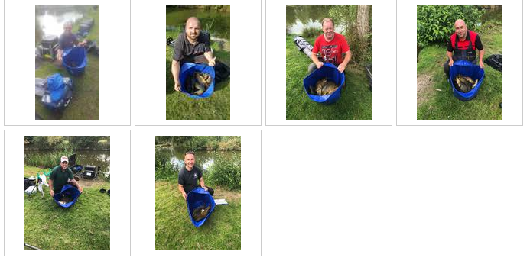

Venue: HERONBROOK FISHERIES; MEADOW AND BRIDGE
Date: 19.08.2018

Holy shit where do I begin!

Only 6 weeks or so since we were at Lindholme when all sorts of records were broken and it’s only gone and happened again! What an amazing days fishing everyone had with personal best weights being smashed all over the place (10 in total). There’s a list below of everyone who broke their PB’s and well done to them all, a top achievement and it makes all the effort of running a match club worthwhile. There was a total of 18 100lb+ weights on the day two of which managed to break the magical 200lb barrier and the overall average weight was just over 110lb per angler….. That’s including Martin Cook who left early and DNW!

Personal Best Weights:
Alan Hesling 176lb 9oz
Daz Gabz 109lb 10oz
Phil Zahra 199lb
Jason Suggett 138lb 10oz
Joe Zahra 79lb 12oz
Paul Tighe 225lb 10oz
Andy Webb 147lb 13oz
Tommy Edwards 175lb 5oz
Stuart Ford 102lb 4oz
Ste Hammerton 130lb 12oz

Once again a huge well done to everyone who broke their Personal Best weight!

The pair’s league has now come to an end and moves onto the knockout stage. There was a big turnaround at this match due to the massive weights being caught which saw Phil Zahra and Ian Clarkson jump up 2 places to secure a place in the Semi-Final – it was so close for the 4th spot with only 13lb separating 4th, 5th and 6th places! Unreal! The semi-final will now be fished across the next 2 matches with each angler posting one weight towards the final total for a place in the final. The table below shows the semi-finalists, well done to you all for making it to this stage!

Section A – Meadow Pegs 3 – 11
1st = Andy Sonley 160lb 7oz
2Nd = Jason Suggett 138lb 10oz

Andy is fresh back from a successful trip to white acres where he broke his personal best weight and also managed some frames in the opens which is a top achievement in itself so well done mate. Andy continues his fine first season with SMAC with a huge weight of carp from peg 7 on Meadow and is now in 5th place in the league which isn’t bad going at all to say he’s missed 2 matches, nice one Andy! Second in the section went to Jason Suggett who put his PB of 138lb 10oz on the scales which is absolutely brilliant, nice one Jay!

Section B – Meadow Pegs 13 – 26
1st = Adrian Wood 179lb 7oz
2nd = Andy Webb 147lb 13oz

Ady Wood made use of a load of space on peg 26 to weigh in a cracking 170lb of mainly carp caught down the edge on his trusty groundbait and dead red method to win his 5th section of the year, well done Ady! Andy Webb came second in the section and is my ‘hero of the day!’ after getting a load of abuse for his win at partridge Andy showed he’s no mug by breaking his personal best weight by some margin. 147lb is a top weight so well done mate, all caught on meat too…. Not a slice of bread in sight, not to mention beating brother Tony too hahahaha!!

Section C – Meadow Pegs 29 – 44
1st = Pete Boggiano 220lb 6oz
2nd = Carl O’Brien 153lb 9oz

What a section this was, every single weight was over 100lb with Pete Boggiano picking up his 6thsection win of the year and his second ever double ton to move himself upto first in the league for the first time this year pushing in front of Carl who was second in the section with 153lb. Pete fished shallow maggot for the majority of the match then moved into the margins to finish off and he thought he’d broke the SMAC record until the news came over from bridge that Paul Tighe had pipped him, unlucky Pete! Unluckier still was Ian Coleman who weighed in 101lb for just 1 point!

Section D – Bridge Pegs 1 – 11
1st = Paul Tighe 225lb 10oz
2nd = Daz Gabz 109lb 10oz

Section D saw a new club match record from inform angler Paul Tighe, Paul fished an almost perfect match fishing caster on the jigger at 5meters catching a fish a chuck all day. This unbelievable performance from peg 3 more than doubled anyone else weight from the section and required a massive 5 weigh ins just to put all the fish on the scales, back breaking work for strong boy Ian Clarkson, at one point Paul got bored of catching on his shallow rig and went down the edge looking for bigger fish but the sport didn’t hold up and he still caught down there. After the match he still had the strength to smash the lock of Eric Quinn’s van and beak into the back as his lock had seized up. Second in the section was the likeable Daz Gabbz who managed a fantastic 109lb smashing his personal best and putting another 100lb+ weight on the scales

Section E – Bridge pegs 13 - 22
1st = Shaun Gallagher 82lb 8oz
2nd = Chris Gabz 81lb 7oz

Section E was arguably the toughest section on the day (well by the amazing Heronbrook standards anyway) nevertheless good weights were caught throughout and the top 3 were separated by just a measly 3lb, it was the recently absent Shaun Gallagher who topped with an impressive 82lb all caught on his top kit down to his right edge on meat, second in the section was the inform angler of the season Chris Gabbz who’s weight just fell short of Shaun’s by 1lb 1oz or one fish, big Ian just missed out on the top 2 with 81lb 5oz however he’s made it into the pairs semi-finals which he’s over the moon with

Section F – Bridge pegs 23 - 30
1st = Phil Zahra 199lb 0oz
2nd = Alan Hesling 176lb 9oz
Section F was another amazing section with the top 3 all smashing their personal best and all catching over 175lb, Phil Zahra topped the section with 199lb dead catching on the jigger and short pole, although he couldn’t of been happier he dropped in a small F1 trying to prove to Tommy Edwards that he wasn’t catching carp earlier on in the match which could of took him over the magical 200lb barrier. 2nd in the section was Alan “VAN” Helsing who fished an epic match shallow and down his right margin with groundbait finishing the match with and unbelievable 176lb 9oz just beating Tommy who finished with 175lb 5oz. Unreal really considering the huge weights were only separated by 1lb 4oz. Final mention in this section goes to Eric who drew the flyer corner peg 24 and only managed 49lb 14oz for last in the section unlucky mate, they must of moved away with all the shouting you do

Below are the photos taken on the day:

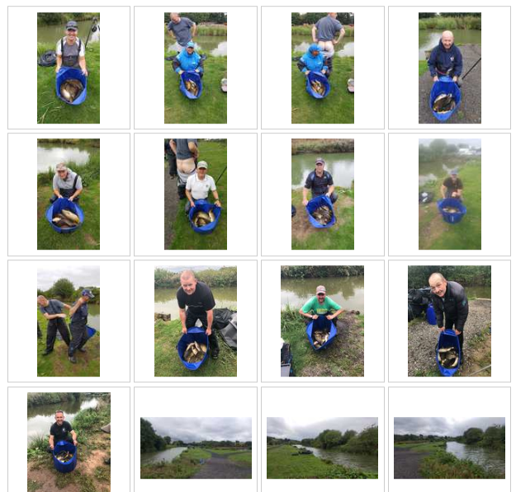

Venue: BORDER FISHERIES MATCH LAKE AND SPECIMEN LAKE
Date: 05.08.2018

Another gorgeous summer’s day greeted 31 SMAC anglers for the 9th match of the 2018 season. The Border fisheries complex is probably one of the most picturesque, well-kept fisheries on our match calendar with some very nice views! We were split across the Match Lake and Specimen Lake with plenty of space for everyone. The Match lake has been used a couple of times in the past and pretty much everyone was hoping for a draw on there as the Specimen Lake was a complete unknown entity. The Match Lake ended up fishing pretty well with some good weights showing but the Specimen Lake was pretty poor to be honest with only 36lb winning the lake! Oh dear!

There’s one more match to post a weight in the pairs competition and things are changing around for the 3rd and 4th place positions with everything to play for at the next Heronbrook match….. usually a big weight venue which could throw up a few upsets!

Section A – Match Lake Pegs 2 – 10
1st = Ian Clarkson 70lb 6oz
2Nd = Gary Marsland 59lb 2oz

Section A on the match lake is a renowned skimmer area – Gary Marsland picked up second in the section with 59lb of them! What a weight of silvers, nice one Gary, bet you still stink of skimmer slime now! Ian Clarkson topped the section from a very fishy looking peg 10 with lilies knocking like mad at the start of the match Ian made the most of his peg to weigh in an impressive 70lb of mainly carp caught to the lilies, well done Ian….. will you consider going in the pools soon?

Section B – Match Lake Pegs 13 – 24
1st = Carl O’Brien 93lb 3oz
2nd = Rodger Dimmock 50lb 5oz

Carl O’Brien continues his run at the top of the league with a superb performance from peg 16. Carl fished the majority of the match in the margins to win the section by a comfortable margin of 43lb, this is Carl’s 5th section win on the trot – is anyone man enough to take him down? Rodger Dimmock gave it a good crack and fished a top match which also pushes himself and partner into third spot in the pairs, nice one Rodger a great days fishing!

Section C – Match Lake Pegs 26 – 34
1st = Pete Boggiano 135lb 13oz
2nd = Phil Zahra 98lb 1oz

Pete Boggiano knows this water reasonably well and knew the margins would play a big part in a winning weight, Pete fished a traditional waggler for the first 2 hours and took about 30lb into the closing stages of the match which was when the margin munters tuned up and Pete put just over 100lb in the net in the last 3 hours which was enough for his first overall match win of the year and keeps him on joint points with Carl at the top. Phil Zahra can’t seem to catch a break this year – after finishing 3rd in his section at lindholme with a huge weight he now finishes second overall in the match but only got to pick up 5 points as he also came second in the section, unlucky mate but well done on a cracking weight!

Section D – Match Lake Pegs 36 – 46
1st = Tony Webb 81lb 1oz
2nd = Alan Hesling 62lb 10oz

Tony Webb had about 10 carp mulling about right at his feet before the all in, it was unreal! They didn’t seem to mind him setting up and chucking his net over their heads! Maybe they knew who it was and thought they must be safe cos he’s useless! It turns out he managed to snare a few to win the section – once again making the most of very active margins, nice work Tony! Well done to Alan Hesling on picking up second place only 9oz in front of Mick Abdy!

Section E – Specimen Lake pegs 2 – 10 & 26 - 27
1st = Chris Gabz 36lb 10oz
2nd = Joe Zahra 16lb 2oz

The guys on the specimen lake had a much tougher day with the fishing being nowhere near as good as the match lake. Chris Gabz continues his fantastic season with another section win, his 4th of the season and also a Lake win to boot. Chris finds himself in 4th position in the league after only dropping out of the top 2 in his section 3 times this year – it’s the sort of consistency which earned Steve Tomo the valued runner up trophy last year; can Chris go one better in 2018?! Second place went to Joe Zahra who lost a load of big fish resulting in a very low section second weight of 16lb, well done for sticking it out guys!

Section F – Specimen Lake pegs 17 – 24
1st = Steve Tomo 35lb 0oz
2nd = Ged Smith 29lb 11oz

Steve Tomo seems to be finding some really good form at the minute and has another section win under his belt – another poor performing area was won with only 35lb which is a shame as walking round the lake before the match I really thought a big weight or two could be had. Ged Came second in section F dropping a point which means he leaves the top spot for the first time in 4 matches – let’s see if he can pull it back at Heronbrook!

Below are the photos taken on the day:

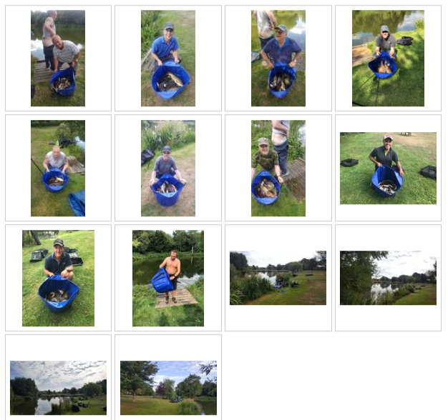

Venue: PARTRIDGE LAKES: COVEY 6 AND RIBBON
Date: 22.07.2018

After a recent long dry spell with the hottest summer since ’76 turning up at a match with a misty rain in the air was actually a relief! Tony Webb still put his umbrella up though because he’s a massive pussy. Another huge attendance saw 37 anglers at the draw which was a bit strange with almost everyone hanging back waiting for ribbon to be filled up before putting their hand in the bag, it turned out to fish pretty well though with 2 out of the top 4 weights coming from this lake…. Shows what we know eh!

The word from partridge recently has been shallow, shallow, shallow….. maggots or caster doing the damage and plenty of them, this was the approach adopted by most but it was pretty tough going up in the water with bites coming thick and fast one minute, then drying up for long spells, strange really must have been the touch of rain pushing them down a bit….. Either that or we’re all shit at shallow fishing!!

A quick Word on the pairs and the team leagues before the report:

Pairs League – the top 4 are now highlighted as the pairs in the top 4 places after match 10 will go into the semi-final which is fished over matches 11 and 12 with each anglers best weight from one of the two matches going towards their total for a place in the final which is fished on either match 13, 14 or 15. Each angler’s worst 2 weights from the first 10 matches are yet to be included in the total so things could change when this is included after the next match!

Teams of 4 – the top 3 teams are highlighted as the top 3 teams get paid out at the end of the season. The points are run in direct correlation to the main league and the competition runs until the end of the year so 7 matches to go it’s all to play for!

Section A – Covey 6 Pegs 133 – 136 & 165-166
1st = Andy Webb 95lb 6oz
2Nd = Steve Hammerton 45lb 2oz

Massive day for Andy Webb, after joining the club last year the best result Andy has managed has been a couple of section seconds, unlucky at the time to come out on top…. Not this time though. Andy put in a mega performance from peg 133 fishing punched bread over micros down the margin to put his highest ever match weight on the scales at 95lb 6oz which wasn’t only good enough for a section win but good enough to top the match overall which is brilliant mate, well done and unlucky not to get the magic ton!! Second in the section went to Ste Hammerton who made the most of a good draw to fatten his wallet even further with the massive £10 winnings for second place

Section B – Covey 6 Pegs 138 – 146
1st = Pete Boggiano 73lb 2oz
2nd = Andy Sonley 62lb 14oz

Section B was an interesting section having 2 of the current league leaders pegged next to each other. A cracking match ensued with Andy and Pete battling it out for the 6 points. Andy opted to fish for carp in the mudholes of peg 140 with groundbait and maggots and Pete went down the shallow route. It was a close finish with both claiming 50lb at the weigh in, Pete swearing down to telling the truth but is obviously full of shit. Andy can’t be accused of being full of shit but those clickers definitely are!

Section C – Covey 6 Pegs 148 - 155
1st = Ged Smith 61lb 13oz
2nd = Tommy Edwards 46lb 7oz

Ged Smith nearly had a disaster when loads of his casters were floating before the all in… he managed to skim off the floaters and fished a good shallow match from the wrong end of the lake to claim his 5th section win of the season securing his place in the top spot in the league shared with 2 others, nice one Ged! Tommy Edwards came second with his 4th section second place on the bounce but continues a proper solid start to the season with a healthy average to take into the second half of the year.

Section D – Covey 6 Pegs 157 - 163
1st = Carl O’Brien 83lb 2oz
2nd = Gary Marsland 33lb 12oz

Carl O’Brien continues an impressive run with 4 section wins on the trot. Carl was struggling until the last hour when he fished a short paste line to pick up a steady run of 18 F1’s to top the section and is holding onto the top spot being over 100lb in front on weight! Well done Carl. Second in the section went to Gary Marsland who’s fresh back from holiday and now up to 10th in the league, nice one Gary!

Section E – Covey 6 Pegs 167 - 173
1st = Steve Tomo 77lb 1oz
2nd = Tony Webb 56lb 14oz

It was a battle of the mouths in section E. Over the bridge Tomo and Tony carried on their verbal abuse of each other following on from the first match of the year, Tomo giving it the big gob for the first two hours whilst he was catching, then the noise shifted down to Tony’s end of the spit when his chub disappeared and some decent fish turned up…. After he put his granny brolly down cos it was spitting. Pussy. Tomo came out on top with a well put together 2 hour 77lb and Tony came second with a lucky 56lb. I’ve no idea how either of them fished as I couldn’t bring myself to ask them cos I’d heard enough of them both throughout the day!

Section F – Ribbon Pegs 2 - 10
1st = Jason Suggett 79lb 4oz
2nd = Alan Hesling 47lb 5oz

Everyone wanted to avoid drawing on Ribbon after the poor weights earlier in the season, but ten people did, and it did fish reasonably well, but can never match the catches from the Coveys.
Section F on Ribbon was won by in-form Jason Suggett from peg 20, next to the lake winner, with 79-4. When you’re drawn on fish, you’re drawn on fish! All credit to J, he fished a tidy match. Alan Hesling was 2nd in section with 47-13 off peg 8, mainly F1s tight across again, only a large F1 ahead of Mick Abdy on 10 who had 43-5, who caught across and on the Zhara paste line later in the match.

Section F – Ribbon Pegs 12 - 20
1st = Ady Wood 89lb 13oz
2nd = Eric Quinn 38lb 12oz

Ady Wood won the lake fishing dead reds over ground bait for 89-13 off peg 20, mostly F1s across. Second in this section was Eric Quinn, recovering from a hernia operation to tip a painful 38-12 on the scales, again F1s from across to a far bank rush bed on peg 12. Highlight of the day was a smallish carp that pulled Phil Topham’s feeder rod off his rest and into the drink when Phil was “otherwise occupied” making up rigs just off his box. That was his excuse anyway. Apparently he’s got form for this happening and it’s not the first time he’s potentially waved goodbye to £200-worth of rod and reel combo. It did have a happy ending after the match though, when throwing out part of a trolley on some borrowed rope he managed to retrieve the rod. Happy days, it made up for almost coming last in the section with 11-4!

Below are the photos taken on the day:

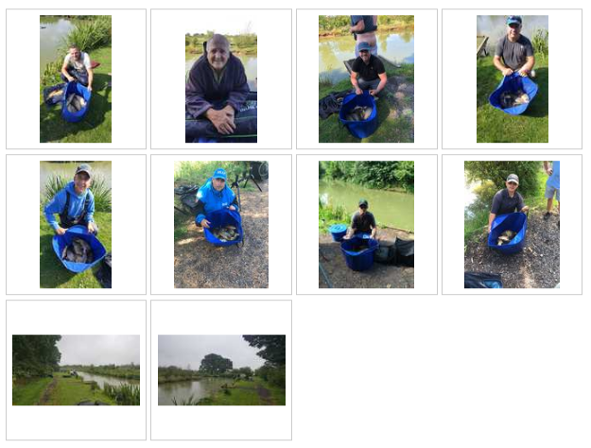
Venue: LINDHOLME LAKES: STRIP AND BEECHES
Date: 08.07.2018

Well what a red letter day for most of the 30 anglers that attended the 7th Match of the SMAC 2018 season! Proper record breaking match with 12 ton+ weights, close to 2600lb of fish caught and a new SMAC individual match record was broken and then broken again! Several anglers managed their personal best weights also! Unbelievable fishing with an average of 86lb per angler, not to mention the flies, the pesky roach and some numpty dropping all his gear in the lake and having to swim around to recover it hahaha!!

The individual league has now had dropped points added as we are halfway through and it makes for very interesting reading, the top 5 anglers are all on the same points with only weight separating their positions and the top 10 in the league are only split by 4 points, it’s going to be a tight second half of the season for sure!

Section A – Strip pegs 2 – 12
1st = Chris Gabz 169lb 7oz
2Nd = Ian Clarkson 137lb 1oz

What an unbelievable weight from Chris to win section A! This broke the current SMAC match record by just over 10lb! Chris had most of his fish short on the paste line which was a method used by loads on the day, this is a new personal best for Chris and will surely be a day for him to remember, well done buddy this moves you into the joint top spot in the league amongst 4 others! Second in the section went to Ian Clarkson with another personal best weight of 137lb 1oz well done Ian, cracking weight! A word must be said for Paul Tighe who weighed in 133lb even though he dropped his gear in and also Dave Bennett who had a 17lb 7oz carp on his first put in which is going to be a tough one to beat for the biggest fish award and he also weighed in 100lb for 4th in the section! Unreal! Well done everyone!

Section B – Strip pegs 14 – 24
1st = Phil Topham 152lb 3oz
2nd = Tommy Edwards 82lb 2oz

Phil Topham is having an great season so far, this is his second 150lb+ weight and his 3rd section win of the year which moves him upto 8th in the league in the tightly spaced chasing pack, Phil started on the method feeder and then moved onto the paste line to make up his cracking net of fish, well done Phil. Tommy Edwards keeps the ball rolling with another solid performance and has now dropped more points than any other angler which is a good sign for later in the year, this means for the time being, Tommy is just out of the top 5 but I’m sure that will change before too long, keep it up team mate!

Section C – Beeches pegs 1 - 6
1st = Carl O’Brien 127lb 6oz
2nd = Stu Brown 79lb 13oz

Last year’s champion Carlos O’Brien had a slow start to 2018 but already finds himself topping the league, with his first 2 matches dropped and in the bin Carl is 100% focussed on retaining his title which is bad news for everyone else! Carl started shallow but got fed up of catching stockies and then moved onto his paste line and destroyed the section handsomely, well done Carl. Second in the section was big Stu Brown who had the majority of his fish on the method feeder across to some trees on the far bank, nice one Stu!

Section D – Beeches pegs 8 - 15
1st = Derek Wood 102lb 15oz
2nd =Pete Boggiano 102lb 10oz

OOOOOOHHHHH this was a close one!!!! Derek and Pete fought out a great battle throughout the match both anglers fancied it shallow but it just wasn’t happening, Derek went down the edge early on and Pete followed suit shortly after both getting pestered by tiny roach but both anglers managed to crack the 100lb barrier and only 5oz separated them! Well done guys a great battle!

Section E – Beeches pegs 16 - 26
1st = Andy Sonley 156lb 7oz
2nd = Tony Webb 98lb 14oz

If Andy Sonley’s clickers were to be believed we would have witnessed the first ever SMAC 300lb+ weight….. LOL just kidding Andy – you really need to calibrate your clicker finger though and stop putting 1lb down for them 6oz roach…. Relax, don’t do it, think of Tony Webbs arse and hold it in man! Andy, who’s been renamed ‘Muggy Andy’ fished his favoured method mugging carp all over his peg 4” deep to weigh in his personal best weight of 156lb 7oz which moves him into second place in the league…. What a guy! Nice one mate, you’re brilliant….. When will my hooklengths be ready???? Second in the section was another over excited angler in Tony Webb who had a half hour battle with a ‘20lb’ carp only to find out at the weigh in it would barely even register on the scales! Tony fished a great match to come close to the 100lb mark and now finds himself 9th in the league only 2 points of first place though! Steve Tomo would have pushed Tony closer but his 3rdnet dropped in which apparently had 100lb in it?!

Section F – Beeches Pegs 27 - 37
1st = Ady Wood 187lb 3oz
2nd = Ian Coleman 136lb 8oz

There are 3 signs to tell when Ady has had a good day:
- He follows the weigh in round and doesn’t disappear in a cloud of smoke
- The angler to his right looks suicidal as he’s had running commentary on every fish
- The angler to his left looks suicidal as he’s had running commentary on every fish
All joking aside though this is an amazing performance from Adrian, Chris Gabz broke the record first and then it was beaten again with a huge weight of 187lb 3oz, nice one Ady what a day! Ady fished dead reds and groundbait into a newly dug mudhole to his left and took first place overall in the greatest SMAC match of all time! Well done Ady nice one. Ian Coleman put his personal best weight on the scales with 136lb 8oz only good enough for second place, congratulations Ian! And Phil Zahra came back to life but could only manage 3rd in his section with 122lb 15oz. Bizarre!

A massive well done to everyone who broke their own personal records and a big thanks to everyone for making the extended journey…. I’m sure you’ll all agree it was worth it…. Even Daz gabz who came last on the day picked up a free rod from Lindholme so well done Daz and thanks to Lindholme for the donation!

Below are the photos taken on the day

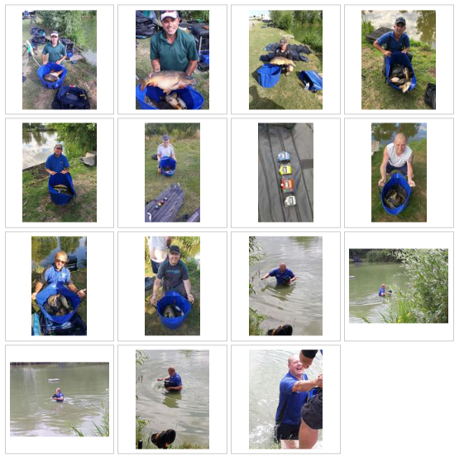

Venue: HAMPTON SPRINGS – MEADOW, LONG ISLAND & OASIS
Date: 10.06.2018

A bright sunny day greeted 32 SMAC members for match number 6, the last match on the calendar before a month break for the annual fishing holiday break at Manor Farm Leisure which we are all looking forward to! Before I go into the report I’d just like to wish Carl O’Brien the best of luck in the clubman championship final at Barston Lakes this week – he’ll be flying the flag for South Manchester Angling Club and we all hope he lifts the title, either way he’s done us proud being the first SMAC member to make it through, nice 1 Carlos!!!

After last years’ match everyone was hoping to avoid the strip section on Long Island and not many were keen on drawing Oasis pool even though the winning weight came off there last year! There was loads of space with 3 lakes offering us 86 pegs to really spread out the pegging and even though the fishing wasn’t amazing for most it was a lovely summers day to be on the bank.

Section A – Meadow pegs 1 – 13
1st = Ged Smith 59lb 5oz
2Nd = Paul Hirst 49lb 6oz

Ged is flying high this year and moves himself upto the top spot in the individual league with his 4th section win on the trot, Ged is also topping the pairs league with new member Andy Sonley although their weight has been caught up slightly after they were way in front after the last match. Ged fished a tidy match to win his section and also post the highest weight on Meadow pool, well Done Blue! Second in the section and also second on the lake was Paul hirst with a 49lb catch to be proud of!

Section B – Meadow pegs 17 - 30
1st = Pete Boggiano 33lb 12oz
2nd = Tommy Edwards 28lb 4oz

Pete Boggiano drew what looked to be a stonking peg with fish cruising all over the place – it turned out they weren’t interested in feeding at all which resulted in a very low section winning weight from a hard, but closely contested section. Second place went to Tommy Edwards, who’s recent birthday lesson from Jamie Hughes has started paying back already.

Section C – Long Island pegs 3 - 14
1st = Steve Barlow 90lb 6oz
2nd = Chris Gabz 34lb 13oz

A cracking weight of 90lb won the dreaded strip section on long island which was posted by new member for 2018 Steve Barlow, this is his first section win for Steve after a run of second place finishes so well done mate, a cracking weight from a terrible section (trust me I know how bad it can be!) Chris Gabz continues a fine start to the year and marches on to 4th in the league with 27 points and 228lb to his name it’s a great foundation for it all to go downhill from here LOL!

Section D – Long Island pegs 16 - 27
1st = Carl O’Brien 122lb 6oz
2nd = Jason Suggett 69lb 5oz

Carl is getting into the zone for his Barston final with an immense weight of bomb and pellet waggler fish from fancied peg 16, points wise Carl hasn’t had a great start to the year and finds himself in 5th place at the moment – he has however caught 65lb more fish than anyone else which shows he’s definitely going to be in the running later on in the year. Carl is the 5th person this year his name added to the SMAC 100lb+ hall of fame which is currently the 3rd time he's on the list - definitely not the last! Jason Suggett missed out on the flyer but managed to nick some fish to put an impressive 70lb on the scales for second in the section, well done Jay.

Section E – Long Island pegs 29 - 39
1st = Ste Hammerton 62lb 4oz
2nd = Martin Cook 57lb 2oz

Another new member for 2018 picked up his first section win of the year from peg 37 on long island, Ste has had a great start to the year and finds himself in 6th place in the league – hope you can keep it up buddy! Martin Cook fished his last match before heading off to get married so we may never see him again LOL! Martin pushed Ste close for the top spot but missed out narrowly, unlucky mate!

Section F – Oasis Pegs 1 - 15
1st = Andy Sonley 46lb 7oz
2nd = Phil Topham 26lb 14oz

Andy Sonley drew last year’s winning peg and managed to top the lake with carp caught across on pellet and he also managed to mug a few to top up his 46lb weight from an unfancied lake, well done Andy, another new guy who’s started with a bang! Phil Topham came second on the lake with 27lb so well done to him!

Below are the photos taken on the day
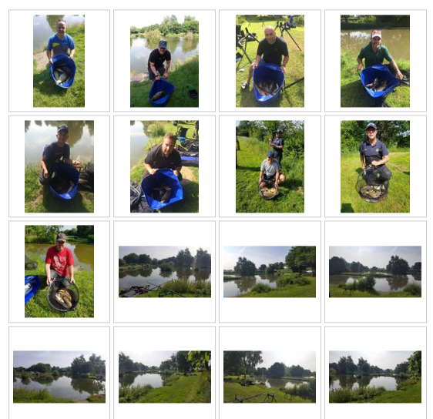

Venue: HERONBROOK – MEADOW & ISLAND
Date: 27.05.2018

Our first outing of the year to the ever popular Heronbrook fisheries was set to throw up some big weights, 34 members attended with the majority hoping to draw on Meadow which generally shows better form. Strangely enough it was one section on Island which tested the scales as you’ll read below. The average weight of 56lb per angler proves why this fishery is one of our favourites!

The first phase of the pair’s competition is halfway through now with Andy Sonley and Ged Smith flying high at the top with the next 6 only separated by 100lb it should be tight as to who finishes in the top 4 for the semi-final places. The teams of 4 competition is looking good also with team Boggiano/Edwards/Quinn/D Gabz out in front and only 10 points separating the next 5 teams – we’re only 1/3rd of the way through this competition yet though so a lot can happen between now and the end of the season!

Section A – Meadow pegs 1 – 11
1st = Tommy Edwards 86lb 5oz
2Nd = Ste Hammerton 59lb 9oz

Tommy Edwards rarely smiles but when he drew peg 9 on Meadow nothing could hold back the grin on his face, he literally sprinted to his peg knowing it was fishing well after recent reports from practice sessions during the week. Tommy didn’t disappoint and topped the section with what would have been the best weight on the lake had he not been docked 2lb 6oz for going over in one net, well done Tommy a cracking start to the year see’s you in second place in the individual league. Well done also to Ste Hammerton who wasn’t overly keen on the idea of being pegged between Tommy and Carl but managed a second in his section with 59lb. Nice one.

Section B – Meadow pegs 13 - 23
1st = Carl O’Brien 86lb 14oz
2nd = Tony Webb 86lb 2oz

Carl made up for being ounced out at the last match by ouncing out Tony Webb in this match which is something we all enjoy doing! Carl seems to be finding his form again after a rather shaky start to 2018 following on from his title last year….. That lesson with Jamie Hughes seems to be paying off already, oh sorry Carl I didn’t know it was a secret hahaha! Well done to Tony also who I usually give loads of grief to but he helped out this week so he’s safe xx

Section C – Meadow pegs 25 - 32
1st = Ged Smith 80lb 3oz
2nd = Steve Tomo 71lb 3oz

Ged Smith is now flying high in the league just behind Tommy on weight after a string of 3 section wins takes him to 23 points also. After a bit of a shaky start to the year Ged is showing us he’s got all the gear and potentially a bit of an idea also – let’s see what the rest of the season holds and if he gets through 9 poles and 25 seatboxes again! Well done to Steve Tomo on the section second who’s another top scorer from last year who has had a poor start by his standards.

Section D – Meadow pegs 34 - 45
1st = Daz Gabz 70lb 2oz
2nd = Rodger Dimmock 52lb 14oz

Daz Gabz pulled out the bonus peg 34 which looked awesome and when he put 70lb 2oz on the scales some tight bastard [no prizes for guessing who] told him he’d won the bonus money….. out of order LOL!!! Just to rub salt in his wounds Ged had his picture took with Daz’s fish for his section win only to launch them back before Daz had his chance, on dear hopefully the section win made up for all this Daz! Second Place was Rodger with 53lb from peg 40; well done Rodge nice work partner!

Section E – Island pegs 1 - 7
1st = Pete Boggiano 70lb 15oz
2nd = Andy Webb 39lb 14oz

Probably the worst performing section of the day with very little ripple on the water and the wind blowing the wrong way for most pegs was topped by Pete Boggiano who struggled for 4 hours before plundering the margins to weigh in some big old munters for 70lb. Well done to Andy Webb for his second place narrowly beating Dave Coleman off the next peg

Section F – Island pegs 11 - 20
1st = Andy Sonley 125lb 04oz
2nd = Gary Marsland 121lb 13oz

The Big surprise on the day was section F on Island where 3 tons were recorded, first Ady Woods weighed in 118lb, then Gary Marsland weighed in 121lb then Andy Sonley blasted it with 125lb! Mental! Andy fished a cracking match dobbing some huge fish in the first hour one of which snapped his elastic with the next 5 hours picking off the odd fish from here and there, top weight mate, really good performance which won the match on the day. Well done to the others in this section who tonned up you’ll all be on the SMAC hall of fame!!

Below are the photos taken on the day [sorry Daz!]

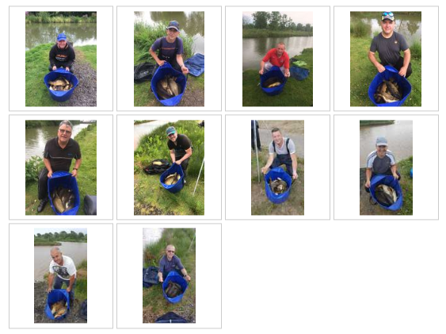

Venue: PARTRIDGE LAKES – COVEY 6 AND RIBBON
Date: 13.05.2018

35 Members joined us for match 4 of the 2018 calendar at Partridge lakes utilising Covey 6 and Ribbon where 7 sections were used for the first time, 5 men in each section with 10 on Ribbon and 25 on Covey 6. The weather was lovely for sitting in the garden drinking beer but hardly perfect for fishing with bright sunshine and a cool breeze only hitting parts of each lake with any consistency, this meant some areas hugely out fished others.

Section A – Covey 6 pegs 133 – 136 & 165 - 166
1st = Ged Smith 90lb 14oz
2Nd = Tommy Edwards 66lb 13oz

Section A on covey 6 saw the largest average weight recorded on the day with most anglers opting to fish caster shallow following on from recent reports that this method was doing the damage. Ged Smith picks up his second section win on the bounce with a cracking weight of 91lb caught shallow under the bridge whilst Tommy Edwards fought off close competition from Dave Bennett to pick up second place.

Section B – Covey 6 pegs 138 - 146
1st = Eamonn Bolger 31lb 6oz
2nd = Ste Hammerton 30lb 12oz

Eamonn Bolger picked up his first section win with SMAC registering 31lb 6oz from peg 140 down the back stretch which is usually the most difficult area of this lake so well done to him on that achievement and also well done to Ste Hammerton with a well-earned close second with 30lb 12oz – not far behind!

Section C – Covey 6 pegs 148 - 155
1st = Daz Gabz 18lb 14oz
2nd = Martin Cook 14lb 10oz

Section D was a really tough section with some very low winning weights. Daz Gabz picked up the victory from peg 151 which I think may also have been his first SMAC section win but not 100% sure so a massive well done to him! Martin Cook came second continuing a solid start to the year which sees him take the top spot in the individual league on weight. Well done guys!

Section D – Covey 6 pegs 157 - 163
1st = Ady Wood 31lb 14oz
2nd = Phil Zahra 20lb 1oz

Ady Woods topped section D with a good performance yet again scratching around to weigh in a respectable weight for the area and Phil Zahra picks up his first section frame of the year which is a very disappointing start for the multiple title winning SMAC legend!

Section E – Covey 6 pegs 167 - 173
1st = Gary Marsland 55lb 11oz
2nd = Steve Thomasobn 29lb 10oz

Gary Marsland continues a cracking start to his first season with SMAC picking up his 3rd section win on the trot with a top performance off peg 172 weighing in a net full of carp caught on caster on his top kit! This moves Gary onto joint points with Martin at the top of the table only behind by 3lb on weight. Well done Gary. Second went to Steve Tomo off the next peg with 29lb made up of mainly silvers.

Section F – Ribbon pegs 2 - 10
1st = Pete Boggiano 40lb 11oz
2nd = Carl O’Brien 40lb 5oz

Pete Boggiano was back in action after missing the last match and ounced out last year’s champion Carl O’Brien to take the top spot in section F on Ribbon. Pete and Carl both fished similar tactics including worms and casters but trying to get a run of fish together was very difficult. Pete won the section with a foul hooked 6oz stockie which leapt from his net as he landed it but was safely landed the second time – jammy bastard!

Section E – Ribbon pegs 12 - 20
1st = Tony Webb 29lb 2oz
2nd = Chris Gabz 6lb 0oz

This was a horrific section! I really can’t believe how bad it fished – walking round doing the weigh in I had to be on suicide watch with 4 out of the 5 anglers failing to register double figures; Phil Topham followed his record breaking catch from the last match with 2lb 2oz!!! Steve Barlow only had 1 fish all day and that was on his first put in and Derek Wood who can usually whittle fish out of thin air in tough conditions really struggled too! Chris Gabz came second in the section with just 6lb and Tony Webb won it with 29lb which was where they must have all been hiding! Unlucky draw guys and well done for sticking it out!!

Below are the photos taken on the day

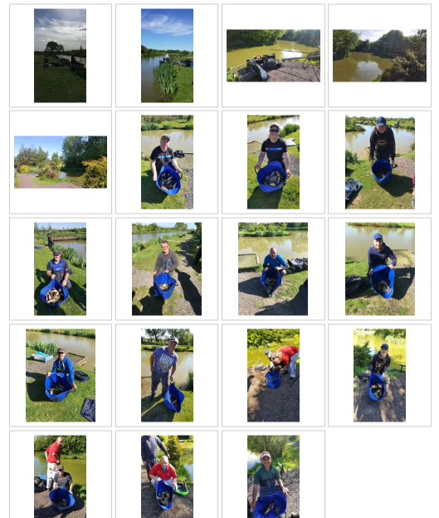

Venue: HALL LANE BESS’S

Date: 29.04.2018

The third match of the 2018 season took us to the immaculate hall lane fisheries on the popular bess’s lake, having booked 50 pegs we was again told that there was another match on the remaining 25 pegs and again same as last year the other club didn’t show which makes me believe that the owner doesn’t want us spread about so just tells us that there’s another match on? It was another cold day with a strong north easterly wind and with reports of both good and bad previous match weights over recent weeks most of us wasn’t sure what to expect. Another unbelievable turn out of 37 anglers made some pegs quite tight but everyone was up for it so it was game on

Section A –Pegs 1-11
1st = Ged Smith 59lb 5oz
2Nd = Steve Barlow 49lb 3oz
3rd = Jay Suggett 42lb 4oz

This was the most fancied section of the lot and getting his hand in the bag early Ged pulls out the dolly peg 1 “decent draw at last” he said to me and he didn’t disappoint catching mainly carp at 14 meters down the edge Ged wins his 1st section of the season, 2nd in the section and his 3rd on the bounce was new boy Steve catching on the far shelf with pellets which shoots him into 1st position in the league with 15 points, definitely one to keep an eye on well done chaps

Section B – Pegs 12-22
1st = Phil Topham 147lb (161lb 11oz)
2nd = Carl O Brien 74lb 8oz
3rd = Dave Coleman 35lb 6oz

Yes you read that right a massive 161lb, committed smac and steering group member Phil absolutely smashes the match catching all his fish from peg 12 on the feeder and didn’t once pick up his pole, unfortunately for Phil 2 of his nets went over the tiny 50lb net limit rule that hall lane enforces which means they are docked down to 50lb but you can’t take nothing away from this guy the last 2 years has seen Phil go from strength to strength I don’t think there’s a better angler in the club if there having it on the tip. A new personal best weight for Phil and not taking into consideration the 14lb he’s been docked this is the best match weight caught by any member of a smac match ever and it just gets better this Huge haul of fish was caught in a match 1/2 hour less in duration than the 3 previous highest weights. Well done mate epic performance from a top bloke 2 section wins from 2 matches I’ll put money on you finishing in the top 5 this season.
2nd place went to last year’s champion Carl who’s finally found his form catching all his fish on the far bank from peg 18

Section C – pegs 24 to 31
1st = Gary Marsland 18lb 8oz
2nd =Paul Tighe 16lb 7oz
3rd = Ady Wood 15lb 6oz

Section C was by far the worst preforming section on the day which is surprising as reports from the lads said that early in the morning before the draw it was solid with carp sucking the scum from the top of the water. Nevertheless last matches overall winner Gary fished a tidy match from peg 30 catching anything that swims on his favourite chopped worm method giving him an impressive joint 3rd league position just beating Paul Tighe from the peg next door but one fishing a similar method, Paul’s carp switched on in literally the last 15mins of the match but it’s was to late to catch up Gary

Section D – pegs 33 to 41
1st = Martin Cook 75lb 3oz
2nd = Ian Coleman 72lb 1oz
3rd = Joe Zahra 55lb 4oz

Martin fished peg 35 and pulled out the 2nd best overall weight on the day catching carp on the far shelf, this now boost him into 2nd place in the league just 1 point behind Steve Barlow excellent skills mate, This is a solid performance from a historically poor area and beating off very close competition from club treasurer Ian on the next peg along who also caught long swapping from corn and expander the keep bites coming after a poor start.

Section E – pegs 43 to 50
1st = Tommy Edwards 70lb 4oz
2nd = Eric Quinn 29lb 10oz
3rd = Paul Pannett 28lb 15oz

Tommy pulled out end peg 50 and took the section by storm catching carp on pellet down the track, it’s not often you see him with a smile from ear to ear but after taking home cash from the section and super pools with 6 points to got with it he was all smiles on the journey home, a great win catching carp in a different style to everyone else from the deep water, Tommy’s 1st section win makes him jump up into top 10.
2nd on the day was the inform Eric catching anything that swims from corner peg 49 this shoots him into joint 2nd place just behind Martin on overall weight

Below are the photos taken on the day [apologies to Gary Marsland for missing yours out]

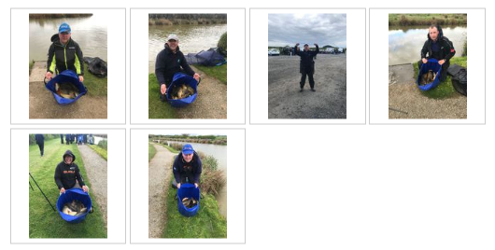

Venue: OLD HOUGH FISHERIES; UPPER BENBO, PROSPECT & GOOSE

Date: 15.04.2018

The highest turnout for a SMAC match in recent years saw 38 out of 40 members attending Old Hough fisheries which was split across 3 lakes; Upper Benbo, Prospect and Goose. Most at the draw were fancying Upper Benbo with some decent weights the day before on the open and the car park side was, as always the sought after area. With a cold, strong wind blowing across the lakes fishing was really difficult for most and presenting a bait to the far bank was nigh on impossible on the pegs where the wind was hitting the worst.

As it turned out Upper Benbo was a big disappointment with some really low weights from the usual hot pegs and the winning weights in both sections A and B came from the complete opposite end than expected. The other two lakes were just as tough with only one or two pegs producing decent weights. Fishing in spring is always a bit odd, the fish never seem to settle into a regular feeding pattern or depth and after the winter we’ve had it’s not surprising it’s taking longer than usual for the fish to get their heads down to feed.

The teams of 4 competition is off to a good start and as the draw was seeded so well it’s looking like it could be a really close competition with only 10 points separating the entire league; hopefully it will stay this close throughout the year and we’ll enjoy a nice climax to the first year of this competition. Climax….. Love that word, oooo eeeerr missus.

Section A – Upper Benbo Pegs 1-12
1st = Phil Topham 59lb 6oz
2nd = Stuart Ford 36lb 12oz

Travelling companions Phil and Stu attended their first match of 2018 after missing the first due to smashing the opens down at whiteacres and both managed to frame in section A from pegs 12 and 6 respectively. As the rain was pouring down I didn’t get chance to ask the guys how they caught but I’d wager a tenner Phil caught on the method feeder and Stu caught down the margins on Paste. After a cracking season last year Stu is now the go to man in the club for paste advice [Mr Zahra may need to see you soon haha] and Phil Topham is steady away no fuss, no messing – cast out the feeder and smoke 20 fags, easy this fishing lark isn’t it! Well done spud guy’s.

Section B– Upper Benbo Pegs 13-24
1st = Gary Marsland 60lb 8oz
2nd = Jason Suggett 36lb 2oz

New Member Gary Marsland tipped 60lb on the scales which picked up his first section win and also an overall match win from peg 13 which he fished in the winter league but through 2ft of ice! I’d like to say conditions were a bit better for this match but they weren’t – well done Gary, a great performance. Jason Suggett puts his hand in the bag and pulls out the peg you’d choose to pleasure fish if you had the entire fishery to go at; and he does it every time…. How he does this nobody knows, maybe we’re all afraid to say he can actually fish a bit…. Errrrr no chance, he’s just a drawbag – no wonder he’s got all the best gear, bet he wins the lottery every week. Just kidding Jay, great performance from the wrong end of the lake, well done buddy.

Section C – Prospect pegs 1 to 8
1st = Ady Wood 48lb 5oz
2nd = Pete Boggiano 43lb 14oz

Ady Woods fished his first match of the year after missing the first one due to attending the high vis vest sales at Matalan, fortunately he was sat far enough away from me so I didn’t have to hear how he caught every fish as he landed it; oh my God did I just say that out loud?! Well done Adrian – definitely a title contender this year. Pete Boggiano came second - according to the ladies he always comes second, boom!

Section D – Prospect pegs 9 to 16
1st = Ian Clarkson 24lb 8oz
2nd = Alan Hesling 12lb 1oz

Well, what a shit section this was! With some class anglers along the bank not troubling double figures it’s a sure sign the section was low on fish numbers. Lanky Bollocks Clarkson didn’t enter the pools due to the pressure of potentially winning a life changing £35 getting into his head to much, this resulted in a much calmer approach and also resulted in a section win…. Come on bully, show us what he could have won! Alan Hesling continues his steady start to the season with his second section second and he’s second in the league, hang on a second, how many times can you type second in a sentence?! Well done to all the guys in this section, it really was shit.

Section E – Goose pegs 1-5 & 17-18
1st = Eric Quinn 32lb 5oz
2nd = Ian Coleman 28lb 6oz

Contrary to popular belief when Eric is catching fish he’s actually quite a nice guy, which meant today he was being exceptionally lovely to all passers-by, quite strange I know. Eric made use of a good draw on peg 5 to win the lake with 32lb followed closely by Ian Coleman on the next peg who is keen to show us all he’s the best of the Coleman bunch after Brother Dave was crowned winter league champion. Well done again Dave, you’re the best – Ian, pull your finger out man!!!!

Section F – Goose pegs 7-15
1st = Chris Gabz 23lb 5oz
2nd = Steve Barlow 20lb 8oz

Some low weights in this section were expected to be honest, this part of the lake usually fishes much more difficult than the early pegs and the bridge pegs. Chris Gabz won the section with 23lb which is his second section win on the bounce and all is looking rosy as he sits at the top of the league on maximum points, nice one Chris, well done mate. Steve Barlow finished second in the section after his second at Bradshaws he’s another who’s steady away into the 2018 season, well done guys.

Below are the photos taken on the day [missing Tony Webb’s arse as he only weighed in 4lb off a flyer and took off in a right mood hahaha]:

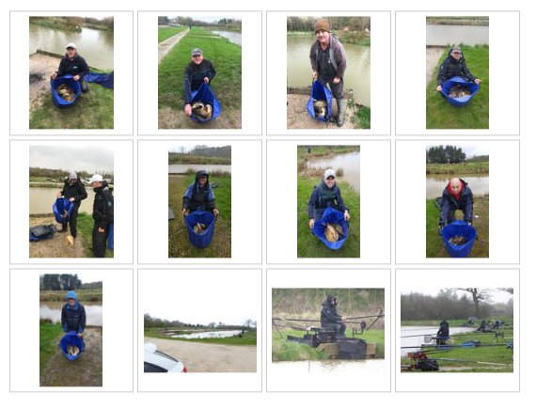

Venue: BRADSHAW HALL FISHERIES – LAKES 3 & 4

Date:01.04.18

Welcome to the 2018 SMAC season to all our members especially the new guys who we hope
Date: 01.04.2018enjoy fishing with us. We had a really good turnout of 34 anglers for the first match split into 5 sections over lakes 3 and 4 at Bradshaws. Pretty much everyone was hoping for a lake 4 draw with pegs 5 to 15 being the most fancied area, Lake 3 is a bit of a weird lake and although some recent open results were looking decent the weather was shocking for this time of year with wind chill factors down to -3 which definitely effected the fishing…. It’s spring! Where’s the sunshine?!

There’s a new competition which everyone is involved in, the teams of 4 competition is set to be a big hit with plenty talking about it at the draw, good luck to all teams and good luck also in the individual leagues and pairs leagues to everyone!

I’m uploading the reports slightly differently this year – I’m putting a gallery at the bottom of each report with all the pictures in rather than under each section write up as last year I ran out of space on the webpage – this gives us the opportunity to upload more pictures so if anyone takes any random pics at the matches please feel free to send them over to me and I’ll add them in….. as long as they don’t contain a naked Tony Webb that is.

Section A – Lake 4 Pegs 3 to 10
1st = Andy Sonley 85lb 0oz
2nd = Alan Hesling 74lb 0oz
3rd = Daz Gabz 60lb 5oz

Andy Sonley fishes his first SMAC summer league match after joining us for a few winter league matches and ends up winning the overall match! Andy fished a good match on the long pole shallow to weigh in a hefty 85lb to win the section and the match, well done mate and welcome to the club…. Any more ‘ringer’ performances though and Tony Might get his bare arse even closer to your head; god help you I bet it stinks! Alan Hesling wasn’t too far behind fishing a similar method from peg 7 to pick up second in section and second overall and Daz Gabz surprised us all with a 60lb net – well done guys!

Section B – Lake 4 Pegs 12 to 23
1st = Chris Gabz 65lb 12oz
2nd = Derek Wood 45lb 3oz
3rd = Mick Abdy 44lb 18oz

Chris Gabz allways seems to do well on Lake 4 and didn’t disappoint this time weighing in close to 66lb for a section win and third overall, I didn’t find out exactly how Chris fished the match but I suspect a method feeder may have been involved? Second in section was Derek wood from the early pegs on the wall side and third went to Mick Abdy on the unfancied causeway pegs – well done guys!

Section C – Lake 4 pegs 24 to 33
1st = Martin Cook 47lb 2oz
2nd = Steve Barlow 37lb 1oz
3rd = Tommy Edwards 33lb 2oz

The cold wind was properly hitting this side of the lake and you can see the weights dropped compared to the early pegs on the other side. Martin Cook fished with a bad back and ended up catching short to win the section – well done mate! New member Steve Barlow gets in the section frame with a second placed weight of 37lb and Tommy Edwards surprised himself with a 3rd place position, hopefully you’ve all warmed up a bit!

Section D – Lake 3 pegs 1 to 10
1st = Tony Webb 32lb 1oz
2nd = Pete Boggiano 31lb 0oz
3rd = Steve Tomo 26lb 11oz

The cold wind also effected this section on Lake 3 with frost being the only thing biting with any consistency…. Steve Tomo and Tony Webb kept themselves warm by being a pair of bitches moaning about who was casting into who’s peg, I was hoping it would turn into a real fight at one point as I like seeing Tony get his arse kicked hahaha. Throughout all the moaning Tony ended up winning the section with 32lb of feeder caught fish from Tomo’s swim…. He actually had his picture taken with Tomo’s fish just to rub it in! Pete Boggiano was second in section from the worst peg on the complex [haha no prizes for guessing who’s writing this] and Tomo was 3rd with 26lb of Tony’s fish. Well done guys!

Section D – Lake 3 pegs 12 to 27
1st = Dave Bennett 40lb 13oz
2nd = Stu Brown 33lb 11oz
3rd = Pete Ransome 23lb 8oz

A busy day in this section for some with silvers making up the majority of the decent weight which suited Dave Bennett down to a tee – Dave weighed in an impressive 41lb of silvers from the causeway side which included the biggest fish of the year so far…. Believe it or not a 3lb 12oz perch found its way into Dave’s net, hopefully for everyone this doesn’t win the trophy! Stu Brown finished second from fancied peg 22 and Pete Ransome had a busy day from the other causeway peg. Well done to everyone in this section as it was by far the worst on the day.

Below are the photos taken on the day:

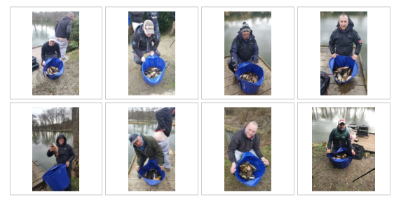
2017/18 Winter League Champion - Dave Coleman

Massive Congratulations to Dave Coleman for winning the SMAC 2017/18 winter league. This year was the closest ever with 6 people in the frame to pick up the trophy on the last match which was a tough day’s fishing in horrendous conditions.

3 anglers ended up tied on 28 points at the top of the league; Derek Wood [last year’s champion] Tony Webb and Dave Coleman. Dave won the title based on his weight of just over 70lb with Tony coming in second with nearly 57lb and then Derek Wood on 56lb! The entire winter has been a proper struggle with some of the worst and coldest weather we’ve ran matches in so thanks to everyone who managed to make the matches ….. Roll On Summer!!

Congratulations Dave Coleman!!

