MATCH REPORTS 2019
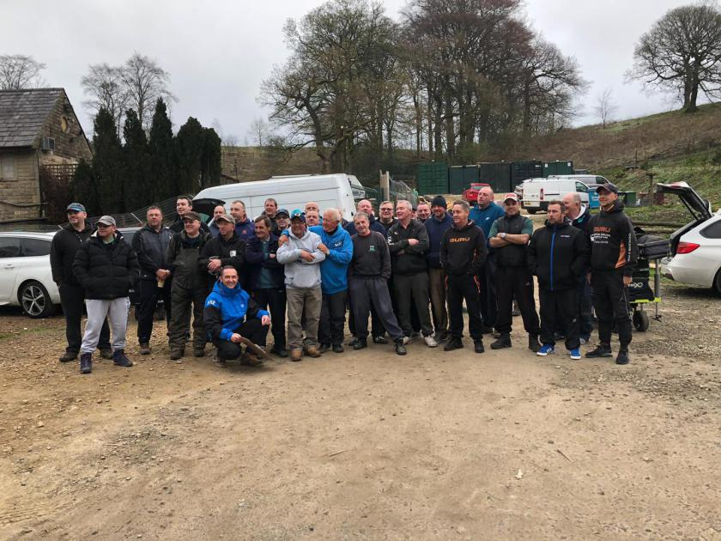
MATCH ANGLING CLUB

Venue: BRADSHAWS LAKES 3, 4 AND 6
Date: 20.10.19

The final match of the 2019 season was fished at Bradshaws across lakes 3, 4 and 6. There was only 29 of us so loads of space available. Lake 6 has a new look to it with the addition of floating islands and expectations for this lake were high but it turned out to be a bit of a let-down with some very poor weights coming off it. Well done to Gary Marsland on winning the lake from peg 17.

The wind was ripping down Lake 4 towards the causeway and was absolutely freezing, as expected the floating island pegs fished well with Paul Tighe winning the match from fancied peg 7, nice one Paul, a great end to a cracking season! Paul finishes on 62 points along with Carl, Adrian and Jason all joined in 3rd place only separated by Weight.

Dave Coleman managed 3rd in his section which gave him just enough points to break free from the pack and achieve second place in the league with 63 points. This is a massive achievement for Dave, after winning the winter league a couple of years ago he’s gone from strength to strength and is definitely one of the best club anglers in the north west as he proved recently finishing 4th in the clubman competition at partridge lakes against 161 other local club anglers. Fantastic mate well done!!

Another shout out to Frank Coleman sat on peg 30 on Lake 4 who picked up his second section win of the year, nice work Frank! Well done to Derek Wood too winning his section from peg 13, nice one Derek!

Lake 3 was won by Ady Wood from peg 6 closely followed by Phil Zahra on peg 13, both fished great matches and both ended the season strongly after poor starts, well done guys!

The teams of 4 league was concluded so well done to the top 3 teams who will all pick up some cash at the presentation evening, another great league and another opportunity for everyone to pick up some dosh and awards, as is the tier 2 and over 55’s league which has been run for the first time this year and was a great success, well done to everyone who entered this league and well done to Brandon Pelling for finishing top of the pile, nice work buddy, a great start to his first SMAC season!

That’s it from me now – I’ll be doing the reports a little differently next year including the table below rather than full individual section write ups to get them a bit more informative and accessible. Thanks to everyone for their input and thanks to all the members for making 2019 another great season with the biggest and best match club in England!! Phil will be writing his match sec report soon so keep your eyes open for that. See you all at the presentation evening on the 22nd November.

Pete.
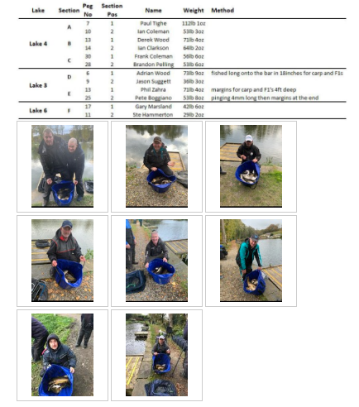

Venue: PARTRIDGE LAKES – COVEY 6, RIBBON AND SPEY
Date: 06.10.19

Another day of terrible weather greeted 34 SMAC anglers for the penultimate match of the 2019 season heavy rain and strong winds throughout the day made the fishing uncomfortable to say the least! The pairs final was contested and came to a really close finish with Tommy and Dave beating Carl and Steve by just over 4lb which is probably the closest pairs final ever so well done to these guys for winning and well done but really unlucky to Carl and Steve for finishing second. The pairs is a cracking competition and even though Tommy and Dave finished second in the preliminary league they managed to claim victory in the knockout stages, really well done guys! Maybe Tommy will stop moaning now!

Pete Boggiano and Carl O’Brien were also contesting the individual league, both anglers faltered in this match finishing second in their sections which means Pete has now retained the title and takes home the trophy for another year. Well done to Carl on pushing Pete this close – he’s missed 2 matches this year and so has had to put in an epic performance all season to get this close, well done mate and unlucky on not taking it down to the wire (big sigh of relief!!) Well done also to both anglers for passing 1000lb+ in a season, fantastic!

Section A – Covey 6 Pegs 133 - 145
1st = Dave Coleman 110lb 4oz
2nd = Jason Suggett 110lb 3oz

Dave and Jay went head to head on the covey 6 flyer pegs 133 and 135 respectively. It couldn’t have been any closer with Dave ouncing out jay to the top spot in the section which is Dave’s 4th section win on the bounce and his second overall match win of the year – both on partridge lakes! Dave fished banded 6mm feeding 4mm all day to the far bank switching between 3ft and 4ft to keep the bites coming. Jay fished dead reds over groundbait down both margins at top kit plus one. Well done guys – both have had great seasons and could potentially claim the runners up trophy at the next match.

Section B – Covey 6 Pegs 147 - 158
1st = Ady Wood 100lb 7oz
2nd = Carl O’Brien 94lb 4oz

Ady Wood edged in front of Carl from peg 151 in the closing stages of the match to edge the section win, Ady’s 3rd section win on the bounce and 5th of the season see him in 6th place in the league. Unlucky Carl for coming second with a top performance from peg 155.

Section C – Covey 6 Pegs 160 - 173
1st = Andy Sonley 102lb 7oz
2nd = Pete Boggiano 75lb 1oz

Andy Sonley piled on the pressure beating Pete from the next peg with a sterling performance fishing dead reds and micros to the pallet all day as the wind was too strong to fish across. A really good performance to win the section from this area, Nice work Mate!

Section D – Ribbon
1st = Derek Wood 39lb 0oz
2nd = Paul Pannett 30lb 5oz

Derek Wood picked up the honours in section D on Ribbon from peg 4 beating Paul Pannett from peg 6 by 9lb well done Derek and well done Paul for finishing second.

Section E – Spey pegs 2 - 10
1st = Chris Gabz 43lb 9oz
2nd = Tony Webb 40lb 6oz

Chris Gabz drew the bonus peg but unfortunately the lake fished really hard. Chris still managed a section win from peg 2 beating the bell end sat on peg 10. Nice one Chris. At least Tony got £15 towards the repair of his car after crashing it into Carl earlier that day.

Section F – Spey pegs 12 - 21
1st = Ian Coleman 21lb 9oz
2nd = Daz Gabz 13lb 7oz

Section F on Spey was not a nice place to be with Ian Coleman picking up the section win with just 21lb!! Stu Brown Managed to weigh in the lowest recorded weight of the year with 1oz only just registering on the scales! Well done to Daz for finishing second with 13lb. Tough section indeed!!!!

Below are the photos taken on the day:
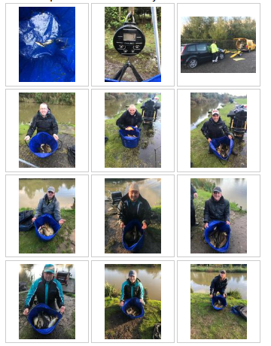

Venue: HERONBROOK - MEADOW AND CANAL
Date: 22.09.19

With thunderstorms forecast all day we had a couple of last minute cry offs which prevented this from being the biggest ever turnout for a SMAC match, still 36 anglers fished across Meadow pool and Canal. Recent reports from Canal weren’t very good at all but the fishing turned out to be pretty good. Meadow fished fantastic as always – what a lake this is!

The second leg of the pairs semi-final was fished with Tommy and Dave taking some solid weights into this round they were going to be hard to beat and proved so taking the first spot in the final with a total combined weight of 236lb which is pretty good going. Carl and Steve ended up taking the second spot in the final with 218lb so well done to them. The final will be fished at the next match at partridge lakes – good luck to the finalists and well done to all semi-final pairings for making it this far.

Section A – Meadow – Pegs 2 - 10
1st = Dave Coleman 129lb 5oz
2nd = Steve Barlow 104lb 4oz
Dave Coleman put in a fantastic performance from peg 10 on Meadow – a cracking peg and fished perfectly by big Dave! Dave fished hard 6mm pellets to the far bank and corn over groundbait in the margins to win the section and get second overall in the match. Steve Barlow tonned up from peg 8 and did enough to get in the pairs final – nice one Steve.

Section B – Meadow – Pegs 12 - 21
1st = Ian Coleman 146lb 7oz
2nd = Ian Clarkson 116lb 15oz
It was a battle of the big Ian’s in section B. [Ian Coleman Big horizontally, Ian Clarkson Big vertically]. Ian Coleman fished a great match to edge out his brother for the overall match win from peg 21. Ian fished hard pellet across and worm over micros down the edge to put his biggest ever SMAC match weight on the scales, well done chubby bollocks. Clarky came second from peg 17 with a well-earned 116lb. Well done lanky bollocks!!

Section C – Meadow – Pegs 23 - 31
1st = Carl O’Brien 113lb 13oz
2nd = Pete Boggiano 110lb 5oz
The top 2 placed anglers in the league went head to head in section C with Carl edging the section win over Pete by just 3lb. Carl was on peg 23 and fished hard pellet across pinging pellets alternating between 3 and 4ft deep on a light dropper rig to attract the carp. This edges Carl 1 point closer to Pete in the league which will result in a close finish over the next 2 matches. Pete was on the better peg but got caught between too many options sticking on the small F1s for too long before going down the margins for carp in the last 2 hours.

Section D – Meadow – Pegs 34 - 44
1st = Andy Sonley 128lb 5oz
2nd = Ste Hammerton 98lb 12oz
Andy Sonley picked up a section win and 3rd overall with 128lb of maggot fish from peg 42. Andy caught most of his fish shallow and some down the edge. Andy was one of the only anglers to catch shallow which is a bit strange for this lake. Ste Hammerton came close to a ton up weight from peg 34 and was unlucky to miss out but managed to pick up a section second as consolation prize! Well done chaps.

Section E – Canal – Pegs 2 - 12
1st = Phil Zahra 65lb 0oz
2nd = Paul Tighe 62lb 2oz
Phil Zahra topped section E from peg 6 starting with a negative approach cad potting maggots at 6meters to his amazement after about 30mins of catching small F1s and the odd silver fish he noticed a swirl up in the water and started getting line bites so he switched to his shallow rigs and caught steady for about 3 hours between 6 and 18 inches, 2nd in the section was Paul from peg 8 with yet another frame in the fantastic season he’s having! Paul caught long up to the rushes before coming down the edge last hour.

Section F – Canal – Pegs 14 - 25
1st = Jason Suggett 109lb 8oz
2nd = Stu Ford 63lb 8oz
Jay fished a tidy match from peg 19 taking advantage of loads of spare pegs either side of him and winning the lake overall, Jay fished topkit plus 1 feeding 4mm pellets with meat on the hook a great result from another inform angler hoping for a top 5 finish, 2nd went to Spudman ford form the next peg along from Jay (23) catching steady all day on worms and casters pushing him into the top 20

Section G – Canal – Pegs 28 - 39
1st = Ady Wood 82lb 0oz
2nd = Tony Webb 62lb 3oz
Ady finished on top in this section from peg 33, Ady fished maggots and pellets across and down the track with a few fish later on in the deeper water down the edge, Adys 4th section win of the season keeps his just 3 points off 3rd place in the league and still well in with a shout of a top 5 finish.
2nd went to the clubs favourite prankster Tony from corner peg 31, tony fished over to the bridge on pellets to also keep him in with a shout of a top 5 finish, Tony had 2 pleasure anglers stood on the bridge about 1 foot away from where he was fishing and had to drop his pants again to get them to move on.

Below are the photos taken on the day:

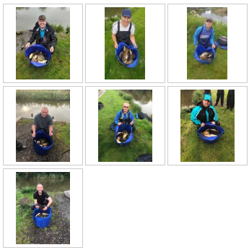

Venue: CUNNERIES – S CANAL AND HAWK
Date: 08.09.19

Low overnight temperatures and previous days big weights off the venue were pointing in the direction of a potential difficult days fishing, it turned out to be not too bad with average weights of 55lb matching the last match at Old Hough exactly!

The first leg of the pair’s tournament Semi-Finals were fished with anglers posting weights and Tommy Edwards / Dave Coleman taking some good weights into the next leg currently topping the Semi-Final table with 198lb. It’s still all to play for with big weight venue heronbrook up next!

Section A – S Canal – Pegs 1 to 12
1st = Andy Sonley 67lb 14oz
2nd = Mike Jones 59lb 14oz

Andy Sonley fished a really busy match catching on maggot all over his swim, one fish then a move to another swim was the order of the day. A solid performance again from Andy. Mike Jones secured his 3rd section second on the bounce! Good angling mate but unlucky at the same time, another decent weight keeps Mike at the top of the T2 and over 55’s league!

Section B – S Canal – Pegs 15 to 25
1st = Ady Wood 77lb 15oz
2nd = Phil Zahra 76lb 15oz

Ady Wood edged out Phil Zahra in a close battle for the honours in section B. Both anglers have fished way below par this year but seem to be getting things together towards the end of the season.

Section C – S Canal – Pegs 26 to 36
1st = Dave Coleman 91lb 3oz
2nd = Chris Gabz 89lb 2oz

Dave Coleman beat off close competition from Chris Gabz to win section C by just over 2lb. Dave fished banded 6mm to the far bank and corn over grounbait down the margins from peg 28 to pick up his 4th section win of the year which moves him into 3rd in the league by just over 25lb – he’s joined on points by Steve barlow and Paul Tighe which will make an interesting battle over the closing 3 matches. Well done to Chris Gabz with a good weight from peg 36 for second in the section.

Section D – S Canal – Pegs 38 to 46
1st = Pete Boggiano 91lb 11oz
2nd = Alan Hesling 57lb 7oz

Pete Boggiano picked up his 9th section win of the year putting him one step closer to regaining the club championship. Pete fished pellet across in the mud hole, pellet down the edge and maggot shallow to weigh in a hard work 91lb from peg 44. Alan came second in the section with a good performance from peg 42 – well done Alan.

Section E – Hawk – Pegs 1, 2 & 15 to 19
1st = Bob Chapman 57lb 10oz
2nd = Ian Clarkson 44lb 0oz

A top performance in section E on Hawk Lake from peg 1 saw Bob Chapman pick up his first section win of the year with a really good weight winning the section by a handsome margin for a handsome chap! Well done to Ian on the second in section – not so handsome though!!

Section F – Hawk – Pegs 4 to 12
1st = Tommy Edwards 107lb 4oz
2nd = Brandon Pelling 71lb 3oz

Tommy fished a cracking match to take the overall match win along with his second section win of the year. Tommy’s had a pretty solid season with only 1 placing outside the top three in his section so well done mate. Brandon keeps on the pressure in the T2 league with a good weight for second on the lake.

Below are the photos taken on the day:
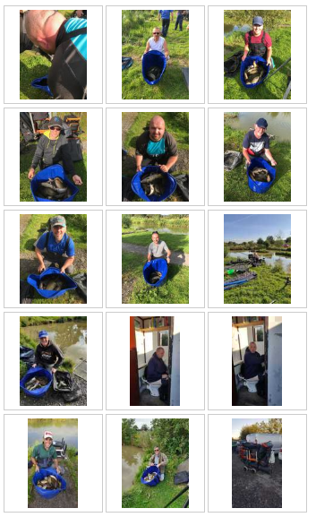

Venue: OLD HOUGH: UPPER BENBO, LUCKY DIP AND PROSPECT
Date: 25.08.19

Match 10 signifies the last opportunity for members to post a weight to get themselves in the pairs finals, with plenty of pairings being closely grouped there could have been a major shift but the guys in the top 4 spots managed to hang on to their places. They will now have the next 2 matches to post 1 weight towards their pairings total for the semi-final to try to get a place in the final which will be held on either of the last 2 matches depending on availability. The pairs making the semi-final are:

Carl O’Brien and Steve Barlow [1272lb]
Tommy Edwards and Dave Coleman [983lb]
Pete Boggiano and Andy Webb [940lb]
Dave Bennett and Mike Jones [894lb]

Well done to all of the above for making it this far!

The fishing actually turned out to be pretty good with some decent weights all round – the average weight per angler was 55lb which has only been bettered at Lindholme and heronbrook so not bad at all!

Section A – Upper Pegs 1 - 12
1st = Jason Suggett 66lb 9oz
2nd = Phil Zahra 65lb 13oz

Section A was a proper close battle with Jason Sugett ouncing out Phil Zahra for the top spot. Jason Fished dead reds over micros at 16m and 6mm expanders over groundbait down the edges to clinch the section win from peg 3 closely followed by Phil Zahra on peg 9. Well done Jay, another section win puts you in 5th place in the league.

Section B – Upper Pegs 13 - 24
1st = Carl O’Brien 113lb 7oz
2nd = Mike Crowther 105lb 12oz

Section B threw up the most surprising result of all time! Carl O’Brien won the section and the match which is pretty standard, he’s a top angler and even though he had his rod bag nicked the day before he managed to borrow the equipment needed to pick up his 7th section win of the year – well done mate! Second in the section went to Mike Crowther….. Mike is a top member and gets to every match he can with his Dad John, he’s now made it onto the SMAC hall of fame with an amazing result netting 105lb 12oz from peg 13, unbelievable!! This puts Mike into 37th in the league which is his highest ever placing…. 3 places above Martin Cook! Absolutely made up for you Mike, what a result….well done buddy!!!

Section C – Lucky Pegs 1 - 7
1st = Steve Barlow 97lb 9oz
2nd = Tommy Edwards 60lb 7oz

Steve Barlow continues a great season and now pushes himself into 4th in the league with his 6th section win, Steve also came close to taking home the bonus pot but Mike and Carl managed to prevent him from winning the overall match! Well done Steve. Tommy Edwards came second from peg 3 to keep himself in the top 10.

Section D – Lucky Pegs 9 - 15
1st = Dave Coleman 84lb 12oz
2nd = Rodger Dimmock 62lb 3oz

Dave Coleman has also had a really good season and continues with his 3rd section win of the year keeping him in 6th place in the league….. Way above his brother Ian in 13th place!!!! Well done to Rodger Dimmock also who did his best to get into the pairs semi’s but was unfortunately let down by his partner Tony Webb!

Section E – Prospect Pegs 1 - 7
1st = Paul Tighe 77lb 6oz
2nd = Mike Jones 74lb 1oz

Paul Tighe secures his 3rd place in the league with his 4th section win of the year. Paul fished a cracking match on worm down the edge on peg 6 to weigh in 77lb beating Mike Jones by just 3lb who was on peg 3. Well done guys another close battle!

Section F – Prospect Pegs 9 - 15
1st = Pete Boggiano 87lb 5oz
2nd = Eric Quinn 63lb 13oz

Pete Boggiano fought off Eric Quinn for the section win. Pete fished the method across, paste short and Margins to pick up his 8th section win of the year. Eric lost a load of fish and could have sewn the section up if he landed them all! Unlucky Eric!

Below are the photos taken on the day:
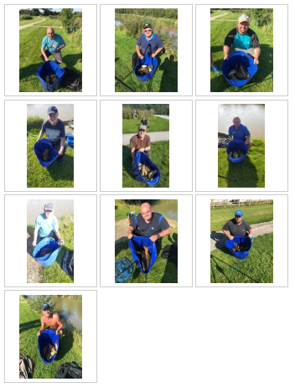
Venue: LINDHOLME LAKES BEECHES AND STRIP
Date: 11.08.19

An eagerly anticipated trip to the amazing Lindholme Lakes was attended by 31 SMAC members hoping for a similar match to last year which produced 12 ton+ weights. Unfortunately the weather the previous week had a real negative effect on the fishing and even though the weights were pretty good we only managed 5 ton+ weights on the day….. How things have changed…. We’d only had 5 ton plus weights in the entire history of the club until 3 years ago!

There’s only 1 match left in the pair’s competition to get into the semi-finals which will be fished over the Cunneries and Heronbrook matches with each angler’s best weight being put towards their total to get them in the final which will be fished at Partridge or Bradshaws depending on availability. Good luck at the next match if you’re aiming for a top 4 slot!

Well done to Dave Bennett on coming 20th at this match – he picks up a bag full of Drennan goodies kindly supplied by Lindholme Lakes.

Section A – Strip Pegs 1 - 11
1st = Chris Gabz 101lb 11oz
2nd = Phil Zahra 95lb 15oz

Chris Gabz quietly went about putting a nice net of fish together from Peg 4 on Strip Lake. Chris fished just past the reeds on his top kit on paste to sneak himself to his 4th section win of the year and now 10th in the league, well done mate! Phil Zahra moves into the top 10 for the first time in ages! LOL after a tough season Phil finally seems to be finding his form!

Section B – Strip Pegs 13 - 24
1st = Pete Boggiano 114lb 2oz
2nd = Mike Jones 110lb 3oz

Pete Boggiano put his 4th ton on the trot on the scales which has never been done before! This gave Pete his 7th section win of the year and 3rd overall match win of the year and keeps him at the top of the league. From peg 20 Pete fished Bomb and pellet halfway [definitely not over halfway LOL] and then dropped on a short paste line to narrowly beat Mike Jones to the top spot – Mike fished a cracking match on peg 24 to put 110lb on the scales which moves him into top spot in the tier 2 and over 55s league, well done Mike!

Section C – Beeches Pegs 1 - 7
1st = Andy Sonley 101lb 7oz
2nd = Ste Hammerton 96lb 6oz

Sonley is back from White Acres and narrowly beat Ste Hammerton to top spot in section C. Andy was on peg 1 and fished corn in the margins all day losing about £30 in tackle as the peg is so snaggy. Ste fished a cracking match from peg 6 to push Andy right to the wire!

Section D – Beeches Pegs 9 - 17
1st = Steve Barlow 85lb 0oz
2nd = Alan Hesling 81lb 1oz

Steve Barlow fished pellets and Worms to pick up his 5th section win of the year from peg 15 on Beeches fighting off close competition from Alan Hesling on peg 9 who fished paste down the margins and a welcome return after a couple of missed matches due to work commitments.

Section E – Beeches Pegs 19 - 28
1st = Steve Tomo 61lb 4oz
2nd = John Crowther 33lb 0oz

Section E was the toughest section won by Steve Tomo with 61lb from peg 21. Well done mate and a massive well done to John Crowther framing from peg 19 nice one guys!

Section F – Beeches Pegs 30 - 41
1st = Carl O’Brien 106lb 4oz
2nd = Paul Tighe 51lb 12oz

Carl O’Brien came first in section F [According to that Doncaster bird he met the night before he came first then too] Carl drew peg 37 and was expecting to be fishing for second in the section but managed to win the lake fishing at 14.5m to the stick ups netting 1 in every 3 fish and losing every hooklength he owns in the process [Let’s hope he kept ‘it’ covered the night before so he doesn’t lose any more tackle!] Well done to Paul Tighe beating Ady Wood to second place by just 1oz! this moves Paul into 3rd place in the league, nice one mate!

Below are the photos taken on the day:
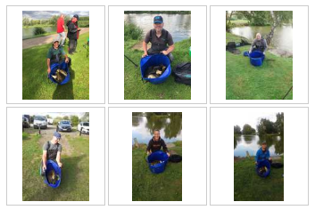

Venue: HERONBROOK; MATCH LAKE, ISLAND & MATCH POOL
Date: 28.07.19

A truly horrible day greeted 35 SMAC anglers for the 8th match of the year the rain didn’t stop at any point during the day and the wind was horrendous making fishing anything beyond a topkit plus 2 extremely difficult!

We’re now beyond the halfway stage of the season and dropped points and weights have now been introduced into each league – here’s a quick summary of how it works:

Individual league: your worst 2 points results are dropped along with the weight associated with these 2 results

Pair’s league: each angler’s worst 3 weights are dropped

Teams of 4 league: exactly as per the individual league for each angler in the team

Tier 2 and over 55’s league: the weights dropped in the individual league are deducted from your overall total

Hopefully that explains how this works – if anyone has any questions please feel free to ask.

The fishing turned out pretty good on the day despite the conditions 10 anglers managed ton plus weights which is testament to the quality of Heronbrook fisheries and one of the reasons we arrange 4 matches a year there – absolute quality!

we're now up to 22 ton plus weights for the year which is 5 more than this time last year with plenty more matches to come with mega weights available! we had a total of 44 throughout the year in 2018 so hopefully we can top that! The hall of fame page is updated showing all ton plus weights.

Section A – Match lake Pegs 1 - 7
1st = Brandon Pelling 123lb 2oz
2nd = Gary Marsland 112lb 8oz

Brandon Pelling won section A from peg 5 on Match Lake closely followed by Gary Marsland from peg 2. This section win puts Brandon at the top of the tier 2 league by a clear 55lb. well done guys! Phil Zahra was 3rd in the section and had to go for a swim early on in the match with the most girly dive you’ll ever see, he landed the fish though but even still he needs to get on to Tom Daley for some advice!

Section B – Match Lake Pegs 8 - 17
1st = Chris Gabz 113lb 11oz
2nd = Daz Gabz 87lb 15oz

The battle of the Gabz brothers in section B was topped by Chris with a cracking 113lb from peg 8. Daz came second who had a close battle with Dave Coleman beating him by just over 1lb in the end. Well done guys

Section C – Match Lake Pegs 19 - 26
1st = Carl O’Brien 150lb 10oz
2nd = Andy Webb 84lb 14oz

Carl stuck his hand in the bag and pulled out a peg he likes in the shape of 19 on Match Lake, Carl fished the method to the island and meat short for the majority of the day and dropped in the margins in 6” of water right at the end to weigh in 150lb and win the section along with the match, top work Carl, he’s now second in the league on 35 points [just 1 point short of a perfect score so far!] well done buddy…. Keep it up! Second went to Andy Webb from peg 23 with 84lb, nice one Andy well done!

Section D – Island Pegs 1 - 9
1st = Steve Barlow 126lb 7oz
2nd = Ian Coleman 106lb 2oz

Steve Barlow topped section D from peg 9 on Island pool after catching F1s on worms for the majority of the day Steve went down the edge to land some monsters at the end and putting the second highest weight of the day on the scales beating ian Coleman to the section win also well done Steve. Ian was on peg 5 and weighed in a handsome 106lb for second in the section!

Section E – Island Pegs 11 - 19
1st = Tony Webb 111lb 12oz
2nd = Jason Suggett 85lb 2oz

Tony Webb put an end to a couple of poor results by winning section E from fancied peg 19 overcoming a challenge from 3rd in the league Jay from the next peg 17, well done guys - these results put Tony and Ian Coleman on joint points in the league with only weight seperating you from 4th/5th place!

Section F – Match Pool Pegs 1 - 9
1st = Paul Tighe 101lb 12oz
2nd = Ged Smith 100lb 9oz

Paul Tighe fished a cracking match from the wrong end of the lake on peg 9 to beat Ged Smith by just over 1lb to win the section, this now moves Paul up to 4th in the individual league, nice one mate!

Section G – Match Pool Pegs 11 - 20
1st = Pete Boggiano 113lb 15oz
2nd = Phil Topham 79lb 2oz

The last section was won by Pete Boggiano who’s now just 1 point clear at the top on 36 points. Pete fished pellet down the margins for the first hour before moving onto a maggot shallow line down the track and ending on meat down the other margin to pick up his 4th section win on the trot! Phil Topham fished the method across and short on paste to pick up second in the section from peg 15 well done Phil! Tommy Edwards was on Peg 20 and at one point was trying to land a fish whilst his brolly was fully wrapped around him in a battle with the wind and rain! Most enjoyable watching LOL!

Below are the photos taken on the day:

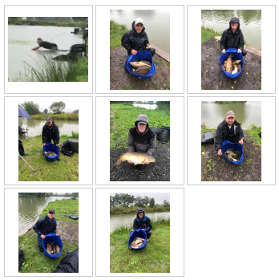

Venue: OLD HOUGH: UPPER BENBO, GOOSE & BIG MAX
Date: 15.07.19

A hot and humid day greeted 33 SMAC members at the Old Hough Fishery in Middlewich for the 7th match marking the halfway point in the 2019 season. Most of the members have recently attended the annual fishing holiday at Manor Farm leisure and there are lots of photos and information on the latest news page for you to enjoy!

All the leagues are hotting up nicely – the individual league has 4 anglers on the same points in second place looking to bully out the current champ from regaining the title. There’s a new leader in the pair’s competition for the first time this year with Dave Coleman and Tommy Edwards edging out Carl O’Brien and Steve Barlow. Both of these leagues will look a bit different after the next match as I’ll implement dropped points and weights once we’re beyond the halfway point.

The majority of the talk at the draw was based around how upper benbo wasn’t being used much by the fishery in their opens and no one really had a clue how it was going to fish so most were hoping to avoid this lake in the draw with the definite favourite being big max. What most people wanted was for Tommy Edwards to draw on Goose for a laugh but it didn’t happen LOL.

Section A – Upper Benbo pegs 1 - 12
1st = Phil Zahra 45lb 0oz
2nd = Stu Ford 28lb 2oz

Phil Zahra drew the ‘old’ best peg on the venue in peg 1 Upper; however good it looks on that peg it’s far from what it used to be. Phil managed to win the section by fishing a small method feeder into the mud hole as holding the pole was difficult in the wind. Phil also had a few on paste down the track late on to put 45lb on the scales. Phil moves up to 14th in the league after his second section win of the year. Well done to Stu Ford coming second with 28lb from peg 9.

Section B – Upper Benbo pegs 13 - 24
1st = Adrian Wood 77lb 14oz
2nd = Stu Brown 35lb 14oz

Ady Wood won Upper Benbo and his section with a cracking weight finishing second overall in the match so well done to do that from this lake. Ady fished paste at 16m down the edge from peg 22….. Who in their right mind sits on their box and thinks “I know what will work today….. Paste at 16m down the edge” talk about making things difficult for yourself!! Well done Ady and well done to Stu Brown for finishing second with 35lb from peg 24.

Section C – Goose pegs 2 - 8
1st = Jason Suggett 51lb 5oz
2nd = Paul Pannett 32lb 7oz

Jay picks up his 3rd section win on the trot and his 4th section win of the season putting him just shy of the group in second place on 32 points, Jay fished maggots across for about 20lb of silvers before moving down the edge on groundbait, micros and dead reds to weigh in the best weight on Goose lake from peg 4. Paul Pannett knows peg 2 very well; he drew there earlier this year and managed a much better result this time with 32lb for second in his section so well done Paul!

Section D – Goose pegs 10 - 18
1st = Derek Wood 49lb 5oz
2nd = Paul Tighe 35lb 12oz

Venue expert Derek Wood made the most of his knowledge to top section D which is generally a really difficult area. Derek was on peg 14 and fought off the challenge from Paul Tighe on peg 18 to top the section. Derek’s having an up and down year with 3 section wins but some poor finishes by his standards Paul Tighe however has had a really solid first half with a 4.57 average to build on for the second half. Well done guys!

Section E – Big Max pegs 1 - 10
1st = Pete Boggiano 106lb 6oz
2nd = Ian Coleman 45lb 15oz

Pete Boggiano pushes on at the top in an effort to regain his title and is now on 38 points – long way to go yet! It was a strange old match with fish feeding for short spells shallow then completely disappearing, Pete fished the majority of the match at 14.5m 4” deep on 6mm pellet feeding 4mm and stuck it out during the dry spells to weigh in 106lb to win the match and the section. Ian Coleman was on the next peg who managed second with 45lb, well done Ian!

Section F – Big Max pegs 12 - 22
1st = Dave Bennett 63lb 1oz
2nd = Tommy Edwards 62lb 15oz

Dave Bennett started on the pellet wag for a couple of fish but after a while of casting into big cruising shoal with little results he went to plan B and fished the jigga for the majority of the rest of the match to ounce out Tommy Edwards for the section win….. 2oz LOL!! Unlucky Tommy! Tommy had 9 major lumps which made up his weight which was close but not close enough for the section win!

Section G – Big Max pegs 26 - 32
1st = Carl O’Brien 51lb 8oz
2nd = Dave Coleman 48lb 15oz

Carls had an amazing run of results recently with 7 100lb+ weights in his last 7 matches and was hoping for more of the same when he pulled out the bonus peg 32 on Big Max, this is usually a really good area so we were all hoping Tony Webb could do us a favour and beat him off the next peg but he didn’t cos he’s a massive Bell End. Carl still won the section with a hard worked for 51lb finishing off with a couple of lumps down the edge to push in front of Dave Coleman who fished a great match on bomb and pellet to the island from peg 28. Carl, Tony and Dave are all on 33 points now joint second in the league along with major lump hunter Tommy Edwards, good luck for the second half of the season guys!

Below are the photos taken on the day:
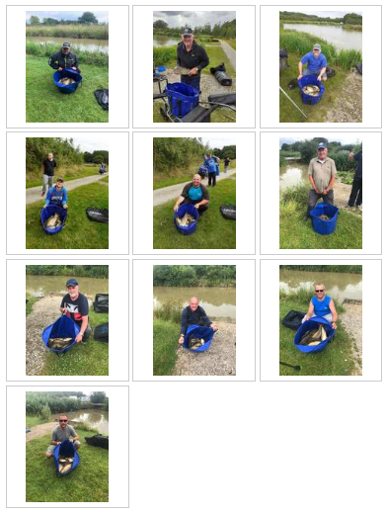

Venue: HERONBROOK FISHERIES - MATCH LAKE, MATCH POOL & BRIDGE
Date: 02.06.19

A blustery day greeted 34 SMAC anglers at the favourite Heronbrook fisheries, we secured an additional lake to give us extra room which worked out nicely with 10 on Match Pool and 12 on Match Lake and Bridge there was loads of room for everyone! Pretty much everyone wanted to draw on Match Lake as it offers something a bit different and some huge weights come of this lake with some monster fish to be caught too, Paul Tighe showed us this with an 18lb 10oz Moby Dick which will be a tough one to beat for the biggest fish award!

Section A – Match Lake Pegs 2 - 12
1st = Pete Boggiano 121lb 9oz
2nd = Eric Quinn 79lb 7oz

Pete drew peg 2 on Match Lake which is apparently the 3rd best peg on the lake however the wind was howling out of the peg down towards the other end of the section so this could have drawn the F1s with it. Pete fished 4 lines throughout the day having a few on the tip, then an hour shallow which was ended by the wind and rain. Pete then dropped in on a short meat line for a good run of fish before ending the match in the margins on groundbait and dead reds to pick up his first overall match win of the year and his 4th section win which puts him 2 points clear at the top of the league!! Eric Quinn fished a cracking match from peg 6 to weigh in close to 80lb for second in the section, nice one Eric!

Section B – Match Lake Pegs 15 - 25
1st = Paul Tighe 118lb 5oz
2nd = Ged Smith 116lb 2oz

Paul Tighe and Ged Smith fought a proper close battle for the honours in section B from adjacent pegs 15 and 17. Both anglers fished the tip towards the island and Paul Tighe managed to edge in front of Ged by hooking that huge Walrus down the margins. Well done to both on ton plus weights and a cracking close match!

Section C – Match Pool Pegs 1 - 9
1st = Ian Coleman 116lb 15oz
2nd = Tommy Edwards 67lb 9oz

Recent reports from the match pool have been pretty promising with some decent weights coming out on the open matches. Ian Coleman came away with the spoils in section C with a cracking ton plus weight which put him 3rd overall in the match. Ian fished pellets across and in the margins and also paste down the track – Ian netted a 14lb+ carp down the track which is monstrous for this lake!!! Well done to Tommy Edwards for coming second – he moans like a little girl cos he never draws where he wants but has had a really good start to the season and is currently in 4th place in the individual league!

Section D – Match Pool Pegs 11 - 20
1st = Jason Suggett 93lb 14oz
2nd = Phil Zahra 77lb 14oz

In contrast to Tommy Jason Suggett always draws where he wants lol! He drew a really nice looking peg in number 20 and managed to fish the entire match on one method which has done him well this season – keep things nice and simple! Jason fished groundbait and dead reds down the edge all day to amass 93lb and a section win, well done Jay. Phil Zahra came back down to earth after his skydiving experience and fished a great match for second in his section – his stamp of fish were way smaller than the others so a great performance to weigh in 77lb, nice one mate.

Section E – Bridge Pegs 1-5 & 24-30
1st = Andy Sonley 62lb 15oz
2nd = Rodger Dimmock 59lb 15oz

Bridge Lake was split into much fairer sections following on from the last match putting the later pegs with the earlier pegs which evens out the sections much better – good job Carl!

Andy Sonley won the section from peg 30 who started off on pellet shallow and caught steady for the first 2 hours, they then disappeared on the shallow line so Andy moved to 16m down the edge to find the shallowest water possible and had a good run of carp and F1s on meat to weigh in 62lb for the section win. Rodger Dimmock followed on from a good match last time on this lake with 59lb and second in the section, very close to picking up a section win! – I’m betting there were worms involved in this weight!

Section F – Bridge Pegs 8 - 22
1st = Adrian Wood 106lb 8oz
2nd = Dave Coleman 83lb 2oz

Ady Wood weighed in the only ton plus weight on Bridge lake with 106lb from peg 22. Ady fished maggots and groundbait to pick up his first section win of the year, a difficult start for Ady but I’m sure he will turn it around. Someone who hasn’t had a difficult start is Dave Coleman who came second in this section to continue a cracking start to the 2019 season currently sitting in 3rd in the individual league on 28 points – nice one Dave!!

Below are the photos taken on the day:

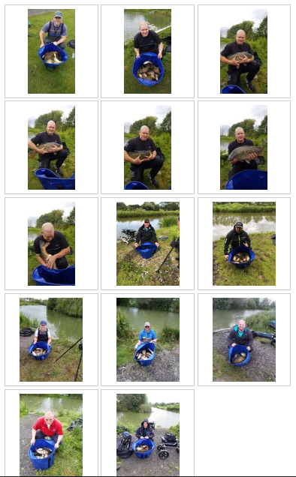

Venue: PARTRIDGE LAKES – COVEY 6, RIBBON AND MARSH
Date: 02.06.19

A huge number of 84 pegs were available split across the 3 lakes above meant the sections were as fair and as well spaced as possible for the 35 members who turned up to fish the 5th match of the 2019 season which is already over a third of the way complete!

The league tables are developing nicely with the pairs competition looking like it’s going to be a close call for the 4 available semi-final places, the teams of 4 competition is also starting to get interesting with not many points separating the 10 teams. Tony Webb is at the top of the individual league for the first time ever after a really solid start and seems to be focussed on the 6 points every match! The newest addition to the leagues is the Tier 2 / over 55’s league which is creating a bit of interest – it’s even got Mick Abdy booked on the next match which is on the 16th June….. River season opening day….. Mick must have his eyes on the prize!

The fishing in general was not too bad across the 3 lakes with covey 6 producing 8 out of the 10 best weights which was expected, the back section of Ribbon fished really hard and most of Marsh was tough going but that’s why we run matches in sections, it’s the fairest way when more than one lake is involved in a match…. Well done to all the guys who stuck it out in the more difficult areas, especially Pete Ransome who slept for most of the match on Marsh after an all-day bender the day before – the man is a machine!!

Section A – Covey 6 Pegs 133 - 143
1st = Ged Smith 73lb 8oz
2nd = Mike Jones 58lb 1oz

Surprisingly the usually tough area on covey 6 produced the section winning weight with Ged Smith sat on peg 143 putting 74lb on the scales. Ged fished caster shallow at 10m to win the section, his second of the year so far and a good return to form after a poor match at the cunneries. Second in the section went to new member Mike Jones with 58lb. well done guys.

Section B – Covey 6 pegs 146 - 156
1st = Jason Suggett 78lb 8oz
2nd = Stu Ford 53lb 11oz

Jason Suggett was only 1 fish away from winning his first club match with SMAC but he unfortunately lost it at the net, mega unlucky mate! Jason fished caster shallow at 6m to win the section from peg 149, Jason has actually had a good start to the season but had 2 really poor results at Old Hough and Heronbrook which result in a league placing which doesn’t really reflect his season so far – hopefully when dropped points kick in this will change. Second place went to Stu Ford who’s been away for a few matches so a nice welcome back!

Section C – Covey 6 pegs 160 - 172
1st = Dave Coleman 80lb 3oz
2nd = Phil Topham 75lb 4oz

Dave Coleman was sat on peg 169 on the spit and did us all a favour by winning the match as Alan Hesling was on 166 which was the bonus peg! Dave fished a cracking match using 3 separate lines; maggot shallow down the track, maggots and caster short down the edge and groundbait and corn in front of the next pallet was enough to win the match less than 2lb in front of Jason! Nice one Dave. Second in the section went to Phil Topham from peg 172 well done mate. Alan thought he’d got the bonus money in the bag after estimating 80-100lb but was gutted to weigh in 71lb 11oz – unlucky Alan! Daz Gabz had a close call after setting up all his gear on the wrong peg like a right numpty, good job someone let him know and good job someone let me know so I could put it on here [thanks Tony]

Section D – Ribbon pegs 2 - 10
1st = Pete Boggiano 56lb 8oz
2nd = Tony Webb 51lb 15oz

Pete Boggiano pulled out peg 6 on Ribbon which is usually a good area to catch shallow across but this was not meant to be; a complete lack of ripple on the water meant it just wouldn’t happen – Pete fished worm and caster tight across in 3ft which was slow going but reasonably consistent whilst feeding up a track maggot line, it was this line that came to life in the last hour to edge Pete in front of Tony for the section win, Tony had a decent day fishing long down the margins but lost too many fish in the end…. He did however land a MAP top kit which is probably worth about £100 and will break after 1 use!

Section E – Ribbon pegs 12 - 20
1st = Martin Cook 20lb 3oz
2nd = Paul Tighe 17lb 4oz

A really tough section was won by Martin Cook which is pretty surprising as he spent most of the match texting and / or walking round as usual! Martin fished groundbait and dead maggot to edge in front of Paul Tighe by the narrowest of margins

Section F – Marsh pegs 2 - 10
1st = Frank Coleman 47lb 10oz
2nd = Ste Hammerton 33lb 6oz

Man of the match was definitely Frank Coleman with a mega performance to win Marsh lake with a relatively huge weight of 47lb 10oz – nice work Frank…. Form is temporary but class is permanent, I’d love to tell you how he caught but neither of his text savvy sons would pass on the information…. Ian and Dave – out of order!!!! We done to Ste Hammerton also who is proving it’s not all about the best pole, box etc etc when a guy who sits on a carp chair and fishes with feeder and margin pole is 6th in the league its proof that you don’t need all the gear…. Just the right idea!! Nice one Ste and Frank!

Section G – Marsh pegs 12 - 21
1st = Derek Wood 34lb 5oz
2nd = Steve Tomo 30lb 4oz

Derek Wood pipped Tomo to the spoils in section G which was almost as bad as section E! Derek fished his favourite margin swim with groundbait and corn which worked just enough to earn the 6 points and will hopefully put an end to a difficult run for Derek after a good start.

Below are the photos taken on the day [apologies for the lack of pictures!]:
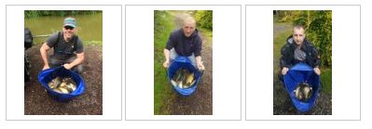
Venue: CUNNERIES FISHERY – S CANAL AND HAWK
Date: 19.05.19

The first of 2 trips to the Cunneries fishery saw 35 anglers spread across the S Canal and Hawk lakes. With the recent warm weather expectations were high for a good match – unfortunately the S Canal just didn’t produce the goods on the day meaning 7 out of the top 10 weights came from Hawk Lake which was pretty unexpected. It was only after the match I found out there had been a big charity match held on S Canal the day before which could have been the reason for the fish going into hiding!

Before I start the report I would like to congratulate Carl O’Brien and Pete Boggiano who represented SMAC at the recent Garbolino Club angler qualifier – for the first time since we have been doing this both nominated anglers have qualified for the final at Barston lakes – Good luck guys ☺

Section A – S Canal Pegs 1 - 12
1st = Carl O’Brien 59lb 15oz
2nd = Tommy Edwards 32lb 12oz

Carl O’Brien put in another cracking performance from peg 12 catching late down the edge on banded pellet to secure his 3rd section win of the season – Carl has only dropped 1 point so far and is on fire – this was the highest weight across the entire S Canal so well done Carl!! Second in the section was Tommy Edwards who’s also had a solid start to the season scoring 19 points so far from 4 matches.

Section B – S Canal pegs 15 - 25
1st = Chris Gabz 41lb 5oz
2nd = John Crowther 27lb 3oz

Chris Gabz picks up his second section win on the bounce with a top performance from peg 21 lightly feeding maggots with maggot hook bait was the trick so well done Chris – a bit of a wobbly first 2 matches but back on form now. John Crowther did ace to finish in second place with a decent weight so well done John…. Even better beating your son off the next peg!

Section C – S Canal pegs 26 - 36
1st = Paul Tighe 55lb 5oz
2nd = Tony Webb 20lb 0oz

Paul Tighe came second on the lake and won his section with a net of F1’s falling to worm in 18” of water tight across on the mudline, well done Paul – hopefully you got all the worm dirt off your immaculate gear! Second went to Tony Webb with a measly 20lb – shocking!

Section D – S Canal pegs 38 - 46
1st = Ian Clarkson 27lb 3oz
2nd = Steve Tomo 22lb 6oz

Ian Clarkson made a switch to worm halfway through the match which proved to be an ingenious move and picked him up a few vital fish to win section D from peg 38, Steve Tomo was on the next peg and managed to foul hook his way to second in the section – well done guys.

Section E – Hawk pegs 1, 2 & 15 - 19
1st = Ian Coleman 69lb 15oz
2nd = Jason Suggett 67lb 11oz

Ian Coleman and Jason Suggett fought a close battle with Ian coming out on top by just over 2lb. Ian fished Maggott feeding micros down the edges and Jay fished close in on maggots for the entire match! Well done chaps.

Section F – Hawk pegs 4 - 12
1st = Steve Barlow 67lb 13oz
2nd = Andy Sonley 66lb 11oz

Steve Barlow remembered to keep all 3 nets in the water this match and picked up a section win by just over a pound over Andy Sonley, well done guys a close battle!!

Below are the photos taken on the day:
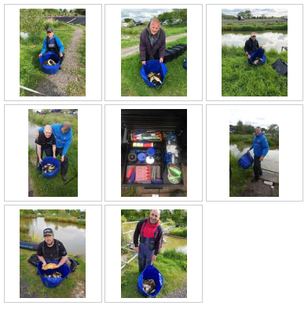

Venue: HERONBROOK – MEADOW AND BRIDGE
Date: 05.05.19

Our first of 4 trips to the club favourite Heronbrook fisheries saw a reduced field of 29 anglers split across Meadow and Bridge pools with tons of space to play with as there were quite a few members down at Whiteacres for their annual trip. There were reports of the fishing not being too great on the complex over the previous few days but when Heronbrook isn’t fishing too well it’s still miles better than most places!

Section A – Meadow pegs 2 - 13
1st = Dave Coleman 110lb 12oz
2nd = Tommy Edwards 105lb 7oz

Dave Coleman and Tommy Edwards battled out a close match from adjacent pegs on 11 and 9 respectively. Dave came out on top by just over 5lb with a cracking ton up weight. Dave struggled with his hard pellet lines across and down the track so moved on to fishing the margins with micros and expanders down one side and groundbait and caster down the other which equated to 70% of his fish – well done Dave a cracking result after struggling at old hough 2 weeks ago!

Section B – Meadow pegs 15 - 27
1st = Chris Gabz 89lb 15oz
2nd = Steve Tomo 79lb 2oz

Section B was won from peg 27 by Chris Gabz who fished a simple but positive match across on the method feeder with micros and 6mm hookbait pinging 4mm over the top which was enough to edge out Steve Tomo into second place, nice work Chris.

Section C – Meadow pegs 29 - 44
1st = Dave Bennett 159lb 7oz
2nd = Ste Hammerton 92lb 11oz

On peg 42 Dave Bennett struggled fishing caster shallow for the first part of the match with loads of missed indications – he then switched to white maggot shallow in the last 2 hours to put the biggest weight of the day on the scales and his best SMAC match weight to date, well done Dave a cracking effort! Ste Hammerton also had a good day but fell just short of the ton up mark from peg 29 well done and unlucky mate!

Section D – Bridge pegs 1 - 14
1st = Tony Webb 122lb 4oz
2nd = Pete Boggiano 70lb 13oz

Tony Webb drew the best peg in the UK in Bridge peg 1 and won the section comfortably fishing banded micros [oh yeah bell end] down the track and meat down the edge finishing 42lb ahead of Pete Boggiano who drew the worst peg in the UK but managed to salvage a result fishing micros and dead reds down the edge like a true hero.

Section E – Bridge pegs 17 - 29
1st = Phil Zahra 74lb 4oz
2nd = Carl O’Brien 73lb 13oz

Phil Zahra and Carl O’Brien [or Carl Ryan as he’s know down south] had a proper close match in section E with Phil ouncing out Carl from peg 22 with 74lb 4oz and Carls 73lb 13oz from peg 26 was just shy of the section win. Phil caught sporadically on caster shallow at 15” depth and then moved down the edge on corn over micros in the last hour, well done Phil, a timely return to form!

Below are the photos taken on the day:
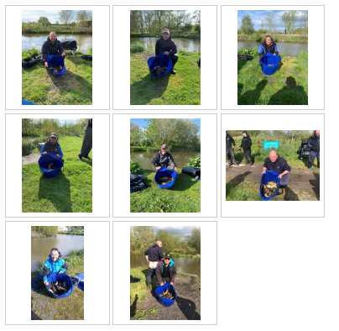

Venue: OLD HOUGH; BIG MAX, GOOSE AND BOULDERS
Date: 21.04.19

Another great turnout for the second match of 2019 where 37 anglers were greeted with a boiling hot Easter Sunday day. Everyone at the draw fancied Big Max as some half decent weights had been coming off there over the last few weeks and it proved to be right as 9 out of the top 10 weights on the day came from this lake. Goose and Boulders both fished really hard but it meant for a close match on these lakes.

Section A – Big max pegs 1 - 10
1st = Brandon Pelling 84lb 4oz
2nd = Stu Ford 70lb 12oz
Brandon Pelling made the most of a good draw pulling out peg 1 on Big Max and made the most of a good margin fishing 13m down the edge on hard pellet to win the section and the overall match, well done Brandon – top of the Tier 2 league after 2 matches. Stu Ford came second with a nice 70lb from peg 10 which moves him up to second in the tier 2 league so well done to him too.

Section B – Big max pegs 12 - 21
1st = Steve Barlow 54lb 7oz
2nd = Alan Hesling 48lb 12oz
Steve Barlow and Alan Hesling fought a close match from adjacent pegs on 18 and 19 with Steve Barlow coming out on top by just over 5lb. a second section win for Steve puts him 3rd in the league and Alan has also had a good start with 11 points from his first 2 matches.

Section C – Big max pegs 23 - 32
1st = Ged Smith 66lb 5oz
2nd = Phil Zahra 66lb 1oz
Ged Smith fished the method across and corn down the margins from peg 29 to just ounce out Phil Zahra from peg 23. Ged also landed the biggest fish of the year so far with a 12lb 2oz carp falling right at the death – Phil said it was foul hooked but I don’t believe him!

Section D – Goose pegs 1 - 8
1st = Pete Boggiano 39lb 6oz
2nd = Eamonn Boulger 33lb 5oz
Pete had to watch Eamonn catching all day from peg 3 and thought the section win was out of reach but Eamonn’s fish were a smaller stamp and Pete managed to snatch the win in the last hour with a good run of fish on hard pellet just off the point of the island. A second section win for Pete puts him second in the league

Section E – Goose pegs 10 - 18
1st = Tommy Edwards 30lb 7oz
2nd = Tony Webb 23lb 13oz
The toughest section of the day was won by Tommy Edwards from peg 16 on Goose and second was Tony Webb from peg 12

Section F – Boulders pegs 1 - 10
1st = Carl O’Brien 39lb 6oz
2nd = Gary Marsland 34lb 12oz
Carl O’Brien picks up his second section win in 2 matches and is top of the individual league. Carl fished corn over micros at 14.5m from peg 6 to win the section only marginally in front of Gary Marsland from peg 8.

Section G – Boulders pegs 11 - 20
1st = Ian Coleman 56lb 5oz
2nd = Ady Wood 40lb 5oz
Ian Coleman is back with a bang, after missing most of last year Ian is ready for a good season and his first match of 2019 shows he’s up for it. Probably the performance of the day putting 56lb on the scales and the only angler not on Big Max in the top 10 overall so well done to him, Ian fished up the far shelf feeding micros and fishing 4mm hard pellet from peg 11. Nice one Ian. Ady Wood came second in the section from peg 16, well done also to Ady.

Below are the photos taken on the day:

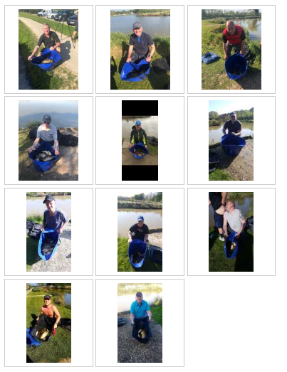

2019 MATCH REPORTS

Venue: BRADSHAWS LAKES 3, 4 AND 6
Date: 07.04.19

Here we go again!! A highly anticipated season is ahead of us and a great turnout of 37 for the first match at Bradshaws with everyone having high hopes for the next 7 months of cracking matches. We were split over 3 lakes on the complex with a huge array of pegs to work with, some of which were fancied draws way more than others but with late reports of lake 4 not fishing brilliant a curve ball was thrown into the mix!

Section A – Lake 4 Pegs 3 - 10
1st = Derek Wood 54lb 0oz
2nd = Dave Coleman 40lb 12oz

The early pegs on Lake 4 can produce some good weights on their day but they can also be a bit of a grind. Derek Wood produced the goods from peg 6 with 54lb of shallow F1’s on banded pellet up to the floating island and Dave Coleman came in second place with 40lb from peg 4 which is a decent result from that peg for Dave, nice one guys.

Section B – Lake 4 Pegs 12 - 23
1st = Carl O’Brien 139lb 11oz
2nd = Tony Webb 90lb 0oz

Carl showed us he is a top contender for the championship by putting in an early performance that smashed the overall match. Carl fished at 16m up to the floating island pinging 4mm pellets to catch 112 F1’s and 4 carp shallow between 4ft and 2ft deep. This is a pretty epic performance seeing as he had to double ship due to the bank behind him which resulted in him losing a top kit right at the end of the day – there’s about 2 grands worth of Carls poles in lake 4 if anyone fancies a swim?! Second place went to birthday bell end Tony Webb who started off planning a rod only match which came to an end after a fruitless hour or so resulting in Tony getting the margin swim going for a cracking weight.

Section C – Lake 4 Pegs 25 - 33
1st = Jason Suggett 61lb 14oz
2nd = Ady Wood 30lb 5oz

Jason kept things nice and simple from the wall side of lake 4 and fished one approach throughout the match to weigh in a cracking net of silvers with a bonus 4 F1s and a 4lb Tench to win the section comfortably – the method was banded caster at 2ft deep – top fishing Jason, well done. Ady was second in the section with 30lb 5oz

Section D – Lake 3 Pegs 1 - 11
1st = Steve Barlow 66lb 14oz
2nd = Ged Smith 47lb 13oz

Steve Barlow and Ged Smith battled it out on adjacent pegs on the wall side of Lake 3 with Steve Barlow coming out on top with 66lb. well done guys.

Section E – Lake 3 Pegs 13 - 27
1st = Pete Boggiano 101lb 7oz
2nd = Paul Tighe 64lb 7oz

Pete Boggiano didn’t fancy his draw on the causeway but early signs of fish were promising. Pete started the match fishing maggot through the water at 6m for about 10lb of silvers in the first 40 mins whilst building up a hard pellet line at 14m towards the lilly pads. After an hour or so Pete moved onto this line which was only 4.5ft deep pinging 4mm coppens pellets with 6mm coppens pellet on the hook and caught F1s steadily all day, Pete had about 10 F1s shallow with the rest firmly on the deck. A good solid start to the season for last year’s champion! A top performance from Paul Tighe on unfancied peg 13 took second in the section with 64lb of ide caught shallow on maggot – nice work Paul!

Section F – Lake 6
1st = Alan Hesling 56lb 2oz
2nd = Andy Sonley 51lb 4oz

Lake 6 fished the hardest of all the lakes with only one side producing decent weights where Alan Hesling and Andy sonly battled out a really close match. Alan came out on top by just over 5lb, Alan caught F1s shallow pinging pellets which seems to be the best method on the day. Well done guys a good result from a difficult lake!

Below are the photos taken on the day:

